function []=Bquestion2()
image=imread('cameraman.png');
if(size(image,3)==3)
image=rgb2gray(image);
end
%code goes here
F=fft2(image);
F=fftshift(F);
[s1,s2]=size(image);
A=abs(F);
max1=max(A(:));
display(max1);
A2=A/max1*255;
display(max(A2(:)));
figure;imshow(A2);
D0=20;
for i=1:s1
for j=1:s2
if((i-s1/2)^2+(j-s2/2)^2>D0)
F(i,j)=0 ;
end
end
end
figure;
s1=70;s2=70;
k=1;steps=3;
for D0=3:4:3+4*(steps-1)
F3(1:s1,1:s2)=1;
for i=1:s1
for j=1:s2
if((i-s1/2)^2+(j-s2/2)^2>D0)
F3(i,j)=0 ;
end
end
end
f3=fftshift(abs(ifft2((F3))));
str=['D0= ' num2str(D0)];
subplot(1,steps,k);imagesc(f3);colorbar;title(str);
k=k+1;
end
F2=ifftshift(F);
imout=uint8(ifft2(F2));
figure;
subplot(1,2,1);imshow(image);title('orignal image');
subplot(1,2,2);imshow(imout);title('Low pass image,with D0=20');
end
% for different values of D0 the level of blurring changes. as the value of
% D0 decreases the cuttoff frequency of the low pass filter decreases, thus
% increasing the blurrness
% As the filter low pass freq increases, the weightage given to the central
% pixel decreases, the weights of the central pixel is increasing, reducing
% the effect of pixels far off from the current pixel , thus reducing
% blurring
max1 =
43166571
ans =
255
Warning: Image is too big to fit on screen; displaying at 67%
Warning: Displaying real part of complex input.
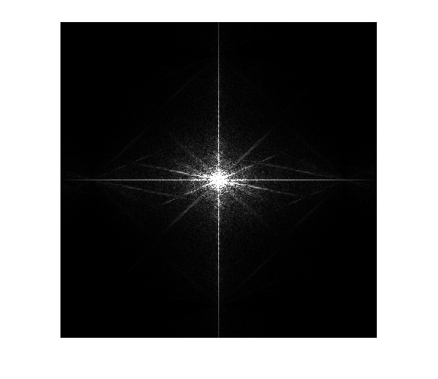
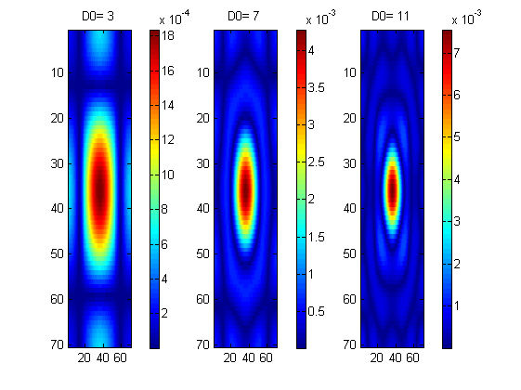
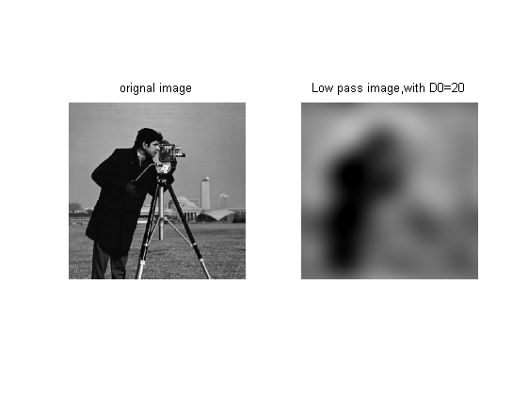
Published with MATLAB® R2013a

