function []=Bquestion3()
image=imread('cameraman.png');
if(size(image,3)==3)
image=rgb2gray(image);
end
[s1,s2]=size(image);
border=floor(s1*0.3);
im1(1:s1+border,1:s2+border)=uint8(0);
im2(1:s1+border,1:s2+border)=uint8(0);
im1(1:s1,1:s2)=image;
im2(border/2:s1+border/2-1,border/2:s2+border/2-1)=image;
figure;
subplot(2,1,1);imshow(im1);
subplot(2,1,2);imshow(im2);
imout1=low_pass(im1,200);
imout2=low_pass(im2,200);
end
function[imout]=low_pass(image,D0)
%code goes here
F=fft2(image);
F=fftshift(F);
[s1,s2]=size(image);
A=abs(F);
max1=max(A(:));
%display(max1);
A2=A/max1*255;
%display(max(A2(:)));
%figure;imshow(A2);
for i=1:s1
for j=1:s2
if((i-s1/2)^2+(j-s2/2)^2>D0)
F(i,j)=0 ;
end
end
end
F2=ifftshift(F);
imout=uint8(abs(ifft2(F2)));
figure;
subplot(1,2,1);imshow(image);title('orignal image');
subplot(1,2,2);imshow(imout);title('Transformed image');
end
% The image with uniform border accross it is preferred because after
% filtering the resulting image can be cropped back to get the resultant
% image of the same size as the orignal one
% In contrast if the image is padded only on one side, then the borders on
% the pixel intensities on non padded sides of the image are lost
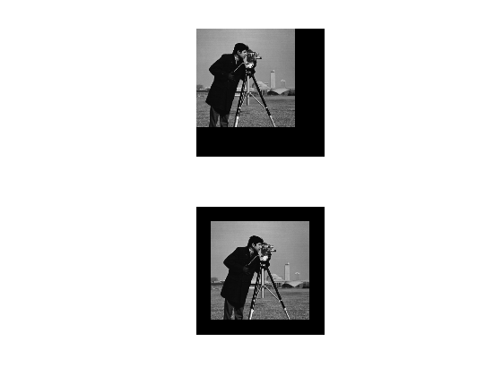
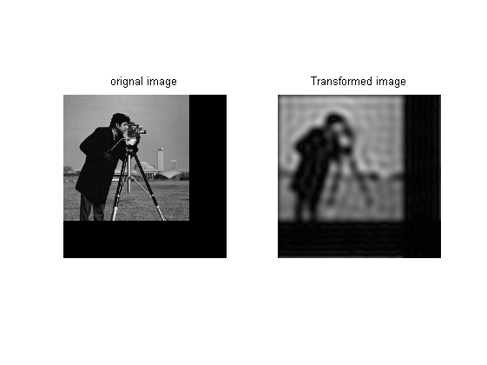
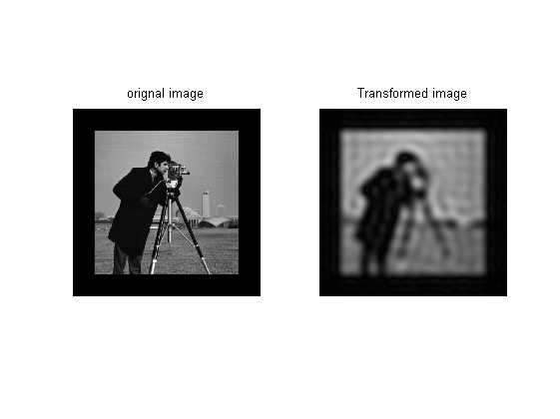
Published with MATLAB® R2013a

