function []=Bquestion4()
image=imread('ThumbPrint.tif');
if(size(image,3)==3)
image=rgb2gray(image);
end
imout=high_pass(image,70);
function[imout]=high_pass(image,D0)
%code goes here
F=fft2(image);
F=fftshift(F);
[s1,s2]=size(image);
A=abs(F);
max1=max(A(:));
display(max1);
A2=A/max1*255;
display(max(A2(:)));
%figure;imshow(A2);
for i=1:s1
for j=1:s2
if((i-s1/2)^2+(j-s2/2)^2<D0)
F(i,j)=0 ;
end
end
end
F2=ifftshift(F);
imout=uint8(ifft2(F2));
str=['high pass filtered image with D0= ' num2str(D0)];
figure;
subplot(1,2,1);imshow(image);title('orignal image');
subplot(1,2,2);imshow(imout);title(str);
end
end
Warning: TIFF library error - '_TIFFVSetField: G:\Acads -UW Madison\First
Sem\Image Processing\Labs\ImgProcessing\Lab2\ThumbPrint.tif: Null count for "Tag
34022" (type 1, writecount -3, passcount 1).' - file may be corrupt.
max1 =
140874449
ans =
255
Warning: Displaying real part of complex input.
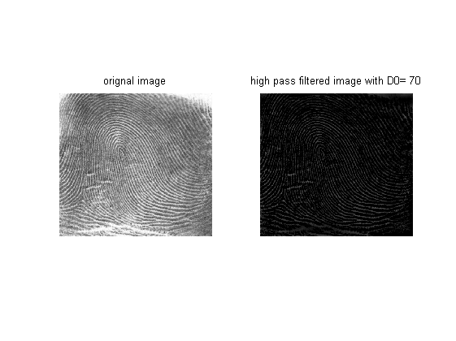
Published with MATLAB® R2013a

