function []=Bquestion5()
image=imread('MoirePattern.tif');
if(size(image,3)==3)
image=rgb2gray(image);
end
F=fftshift(fft2(image));
show_F(F,'Fourier Transform of Orignal image');
Fcopy=F;
r=80;
Fcopy=notch_filter(Fcopy,166,58,r);
Fcopy=notch_filter(Fcopy,86,58,r);
Fcopy=notch_filter(Fcopy,86,112,r);
Fcopy=notch_filter(Fcopy,166,112,r);
show_F(Fcopy,'Fourier Transform of Transformed image');
y=uint8(abs(ifft2(Fcopy)));
figure;
subplot(1,2,1);imshow(image);title('Orignal Image');
subplot(1,2,2);imshow(y);title('Filtered Image');
end
function[]=show_F(F,str)
A=abs(F);
max1=max(A(:));
A2=A/max1*255;
figure;imshow(A2);title(str);
end
function[F]=notch_filter(F,x,y,r)
[s1,s2]=size(F);
for i=1:s1
for j=1:s2
D=(i-x)^2+(j-y)^2;
if(D<r)
F(i,j)=0;
end
end
end
end
Warning: TIFF library error - '_TIFFVSetField:
G:\Acads -UW Madison\First Sem\Image
Processing\Labs\ImgProcessing\Lab2\MoirePattern.tif:
Null count for "Tag 34022" (type 1, writecount
-3, passcount 1).' - file may be corrupt.
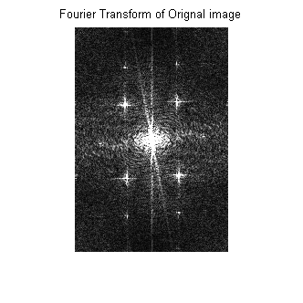
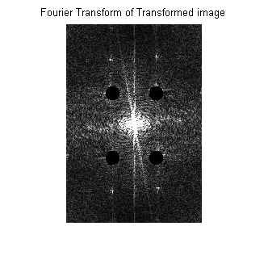
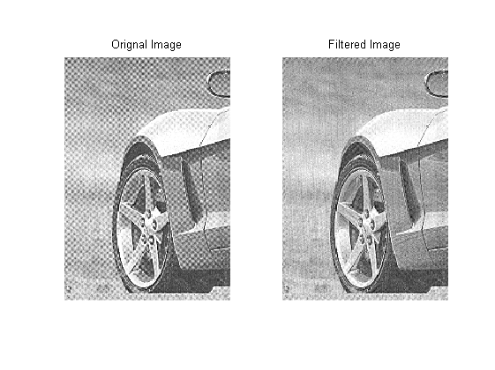
Published with MATLAB® R2013a

