function []=Bquestion6()
image=imread('PeriodicInterference.tif');
if(size(image,3)==3)
image=rgb2gray(image);
end
%figure;imshow(image);
%imout=band_reject(image,30,330);
imout2=band_reject2(image);
end
function[A2]=show_F(F,str)
A=abs(F);
max1=max(A(:));
A2=A/max1*255;
%figure;imshow(A2);title(str);
end
function[imout]=band_reject(image,D1,D2)
%code goes here
F=fft2(image);
F=fftshift(F);
figure;imagesc(uint8(log(1+abs(F))));colorbar;
[s1,s2]=size(image);
A=abs(F);
max1=max(A(:));
display(max1);
A2=A/max1*255;
display(max(A2(:)));
figure;imshow(A2);
for i=1:s1
for j=1:s2
kip=sqrt((i-s1/2)^2+(j-s2/2)^2);
if(kip>=D1&&kip<=D2)
F(i,j)=0 ;
end
end
end
A=abs(F);
max1=max(A(:));
display(max1);
A2=A/max1*255;
display(max(A2(:)));
figure;imshow(A2);
F2=ifftshift(F);
imout=uint8(ifft2(F2));
figure;
subplot(1,2,1);imshow(image);title('orignal image');
subplot(1,2,2);imshow(imout);title('Transformed image');
end
function[F]=band_reject2(image)
[s1,s2]=size(image);
F=fft2(image);F=fftshift(F);
A_in=show_F(F,'orignal');
mag=abs(F);
mag_sorted_dec=sort(mag,'descend');
max_value=mag_sorted_dec(1);
threshold=0.6*max_value;
theta1=15;theta2=50;
for i=1:s1
for j=1:s2
D=(i-floor(s1/2))^2+(j-floor(s2/2))^2;
theta=atan((i-s1/2)/(-j+s2/2))*180/pi;
if(theta>theta1&&theta<theta2&&D>30)
F(i,j)=0;
end
end
end
A_out=show_F(F,'transformed');
y=uint8(abs(ifft2(F)));
figure;
subplot(1,2,1);imshow(image);title('orignal image');
subplot(1,2,2);imshow(y);title('transformed image');
figure;
subplot(1,2,1);imshow(A_in);title('Orignal Fourier Transform');
subplot(1,2,2);imshow(A_out);title('Filtered Fourier Transform');
end
Warning: TIFF library error - '_TIFFVSetField:
G:\Acads -UW Madison\First Sem\Image
Processing\Labs\ImgProcessing\Lab2\PeriodicInterference.tif:
Null count for "Tag 34022" (type 1, writecount
-3, passcount 1).' - file may be corrupt.
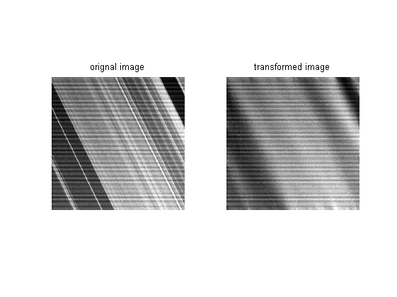
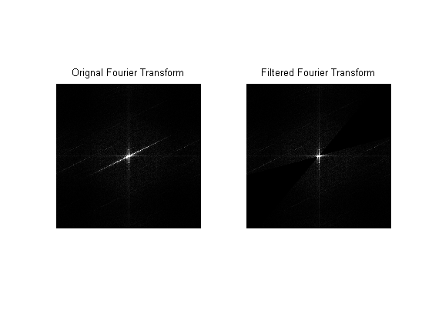
Published with MATLAB® R2013a

