function[]=Bquestion8()
image=imread('barbara.png');
if(size(image,3)==3)
image=rgb2gray(image);
end
image=image(1:64,1:64);
%image=[1 2 ;3 4 ];
[s1,s2]=size(image);
% if(2^floor(log2(s1))~=s1||2^floor(log2(s2))~=s2)
% display('program applicable only for images with dimensions with the power of 2');
% display(size(image));
% return;
% end
for i=1:s1
F(i,:)=questionB8_sub(image(i,:));
%display(image(i,:));
end
%display(F);
for j=1:s2
%display(transpose(image(:,j)));
F2(:,j)=transpose(questionB8_sub(transpose(F(:,j))));
end
F_base(1:s1,1:s2)=fft2(image);
figure;
subplot(1,2,1);imshow(image);title('orignal image');
subplot(1,2,2);imshow(uint8(abs(ifft2(F2))));title('Reconstructed image from computed FFT');
figure;
subplot(1,2,1);imagesc(log(1+abs(fftshift(F_base))));title('orignal Fourier Tranform');
subplot(1,2,2);imagesc(log(1+abs(fftshift(F2))));title('Computed Fourier Transform');
end
function [F_comb]=questionB8_sub(image)
%image=[1 1 1 1 1 1 1 1];
num_steps=log2(size(image,2));
% if(2^floor(log2(num_steps))~=num_steps)
% display('program only for power of 2');
% return;
% end
%display(num_steps);
test=[1 1];
%fft1d(test,0);
F_comb=fft1d_g(image);
% display(F_comb);
end
function[F_comb]=fft1d_g(seq)
num_entries=size(seq,2);
F_even(1:num_entries/2)=0;
F_odd(1:num_entries/2)=0;
F_comb(1:num_entries)=0;
seq_even(1:num_entries/2)=0;
seq_odd(1:num_entries/2)=0;
for i=1:num_entries/2
seq_even(i)=seq(2*i-1);
seq_odd(i)=seq(2*i);
end
if(num_entries==2)
F_comb=[seq(1)+seq(2),seq(1)-seq(2)];
return;
else
for u=1:num_entries
% clc;
% display(u);
F_comb(u)=fft1d(seq_even,u-1)+exp(-2*pi*1i*(u-1)/num_entries)*fft1d(seq_odd,u-1);
end
end
end
function[result]=fft1d(seq,u)
num_entries=size(seq,2);
% display(num_entries);
if(num_entries==1)
result=seq;
else
seq_even(1:num_entries/2)=0;
seq_odd(1:num_entries/2)=0;
for i=1:num_entries/2
seq_even(i)=seq(2*i-1);
seq_odd(i)=seq(2*i);
end
% display(seq_even);
% display(seq_odd);
%pause(3);
result=fft1d(seq_even,u)+exp(-2*pi*1i*u/num_entries)*fft1d(seq_odd,u);
end
end
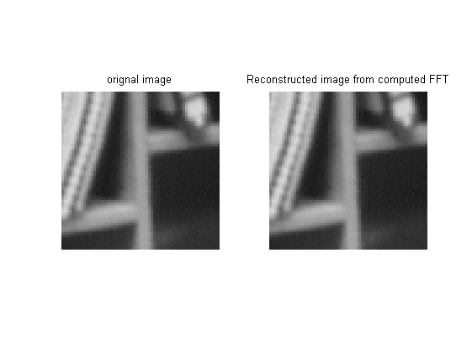
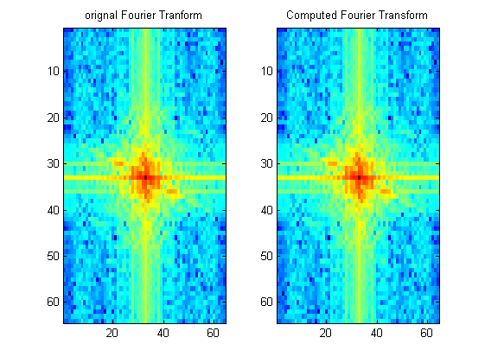
Published with MATLAB® R2013a

