function[]=question4b()
%Author - Guneet Singh Mehta ,ECE Department, UW Madison
image=imread('cameraman.png');
if(size(image,3)==3)
image=rgb2gray(image);
end
F=fft2(image);
s1=size(F,1);s2=size(F,2);
for i=1:s1
for j=1:s2
if(i==1)
F(1,j)=0;
end
end
end
imout=uint8(abs(ifft2(F)));
%imshow(image,'Border','tight');
figure;
subplot(1,2,1);imshow(image,'Border','tight');title('orignal image');
subplot(1,2,2);imshow(imout,'Border','tight');title('image with 1st row element zero');
end
% Horizontal Edges are more enhanced than vertical edges, as can be seen in the enhanced horizontal edges of building in the background of the cameraman
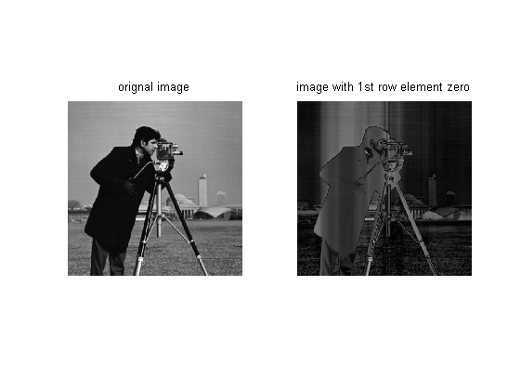

Question 4c
function[]=question4c()
%Author - Guneet Singh Mehta ,ECE Department, UW Madison
image=imread('cameraman.png');
if(size(image,3)==3)
image=rgb2gray(image);
end
F=fft2(image);
s1=size(F,1);s2=size(F,2);
for i=1:s1
for j=1:s2
if(j==1)
F(i,1)=0;
end
end
end
imout=uint8(abs(ifft2(F)));
figure;
subplot(1,2,1);imshow(image);title('orignal image');
subplot(1,2,2);imshow(imout);title('image with 1st column element zero');
end
% Horizontal Edges are more enhanced than vertical edges, as can be seen in the enhanced horizontal edges of building in the background of the cameraman

