function[]=question4g()
%Author - Guneet Singh Mehta ,ECE Department, UW Madison
image=imread('cameraman.png');
if(size(image,3)==3)
image=rgb2gray(image);
end
F=fft2(image);
s1=size(F,1);s2=size(F,2);
c=floor(0.01*s2);
for k1=1:s1
for k2=1:s2
if(k1<c&&k2<c)
F(k1,k2)=0;
end
end
end
imout=uint8(abs(ifft2(F)));
figure;
subplot(1,2,1);imshow(image);title('orignal image');
subplot(1,2,2);imshow(imout);title('resultant image');
end
% In the resultant image the edges which are not aligned along either x or
% y direction seem to be enhanced
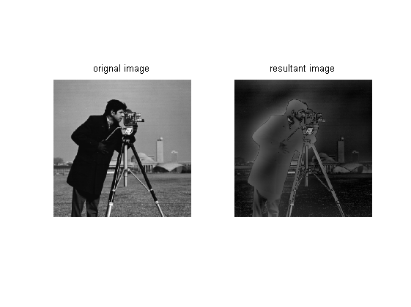
Published with MATLAB® R2013a

