function[]=question6a()
im1=imread('barbara.png');
if(size(im1,3)==3)
im1=rgbgray(im1);
end
IM1 = fft2(im1);
mag1 = abs(IM1);
phase1 = angle(IM1);
im1_test = uint8(ifft2(mag1.*exp(1i*phase1)));
figure;
subplot(1,2,1);imshow(im1);title('orignal image');
subplot(1,2,2);imshow(im1_test);title('reconstructed image');
end
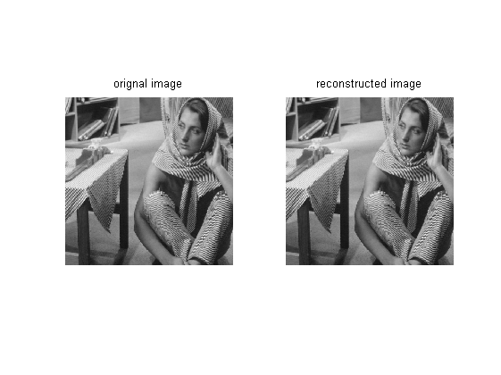
Published with MATLAB® R2013a

