function[]=question6c()
im1=imread('barbara.png');
if(size(im1,3)==3)
im1=rgbgray(im1);
end
IM1 = fft2(im1);
s1=size(im1,1);s2=size(im1,2);
mag1=abs(IM1);
phase1 = angle(IM1);
% display(phase1(1:10,1:10));
phase1=randn(1:s1,1:s2);
im1_test = uint8(real(ifft2(mag1.*exp(1i*phase1))));
figure;
subplot(1,2,1);imshow(im1);title('orignal image');
subplot(1,2,2);imshow(im1_test);title('reconstructed image');
end
%The reconstructed image has no similarities with the orignal image. The
%reconstructed image appears to be a random smudge. The phase information
%is required so that the reconstructed image has some similarity with the
%orignal image. While the magnitude infomation is also necessary , but
% phase information is more important for visual similarity
Warning: Size inputs must be scalar. This will error in a future release.
Warning: Size inputs must be scalar. This will error in a future release.
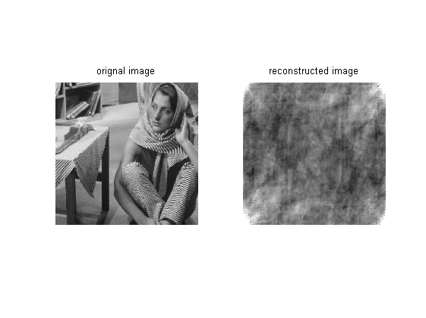
Published with MATLAB® R2013a

