function[]=question7a2()
image=imread('cameraman.png');k=1000;
% using the k highest coefficients in DFT
show_figs=1;
F=fft2(image);
[s1,s2]=size(image);
temp=k;
mag=abs(F);phase=angle(F);
a(1:s1*s2)=0;
mags=sort(mag(:),'descend');
k_threshold=mags(k+1);
mag2=mag;
for i=1:s1
for j=1:s2
if(mag2(i,j)<k_threshold)
mag2(i,j)=0;
end
end
end
F2=mag2.*exp(1i*phase);imout=uint8(ifft2(F2));
if(show_figs==1)
figure;
subplot(1,2,1);imshow(image);title('orignal image');
subplot(1,2,2);imshow(imout);title('reconstructed image');
end
end
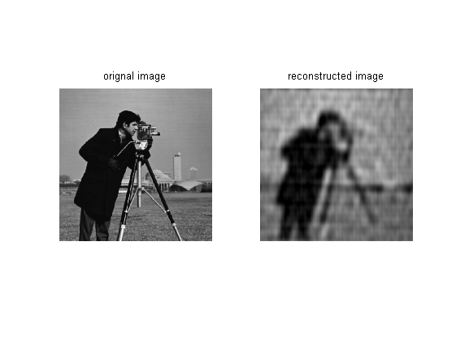
Published with MATLAB® R2013a

