function[]=question7c()
image=double(imread('cameraman.png'));
im_noise=imnoise(image,'gaussian',0,0.05);
[s1,s2]=size(image);
counter=1;
steps=100;
MSE(1:steps)=0;
indices=1:steps;
for k=10:100:100*steps
imout=question7a(im_noise,k);
MSE(counter)=0;
imdiff=image-imout;
MSE(counter)=sum(imdiff(:).*imdiff(:));
% for i=1:s1
% for j=1:s2
% MSE(counter)=MSE(counter)+(image(i,j)-imout(i,j))^2;
% end
% end
MSE(counter)=MSE(counter)/(s1*s2);
counter=counter+1;
fprintf('%d ',counter);
end
indices=indices*k;
figure;plot(indices,MSE);title('MSE with increasing k values');
end
2 3 4 5 6 7 8 9 10 11 12 13 14 15 16 17 18 19 20 21 22 23 24 25 26 27 28 29 30 31 32 33 34 35 36 37 38 39 40 41 42 43 44 45 46 47 48 49 50 51 52 53 54 55 56 57 58 59 60 61 62 63 64 65 66 67 68 69 70 71 72 73 74 75 76 77 78 79 80 81 82 83 84 85 86 87 88 89 90 91 92 93 94 95 96 97 98 99 100 101
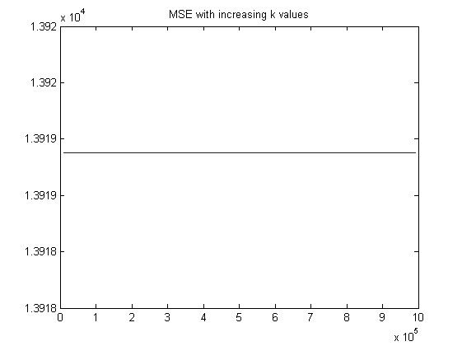
Published with MATLAB® R2013a

