function[]=question7d()
image=imread('cameraman.png');
if(size(image,3)==3)
image=double(rgb2gray(image));
end
[s1,s2]=size(image);
counter=1;
steps=100;
MSE(1:steps)=0;
indices=10:100:100*steps;
for k=10:100:100*steps
[imout,k_actual]=question7d_sub(image,k);
MSE(counter)=0;
imdiff=image-imout;
MSE(counter)=sum(imdiff(:).*imdiff(:));
% for i=1:s1
% for j=1:s2
% MSE(counter)=MSE(counter)+(image(i,j)-imout(i,j))^2;
% end
% end
MSE(counter)=MSE(counter)/(s1*s2);
indices(counter)=k_actual;
counter=counter+1;
fprintf('%d ',counter);
end
display(indices);
figure;plot(indices,MSE);title('MSE with increasing k values');
end
function[imout,k_actual]=question7d_sub(image,k)
% using the k highest coefficients in DFT
show_figs=0;
F=fft2(image);
[s1,s2]=size(image);
mag=abs(F);phase=angle(F);
mag2(1:s1,1:s2)=0;
k_temp=k;sum=1;
while(k_temp-sum>=0)
for i=1:sum
j=sum-i+1;
mag2(i,j)=mag(i,j);
end
k_temp=k_temp-sum;
sum=sum+1;
end
k_actual=k-(k_temp);
% % display(size(mag2));
% display(size(phase));%pause(5);
F2=mag2.*exp(1i*phase);imout=uint8(ifft2(F2));
if(show_figs==1)
figure;
subplot(1,2,1);imshow(image);title('orignal image');
subplot(1,2,2);imshow(imout);title('reconstructed image');
end
imout=double(imout);
end
2 3 4 5 6 7 8 9 10 11 12 13 14 15 16 17 18 19 20 21 22 23 24 25 26 27 28 29 30 31 32 33 34 35 36 37 38 39 40 41 42 43 44 45 46 47 48 49 50 51 52 53 54 55 56 57 58 59 60 61 62 63 64 65 66 67 68 69 70 71 72 73 74 75 76 77 78 79 80 81 82 83 84 85 86 87 88 89 90 91 92 93 94 95 96 97 98 99 100 101
indices =
Columns 1 through 6
10 105 210 300 406 496
Columns 7 through 12
595 703 780 903 990 1081
Columns 13 through 18
1176 1275 1378 1485 1596 1653
Columns 19 through 24
1770 1891 1953 2080 2145 2278
Columns 25 through 30
2346 2485 2556 2701 2775 2850
Columns 31 through 36
3003 3081 3160 3240 3403 3486
Columns 37 through 42
3570 3655 3741 3828 4005 4095
Columns 43 through 48
4186 4278 4371 4465 4560 4656
Columns 49 through 54
4753 4851 4950 5050 5151 5253
Columns 55 through 60
5356 5460 5565 5671 5778 5886
Columns 61 through 66
5995 6105 6105 6216 6328 6441
Columns 67 through 72
6555 6670 6786 6903 6903 7021
Columns 73 through 78
7140 7260 7381 7503 7503 7626
Columns 79 through 84
7750 7875 8001 8001 8128 8256
Columns 85 through 90
8385 8385 8515 8646 8778 8778
Columns 91 through 96
8911 9045 9180 9180 9316 9453
Columns 97 through 100
9591 9591 9730 9870
Warning: Imaginary parts of complex X and/or Y
arguments ignored
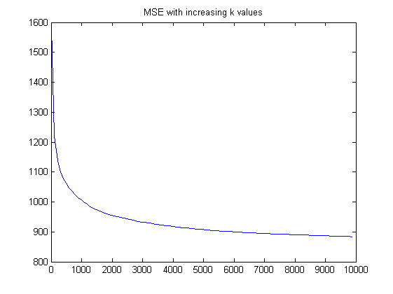
Published with MATLAB® R2013a

