% Implement a spatial smoothing filter. (HINT: the Matlab command fspecial has several useful
% filters you may use, and conv2 performs two-dimensional convolution.) How does the filter performance
% change as you change the size of the filter? What if you leave the filter size constant but vary
% the values of the filter coefficients? What is the difference between a boxcar and Gaussian filter?
function[]=Bquestion1()
% Author - Guneet Singh Mehta, ECE Masters Student, UW Madison
% email id- gmehta2@wisc.edu
h1=fspecial('gaussian',5,2);
image=imread('BirdFish.jpg');
if(size(image,3)==3)
image=rgb2gray(image);
end
imout=conv2(double(image),double(h1));
colormap jet;
f1=figure;% part 1 of question
subplot(1,2,1);imagesc(uint8(image));title('orignal image');
subplot(1,2,2);imagesc(uint8(imout));title('smoothened image');
f2=figure;%change of filter size
var=3;% for more visible filtering
filter_size_num=4;rows=2;column=ceil(filter_size_num/rows);
for i=1:filter_size_num
filter_size=3+2*(i-1);
h1=fspecial('gaussian',filter_size,var);
imout=conv2(double(image),double(h1));
subplot(rows,column,i);imagesc(uint8(imout));
title_string=['filter size=' num2str(filter_size)];
title(title_string);
end
% as filter size increases the image becomes more blurred
% for varying variances
f3=figure;%change of filter size
filter_size_num=4;rows=2;column=ceil(filter_size_num/rows);
var_num=4;
for i=1:var_num
var=0.5+1*(i-1);
h1=fspecial('gaussian',5,var);
imout=conv2(double(image),double(h1));
subplot(rows,column,i);imagesc(uint8(imout));
title_string=['variance=' num2str(var)];
title(title_string);
end
% as variance increases for the same filter size , image gets
% progressively blurred
% A gaussian filter for image filtering has maximum value of
% coefficient near the center of the filter , which decreases according
% to the Gaussian function as distance from the center increases. While
% in Boxcar filter the value of all the coefficients in the filter
% remain the same and equal to =1/(number of elements in the filter)
end
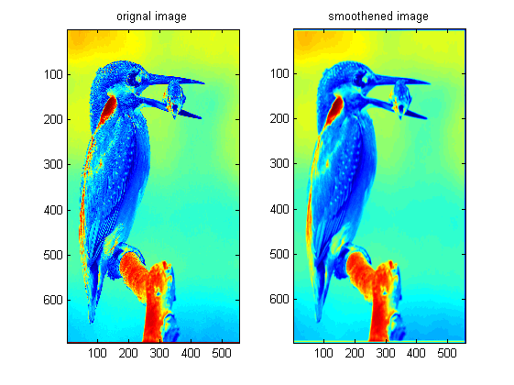
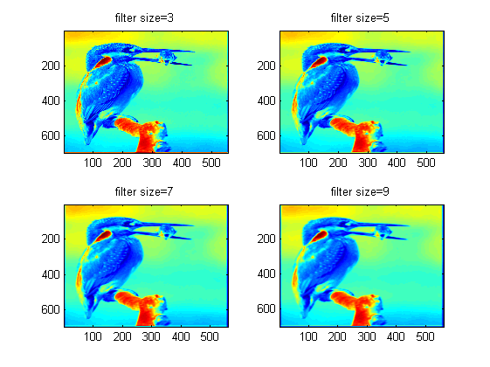
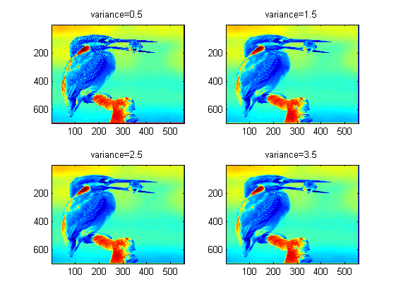
Published with MATLAB® R2013a

