% Question 2 Part B
% Implement a spatial edge-emphasizing filter. Again, what is the impact of different choices of filter
% coefficients? Does the emphasis of edges depend on the edge orientation? How is this related to the
% filter coefficients?
function[]=Bquestion2()
% Author - Guneet Singh Mehta, ECE Masters Student, UW Madison
% email id- gmehta2@wisc.edu
% Using sobel filter to detect edges
image=imread('boat.png');% using this image becuase of horizontal and vertical lines
horz_edge_filter=fspecial('sobel');
vert_edge_filter=transpose(fspecial('sobel'));
imout_horz=conv2(double(image),double(horz_edge_filter));
imout_vert=conv2(double(image),double(vert_edge_filter));
colormap jet;
f1=figure;
subplot(1,2,1);imagesc(uint8(abs(imout_horz)));title('horizontal edges');
subplot(1,2,2);imagesc(uint8(abs(imout_vert)));title('vertical edges');
f2=figure;
subplot(1,2,1);imshow(uint8(abs(imout_horz)));title('horizontal edges');
subplot(1,2,2);imshow(uint8(abs(imout_vert)));title('vertical edges');
end
% A sobel filter with coeffs= [1 2 1; 0 0 0;-1 -2 -1] on encountering a
% horizontal boundary , lets say [ 1 1 1 ; 0 0 0 ; 0 0 0] will result in a
% non zero value while on encountering a vertical edge like
% [1 0 0;1 0 0;1 0 0] will result in a zero value because the coefficients
% times the pixel value will negate each other.
% Similarly the transpose of sobel filter will detect only the vertical
% edges and not horizontal edges
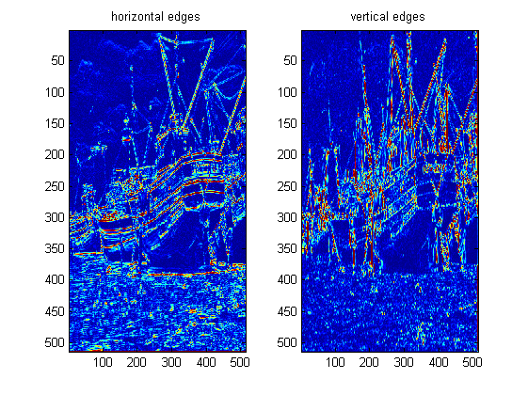
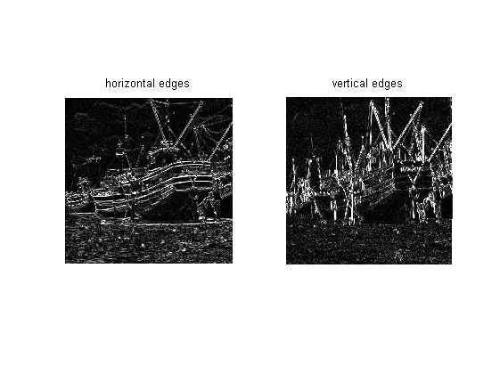
Published with MATLAB® R2013a

