% Generate a sharpening filter by combining the above smoothing and edge-emphasizing filters. HINT:
% this is a kind of unsharp masking. Explain how the same process can be implemented with a single
% filter.
function [ output_args ] = Bquestion4( input_args )
%Author - Guneet Singh Mehta ,ECE Department, UW Madison
im=imread('BirdFish.jpg');im=rgb2gray(im);
%im=imread('saturn.png');
%im=imread('boat.png');
h1=fspecial('laplacian');
sharp=conv2(im,h1);
h2=fspecial('gaussian',3,0.5);
smooth=conv2(im,h2);
figure;imshow(im);title('orignal');
figure; imshow(uint8(sharp));title('sharp');
figure;imshow(uint8(smooth));title('smooth');
figure;imshow(uint8(0.5*sharp+smooth));title('unsharp k=0.5');
figure;imshow(uint8(0.3*sharp+smooth));title('unsharp k=0.3');
h3=h1+h2;
combined=conv2(im,h3);
figure;imshow(uint8(combined));title('combined');
end
Warning: CONV2 on values of class UINT8 is obsolete.
Use CONV2(DOUBLE(A),DOUBLE(B)) or CONV2(SINGLE(A),SINGLE(B)) instead.
Warning: CONV2 on values of class UINT8 is obsolete.
Use CONV2(DOUBLE(A),DOUBLE(B)) or CONV2(SINGLE(A),SINGLE(B)) instead.
Warning: Image is too big to fit on screen; displaying at 67%
Warning: Image is too big to fit on screen; displaying at 67%
Warning: Image is too big to fit on screen; displaying at 67%
Warning: Image is too big to fit on screen; displaying at 67%
Warning: Image is too big to fit on screen; displaying at 67%
Warning: CONV2 on values of class UINT8 is obsolete.
Use CONV2(DOUBLE(A),DOUBLE(B)) or CONV2(SINGLE(A),SINGLE(B)) instead.
Warning: Image is too big to fit on screen; displaying at 67%
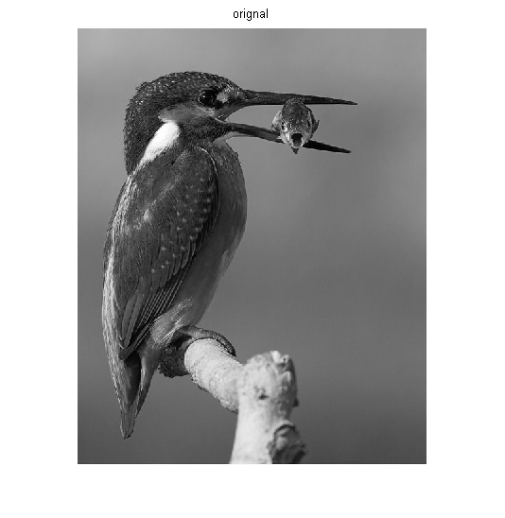
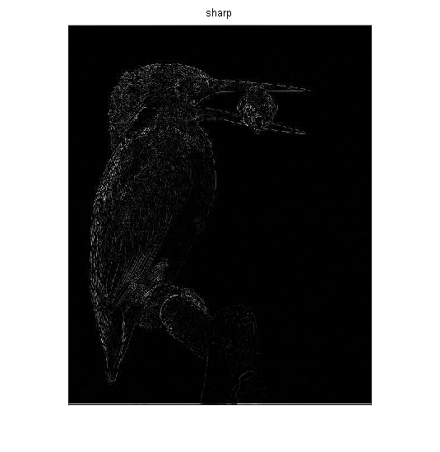
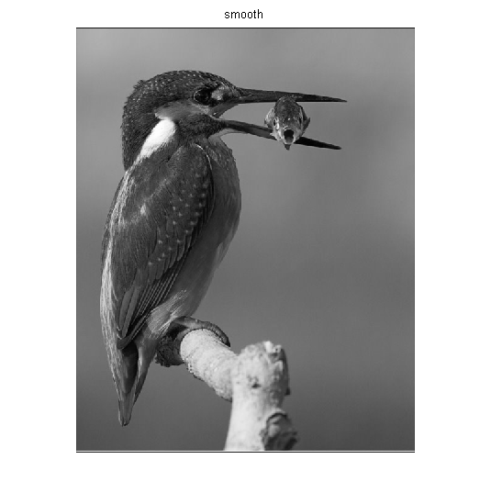
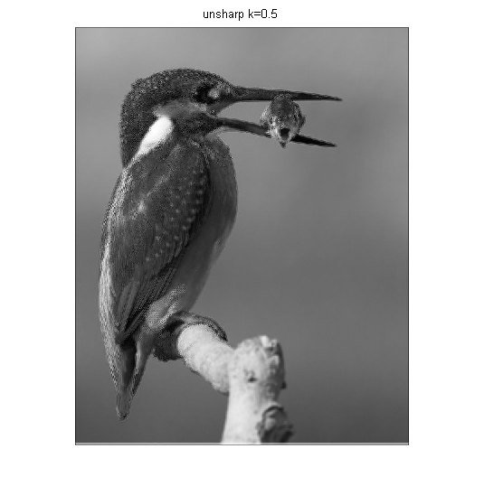
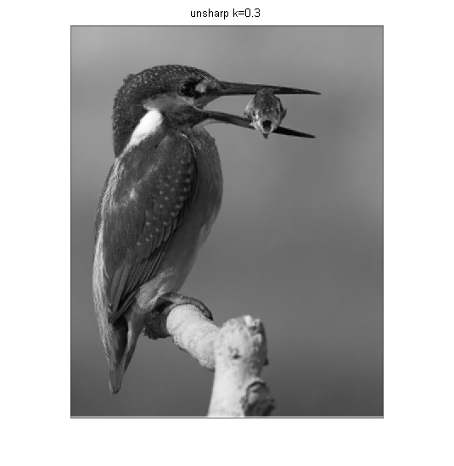
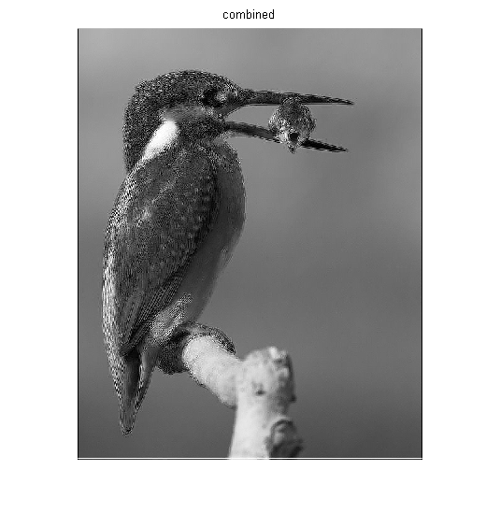
Published with MATLAB® R2013a

