% Experiment with
% filtering for contrast enhancement. In particular, if im is your original image and
% im_gam is your filtered image, then for each pixel i the
% filter performs the following operation:
% im_gam[i] = im[i]ˆgamma;
% What is the effect of this filter? How does the effect change with the value of
% , particularly when it
% is less than or greater than 1? Does it help if your image pixel values are between 0 and 1?
function[]=Bquestion6()
% Author - Guneet Singh Mehta, ECE Masters Student, UW Madison
% email id- gmehta2@wisc.edu
image=imread('BirdFish.jpg');
if(size(image,3)==3)
image=rgb2gray(image);
end
s1=size(image,1);s2=size(image,2);
imout(1:s1,1:s2)=uint8(0);
for gamma=0.6:0.2:1.4
c=255/(255)^gamma;
for i=1:s1
for j=1:s2
imout(i,j)=uint8(c*double(image(i,j))^gamma);
end
end
figure;
title_text=['Gamma=' num2str(gamma)];
subplot(1,2,1);imshow(image);title('Orignal Image');
subplot(1,2,2);imshow(imout);title(title_text);
%colorbar;
% display(size(imout));
% display(size(image));
end
% for gamma values less than 1 the contrast in the darker regions (low
% intensity value) is increased while for gamma values greater than 1
% the contrast in the brighter regions (high intensity value ) is
% increased
end
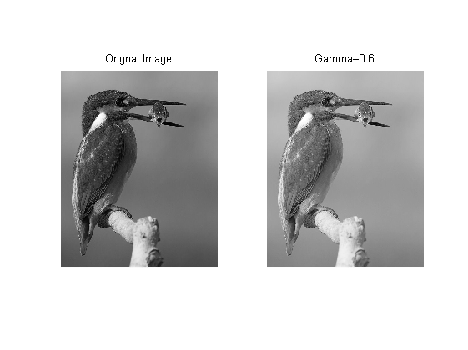
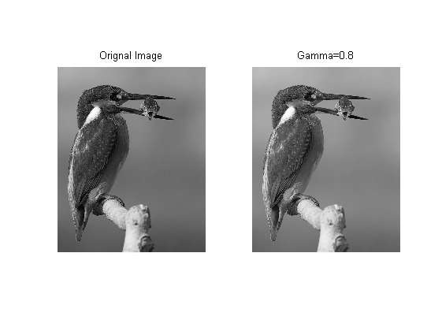
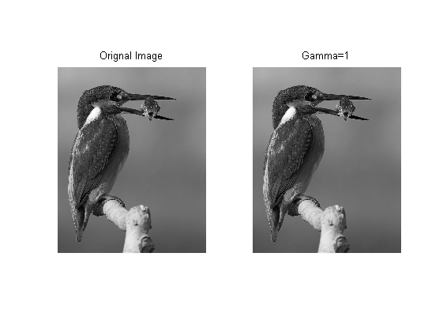
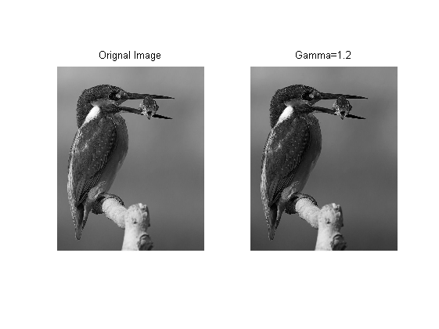
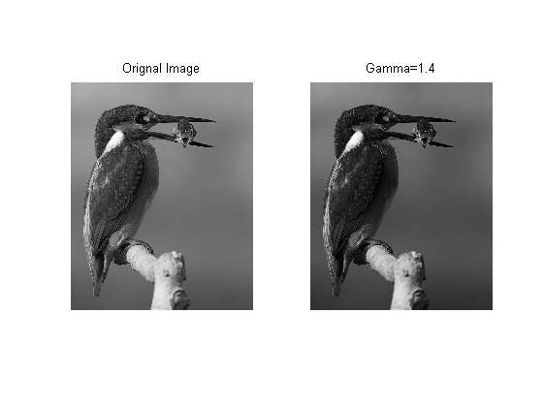
Published with MATLAB® R2013a

