% Next experiment with the effect of these filters on a noisy image.
function[]=Bquestion7()
% Author - Guneet Singh Mehta, ECE Masters Student, UW Madison
% email id- gmehta2@wisc.edu
% code copied from pdf handout in ECE 533 as illustration
image = imread('BirdFish.jpg');
if(size(image,3)>1)
image=rgb2gray(image);
end
figure;imshow(image);
sigma = 15;
noise = randn(size(image))*sigma;
im_noisy = double(image) + noise;
figure;
subplot(1,2,1);imagesc(uint8(image));title('orignal image');
axis image;colormap gray;
subplot(1,2,2);imagesc(uint8(im_noisy),[min(image(:)), max(image(:))]);title('noisy image');
axis image;colormap gray;
linkaxes;
%pause(5);
h_smooth=fspecial('gaussian',5,2);
h_edge_prewitt=fspecial('prewitt');
h_unsharp=fspecial('gaussian',3,0.5)+0.4*h_edge_prewitt;
colormap jet;
imout_smooth=uint8(conv2(double(image),double(h_smooth)));
imout_prewitt=uint8(conv2(double(image),double(h_edge_prewitt)));
imout_unsharp=uint8(conv2(double(image),double(h_unsharp)));
f1=figure;
subplot(2,2,1);imagesc(image);title('orignal image');
subplot(2,2,2);imagesc(imout_smooth);title('gaussian smooth image');
subplot(2,2,3);imagesc(imout_prewitt);title('edge enhanced image - prewitt');
subplot(2,2,4);imagesc(imout_unsharp);title('unsharp image');
%median ,max and min filtering
s1=size(image,1);s2=size(image,2);
imout_median(1:s1,1:s2)=uint8(0);
imout_max(1:s1,1:s2)=uint8(0);
imout_min(1:s1,1:s2)=uint8(0);
imout_gamma_half(1:s1,1:s2)=uint8(0);
imout_gamma_two(1:s1,1:s2)=uint8(0);
mask_size=3;
c_gamma_half=double(255)/(255.0)^0.8;
c_gamma_two=(255.0)^(-0.2);
for i=1:s1
for j=1:s2
if(i<=floor(mask_size/2)||i>=s1-floor(mask_size/2)||j<=floor(mask_size/2)||j>=s2-floor(mask_size/2))
imout_median(i,j)=image(i,j);
imout_max(i,j)=image(i,j);
imout_min(i,j)=image(i,j);
else
submatrix=image(i-floor(mask_size/2):i+ floor(mask_size/2),j-floor(mask_size/2):j+ floor(mask_size/2));
imout_median(i,j)=median(submatrix(:));
imout_max(i,j)=max(submatrix(:));
imout_min(i,j)=min(submatrix(:));
end
imout_gamma_half(i,j)=uint8(c_gamma_half*(double(image(i,j))^0.8));
imout_gamma_two(i,j)=uint8(c_gamma_two*(double(image(i,j))^1.2));
end
end
f2=figure;
subplot(2,2,1);imagesc(image);title('orignal image');
subplot(2,2,2);imagesc(imout_median);title('median filtered image');
subplot(2,2,3);imagesc(imout_max);title('max filtered image');
subplot(2,2,4);imagesc(imout_min);title('min filtered image');
f3=figure;
subplot(1,3,1);imagesc(image);title('orignal image');
subplot(1,3,2);imagesc(imout_gamma_half);title('gamma filtered = 0.5');
subplot(1,3,3);imagesc(imout_gamma_two);title('gamma filtered = 2.0');
end
% seeing the output images , it can be inferred that Gaussian filter,
% and median filter are able to remove the noise and are closer to the
% orignal image.
% Max and Min filters were able to remove the noise but the resultant
% image is not close to the orignal image.
% Edge enhanced, unsharp images added had more noise compared to the
% orignal image
%Gamma filtered images for gamma>1 and Gamma<1 were also not able to
%remove the noise
Warning: Image is too big to fit on screen; displaying at 67%
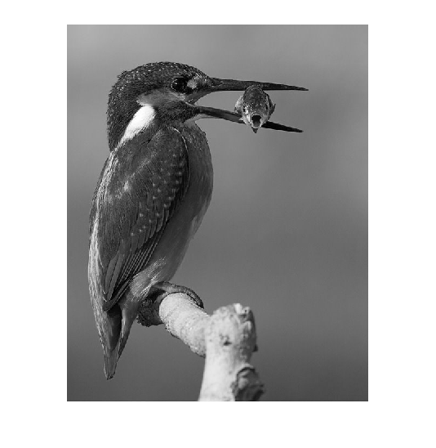
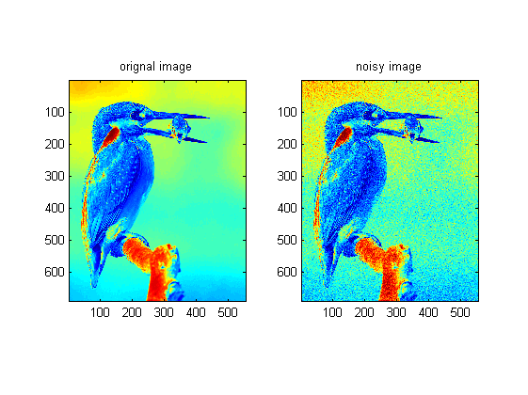
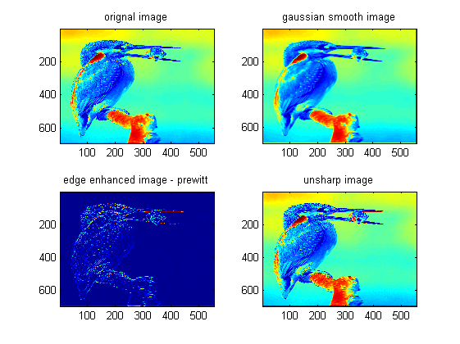
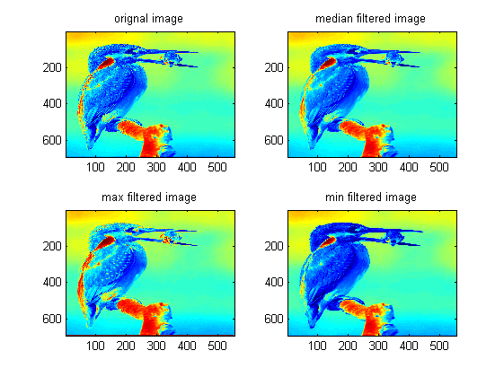
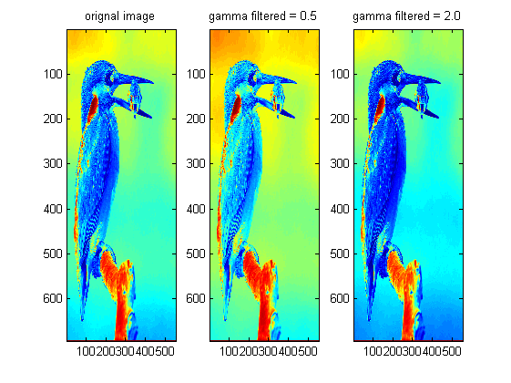
Published with MATLAB® R2013a

