function[]=question10()
%Author - Guneet Singh Mehta ,ECE Department, UW Madison
im=imread('saturn.png');
s1=size(im,1);s2=size(im,2);
figure;imshow(im);title(['orignal image with size=',num2str(s1),'x',num2str(s2)]);
im2=imresize(im,[s1,s2/2]);
figure;imshow(im2);title(['modified image with size=',num2str(s1),'x',num2str(s2/2)]);
imwrite(im2,'saturn_modified.png'); %writing the modified image to default directory
end
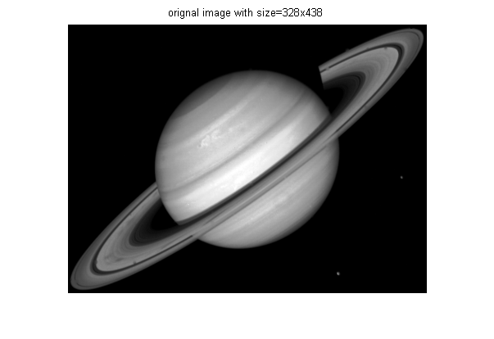
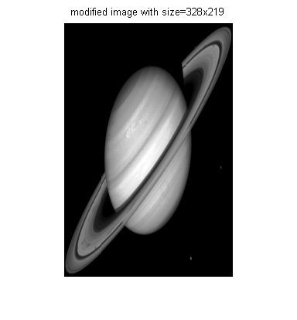
Published with MATLAB® R2013a

