function[]=question4()
%Author - Guneet Singh Mehta ,ECE Department, UW Madison
im=imread('saturn.png');
figure;imshow(im);
figure;imagesc(double(im));
% imshow basically shows all images as it is. That is a grayscale image
% will be displayed as a grayscale image , a color image will be shown as
% a color image
% While imagesc replaces the image data (grayscale in the case of
% 'saturn.png' to colors from colormap. The colormap links each intensity
% value in the image to a particular color. the default colormap of
% imagesc is 'jet'
end
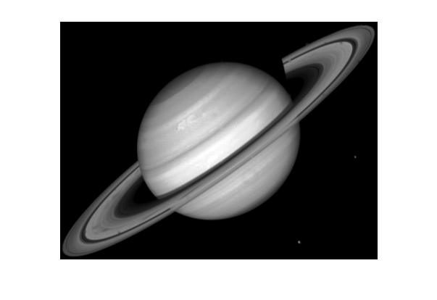
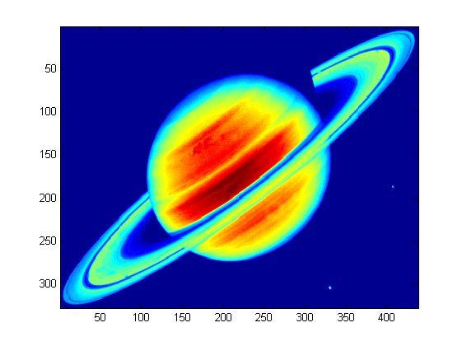
Published with MATLAB® R2013a

