function[]=question5()
%Author - Guneet Singh Mehta ,ECE Department, UW Madison
im=imread('BirdFish.jpg');
min_3channel=min(im(:));
max_3channel=max(im(:));
fprintf('Maximum value in the image=%d\nMinimum Value in image=%d\n',max_3channel,min_3channel);
if(size(im,3)==3)
for k=1:3
min_value(k)=min(min(im(:,:,k)));
max_value(k)=max(max(im(:,:,k)));
fprintf('Minimum value for channel %d=%d Maximum value for channel %d=%d\n',k,min_value(k),k,max_value(k));
end
end
fprintf('Result of whos im command=\n');
whos im;
fprintf('plotting results of imagesc for each channel\n');
k1=0;k2=100;
if(size(im,3)==3)
for k=1:3
figure;imagesc(im(:,:,k),[k1,k2]);
end
end
end
Maximum value in the image=255
Minimum Value in image=0
Minimum value for channel 1=0 Maximum value for channel 1=255
Minimum value for channel 2=0 Maximum value for channel 2=255
Minimum value for channel 3=0 Maximum value for channel 3=255
Result of whos im command=
Name Size Bytes Class Attributes
im 693x553x3 1149687 uint8
plotting results of imagesc for each channel
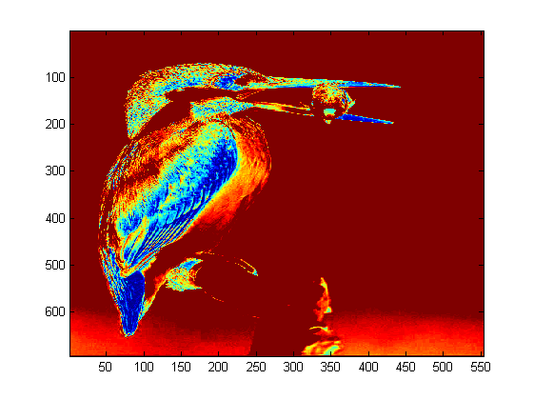
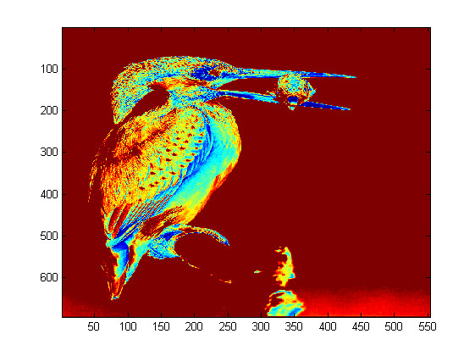
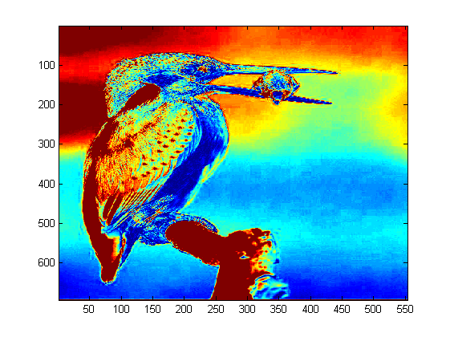
Published with MATLAB® R2013a

