function[]=question6()
% Code Taken from - https://ay15-16.moodle.wisc.edu/prod/pluginfile.php/90512/mod_assign/introattachment/0/Lab1.pdf?forcedownload=1
% code written courtsey to Prof Rebecca Willett, University of Wisconsin
% Madison
imC=imread('BirdFish.jpg');
figure(15);
subplot(221);image(imC/255);axis image;title('orig');
subplot(222);imagesc(imC(:,:,1),[0,255]);axis image;
title('red');colormap gray;
subplot(223);imagesc(imC(:,:,2),[0,255]);axis image;
title('green');colormap gray;
subplot(224);imagesc(imC(:,:,3),[0,255]);axis image;
title('blue');colormap gray;
linkaxes;
load cmapRGB
figure(16);imagesc(imC(:,:,1),[0,255]);axis image;
title('red');colormap(cmap_red)
figure(17);imagesc(imC(:,:,2),[0,255]);axis image;
title('green');colormap(cmap_green)
figure(18);imagesc(imC(:,:,3),[0,255]);axis image;
title('blue');colormap(cmap_blue)
end
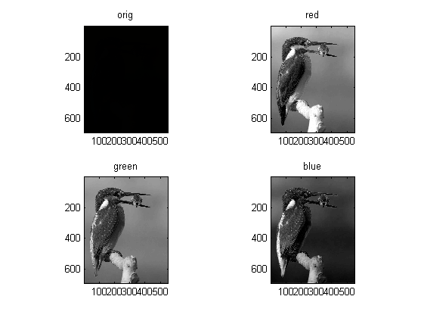
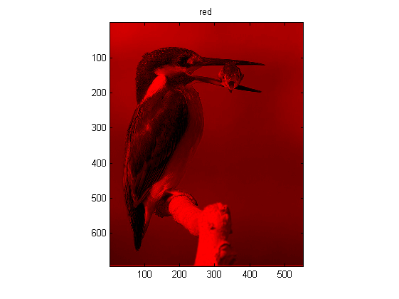
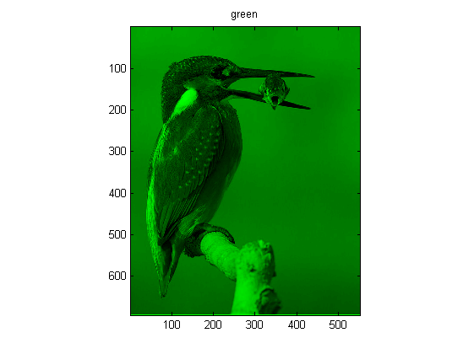
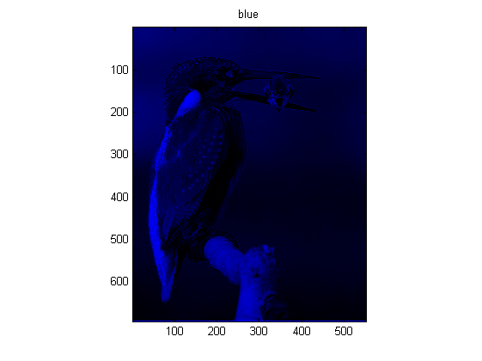
Published with MATLAB® R2013a

