function[]=question7()
%Author - Guneet Singh Mehta ,ECE Department, UW Madison
% code snippets for imtransform taken from MATLAB help of function imtransform
im=imread('saturn.png');
figure;imshow(imrotate(im,-90));title('Image Rotation using imrotate');
A=[0 1 0;-1 0 0;0 0 1]; % A is of the form of [cos(angle),sin(angle),0;-sin(angle) cos(angle) 0;0 0 1]
tform = maketform('affine',A);
J = imtransform(im,tform);
figure, imshow(J);title('Image Rotation using imtransform');
if(size(im,3)==3)
for k=1:3
im2_temp=flipdim(im(:,:,k),2);
im2_temp=transpose(im2_temp);
im2_temp=flipdim(im2_temp,1);
im2_temp=flipdim(im2_temp,2);
im2(:,:,k)=im2_temp;
end
elseif(size(im,3)==1)
im2=flipdim(im,2);%flipping along columns
im2=transpose(im2);%transpose
im2=flipdim(im2,1);% flipping along rows
im2=flipdim(im2,2);%flipping along columns
end
figure;imshow(im2);title('rotating image using matrix operations ');
end
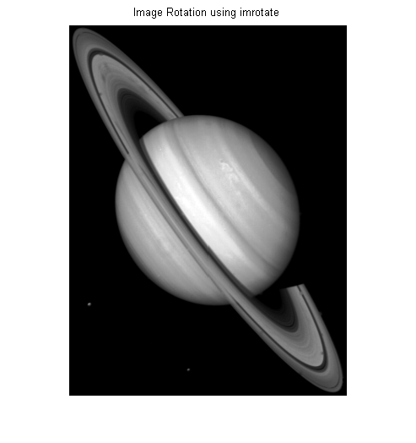
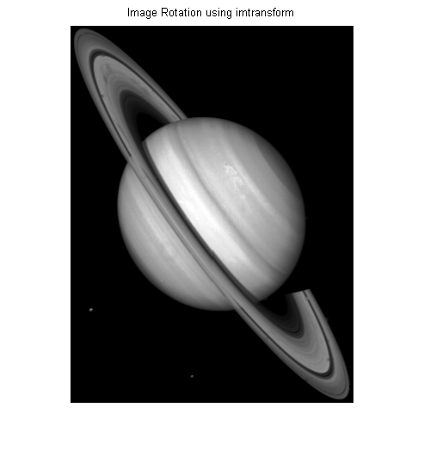
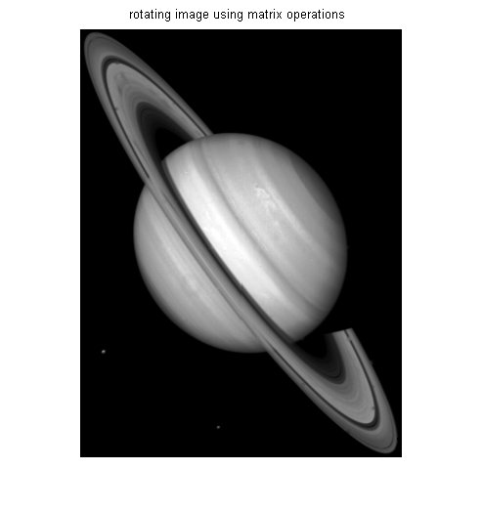
Published with MATLAB® R2013a

