function[]=question8()
%Author - Guneet Singh Mehta ,ECE Department, UW Madison
im=imread('saturn.png');
figure;imshow(im);title('orignal image');
steps=5;
A=[1 0 0;0 1 0;-steps 0 1]; % A is of the form of [cos(angle),sin(angle),0;-sin(angle) cos(angle) 0;xshift yshift 1]
% -steps because the shift is towards left
tform = maketform('affine',A);
J = imtransform(im,tform);
figure, imshow(J);title('Image translation using imtransform');
s1=size(im,1);s2=size(im,2);
steps=50;
im2(:,1:s2-steps)=im(:,steps+1:end);
im2(:,s2-steps+1:s2)=uint8(0);
figure;imshow(im2);title('shifting image by matrix manipulation');
end
Warning: You just called IMTRANSFORM with a pure translation. The output image
will be the same as the input image unless you specify 'XData' and 'YData'
values in your call to IMTRANSFORM. For example, if you want the output to be
the same size as the input revealing the translation relative to the input
image, call IMTRANSFORM like this:
B = IMTRANSFORM(A,T,'XData',[1 size(A,2)],'YData',[1 size(A,1)])
For more information about this topic, see the example <a
href="matlab:helpview(fullfile(docroot,'toolbox','images','images.map'),'translation_example')">Performing
a Translation</a> in the User's Guide, especially the section in Step 5 on
"Understanding the Coordinates of the Transformed Image."
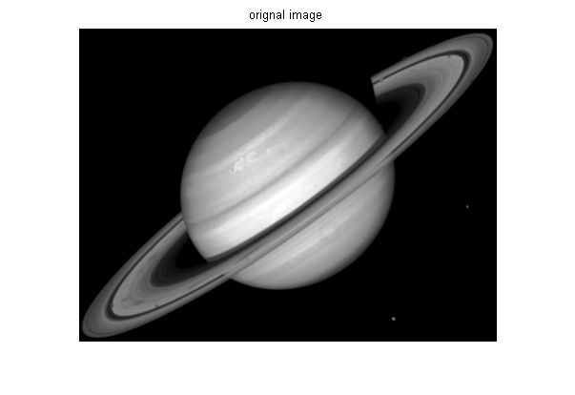
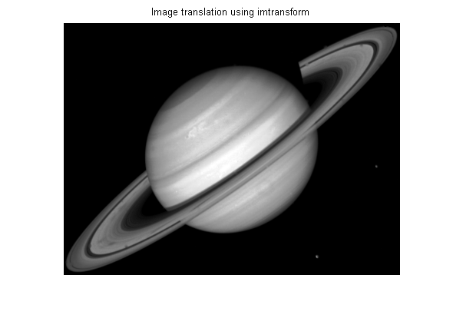
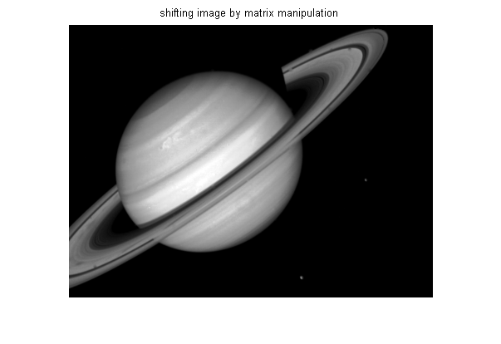
Published with MATLAB® R2013a

