function [ ] = q1( )
%finding haar_LLevel
s_image=128;
f = double(phantom(s_image));
w=haar_LLevel(f,log2(s_image));
figure;imagesc(log(1+abs(w)));colorbar;title('haar wavelet transform');
f_out=invhaar_LLevel(w,log2(s_image));
figure;imagesc(f_out);colorbar;title('Inverse Haar wavelet Transform');
end
function[w]=haar_LLevel(f,steps)
s1=size(f,1);
w=haar_oneLevel(f);
for k=1:steps-1
w(1:s1/2,1:s1/2)=haar_oneLevel(w(1:s1/2,1:s1/2));
s1=s1/2;
end
end
function w = haar_oneLevel(x)
[M,N] = size(x);
if M~=N
error('image must be square');
end
if 2^round(log2(M))~=M
error('sidelength must be power of two');
end
h00 = [1 1; 1 1]/2;
h01 = [-1 1; -1 1]/2;
h10 = [-1 -1; 1 1]/2;
h11 = [1 -1; -1 1]/2;
w00 = conv2(x,h00,'same');
w00 = w00(1:2:end,1:2:end);
w01 = conv2(x,h01,'same');
w01 = w01(1:2:end,1:2:end);
w10 = conv2(x,h10,'same');
w10 = w10(1:2:end,1:2:end);
w11 = conv2(x,h11,'same');
w11 = w11(1:2:end,1:2:end);
w = [w00 w01; w10 w11];
end
function [x] = invhaar_oneLevel(w)
[M,N] = size(w);
if M~=N
error('image must be square');
end
if 2^round(log2(M))~=M
error('sidelength must be power of two');
end
wup = kron(w,[0 0; 0 1]);
h00 = [1 1; 1 1]/2;
h01 = [1 -1; 1 -1]/2;
h10 = [1 1; -1 -1]/2;
h11 = [1 -1; -1 1]/2;
w00 = wup(1:M,1:M);
x00 = conv2(w00,h00,'same');
w01 = wup(1:M,((1:M)+M));
x01 = conv2(w01,h01,'same');
w10 = wup(((1:M)+M),1:M);
x10 = conv2(w10,h10,'same');
w11 = wup(((1:M)+M),((1:M)+M));
x11 = conv2(w11,h11,'same');
x = (x00+x01+x10+x11);
end
function[f]=invhaar_LLevel(w,num_steps)
f=w;
[s1,s2]=size(w);
for i=num_steps:-1:1
s_temp=power(2,i-1);
%display(s_temp);
f(1:s1/s_temp,1:s2/s_temp)=invhaar_oneLevel(f(1:s1/s_temp,1:s2/s_temp));
end
end
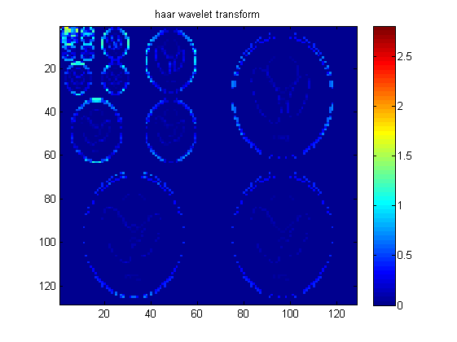
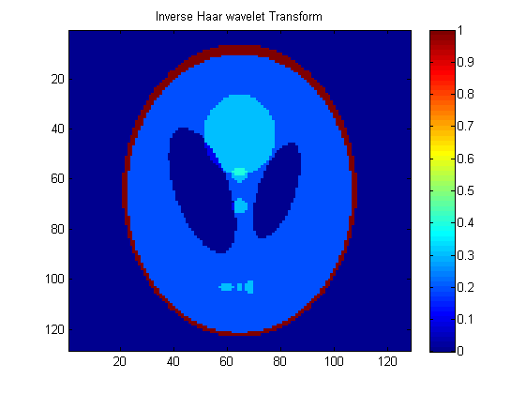
Published with MATLAB® R2013a

