function[]=q2a()
variance=10;
% Comment - optimum neighborhood for removing gaussian noise is 3*3 size, which results in minimum MSE
% Thus we choose a 3*3 gaussian filter
%variance=10;
for i=1:30
filter_size(i)=2*i+1;
MSE(i)=q2_sub(filter_size(i),variance);
x(i)=i;
end
figure;plot(filter_size,MSE);title(['MSE vs filter_size for variance' num2str(variance)]);
end
function[Avg_MSE]=q2_sub(filter_size,variance)
D0=filter_size;
f=double(imread('CircleSquare.tif'));
MSE(1:10)=0;x(1:10)=0;%initialisation
fmax = max(f(:));
I = 100;
a = 1.1;
f = f/fmax*I;
fmin = 0;
fmax = max(f(:));
orignal_image=f;
for i=1:10
% generating noise
snr = I^2/variance; % = I^2/sigma^2
sigma = sqrt(I^2/snr);
gaussian_noise = randn(size(f))*sigma;
noisy_image=f+gaussian_noise;
[filtered_image,MSE(i)]=gaussian_filter(noisy_image,orignal_image,D0,sigma);
% figure;imagesc(f);
% figure;imagesc(noisy_image);
% figure;imagesc(filtered_image);title(['MSE=' num2str(MSE)]);
% pause(20);
x(i)=i;
end
Avg_MSE=sum(MSE(:))/size(MSE,1);
% fpritnf('Average Error =%f',Avg_MSE);
% figure;plot(x,MSE);
end
function[imout,MSE]=gaussian_filter(noisy_image,orignal_image,D0,sigma)
f=double(noisy_image);
h=fspecial('gaussian',D0,double(sigma));
imout=conv2(f,h,'same');
diff=orignal_image-imout;
MSE=sum(diff(:).*diff(:) )/(size(noisy_image,1)*size(noisy_image,2));
end
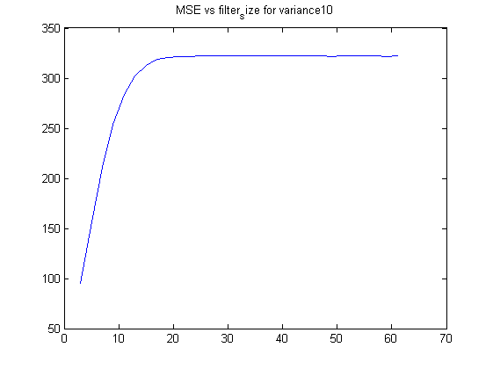
Published with MATLAB® R2013a

