function[]=q2b()
%Median Filter
variance=10;
for i=1:10
filter_size(i)=2*i+1;
MSE(i)=q2b_sub(filter_size(i),variance);
x(i)=i;
display(i);
end
figure;plot(filter_size,MSE);title(['MSE vs filter_size for variance' num2str(variance)]);
end
function[Avg_MSE]=q2b_sub(filter_size,variance)
D0=filter_size;
f=double(imread('CircleSquare.tif'));
MSE(1:10)=0;x(1:10)=0;%initialisation
fmax = max(f(:));
I = 100;
a = 1.1;
f = f/fmax*I;
fmin = 0;
fmax = max(f(:));
orignal_image=f;
for i=1:10
snr = I^2/variance; % = I^2/sigma^2
sigma = sqrt(I^2/snr);
gaussian_noise = randn(size(f))*sigma;
noisy_image=f+gaussian_noise;
[filtered_image,MSE(i)]=median_filter(noisy_image,orignal_image,D0,sigma);
% figure;imagesc(f);
% figure;imagesc(noisy_image);
% figure;imagesc(filtered_image);title(['MSE=' num2str(MSE(i))]);
% pause(20);
x(i)=i;
end
Avg_MSE=sum(MSE(:))/size(MSE,1);
end
function[f2,MSE]=median_filter(noisy_image,orignal_image,D0,sigma)
neighborhood_size=D0;
f=double(noisy_image);
[s1,s2]=size(orignal_image);
f2(1:s1+2*floor(neighborhood_size/2),1:s2+2*floor(neighborhood_size/2))=0;
g=padarray(noisy_image,[floor(neighborhood_size/2),floor(neighborhood_size/2)],'symmetric');
for m=1+floor(neighborhood_size/2):s1+floor(neighborhood_size/2)
for n= 1+floor(neighborhood_size/2):s2+floor(neighborhood_size/2)
sub=g(m-floor(neighborhood_size/2):m+floor(neighborhood_size/2),n-floor(neighborhood_size/2):n+floor(neighborhood_size/2));
f2(m,n)=median(sub(:));
end
end
f2=f2(1+floor(neighborhood_size/2):s1+floor(neighborhood_size/2),1+floor(neighborhood_size/2):s2+floor(neighborhood_size/2));
diff=orignal_image-f2;
MSE=sum(diff(:).*diff(:))/(s1*s2);
% figure;imagesc(orignal_image);
% figure;imagesc(noisy_image);
% figure;imagesc(f2);
% pause(20);
%
end
i =
1
i =
2
i =
3
i =
4
i =
5
i =
6
i =
7
i =
8
i =
9
i =
10
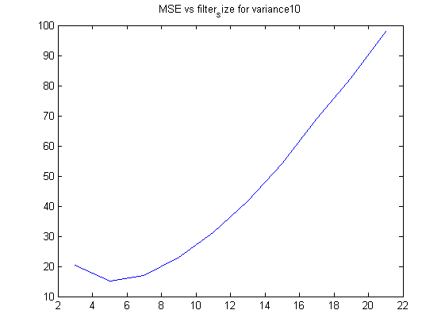
Published with MATLAB® R2013a

