function[]=q2c()
variance=10;
for i=1:10
filter_size(i)=2*i+1;
MSE(i)=MSE_bilateral_fn(variance,filter_size(i));
x(i)=i;
display(i);
end
figure;plot(filter_size,MSE);title(['MSE vs filter_size for variance' num2str(variance)]);
end
function[MSE_avg]=MSE_bilateral_fn(variance, neighborhood_size)
% tic;
image=double(imread('CircleSquare.tif'));
intensity_cutoff=100;
num_iterations=10;MSE_avg=0;
[s1,s2]=size(image);
f=double(image);
MSE(1:10)=0;x(1:10)=0;%initialisation
fmax = max(f(:));
I = 100;
a = 1.1;
f = f/fmax*I;
MSE(1:num_iterations)=0;
%neighborhood_size=3;
f2(1:s1+2*floor(neighborhood_size/2),1:s2+2*floor(neighborhood_size/2))=0;
for k=1:num_iterations
% fprintf('slice number=%d \n',k);
snr = I^2/variance; % = I^2/sigma^2
sigma = sqrt(I^2/snr);
gaussian_noise = randn(size(f))*sigma;
noisy_image=f+gaussian_noise;
g=noisy_image;
g=padarray(g,[floor(neighborhood_size/2),floor(neighborhood_size/2)],'symmetric');
for i=1+floor(neighborhood_size/2):s1+floor(neighborhood_size/2)
for j=1+floor(neighborhood_size/2):s2+floor(neighborhood_size/2)
sub_g=g(i-floor(neighborhood_size/2):i+floor(neighborhood_size/2),j-floor(neighborhood_size/2):j+floor(neighborhood_size/2));
count=0;%will be zero for the central pixel anyways
sum_of_pixels=0;
for m=1:2*floor(neighborhood_size/2)+1
for n=1:2*floor(neighborhood_size/2)+1
w=1*(sqrt((sub_g(m,n)-g(i,j))^2)<intensity_cutoff);
if(w==1)
sum_of_pixels=sum_of_pixels+sub_g(m,n); count=count+1;
end
end
end
f2(i,j)=sum_of_pixels/count;
% display(w);pause(5);
end
end
f2=f2(1+floor(neighborhood_size/2):s1+floor(neighborhood_size/2),1+floor(neighborhood_size/2):s2+floor(neighborhood_size/2));
% display(size(f2));
diff=f-f2;
MSE(k)=sum(diff(:).*diff(:))/(s1*s2);
%figure;imshow(uint8(f2));
end
MSE_avg=sum(MSE(:))/num_iterations;
% toc;
end
i =
1
i =
2
i =
3
i =
4
i =
5
i =
6
i =
7
i =
8
i =
9
i =
10
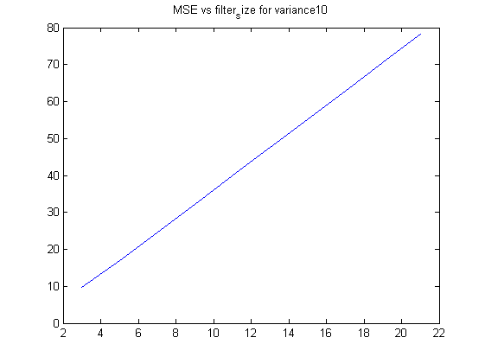
Published with MATLAB® R2013a

