function[]=q2d()
variance=10;
n_size=15;
for i=1:4
p_size=5+2*i;
display(i);
MSE(i)=q2d_sub(variance,n_size,p_size);
x(i)=p_size;
end
figure;plot(x,MSE);title(['MSE vs filter_size for variance' num2str(variance)]);
end
function[MSE_avg]=q2d_sub(noise_variance, n_size,p_size)
f=double(imread('CircleSquare.tif'));
f=f(1:4:end,1:4:end);% done so as to reduce the time
MSE(1:10)=0;x(1:10)=0;%initialisation
fmax = max(f(:));
I = 100;
a = 1.1;
f = f/fmax*I;
orignal_image=f;
filtered_image=f;filtered_image(:)=0;
for i=1:10
snr = I^2/noise_variance; % = I^2/sigma^2
sigma = sqrt(I^2/snr);
gaussian_noise = randn(size(f))*sigma;
% display(size(f));display(size(gaussian_noise));
noisy_image=f+gaussian_noise;
[filtered_image,MSE(i)]=nlm_filter(noisy_image,orignal_image,n_size,p_size);
if(i==1)
% figure;imagesc(noisy_image);title('noisy_image');
% figure;imagesc(orignal_image);title('orignal_image');
% figure;imagesc(filtered_image);title('filtered image');
% pause(5);
%
end
%figure;imagesc(filtered_image);title('filtered image');pause(2);
end
MSE_avg=sum(MSE(:))/size(MSE,1);
end
function[imout,MSE]=nlm_filter(noisy_image,orignal_image,n_size,p_size)
threshold=100;
[s1,s2]=size(orignal_image);
imout(1:s1,1:s2)=0;
%n_size=7;p_size=3;
%f1=figure;
% f=padarray(f,[floor(n_size/2),floor(n_size/2)]);
noisy_image=padarray(noisy_image,[floor(n_size/2),floor(n_size/2)],'symmetric');
for m=1+floor(n_size/2):s1+floor(n_size/2)
for n=1+floor(n_size/2):s1+floor(n_size/2)
% sub_g=f(m-floor(n_size/2):m+floor(n_size/2),n-floor(n_size/2):n+floor(n_size/2));
patch_mn=noisy_image(m-floor(p_size/2):m+floor(p_size/2),n-floor(p_size/2):n+floor(p_size/2));
% f(m-floor(p_size/2):m+floor(p_size/2),n-floor(p_size/2):n+floor(p_size/2))=1;
% f(m-floor(n_size/2):m+floor(n_size/2),n-floor(n_size/2):n+floor(n_size/2))=2;
% f(m-floor(p_size/2):m+floor(p_size/2),n-floor(p_size/2):n+floor(p_size/2))=4;
% figure(f1);imagesc(f);pause(0.1);
sum=0;count=0;
for s=1+floor(p_size/2):n_size-floor(p_size/2)
for t=1+floor(p_size/2):n_size-floor(p_size/2)
a=m-1-floor(n_size/2);b=n-1-floor(n_size/2);
% f(a+s-floor(p_size/2):a+s+floor(p_size/2),b+t-floor(p_size/2):b+t+floor(p_size/2))=1;
patch_st=noisy_image(a+s-floor(p_size/2):a+s+floor(p_size/2),b+t-floor(p_size/2):b+t+floor(p_size/2));
diff=abs(patch_mn-patch_st);
% display(size(diff));pause(10);
if(diff(:).*diff(:)<threshold)
sum=sum+noisy_image(a+s,b+t);count=count+1;
end
% figure(f1);imagesc(f);pause(0.01);
end
end
imout(m-floor(n_size/2),n-floor(n_size/2))=sum/count;
end
end
% noisy_image=noisy_image(1+floor(n_size/2):s1+floor(n_size/2),1+floor(n_size/2):s2+floor(n_size/2));
%display(size(imout));display(size(orignal_image));
diff2=orignal_image-imout;
MSE=diff2(:).*diff2(:)/(s1*s2);
%display(size(MSE));
%display(size(diff2));
MSE_sum=0;
for k=1:size(MSE,1)
MSE_sum=MSE_sum+MSE(k,1);
end
MSE=MSE_sum;
% figure;imagesc(orignal_image);
% figure;imagesc(imout);
end
i =
1
i =
2
i =
3
i =
4
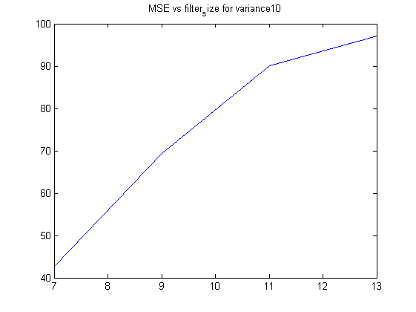
Published with MATLAB® R2013a

