function[]=q2e()
prob=0.25;
image=imread('CircleSquare.tif');
window_size_max=21;I=100;
[s1,s2]=size(image);
noisy_image=imnoise(image,'salt & pepper',prob);
image=I*double(image)/max(double(image(:)));
noisy_image=I*double(noisy_image)/max(double(noisy_image(:)));
noisy_image=padarray(noisy_image,[floor(window_size_max/2),floor(window_size_max/2)],'symmetric');
figure;imagesc(noisy_image);colorbar;
imout=noisy_image;
for i=1+floor(window_size_max/2):s1+floor(window_size_max/2)
for j=1+floor(window_size_max/2):s2+floor(window_size_max/2)
window_size=3;
while(window_size<window_size_max)
sub=noisy_image(i-floor(window_size/2): i+floor(window_size/2),j-floor(window_size/2): j+floor(window_size/2));
zmed=median(sub(:));
zmin=min(sub(:));
zmax=max(sub(:));
A1=zmed-zmin;A2=zmed-zmax;
if(A1>0&&A2<0)
B1=noisy_image(i,j)-zmin;
B2=noisy_image(i,j)-zmax;
if(B1>0&&B2<0)
imout(i,j)=noisy_image(i,j);window_size=window_size_max;
else
imout(i,j)=zmed;window_size=window_size_max;
end
else
if(window_size<window_size_max)
window_size=window_size+2;
else
imout(i,j)=noisy_image(i,j);window_size=window_size_max;
end
end
end
end
end
imout_final=imout(1+floor(window_size_max/2):s1+floor(window_size_max/2),1+floor(window_size_max/2):s2+floor(window_size_max/2));
figure;imagesc(imout_final);colorbar;
end
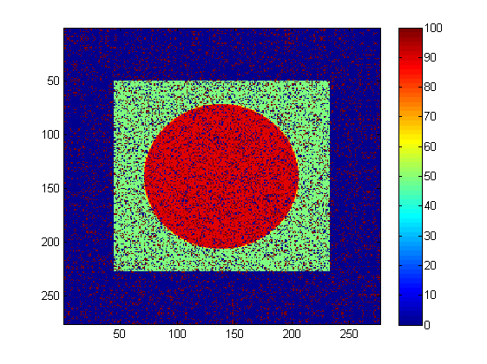
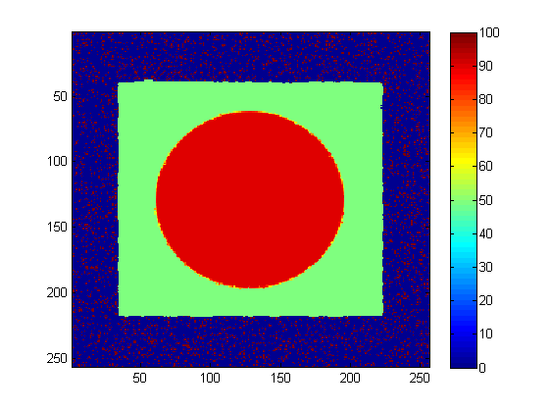
Published with MATLAB® R2013a

