function[]=q2f()
noise_variance=10;
%thresholding using Fourier Coefficients
for i=1:10
percentile=0.9+0.01*i;
MSE(i)=q2b_sub(percentile,noise_variance);
x(i)=percentile;
end
figure;plot(x,MSE);title('MSE vs percentile energy kept');
end
function[Avg_MSE]=q2b_sub(percentile_thresh,noise_variance)
f=double(imread('CircleSquare.tif'));
MSE(1:10)=0;x(1:10)=0;%initialisation
fmax = max(f(:));
I = 100;
a = 1.1;
f = f/fmax*I;
fmin = 0;
fmax = max(f(:));
orignal_image=f;
for i=1:10
snr = I^2/noise_variance; % = I^2/sigma^2
sigma = sqrt(I^2/snr);
gaussian_noise = randn(size(f))*sigma;
noisy_image=f+gaussian_noise;
[filtered_image,MSE(i)]=fourier_thresholding_filter(noisy_image,orignal_image,percentile_thresh);
% figure;imagesc(f);
% figure;imagesc(noisy_image);
% figure;imagesc(filtered_image);title(['MSE=' num2str(MSE(i))]);
% pause(20);
x(i)=i;
if(i==1)
% figure;imagesc(noisy_image);title('noisy_image');
% figure;imagesc(orignal_image);title('orignal_image');
figure;imagesc(filtered_image);title('filtered image');
pause(1);
close all;
end
end
Avg_MSE=sum(MSE(:))/size(MSE,1);
end
function[filtered_image,MSE]=fourier_thresholding_filter(noisy_image,orignal_image,percentile_thresh)
% percentile_thresh is the percent of energy which would remain in filtered
% image
F_noisy_image=fftshift(fft2(noisy_image));
F_orignal_image=fftshift(fft2(orignal_image));
% figure;imagesc(log(1+abs(F_noisy_image)));colorbar;
% figure;imagesc(log(1+abs(F_orignal_image)));colorbar;
X=abs(F_noisy_image).*abs(F_noisy_image);
max_X=max(X(:));
% figure;hist(X(:),100);title('histogram');
[s1,s2]=size(noisy_image);
sum_X=sum(X(:));
X=X/sum_X;
F_filtered_image=F_noisy_image;F_filtered_image(:,:)=0;
default_radius=50;
for default_radius=1:30
energy_sum=0;
for i=-default_radius:default_radius
for j=-default_radius:default_radius
D=sqrt((i)^2+(j)^2);
if(D<default_radius)
energy_sum=energy_sum+X(floor(s1/2)+i,floor(s1/2)+j);
end
end
end
% display(energy_sum);
if(energy_sum>percentile_thresh)
break;
end
end
for i=-default_radius:default_radius
for j=-default_radius:default_radius
D=sqrt((i)^2+(j)^2);
if(D<default_radius)
F_filtered_image(floor(s1/2)+i,floor(s2/2)+j)=F_noisy_image(floor(s1/2)+i,floor(s2/2)+j);
end
end
end
filtered_image=real(ifft2(fftshift(F_filtered_image)));
%
diff=orignal_image-filtered_image;
MSE=sum(diff(:).*diff(:))/(s1*s2);
end
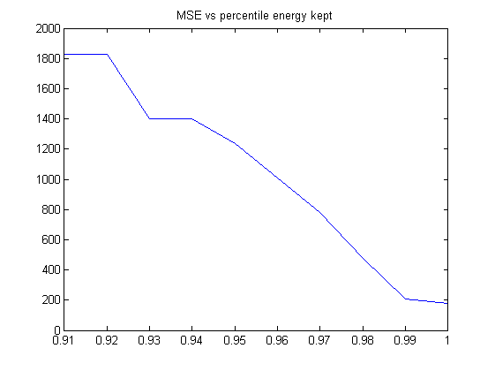
Published with MATLAB® R2013a

