function [ ] = q2g()
% as the threshold reaches 10 the MSE decreases after that is starts
% increasing again. This value 10 is due to the specific noise level
s_image=128;
variance=10;
%f = double(phantom(s_image));
%threshold=0.01;
for i=1:20
threshold=0.1+1*i;
MSE(i)= q2g_sub(threshold,variance);
x(i)=threshold;
end
figure;plot(x,MSE);title('MSE vs Threshold in wavelet filtering');
xlabel('Threshold used');ylabel('MSE');
%display(MSE);
end
function[Avg_MSE]=q2g_sub(absolute_thresh,noise_variance)
f=double(imread('CircleSquare.tif'));
MSE(1:10)=0;x(1:10)=0;%initialisation
fmax = max(f(:));
I = 100;
a = 1.1;
f = f/fmax*I;
orignal_image=f;
filtered_image=f;filtered_image(:)=0;
for i=1:10
snr = I^2/noise_variance; % = I^2/sigma^2
sigma = sqrt(I^2/snr);
gaussian_noise = randn(size(f))*sigma;
% display(size(f));display(size(gaussian_noise));
noisy_image=f+gaussian_noise;
[filtered_image,MSE(i)]=wavelet_thresholding_filter(noisy_image,orignal_image,absolute_thresh);
if(i==1)
% figure;imagesc(noisy_image);title('noisy_image');
% figure;imagesc(orignal_image);title('orignal_image');
% figure;imagesc(filtered_image);title('filtered image');
% pause(2);
% close all;
end
end
Avg_MSE=sum(MSE(:))/size(MSE,1);
end
function[filtered_image,MSE]=wavelet_thresholding_filter(noisy_image,orignal_image,absolute_thresh)
[s1,s2]=size(orignal_image);
w=haar_LLevel(noisy_image,log2(s1));
for i=1:s1
for j=1:s1%assuming s1 and s2 are same, since haar wavelet is applicable to images of size as powers of 2
if(abs(w(i,j))<absolute_thresh)
w(i,j)=0;
end
end
end
% figure;plot(w(:));
filtered_image=invhaar_LLevel(w,log2(s1));
% figure;imagesc(noisy_image);title('noisy_image');
% figure;imagesc(orignal_image);title('orignal_image');
% figure;imagesc(filtered_image);title('filtered image');
% pause(5);
% close all;
diff=filtered_image-orignal_image;
MSE=diff(:).*diff(:)/(s1*s1);
MSE=sum(MSE(:));
end
function[w]=haar_LLevel(f,steps)
s1=size(f,1);
w=haar_oneLevel(f);
for k=1:steps-1
w(1:s1/2,1:s1/2)=haar_oneLevel(w(1:s1/2,1:s1/2));
s1=s1/2;
end
end
function w = haar_oneLevel(x)
[M,N] = size(x);
if M~=N
error('image must be square');
end
if 2^round(log2(M))~=M
error('sidelength must be power of two');
end
h00 = [1 1; 1 1]/2;
h01 = [-1 1; -1 1]/2;
h10 = [-1 -1; 1 1]/2;
h11 = [1 -1; -1 1]/2;
w00 = conv2(x,h00,'same');
w00 = w00(1:2:end,1:2:end);
w01 = conv2(x,h01,'same');
w01 = w01(1:2:end,1:2:end);
w10 = conv2(x,h10,'same');
w10 = w10(1:2:end,1:2:end);
w11 = conv2(x,h11,'same');
w11 = w11(1:2:end,1:2:end);
w = [w00 w01; w10 w11];
end
function [x] = invhaar_oneLevel(w)
[M,N] = size(w);
if M~=N
error('image must be square');
end
if 2^round(log2(M))~=M
error('sidelength must be power of two');
end
wup = kron(w,[0 0; 0 1]);
h00 = [1 1; 1 1]/2;
h01 = [1 -1; 1 -1]/2;
h10 = [1 1; -1 -1]/2;
h11 = [1 -1; -1 1]/2;
w00 = wup(1:M,1:M);
x00 = conv2(w00,h00,'same');
w01 = wup(1:M,((1:M)+M));
x01 = conv2(w01,h01,'same');
w10 = wup(((1:M)+M),1:M);
x10 = conv2(w10,h10,'same');
w11 = wup(((1:M)+M),((1:M)+M));
x11 = conv2(w11,h11,'same');
x = (x00+x01+x10+x11);
end
function[f]=invhaar_LLevel(w,num_steps)
f=w;
[s1,s2]=size(w);
for i=num_steps:-1:1
s_temp=power(2,i-1);
%display(s_temp);
f(1:s1/s_temp,1:s2/s_temp)=invhaar_oneLevel(f(1:s1/s_temp,1:s2/s_temp));
end
end
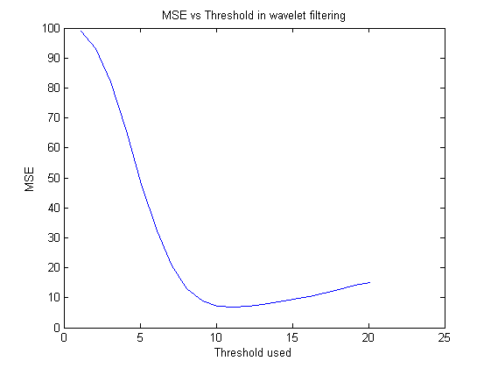
Published with MATLAB® R2013a

