**CE412 – PROJECT 4**

**“SIMULATION OF A CAR WASH SYSTEM”**

Mr. Clean will start a car wash company and he wants to analyze how efficient the company will work. The car wash company contains two units: washing and drying. An arriving car will first enter the washing unit and when the washing is finished it will be transferred to the drying unit. Both the washing unit and drying unit will be able to hold one car at a time. If an arriving car finds the washing unit (or drying unit) busy, it will wait until the washing unit (or drying unit) becomes available. Mr. Clean expects that a car will arrive every  minute. The washing unit will clean 30% of the cars in 8 minutes, 40% in 10 minutes and the remaining 30% in 12 minutes. The drying unit will dry 20% of the cars in 5 minutes, 30% of the cars in 8 minutes and the remaining 50% of the cars in 10 minutes.

Washing Unit

Drying Unit

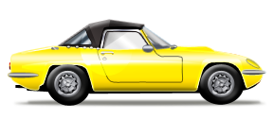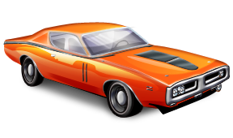

Exit the system

Mr. Clean wants to measure the average time a car spends at his company, the utilization of the washer, the utilization of the dryer and the average waiting time for the washer and the dryer. Compute these results through a discrete-event system simulation for *N* cars, where *N* is sprecified by the user.

Please note that the interarrival time distribution is continuous while washing and drying times are discrete.

***Project 4 Submission***:

Name your program as *yournamePrj4.X* and submit it to Blackboard or e-mail it to [tamer.dag@khas.edu.tr](mailto:tamer.dag@khas.edu.tr) before April 17th, 2014. You have to submit your project report (hard copy) in class on April 17th, 2014. In your project report, please include the flowcharts of the events, system states, entities, ... and also show a sample output of your program. Late submissions up to one week has a penalty of 50%. Late submissions beyond one week will not be accepted.

***Project 4 Grading:***

* Project Report 30%
* Program 70% (If your program do not produce correct results, you might only get at most 35%)