**SOFTWARE PROJECT MANAGEMENT PLAN**

1. Introduction 1

* 1. Objective 1
  2. Major Function 1
  3. Performance Issue 1
  4. Management & Technical Constraint 1

1. Project Estimation 3
   1. Historical Data Used 3
   2. Estimation Technique Used 3
   3. Effort Resource, Cost, Project Duration Estimation 3
2. Risk Management Plan 4
   1. Risk Analysis 4
   2. Risk Identification 4
   3. Risk Estimation , Risk Abatement Procedure 4
3. Schedule 5

* 1. Work Breakdown Structure 5
  2. Task Network Representation 6
  3. Gantt Chart Representation 7
  4. Pert Chart Representation 8

1. Project Resources 10
   1. People 10
   2. Hardware & Software 10
   3. Special Resources 10
2. Staff organization 11
   1. Teams structure 11
   2. Management reporter 11
3. Project tracking & control plan 12

1. Miscellaneous plan 14
   1. Process tailoring 14
   2. QA (quality assurance) 14
   3. Configuration management 14
   4. Validation & Verification 14
   5. System testing 14
   6. Delivery installation & maintenance 14
2. **INTRODUCTION**

1. **Objective**

The project aims at development of a system that will used be to protect any confidential & critical information of any web application using reverse proxy on WAF box.

After using priWAF (web application firewall) on clients IP proxy we can decrease or patch possible vulnerabilities categorized under OWASP Top 10.

1. **MAJOR FUNCTIONS**

The major functions of the application are listed below:

* Client Registration and Login
* Client can find their Vulnerability report, which will updated by Scanner in database server.
* priWAF admin is the only user able to manage whole WAF portal.
* priWAF admin can add details about client’s web application.
* He should learn about the vulnerabilities of client’s web application using different scanners & manual attacks.
* He should configure rulesets for specific client’s web application & can push those rules file on WAF box using priWAF portal.
* After pushing the rule file he can reload apache with mod security from portal itself.

1. **PERFORMANCE ISSUES**

The performance issues of the priWAF are listed below:

* The project might face different view issues by using different configuration hardware.
* Maintenance of the database might be difficult sometimes.
* To handle number of client’s requests there might be difficult at a same time.
* The hardware configuration must be higher than any other normal web server (BOX).

1. **MANAGEMENT ISSUES**

MANAGEMENT CONSTRAINTS:

* TIME CONSTRAINT:

The project needs to be completed within the end of the semester that is roughly 3-4 months. According to the definition and the functional requirements of the project, the time duration required for the project to get completed successfully is 6 months with at least 4 people working on the project.

* COST CONSTRAINT:

As the project is based as a part of our college curriculum, we are preparing the project only for learning purpose.

* SCOPE CONSTRAINT:

The project can be considered to be completed successfully with functional requirements such as client registration, client login, WAF admin login, WAF dashboard and user review.

* SKILLS:

Implementation of this project requires good knowledge of Basics of Computer Networks, Operating System, UNIX, Apache2, Mod security, php, SQL and basic knowledge along with knowledge of software engineering principles.

TECHNICAL CONSTRAINTS:

* HARDWARE CONSTRAINTS:

This applications have higher hardware constraints but for efficient development and working the machine must have at least minimum 2GB RAM, 50GB disk space for Virtual BOX.

* SOFTWARE CONSTRAINTS:

Firefox & Chrome are the best suitable browsers for using the php backend. In the development phase using of Apache Lamp webserver, SQL server is recommended. Use of php can be done for the coding and apache with mod security module can be done for Signature development (secrule development).

1. **PROJECT ESTIMATION**
2. **HISTORICAL DATA USED**

Information from similar systems and other details about items used.

1. **ESTIMATION TECHNIQUE USED**

We have used basic COCOMO model to estimate the effort, development time of ourproject.

Although this project is not developed for commercial purpose, we have incorporated the project cost for learning purpose.

1. **EFFORT RESOURCE,COST,PROJECT DURATION ESTIMATION**

LINE OF CODE=2,000

KLOC=2

EFFORT=2.4*(2)1.05= 4.9692PM

DEVELOPMENT TIME=2.5*(4.9692)0.38= **5** months (approx.)

COST REQUIRED TO DEVELOP THE PRODUCT=5*2,000=10,000

1. **RISK MANAGEMENT PLAN**

|  |  |  |  |
| --- | --- | --- | --- |
| **Risk Identification** | **Risk Analysis** | **Risk Estimation** | **Risk Abatement**  **Procedures** |
| Unavailability of resources | **Probability:**10%  **Impact:** low | This may occur in case resources are not available for development and implementation. | We can inform higher authorities about the resources required for the project development. |
| Project cost higher than estimated | **Probability:**5%  **Impact:** low | This may happen if additional functionality is added or team members don’t use resources judiciously. | We need to evaluate the project cost at every stage and allocate funds for every stage. |
| Server runs down | **Probability:**30%  **Impact:** medium | This may happen due to overload on site server. | Number of members registering for site should be kept in mind and accordingly server capacity should be increased |
| |  |  | | --- | --- | | Unavailability of team members |  | |  |  | | **Probability:**5%  **Impact:** low | This risk may happen when any team member’s illness or due to some inevitable circumstances | We can increase the number of our weekly meetings to having the report before the deadline if there is one or two team members absent. |
| Difficulty of semester and timing constraints | **Probability:**40%  **Impact:** medium | This risk may occur when our tasks overlap. | We all know our midterm exam dates, project’s report deadlines. When there is conflict between midterm, homework or report, we can arrange them according to their importance |
| Deficiency of programming knowledge | **Probability:**40%  **Impact:** medium | This risk can happen if there is insufficiency of our staff training plan. | We can improve our programming by using internet sources and with our staff training plan. |
| Deadline expiration | **Probability:**5%  **Impact:** low | This risk can occur when we do not have any idea of project report’s deadlines | Having a scheduler plan can handle with this risk |

1. **SCHEDULE**
2. **WORK BREAKDOWN STRUCTURE**

priWAF (Web Application Firewall)

Documentation

Coding

Testing

Design

Analysis

Module-1  
 **mod security**

Requirement   
Gathering

Unit Testing

Module-2  
 **PHP**

Process Design

Requirement  
Specification

System testing

**B.TASK NETWORK REPRESENTATION**

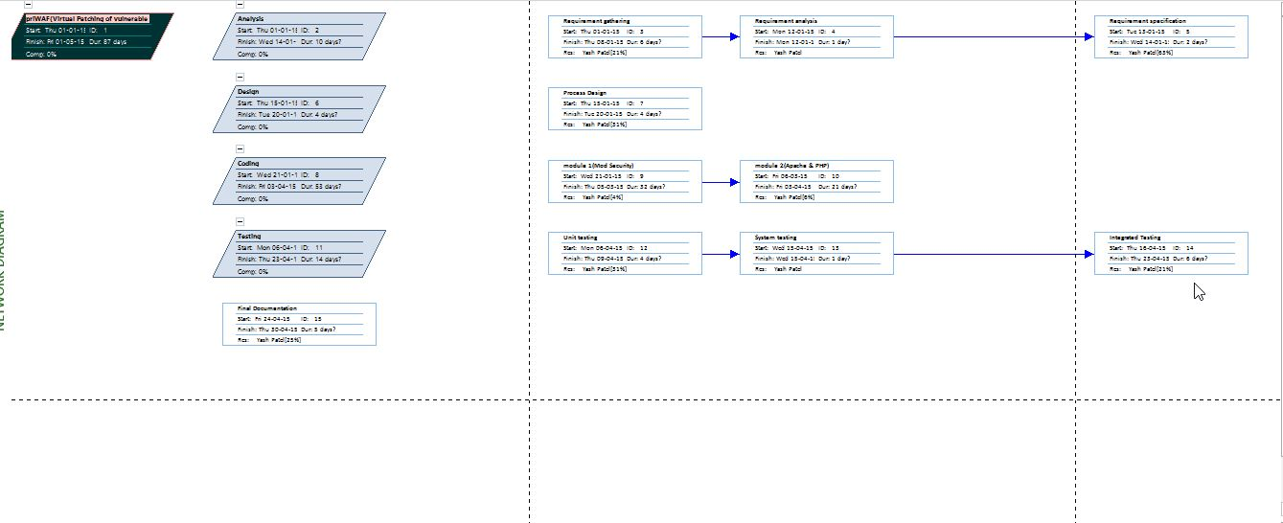

**C.GANTT CHART REPERESENTATION**

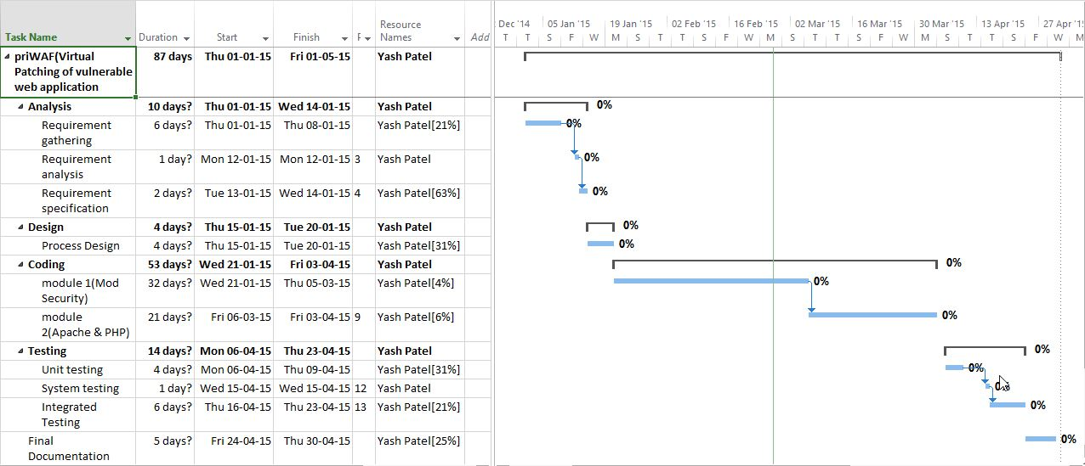

1. **PERT CHART REPRESENTATION**

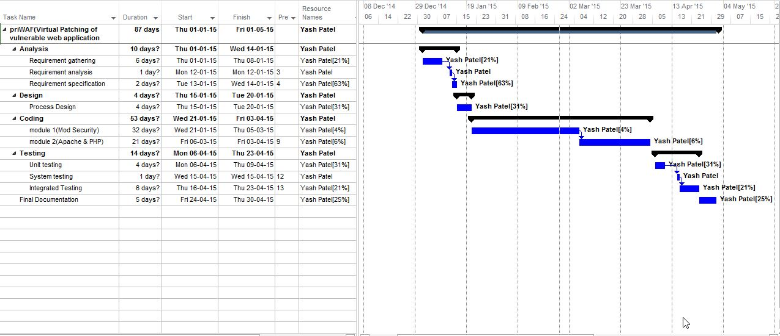

1. **PROJECT RESOURCES**
2. **PEOPLE**

Number of people required to develop the project is at least three. But due to inevitable circumstances I am developing the project alone.

1. **HARDWARE & SOFTWARE**

Hardware Resources:

* PC or Laptop with Intel Core i3/i5 Processor and 4 GB RAM.
* Minimum 50GB of free hard disk space.

Software Resources:

* Microsoft Windows 7
* Firefox ,Google Chrome Web Browser
* Notepad ++
* Apache2 server(LMAP)
* MySQL 5.5 database server
* Mod security 2

1. **SPECIAL RESOURCES**

Various Microsoft tools are used as below:

* Microsoft Word for preparing SRS Document and SPMP Document
* Microsoft Project for preparing Gantt Chart
* Microsoft Visio for preparing UML Diagrams as well as DFD Diagrams

1. **STAFF ORGANIZATION**
2. **TEAM STRUCTURE**

As I am the only team member, so everything is done by me. I have used democratic approach because we are doing this project for learning purpose.

1. **MANAGEMENT REPORTING**

Since, this project is a temporary project, our external interface will be our faculties of this respective subject and all part of the project will be examined by this faculty members as shown in following table. We took some help from these supervisors to define our project requirements and learn all details**.**

|  |  |
| --- | --- |
| **NAME** | **TASK** |
| Prof Mayur Patel | First Internal Guide |
| Prof Mayuri Popat | Second Internal Guide |
| Mr. Bhaumik Marchant | External Guide |

1. **PROJECT TRACKING AND CONTROL PLAN**

In this stage of the report, requirements control plan, schedule control plan, budget control plan, quality control plan, reporting plan and metrics control plan will be described. In Software Project Management, it is important to have a plan to execute project. So, we have our weekly plan to run our project.

**REQUIREMENTS CONTROL PLAN**

We discussed and considered hardware and software requirements during preparing SPMP, but it may change during the stage of Software Requirement Specification. While discussing for our project, firstly we asked our supervisor Mr.Bhaumik Marchant that how our project will look and which properties it will have.

**SCHEDULE CONTROL PLAN**

We consider the schedule plan by looking our university programs. After senior project meeting and paying attention to deadlines of project report like SPMP, SRS etc., we arrange weekly meetings and consider our free times to preparing our project reports. Also, we think our exam dates and other things that prevent our meetings, in this case some of the group members work extra hours and we will equilibrate these extra hours later.

**BUDGET CONTROL PLAN**

There will be no budget plan in this project because our project’s purpose is purely to increase our knowledge and for learning purpose. It is a part of our university syllabus.

**QUALITY CONTROL PLAN**

Quality control will be made accessed at regular intervals. For project reports, quality control will be made by our supervisor. After reviewing report, we will change our report by considering it. Then, in coding part, we will write the codes under the security standards. We will test it by using our personal computers separately to have a great result.

**REPORTING PLAN** We will prepare our all project report by considering IEEE standards. All the reports will be prepared on time in our weekly meetings with all group members. After that, we will take review of the report. By considering it, we will change our previous report. And we will update the version of the report.

**VALIDATION AND VERIFICATION**

We have included the validation of form in our software. Each and every information of a user is first validated and then only it is entered into the database. Moreover, for verification we have included the functionality of providing username and password to the user. This additional function will help us achieve our goal of verification.

# MISCELLANEOUS PLANS

## QUALITY ASSURANCE PLAN

In order to achieve a high quality in the project, deliverables should be fully compatible with the IEEE standards. Moreover, meetings with the team members and our supervisor will take place very often to be able to control the versions and to have a useful feedback.

## CONFIGURATION MANAGEMENT PLAN

All the project deliverables are to be considered as configuration items. The configuration item as well as its file would be named after the document like SRS, SPMP and followed by the version number. For example, all the preliminary versions that are submitted to the advisor for review would be named with the abbreviation followed by 0.1, 0.2. After the advisor approves the basic SPMP, this baseline document will be version 1.0 and is distributed to the committee members and stakeholders. Informal updates with the advisor will be numbered with 1.1, 1.2, etc. and the next full distribution to the committee would be version 2.0, etc.

## VALIDATION AND VERIFICATION PLAN

Verification and validation plans are essential for the project in order to develop it correctly. Both of these processes will be made by a committee of instructors. The next versions of the documents will be generated after the approval of this committee.

## SYSTEM TESTING PLAN

After the project is made, it will be checked and tested by the supervisors of this subject and changes will be made accordingly.

## DELIVERY, INSTALLATION, AND MAINTENANCE PLAN

This project will be delivered before our practical exams and viva. Installation of this tool is easy, we can also host the project to help the users.