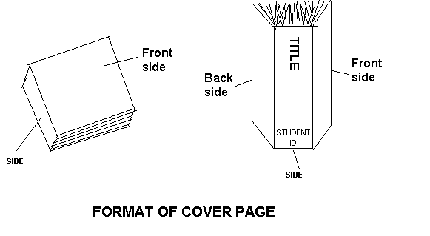

**Front side you have to emboss the coverpage that is attached without image of your project.**