

**MIDDLE EAST TECHNICAL UNIVERSITY**

**ELECTRICAL AND ELECTRONICS ENGINEERING**

**EE374 TERM PROJECT**

**NAME 1: FURKAN KARAKAYA**

**NAME 2: İBRAHİM GÜNGEN**

**Graphical User Interface**

For this project, an interface is designed so that the user can import or enter bus/load properties easily and can see the results through the plotting and texts on the interface screen.

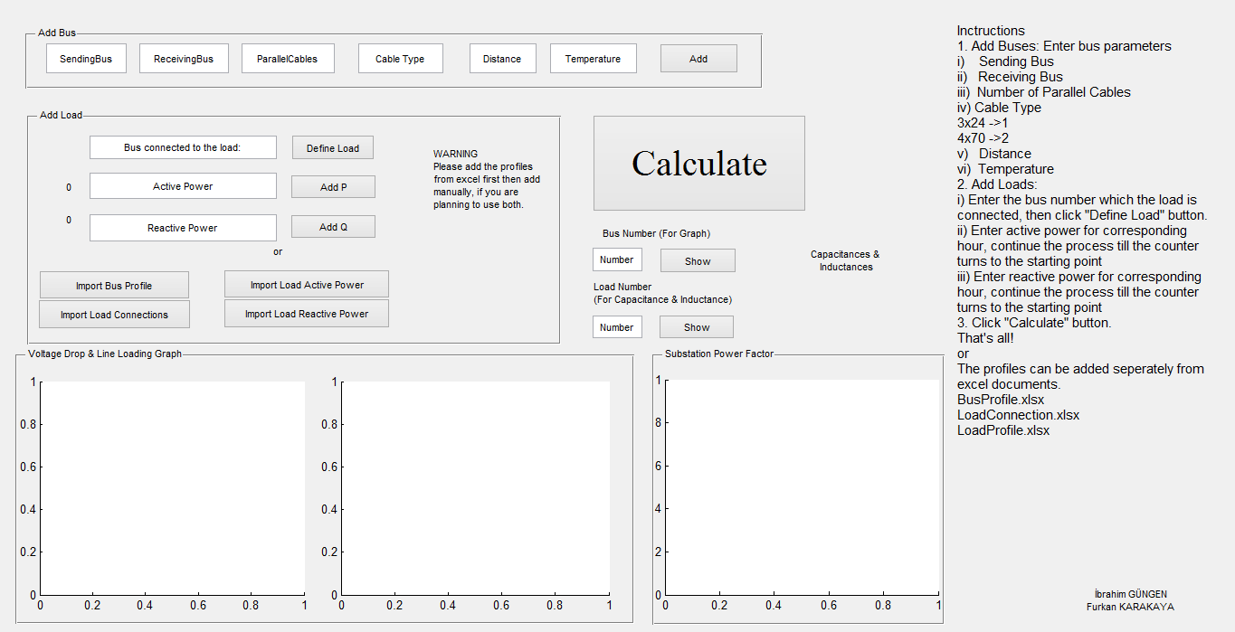

Figure 1: The Graphical User Interface of the Compensation Calculator

**Manually Importing Load/Bus Profiles**

In order to import bus profile manually, the following blanks should be filled with proper values.

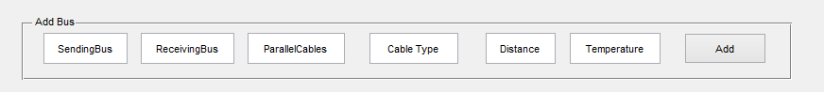

Figure 2: Manually Bus Adding Part

First two blanks, ‘*Sending Bus’* and *‘Receiving Bus’* indicate the bus transmission cable connections. The third blank, ‘*Parallel Cables’,* is the number of the parallel transmission cables. The next one, *‘Cable Type’*, is encoded such that 3x240+120 cable -> 1 & 4x70 cable -> 2, so for 3x240 cable, ‘1’ should be entered. The fifth one is distance in meter and the last one is the temperature in Celsius. Note that, it is assumed that the transmission cables are in the environment of 30˚C always. Then clicking ‘*Add’* button the bus is defined. The process can be repeated until all buses are added.

For importing load profile manually, these steps should be followed:

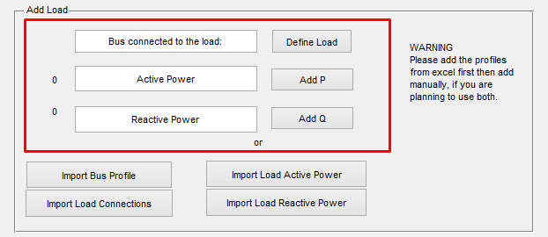

Figure 3: Manually Load Adding Part

Firstly, the bus number defined before as ‘*Receiving Bus’* should be entered so that the system can know where the load is connected. After defining the load, the active power of the load should be added while following the counter just at the left of the corresponding blank. For each hour, the data should be entered then ‘*Add P’* button should be clicked. When the active power profile importing is ended the counter turns back to 0. The reactive power should be added in the same way. This is how the load is added and the procedure should be repeated for each load.

**Importing Bus/Load Profiles from Excel Documents**

At the beginning, the profile documents should be placed in the same folder with the program and it is required that they should be named as *‘BusProfile.xlsx’, ‘LoadConnection.xlsx’, ‘LoadProfile.xlsx’.*

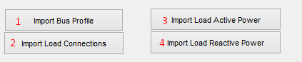

Figure 4: Importing profiles from Excel Part

Next, the steps should be followed as indicated on the figure above. Clicking on the ‘*Import Bus Profile’* the excel document will be opened. On this document MATLAB menu should not be closed before the corresponding matrixes are selected.

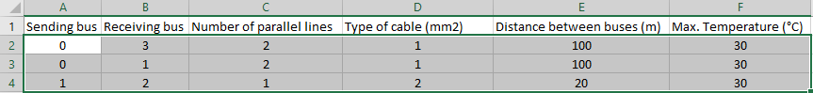

Figure 5: The matrixes selected for importing bus profile

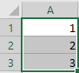

Figure 6: The matrixes selected for importing load connection

Load Connection document stores the information of where the loads will be connected. As seen on the figure above, the first load, whose active power and reactive power will be imported, will be connected to first bus.

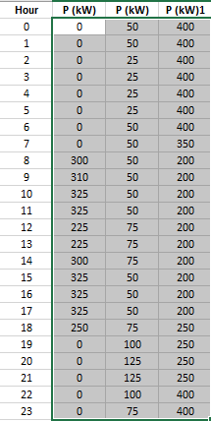

Figure 7: Active Power profiles of loads which are connected in the order of first, second and third buses

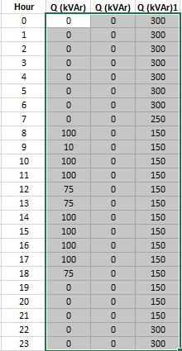

Figure 8: Active Power profiles of loads which are connected in the order of first, second and third buses

On the figures above, the matrix selection for active power and reactive power is illustrated. For each importing, the excel document opens and closes.

**Results**

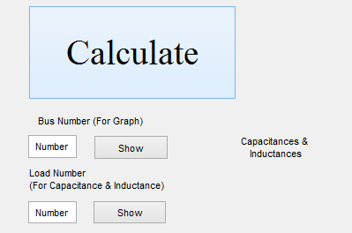

Figure 9: The calculation button part

After importing bus/load profiles, the ‘*Calculate’* button should be clicked. Then the substation power factor graph will appear and it stays where it is.

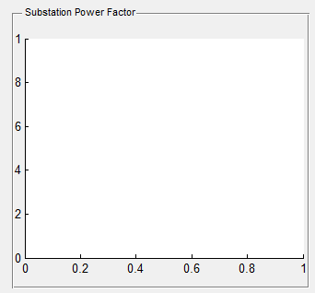

Figure 10: Substation Power Factor Graph Segment

In order to see line loadings and voltage drops for each buses, the corresponding bus number which is ‘*Receiving Bus’* number should be entered and the ‘*Show’* button should be clicked. Then other two plots will appear.

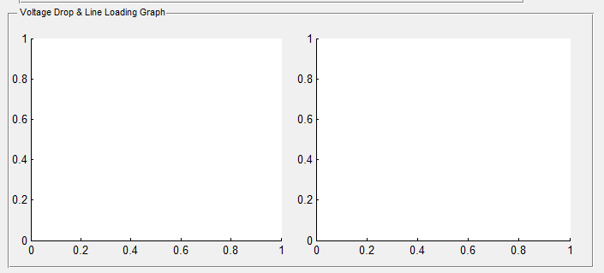

Figure 11: Voltage Drop & Line Loading Graph Segment

Then, in order to see the Case I & Case II compensation results, the capacitance & inductance values, load number should be entered. Note that the load number is encoded with the order of active power/reactive power entries order. By doing that, each load compensations can be seen. In order to see the substation compensation result for load number blank ‘*0’* should be entered. The result will appear on the corresponding part as indicated on the graph below.

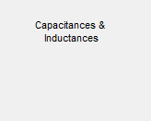

Figure 12: The part where capacitance & inductance values can be seen

**Designing GUI**

It is glad to say that although we have no information about GUI at the beginning, at the end a fine result is obtained. Firstly, the MATLAB GUI tool is used and the corresponding image is the following.

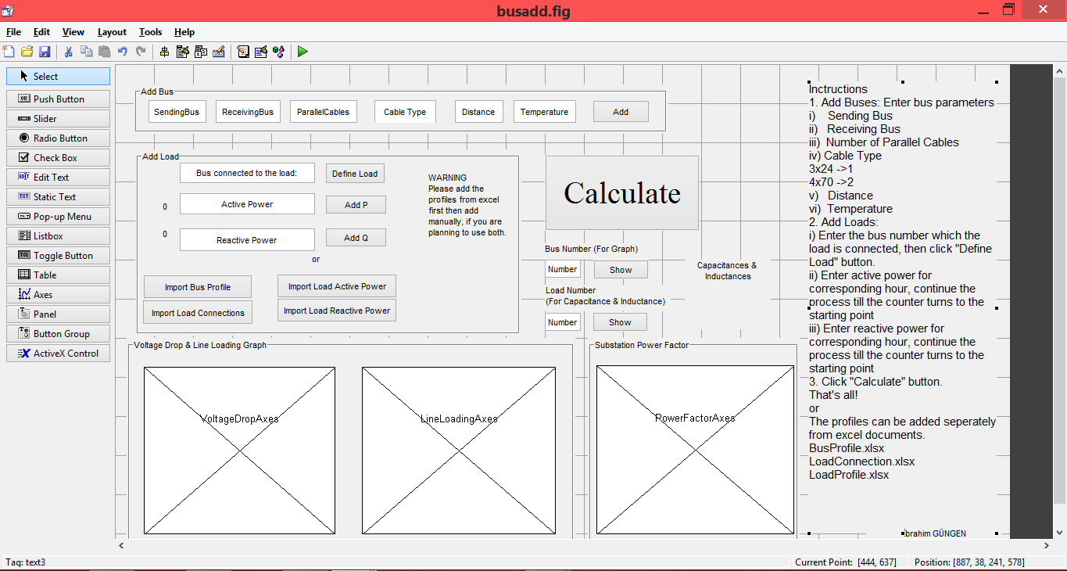

Figure 13: The MATLAB GUI tool

Then for each edit text, button, plot, static text the functions are used which are provided in .m file.

In the opening function of GUI, the variables are declared.

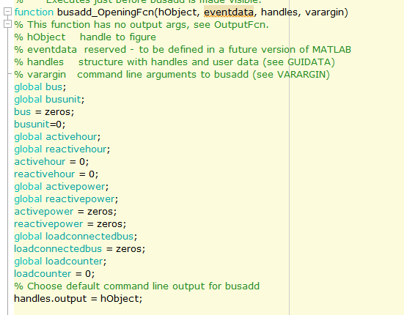

Figure 14

The detailed codes can be reached in .m file. However, the call back functions of each type of objects is used to interact with the object and *get* & *set* commands used for reading / writing for the texts.

**Algorithm & Coding**

In order not to make the project bounded, any number of the load can be imported. We serve the load profiles to the program in matrixes, which are active powers of loads & reactive powers and also bus features & load-bus connections.

In case 1, we have to compensate each load separately. In order to achieve this, we calculate each load’s power factor by using active and reactive power matrixes.

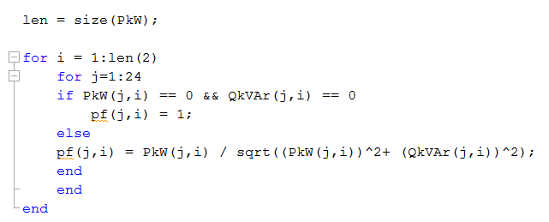

Figure 15 : calculating power factor code

Then if power factors are not appropriate for the given conditions (pf =0.98 lagging load, pf =0.95 leading load) we calculate the maximum possible reactive power.

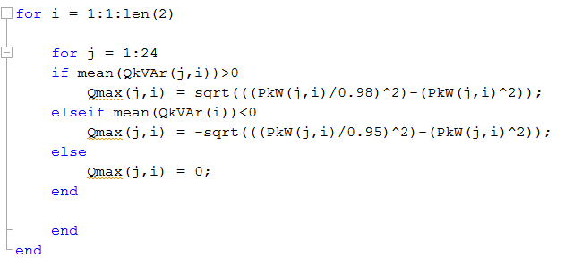

Figure 16: maximum possible reactive power of each hours

Therefore, it is required to subtract the maximum possible reactive power from load’s reactive powers for each hour. Doing this, we obtain an array which shows us the minimum power which need to be compensated to achieve to the given conditions.

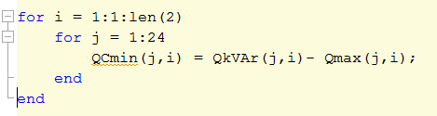

Figure 17: minimum power we should compensate calculation

After obtaining the minimum power compensation array, we find the maximum and the minimum value of minimum compensation array different from zero.

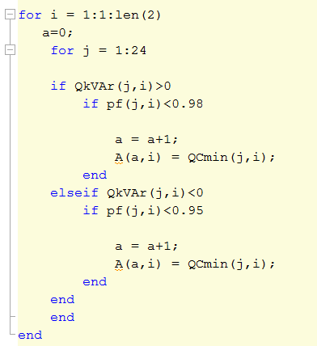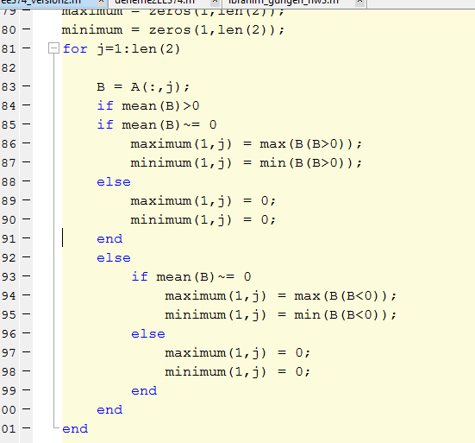

Figure 18 : code for find maximum and minimum bound for choosing capacitors

We calculated component values from that minimum and maximum value of minimum compensated value array. And we added %15 of that value at that maximum and minimum points of the minimum compensated array to get better power factor value because If we don’t increase %15 of that values and adding same active and reactive power same, all time interval ; we can obtain exactly 0.98 and 0.95 power factor values. These are enough but by that way we increase power factor values, why not we make better if we can.

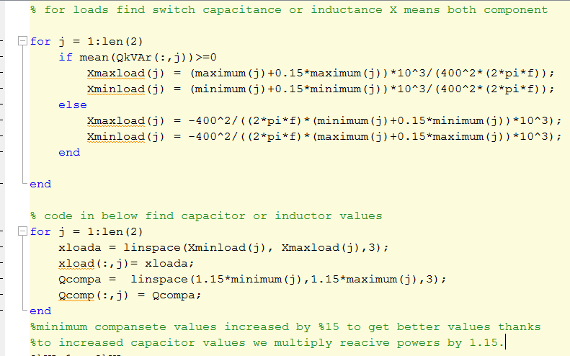

Figure 19: calculating compensated components values code

As shown on the just previous screenshot, we added 3 capacitors for all loads to compensate which are detected according to the minimum compensation power and maximum compensation power we should add, then using ‘linspace’ function, we obtained 3 capacitor values to be switched. Then checking the range of the reactance power and the power we can give the load, system choose best capacitor for it. Thanks to smooth reactive power characteristic less number of components is enough for us; however, if we work on more fluctuating cases, we can solve that problem by adding more than three capacitors and multiple switching. For multiple switching we have to use while or kind of functions. Unfortunately, that functions are making our program speed slow, so we use single switching system which means just 1 capacitor is being used for each time interval.

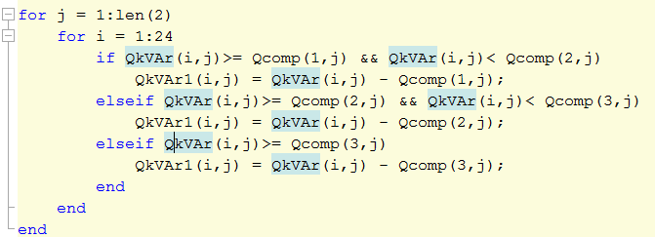

Figure 20: checking reactive power to choose which capacitor is switched each time interval

Then we calculated new power factors of load which are compensated. Pf1 matrixes include all loads pf’s inside.

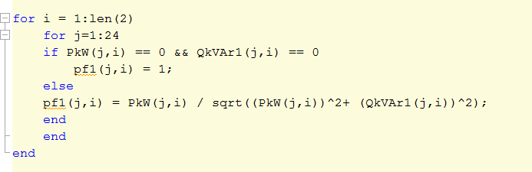

Figure 21: after companate calculating power factor

**Case 2**

This part is more complicated than previous part because in order to compensate the system at substation we should calculate all loses and uncompensated load powers. To reach these goal we calculate active and reactive current which passes through each bus. We make only one assumption which is terminal voltage of buses are 400 Volt. And if any bus is connected to the other bus we add these currents - active and reactive- to the bus which the new one is connected and which is nearer to the main bus (transformer buses). And also we can calculate main bus loading from main load powers.

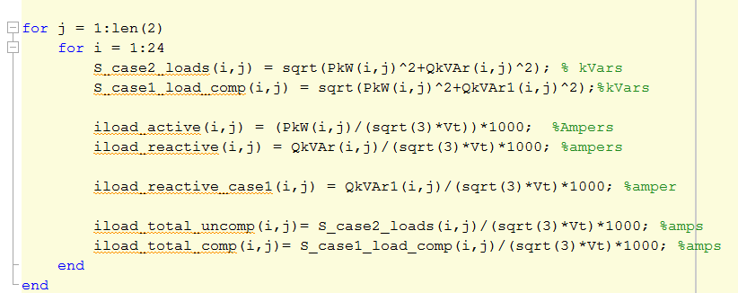

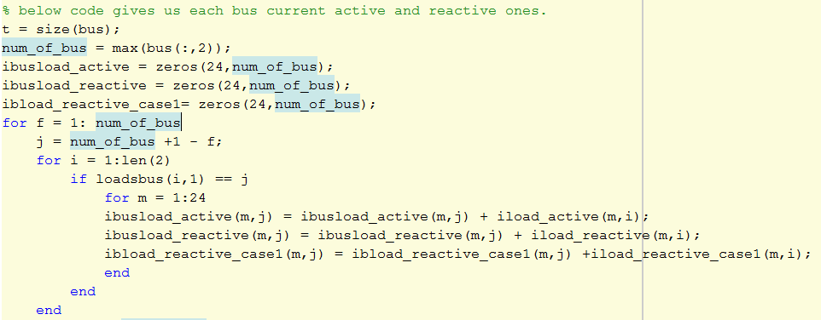

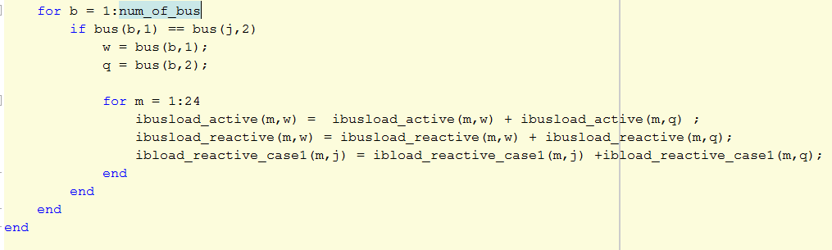

Figure 22: calculating all line current and load currents for both cases and load currents

After calculating bus current, we found line loadings same time, then we calculate line’s resistance and reactance from importing bus matrixes which include receiving-sending buses, parallel line, distance etc. For these calculations, we assumed temperature is constant at 30˚C but it is not complicated to add the variable temperature case; however, because line characteristics are imported by user we did not want to add it. If user choose cable type ‘1’, it means 3x240+120 cable type, type ‘2’, it means 4x70. The code below shows line property calculations.

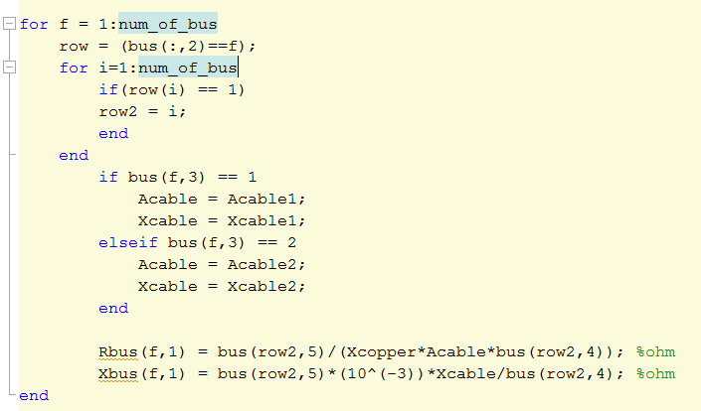

Figure 23: calculating resistance and reactamce of bus lines

After we found all parameters which are needed to find the line loses, we calculated the line losses and total power which transformer can supply, and we calculated them for each case to compare them. In common for loop, we calculate power factors for both load compensated case (case 1) and uncompensated power factor at substation.

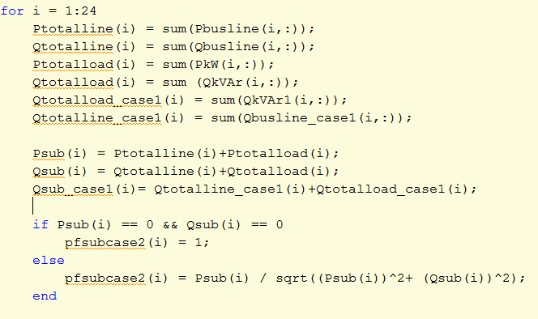

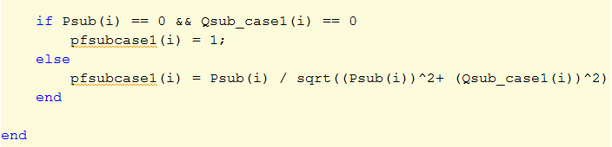

Figure 24: code for find power factor of substation at case 2 before compansated

After we found uncompensated power factor for case 2, we applied the same procedure to compensate with previous load compensation but this time we think that we need to use 5 components, capacitor or inductor.

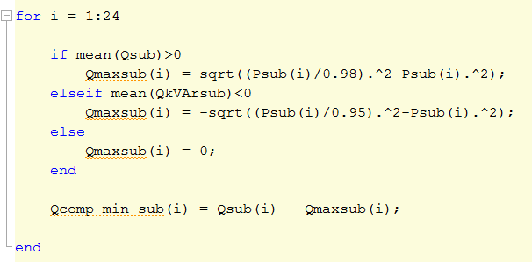

Figure 25: code for find maximum possible reactive power at substation

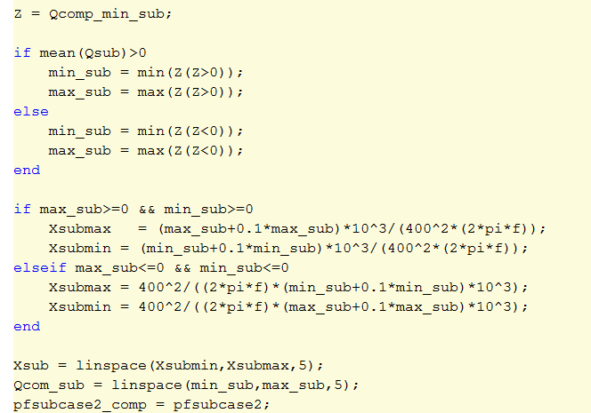

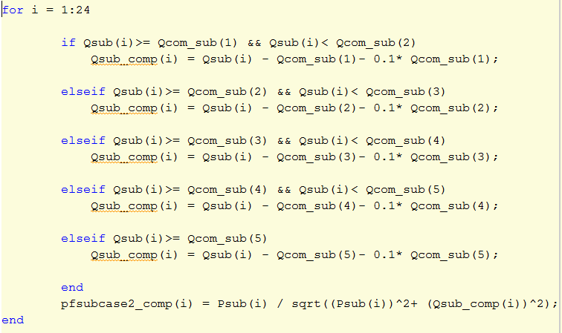

Figure 26: code for find components values and checking switched capacitors

At the final part of the calculation, we calculate voltage regulation of each bus and we don’t calculate voltage regulation of loads because more than one load can be connected at any bus so bus voltage is our changeable value also.

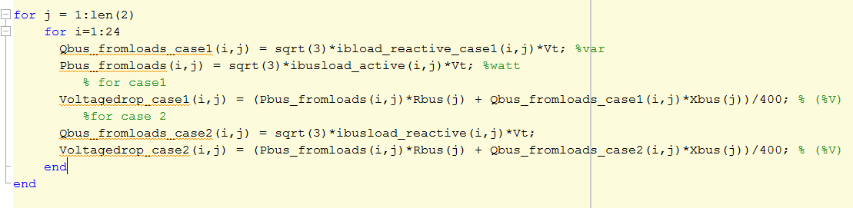

Figure 27: calculating voltage drop at all buses