MIDDLE EAST TECHNICAL UNIVERSITY

ELECTRICAL AND ELECTRONICS ENGINEERING
EE498
CONTROL SYSTEM DESIGN AND SIMULATION
-TERM PROJECT-

Name: İbrahim Güngen
No: 1936939
Instructor: Assoc. Prof. Dr. Klaus Werner Schmidt

Introduction
In this project, Model Predictive Control method will be implemented to steering system of the vehicle. In order to achieve this, system will be modeled first, then realize the MPC on MATLAB, and finally system will be simulate in Simulink. I will use number of horizon as 4, and select preview distance as 5 m. (p is 1/R.)

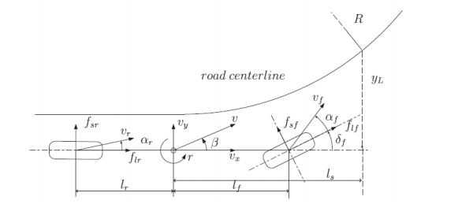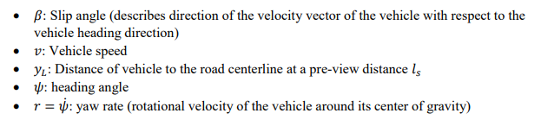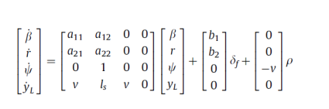
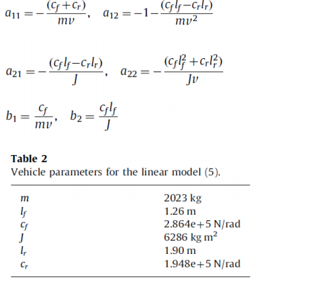

Modeling and Realizing
Main modeling parameters are given previous part and also A,B and C matrices should be calculated. Therefore, obtained matrices should be made discrete. Given parameters and values following matrices are obtained.
Ac = [a11 a12 0 0;
a21 a22 0 0;
0 1 0 0;
v ls v 0];
Bc = [b1; b2; 0; 0];
C = [0 0 0 1];
D = [0];

A_dis = exp(Ac*T)
B_dis = integral(exp(Ac*x),x,[0,T])*Bc)

Speed variable of the vehicle is not given at the model so that I will show that effect variable change of speed, initial distance to the centerline at preview distance, preview distance and road curvature.
In this model predictive controller, dual mode prediction is used. With this prediction, we prevent the instability. This can be occurred when finite horizon is used like this project.

Road Curvature
According to road curvature, steering angle of the vehicle which means input signal has an offset. As following figure shows differences of disturbance signal with constant other parameters. Speed is 30 m/s and R is infinity (straight line) and 1000m, initial distance 10m and preview distance is 5m taken.

%% changable values
x0 = [ 0;0;0;10];
p_dis = 0, 0.001; %1/R
v = 30; %m/sec
ls = 5; % m

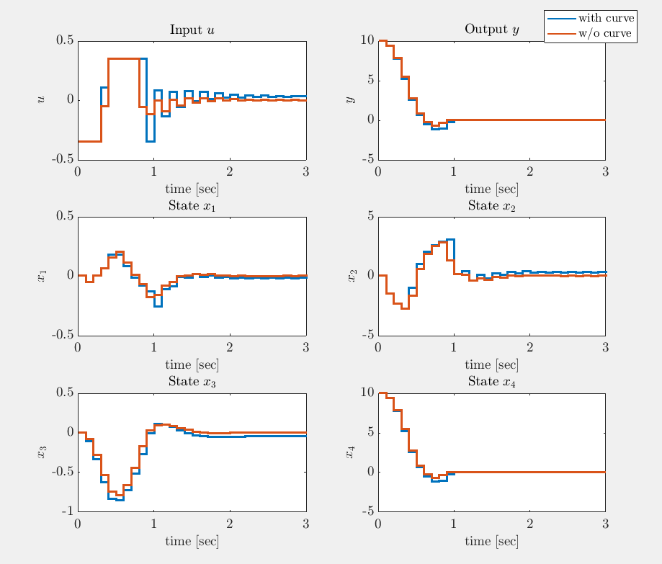

Note: Input values of the system limited -20,20 degree but in these calculation this value should be taken radian so that all figure shows that -0.3491, 0.3491radian values.

Velocity
When velocity increases, undershoot occurs at the output response and also input response rising time decreases, after some high speed controller cannot handle with this parameters. But this speeds are not realized with vehicle today (80m/s = 288km/h).
%% changable values
x0 = [ 0;0;0;10];
p_dis = 0.001; %1/R
v = 20, 60, 80; %m/sec
ls = 5; % m

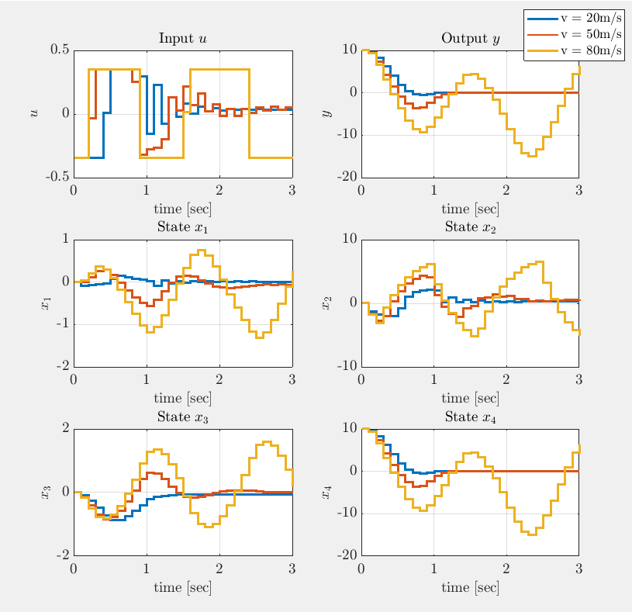

Note: Input values of the system limited -20,20 degree but in these calculation this value should be taken radian so that all figure shows that -0.3491, 0.3491radian values.

Initial Distance from Center Line
Aim of this controller is keep the vehicle at the road line so that initial distance to the centerline at preview distance should become 0. So that initial value of this value is given to the controller. Because of the speed of the response undershoot is observed and converging time of the distance is increase and vehicle goes oscillating.

%% changable values
x0 = [ 0;0;0;10], [ 0;0;0;100] ;
p_dis = 0.001; %1/R
v = 30; %m/sec
ls = 5; % m

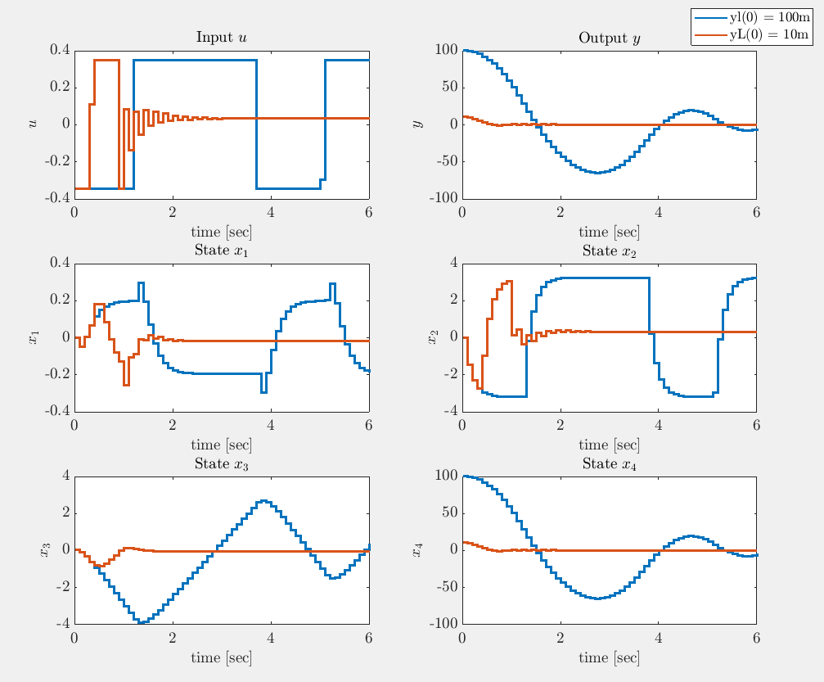
Note: Input values of the system limited -20,20 degree but in these calculation this value should be taken radian so that all figure shows that -0.3491, 0.3491 radian values.

Preview Distance
Increasing preview distance of the controller, converging time of the vehicle decreases because predicting to the signal is more realistic.

%% changable values
x0 = [ 0;0;0;10];
p_dis = 0.001; %1/R
v = 30; %m/sec
ls = 5,10,20; % m

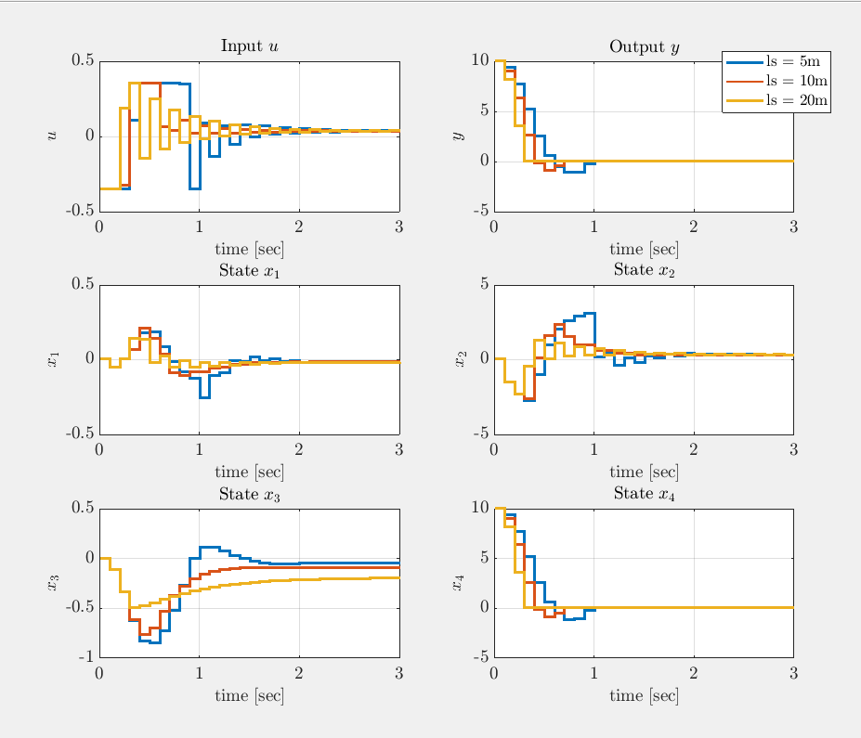
Note: Input values of the system limited -20,20 degree but in these calculation this value should be taken radian so that all figure shows that -0.3491, 0.3491 radian values.

Sampling Time
Until now, all simulations are made with Ts = 0.1s. But this value should be arranged according to the system and system requirement. This part of the project differences of the sampling time values are shown.
%% changable values
x0 = [ 0;0;0;10];
p_dis = 0.001; %1/R
v = 30; %m/sec
ls = 10; % m
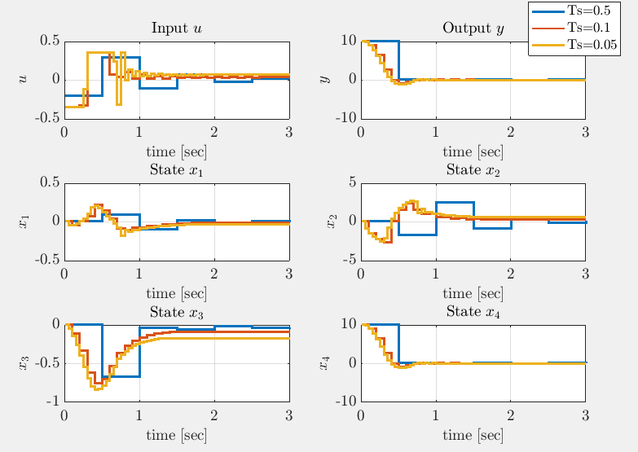

Appendix
Matlab Code
%% EE498 Term Project
%%
% İbrahim Güngen
% 1936939

%%
% Some figure formatting
set(groot,'defaulttextinterpreter','latex');
set(groot, 'defaultAxesTickLabelInterpreter','latex');
set(groot, 'defaultLegendInterpreter','latex');
clc
clear all

%% Introduction
%%
%
%
%%

% System parameters
m = 2023; %kg
lf = 1.26; %m
cf = 2.864e5; %N/rad
J = 6286; %kg.m2
lr = 1.90; %m
cr = 1.948e5; %N/rad

%% changable values
x0 = [ 0;0;0;10];
p_dis = 0.001; %1/R
v = 30; %m/sec
ls = 10; % m
%%

a11 = -(cf+cr)/(m*v);
a12 = -1-(cf*lf-cr*lr)/(m*v^2);
a21 = -(cf*lf-cr*lr)/(J);
a22 = -(cf*lf^2 + cr*lr^2)/(J*v);
b1 = cf / (m*v);
b2 = cf*lf / J;

% Finite Horizon MPC as quadratic program
% State-Space Model of the System
Ac = [a11 a12 0 0;
a21 a22 0 0;
0 1 0 0;
v ls v 0];
Bc = [b1; b2; 0; 0];
C = [0 0 0 1];
D = [0];

Ts = 0.05;

%%
T = sym('T');
x = sym('x');

A_dis = expm(Ac*T);
B_dis = int(expm(Ac*x),x,[0 T])*Bc;
%%

A_dis = subs(A_dis,T,Ts);
B_dis = subs(B_dis,T,Ts);
A = double(A_dis);
B = real(double(B_dis));

% Optimal control solution for $N = 4$
G = [zeros(4,1) zeros(4,1) zeros(4,1) zeros(4,1); B zeros(4,1) zeros(4,1) zeros(4,1); ...
A*B B zeros(4,1) zeros(4,1); A^2*B A*B B zeros(4,1); A^3*B A^2*B A*B B];
H = [eye(4); A; A^2; A^3; A^4];
Q = C'*C;
R = 0.001;

% Q = eye(2);
Pinf = dare(A,B,Q,R,zeros(4,1),eye(4));
Kinf = inv(R+B'*Pinf*B)*B'*Pinf*A;
% A*X*A' - X + Q = 0; X = dlyap(A,Q)
P = dlyap( (A-B*Kinf)',Q+Kinf'*R*Kinf );
Qf = P;
Qbar = blkdiag(Q,Q,Q,Q,Qf);
Rbar = blkdiag(R,R,R,R);
M = G'*Qbar*G + Rbar;
% input bound: umin <= u <= umax
umin = -0.3491; % -20 degrees
umax = 0.3491; % 20 degrees
lb = [umin;umin;umin;umin];
ub = [umax;umax;umax;umax];
% Apply MPC steps
xVec(:,1) = x0;
yVec(1) = C*x0;
uVec = [];
for kk = 1:60
alpha = G'*Qbar*H*xVec(:,kk);
Usol = quadprog(M,alpha',[],[],[],[],lb,ub);
uVec(kk) = Usol(1);
xVec(:,kk+1) = A*xVec(:,kk) + B*uVec(kk) + [0; 0; -v*p_dis; 0];
yVec(kk+1) = C*xVec(:,kk+1);
Xsol(:,1) = xVec(:,kk);
Xsol(:,2) = A*Xsol(:,1) + B*Usol(1);
Xsol(:,3) = A*Xsol(:,2) + B*Usol(2);
Xsol(:,4) = A*Xsol(:,3) + B*Usol(3);
Ysol(1) = C*Xsol(:,1);
Ysol(2) = C*Xsol(:,2);
Ysol(3) = C*Xsol(:,3);
Ysol(4) = C*Xsol(:,4);
end

uVec = [uVec uVec(end)];
tVec = [0:Ts:3];
%figure;
subplot(3,2,1)
stairs(tVec,uVec,'LineWidth',2);
hold all;
xlabel('time [sec]')
grid
ylabel('$u$')
title('Input $u$')

subplot(3,2,2)
stairs(tVec,C*xVec,'LineWidth',2)
hold all;
grid
xlabel('time [sec]')
ylabel('$y$')
title('Output $y$')

subplot(3,2,3)
stairs(tVec,[1 0 0 0]*xVec,'LineWidth',2)
hold all;
grid
xlabel('time [sec]')
ylabel('$x_1$')
title('State $x_1$')

subplot(3,2,4)
stairs(tVec,[0 1 0 0]*xVec,'LineWidth',2)
hold all;
grid
xlabel('time [sec]')
ylabel('$x_2$')
title('State $x_2$')

subplot(3,2,5)
stairs(tVec,[0 0 1 0]*xVec,'LineWidth',2)
hold all;
grid
xlabel('time [sec]')
ylabel('$x_3$')
title('State $x_3$')

subplot(3,2,6)
stairs(tVec,[0 0 0 1]*xVec,'LineWidth',2)
hold all;
grid
xlabel('time [sec]')
ylabel('$x_4$')
title('State $x_4$')

set(findall(gcf,'Type','line'),'LineWidth',2)
set(findall(gcf,'-property','FontSize'),'FontSize',14);
% legend('$u_{max} = 1.5$','$u_{max} = 2.5$','$u_{max} = 4$')

