# Detection of Electrical Machines Errors with Phase Currents by Using Machine Learning Methods

İbrahim GÜNGEN

METU-EE

[gungenibrahim@gmail.com](mailto:gungenibrahim@gmail.com)

05542890259

Abstract- At electrical machines, detecting fault is more complicated. In order to do this, a lot of methods are researched like current signature analysis, motor vibration analysis, flux signature analysis, etc. Most of them are signal processing based methods. In general, these are used like Fourier transform, short time Fourier transform and wavelet transform methods. None of them gives best performance for all type faults and results quick enough. Also, some of these faults need to significantly important knowledge of electrical machine theorems or experiences. Because of this reason, machine learning methods could be used decide to faults types and locations in the future. Experienced and decided fault types and their signals (like current signals, terminal voltage signals etc.) can be learnt to the any machine learning algorithm. When, any signals package is gave the algorithm, faults could be decided quickly. In this project, small simulation of this work is made with induction machine current signal data packet. Convolution Neural Network and Multilayer Perceptron methods are used for classify healthy condition, broken rotor condition and static eccentricity fault conditions. Datasets are obtained from oscilloscope with 5 different motor speeds and 3 different torque value with 200000 data points. Total number of input data are 6750(1250x3) for learning and 450(1250x3) for test, data packages are separated same data size for all phases. %98 and %93 success of test package are obtained by CNN and MP respectively.

## INTRODUCTION

Approximately, %45 of total global electricity is consuming by electrical machines, which means large number of electrical machines are using at the world. With the expansion of electrical vehicle, this number will increase. Also faults can occur, and then number of electrical machine faults will increase. Today’s industry and also people need to be fixed these problems quickly. My work is parallel to this need. I would like to make that fault with their types with current signature is learned by computer algorithm. By doing this, people at the industry can detect errors easily by importing 3 phase current wave (at least 1 cycle).

Fault analysis of electrical machined are made with signal processing by using different transform methods. As a different solution, I have tried to design filter which produce by computer with learning algorithms to use at detection.

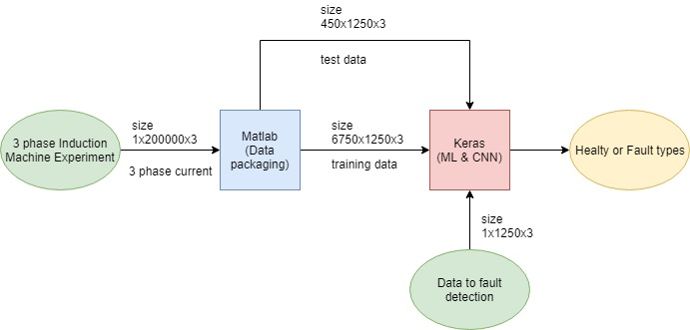

Figure 1. Block diagram of the project work

I arrange dataset according to the learning algorithms by MATLAB so that I have not used preprocessing tools of Keras.

At CNN method, I have used 3 convolution layers, 2 pooling layers and 1 softmax classifier layers. At ML network, 5 layers are used.

According to the dataset I have used 3 classes to classify, these are healthy condition, broken magnet rotor fault condition and static eccentricity fault condition. These dataset is taken from paper at Reference [1].

## DATASET

As I mentioned previous part, I have taken data from authors of paper at Reference [1]. This includes experimental 3 phase current results of the 8 phase permanent magnet electrical induction machines. Experiment has been made with 3 conditions as healthy, broken magnet rotor fault and static eccentricity fault. They have taken 200.000 data points each part. They made this experiment 5 different speed (600, 1200, 1800, 2400, 3000 rpm) and 3 different torque value for each speed. I have inserted these data to MATLAB and convert them to the Keras input package. I have used 15 different data txt including 200.000 data point at 3 phases, and then I have divided a package 1250 data because this value includes 1 sinusoidal signal at the lowest speed (600 rpm). Finally, I have obtained 6750 training data package, 450 testing package for 3 classes. Following figure shows samples of lowest and highest speed data.

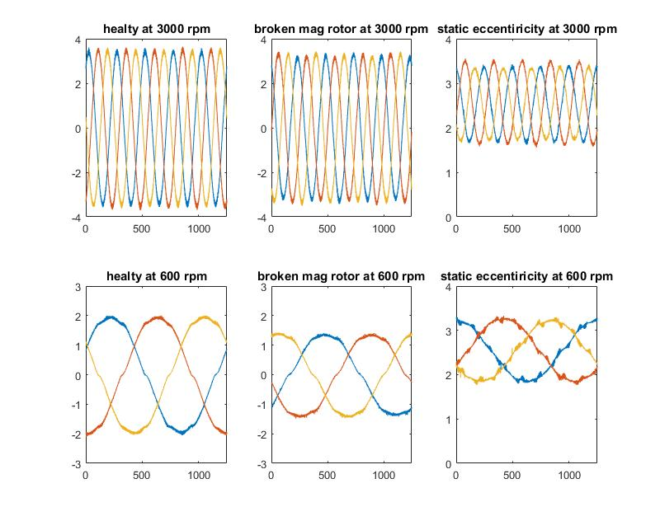

Figure 2. Sample of data highest and lowest speed at random torque values (magnitudes are changing)

## METHODS

### Convolutional Neural Network

I have chosen this method because it is not so spread at my research area and also at the literature, this method is using image classification successfully. At this method, I have tried a lot of combination such as much higher number of kernel layers (like 1024), number of convolution layer, pooling layer and different combinations of all of them. When I increase number of layers and kernel, learning time is increase significantly, also performance does not increase as parallel. I have optimized layer by focusing harmonics of the signals. First off all, I used kernel by filtering DC and AC values, then other layers used for filtering higher order harmonics then last layer for classification. Of course, I thought that way but how I don’t know machine learn the filter. Finally, I have use the flatten layer to obtain fully connected classification layer.

|  |  |  |  |  |  |  |  |
| --- | --- | --- | --- | --- | --- | --- | --- |
| Network name | Block name | Layer name | Number of kernels | Kernel size | stride | Number of neurons | Neuron type |
| CNN | C1 | 1DConv1  1D Pool1 | 2 | 3  2 | -  - | - | ReLu |
| C2 | 1D Conv2  1D Pool2 | 64 | 3  2 | -  - | -  - | ReLu |
| C3 | 1D Conv3  1D Pool3 | 128 | 2  8 | -  - | -  - | ReLu |
| F1 | Flaten | - | - | - | - | Softmax |
| O1 | Output | - | - | - | 3 | Softmax |

Table 1

Moreover, I have used 1D convolution because my data package size is 1250x3 that is not more appropriate for 2D convolution. Moreover I have not used any feature extraction and preprocessing method both methods, because every data of mine have importance of harmonics. At this method I have choose ‘Adam optimizer’ as an optimizer and ‘categorical crossentropy’ as a loss function.

### Multilayer Neural Network

This method is chosen because, building the model a little bit easier at smaller dataset, and also I think that processing time per step can be faster than other more complicated network types for my dataset. I arrange my data for this network 1D. I collected all 3 phase’s data at 1D package (1250x3 -> 3750x1).

|  |  |  |  |  |  |  |  |
| --- | --- | --- | --- | --- | --- | --- | --- |
| Network name | Block name | Layer name | Number of kernels | Kernel size | stride | Number of neurons | Neuron type |
| MLP | M1 | Dense1 |  | - | -  - | 1250 | ReLu |
| M2 | Dense2  Dropout1(0.01) |  | - | -  - | 250 | tanh |
| M3 | Dense3  Dropout2(0.1) |  | - | -  - | 50 | tanh |
| M4 | Dense4 |  | - | - | 10 | ReLu |
| O1 | Dense5 |  |  |  | 3 | Softmax |
|  |  |  |  |  |  |  |

Table

To obtain better performance, I have increase number of layer and to keep processing time less I tried to keep number or neurons smaller. Also, again I have tried to figure harmonics at the second layer. 3rd and 4th layers are used for combinations of these layers so that I have used dropout layer to drop unnecessary connections to prevent overfitting. At this method I have choose ‘gradient descent optimizer’ as an optimizer and ‘squared hinge’ as a loss function.

## PERFORMANCE CRITERIA

When I arrange training data bench, I obtained test bench also. I have separated data package 150-10 training and test data for all 15 experiments. So that, I have 450 sample for test the network accuracy. Accuracy performance is calculated with percentage of prediction of these samples. Moreover loss calculation of these methods is different.



Figure 3. Hinge loss function

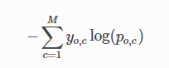

Figure 4. Cross-entropy loss function(p: pred. Prob, y: binary ind, M: number of classes)

## EXPERRIMENTAL RESULTS

### Convolutional Neural Network

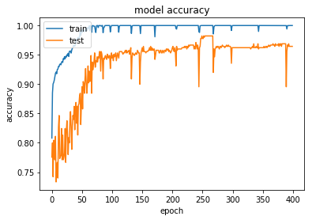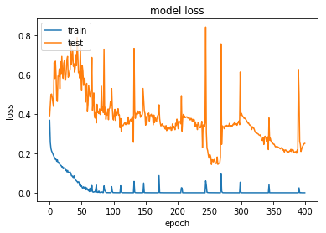

Figure 5. Model accuracy and loss graphs according to the epoch for CNN

As figure 5 shows, test accuracy of network increase up to %98 and losses of test is %20. Final of 400 epochs, I obtained [0.251, 0.964] test loss and test accuracy values respectively. Also trained accuracy and loss values converge to 1.0 and 0 respectively.

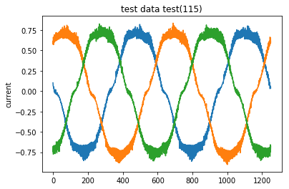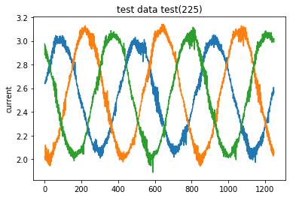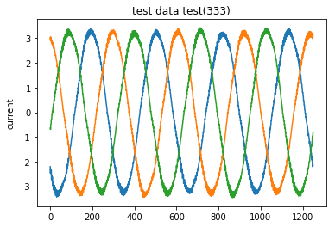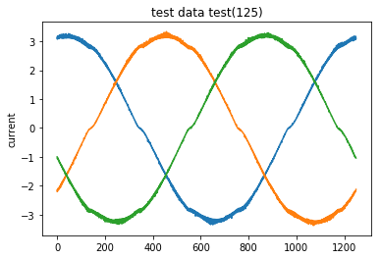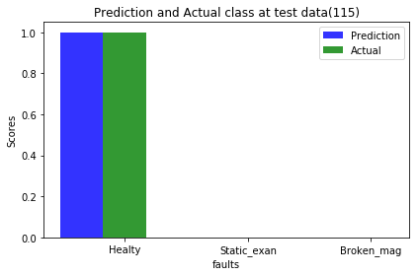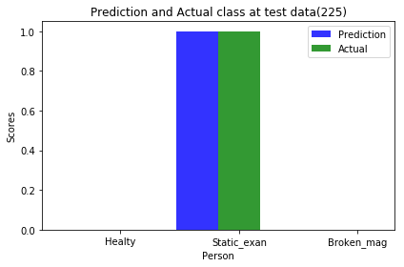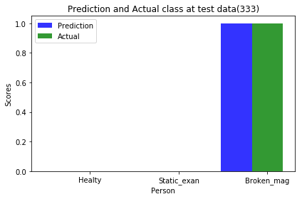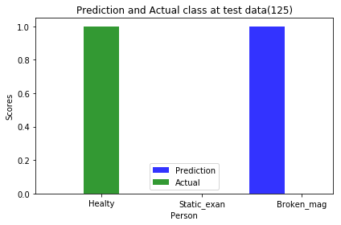

Figure 6. Some samples of test data and their predicted-actual values (CNN)

As figure5 and 6 show that, independently frequency of the current signal, data are classified with high percentage. Non-classified data packages could be include experimental error because both methods are failure almost same test package.

### Multilayer Neural Network

MLP train accuracy and losses are converges to 0,99 and 0,66 respectively, and also test accuracy goes up to %93 and losses decrease 0,69. Final of 400 epochs, [0.69, 0.93] values are obtained as loss and accuracy values.

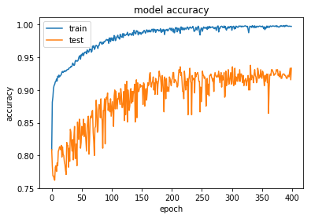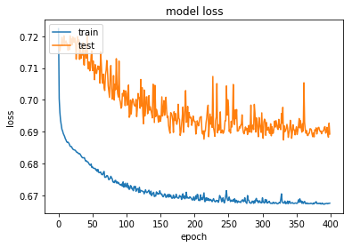

Figure 7. Model accuracy and loss graphs according to the epoch for MLP

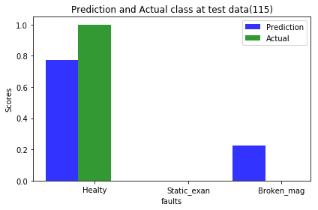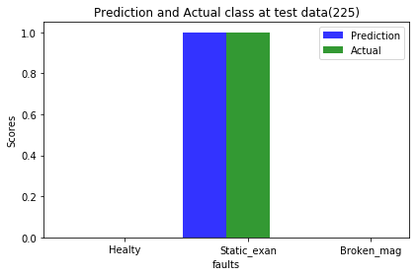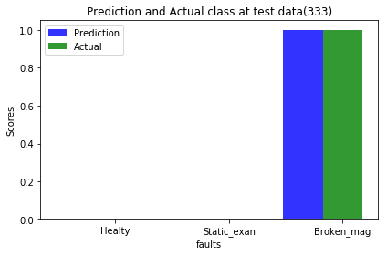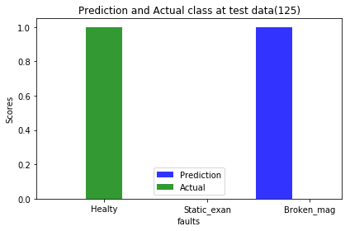

Figure 8. Predictions and actual class of Test data package at the figure 6

### Comparison

Previous algorithms have compiled different time steps. CNN learning takes 310us per steps and MLP takes 246us per steps when I using 4gb Nvidia GPU. Accuracy of CNN is a little bit higher than MLP, but CNN test accuracy have increased up to %98 but CNN is increase %93 max. Losses of CNN are near to the 0 but MLP has 0.67 losses value which is higher value. Moreover, when I examine non-classified signal packages, I see that no load condition of 2400rpm has much more harmonics like a broken rotor fault. Classifying these data has not good performance both methods. Also, some broken rotor conditions data have less harmonic components which are almost same as healthy conditions.

## CONCLUSION

This work and performance values shows that machine learning methods can be used for fault detection and leads to need less effort to do that. According to my opinion, Convolution Neural Network is more appropriate than Multilayer Perceptron for my work because it gives better results and also after increasing training data, performance could be better. In the future, data sample and fault classes will increase by doing new experiments and simulation for these algorithms at first step. There are a lot of faults types for electrical machine so that it is significantly hard and expensive to collect data from experiments for each class. At next step, I aim that after simulation results (data) of faults will be learned by algorithm, it will classify experimental (real current signal) data. By doing this, we can success to work on fault types and detection of these without complicated experiment setups. Finally, this project was an inspiring start for my research.

### ACKNOWLEDGEMENTS

Firstly, I thank to Prof. Ugur Halıcı to give this lecture to us. This study is directly related my thesis and Assist. Prof. [Emine BOSTANCI](https://eee.metu.edu.tr/personel/emine-bostanci) is my advisor; I thank her for guiding me in my works. Moreover, I owe thanks to Mehrdad Heydarzadeh, Mohsen Zafarani,  Bilal Akin and Mehrdad Nourani for sharing data of these paper with us.

### REFERENCE

[1] Heydarzadeh, M., Zafarani, M., Akin, B., & Nourani, M. (2018). A Wavelet-Based Fault Diagnosis Approach for Permanent Magnet Synchronous Motors. *IEEE Transactions on Energy Conversion,* 1-1. doi:10.1109/tec.2018.2864570