

**MIDDLE EAST TECHNICAL UNIVERSITY**

**ELECTRICAL AND ELECTRONICS ENGINEERING**

**EE564**

**DESIGN OF ELECTRICAL MACHINES**

**-PROJECT 1-**

***Name:* İBRAHİM GÜNGEN**

***No:* 1936939**

***Instructor:* OZAN KEYSAN**

INDEX

Question 1 3

Part A 3

Part A.1 3

Part A.2 3

Part A.3 6

Part A.4 9

Part A.5 10

Part B 11

Part B.1 11

Part B.2 12

Part B.3 14

Part B.4 18

Part C 20

Question 2 21

Appendix 22

# Question 1

## Part A

In this part I made all calculations with MATLAB so I have used MATLAB report generator.

### Part A.1

% In this part, magnetic flux is assumed homogeneously, and use effective  
% length from datasheet.  
  
  
u0 = 4*pi*10^-7;  
  
core_Al = 5040; % nH/turn^2  
core_le = 103e-3; % m eff length  
core_Ae = 138e-6; %m^2 cross sec area  
core_height = 18e-3;  
  
core_inner_r = 13.1e-3;  
core_outer_r = 20.9e-3;  
  
  
core_init_ur = 3000; %initial ur  
  
core_ur = 4500; % @ 425mT  
  
B_op = 0.425;  
  
N = 20;  
Imax = B_op*core_le/(core_ur*u0*N);  
  
I = 0.43;  
  
core_R = core_le/(core_ur*u0*core_Ae); %reluctance  
  
core_L = N^2/core_R %H

core_L =

0.0030

### Part A.2

% L = N*fi/I , fi = NI/R, L = N^2(1/R1+1/R2...)  
  
% in order to modeled this I have calculated 10 different reluctance  
% which is effected flux and inductance then calculated inductance  
  
% inner parts of the toroid has small effective length this cause smaller  
% reluctance so that magnetic flux density and magnetic flux is high at  
% smaller radius and smaller higher radius. Also our assumption of the  
% first part is verified.  
  
core_r_div = linspace(core_inner_r,core_outer_r, 11);  
  
core_r_div_effective = zeros(10,0);  
core_R_div_effective = zeros(10,0);  
core_le_div_effective = zeros(10,0);  
core_Ae_div = zeros(10,0);  
core_L_div = zeros(10,0);  
core_flux_div = zeros(10,0);  
total_div_flux = 0;  
total_div_inductance = 0;  
  
for i = 1:10  
  
 core_r_div_effective(i) = (core_r_div(i) + core_r_div(i+1))/2;  
  
 core_le_div_effective(i) = 2*pi*core_r_div_effective(i);  
  
 core_R_div_effective(i) = core_le_div_effective(i)/(core_ur*u0*core_Ae/10);  
  
 core_L_div(i) = N^2 / core_R_div_effective(i);  
  
 core_flux_div(i) = N*I/core_R_div_effective(i);  
  
 total_div_inductance = total_div_inductance + core_L_div(i);  
 total_div_flux = total_div_flux + core_flux_div(i);  
  
end  
  
  
plot(core_r_div_effective,core_L_div);  
title('inductance vs radius part 1');  
xlabel('radius');  
ylabel('inductance');  
  
figure;  
  
plot(core_r_div_effective,core_flux_div);  
title('flux vs radius part 1');  
xlabel('radius');  
ylabel('flux');  
  
figure;  
  
total_div_flux  
  
total_div_inductance

total_div_flux =  
 6.3957e-05  
  
total_div_inductance =  
  
 0.0030

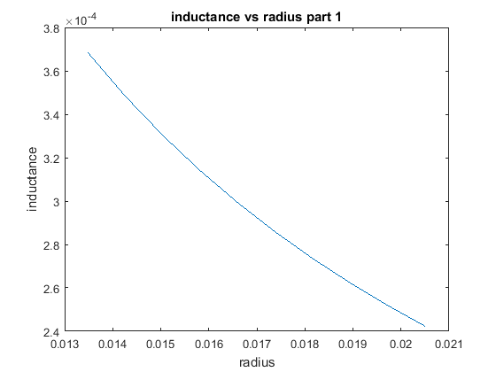

Figure 1. Inductance values for each dividing region

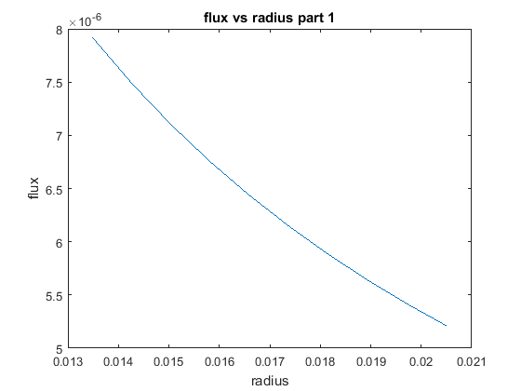

Figure 2. Magnetic flux for each dividing region

### Part A.3

% In this part magnetic flux density is saturated so that increasing  
% current cause to decrease permeability then, inductance of the inductor  
% decreases. Moreover, same as part 3, magnetic flux and flux density are higher  
% at the smaller radius of the core because of smaller effective distance  
% and reluctance.  
  
% In this part magnetic flux density is saturated so that increasing  
% current cause to decrease permiability so that inductance of the inductor  
% decrease also, same as part 3 magnetic flux and flux density higher  
% at the smaller radius of the core because of smaller effective distance  
% and reluctance.  
  
  
% NI = B*A*R  
I_part3 = 0.6525;  
  
core_B_sat = 0.53;  
  
core_ur_part3 = 4500*0.53/0.425/1.5;  
  
core_R_part3 = core_le/(core_ur_part3*u0*core_Ae); %reluctance  
  
  
core_L_part3 = N^2/core_R_part3 %H  
  
core_flux_part3 = N*I_part3/core_R_part3  
  
% part 3 division  
  
core_R_div_effective_part3 = zeros(10,0);  
core_L_div_part3 = zeros(10,0);  
core_flux_div_part3 =zeros(10,0);  
total_inductance_div_part3 = 0;  
total_flux_div_part3 = 0;  
  
for i = 1:10  
  
 core_R_div_effective_part3(i) = core_le_div_effective(i)/(core_ur_part3*u0*core_Ae/10);  
  
 core_L_div_part3(i) = N^2 / core_R_div_effective_part3(i);  
  
 core_flux_div_part3(i) = N*I_part3/core_R_div_effective_part3(i);  
  
 total_inductance_div_part3 = total_inductance_div_part3 + core_L_div_part3(i);  
 total_flux_div_part3 = total_flux_div_part3 + core_flux_div_part3(i);  
  
end  
  
  
plot(core_r_div_effective,core_L_div_part3);  
title('inductance vs radius part 3');  
xlabel('radius');  
ylabel('inductance');  
  
figure;  
  
plot(core_r_div_effective,core_flux_div_part3);  
title('flux vs radius part 3');  
xlabel('radius');  
ylabel('flux');  
  
figure;  
  
total_flux_div_part3  
  
total_inductance_div_part3

core_L_part3 =  
  
 0.0025  
  
  
core_flux_part3 =  
  
 8.2200e-05  
  
  
total_flux_div_part3 =  
  
 8.0685e-05  
  
  
total_inductance_div_part3 =  
  
 0.0025

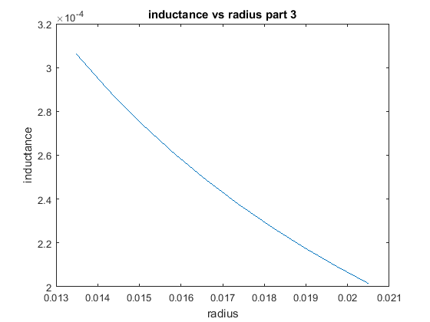

Figure 3. Inductance values for each dividing region for saturated flux density

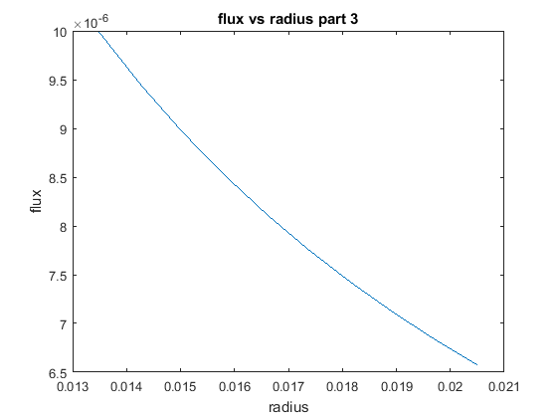

Figure 4. Magnetic flux for each dividing region for saturated flux density

### Part A.4

% By adding gap to core cause to increase the reluctance so the inductance and  
% core flux are decreasing. Fringing flux is neglected.  
  
d_gap = 2e-3;  
  
core_le_part4 = core_le - 2e-3;  
  
gap_R = d_gap/(core_Ae*u0);  
  
core_R_part4 = core_le_part4/(core_ur*u0*core_Ae); %reluctance  
  
core_L_part4 = N^2/(core_R_part4+gap_R) %H

core_L_part4 =  
  
 3.4298e-05

### Part A.5

% In this part, in order to model fringing flux, I increased the air gap a  
% little, in order to decide this distance I found required reluctance to model  
% fringing distance. Also, ı have used this reluctance to calculate  
% inductance  
%  
% Formula of fringing flux is flux = 1+(d_gap/sqrt(Acore))*ln(2*window_area/d_gap)  
%  
  
area_window= 2*pi*core_inner_r;  
  
fringing_flux = 1+(d_gap/sqrt(core_Ae))* log(2*area_window/d_gap);  
  
d_fringing = N*I*core_Ae*u0/fringing_flux  
  
fringing_R = d_fringing/(core_Ae*u0);  
  
core_L_part5 = N^2/(core_R_part4+gap_R+fringing_R) %H  
  
% By using this formula, d_fringing is came so small, so that effect of fringing  
% could not seen obviously

d_fringing =  
 8.5178e-10

core_L_part5 =  
 3.4298e-05

## Part B

### Part B.1

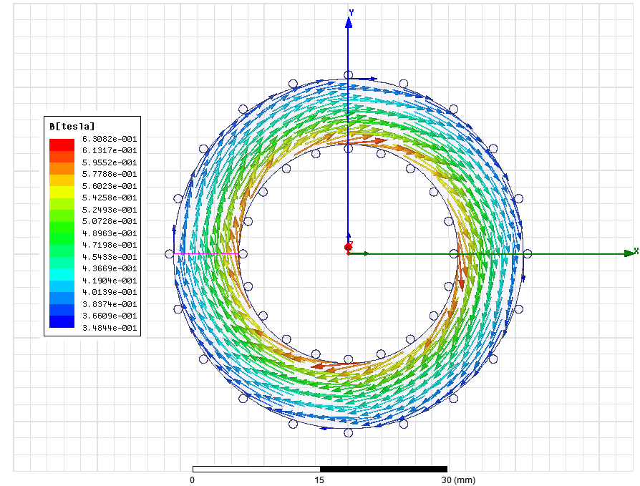

Figure 5. Magnetic flux density for linear core material with symmetrical excitation

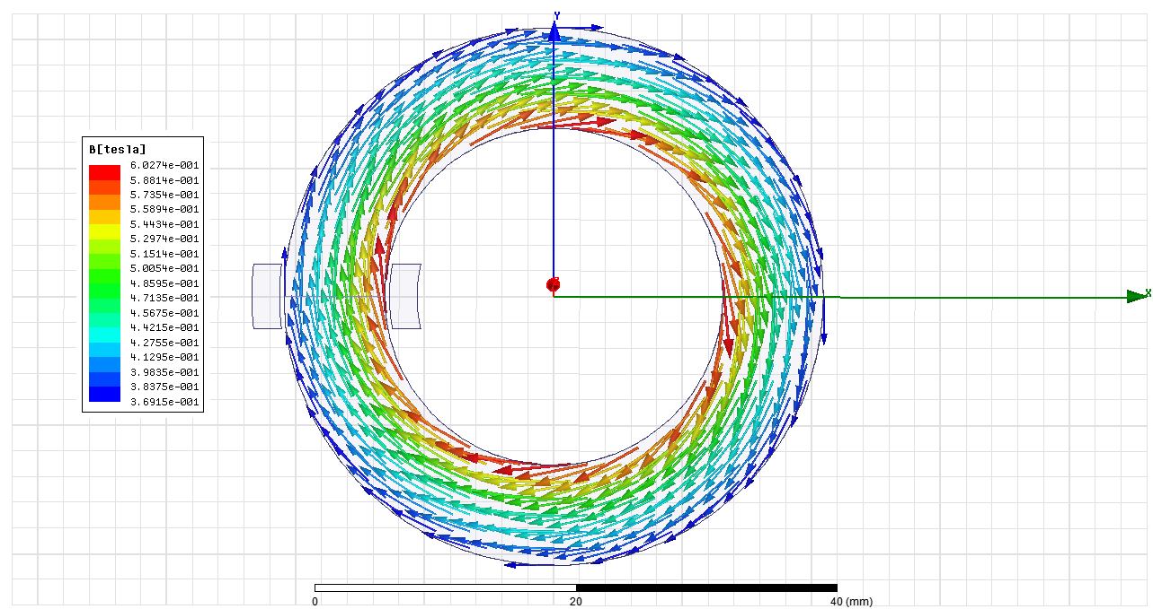

Figure 6. Magnetic flux density for linear core material

### Part B.2

Stored energy of the core is calculated from magnetic flux passing on L1 and leakages are modeled with L2 and L3 line fluxes.

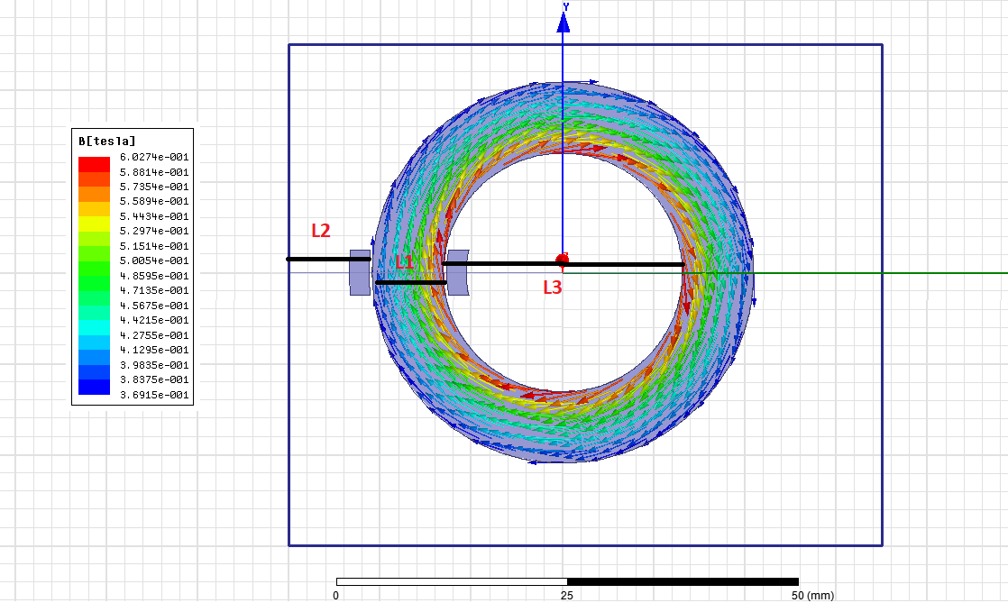

Figure 7: Magnetic flux density for linear core material and lines using to measure passing flux and energy

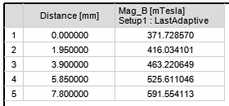

Figure 8. Magnitude of magnetic flux density on L1

From figure 8, average magnetic flux density on the core is calculated as 473.2 mT. Then with following formula reluctance is calculated. (N = 20, I = 0.435A, B = 0.473.2T, A = 138mm^2)

$$R=\frac{N*I}{B*A}$$

Reluctance is found as R = 133.22 * 10^3, then with following formula, total inductance is nearly **3mH** as founded analytically.

L = **3mH**

By using previous reluctance and inductance formula, next formula is derived.

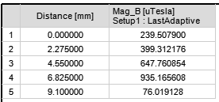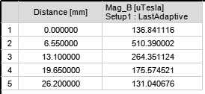

Figure 9. Magnitude of magnetic flux density on L2(left) and L3(right)

Note: I have calculated average magnetic flux density until 9.1 mm outside of core as. Then I used cross section area of this distance.

Average magnetic flux density on L2 is 459uT and on L3 is 243uT, then leakage inductances are (N = 20, I = 0.435, A1= 18*9.1mm2, A2= 18*26.2mm2 )

LL1 = 3.45uH, LL2 =5.27 uH

Lleakage = **8.72uH**.

### Part B.3

In this part simulations are made for desired current value and %50 higher of it separately.

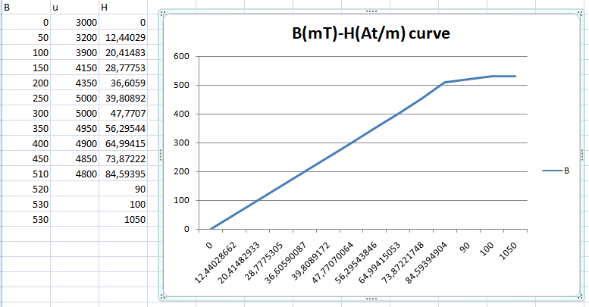

**Figure 10. B-H curve of core which is obtained permeability- flux density of the core (at appendix)**

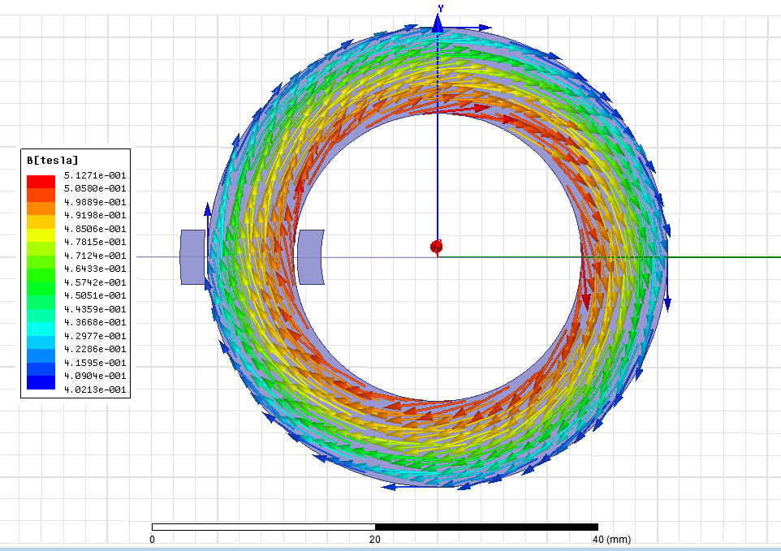

Figure 11. Magnetic flux density for non-linear core material (current = 0.435A)

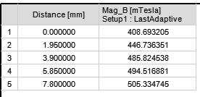

Figure 12. Magnitude of magnetic flux density on L1 for non-linear core

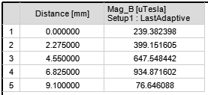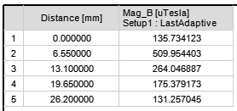

Figure 13. Magnitude of magnetic flux density on L2 and L3 for non-linear core

Same formulas are used as previous parts. Average magnetic flux on core cross section is Bav = 468.2 mT. (N = 20, I = 0.435, A= 138mm2)

L = = **2.96mH**

Also, avarege flux densities for leakage inductance are B1 = 459.4uT and B2 = 243uT, then leakage inductances are (N = 20, I = 0.435, A1= 18*9.1mm2, A2= 18*26.2mm2 ).

Lleakage = **8.71uH**

Inductor is operates linear region of the B-H curve for this current value so that inductance values of Part B.2 and Part B.3 almost same.

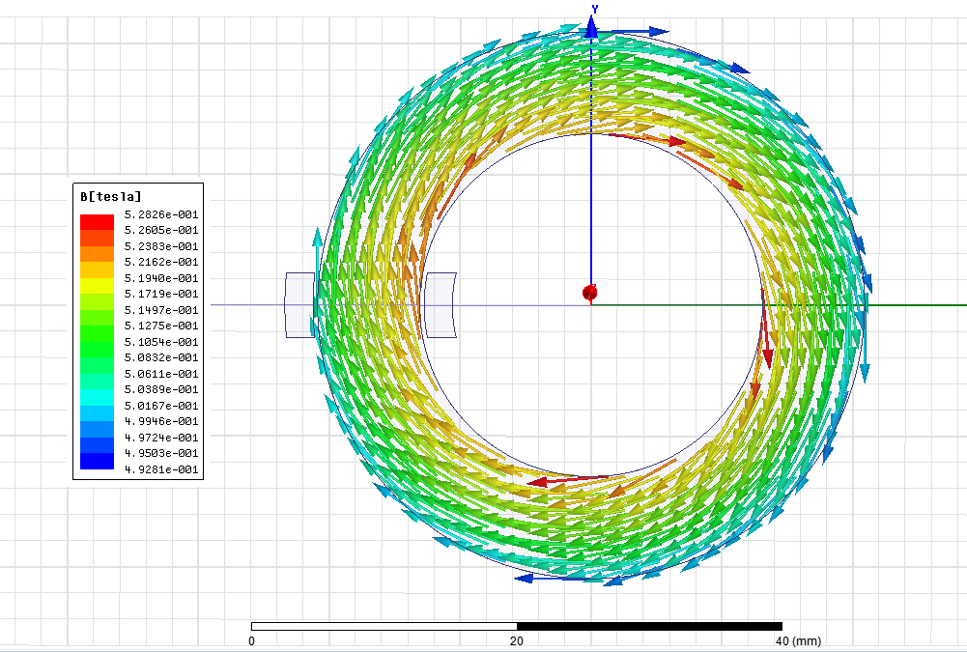

Figure 14. Magnetic flux density for non-linear core material (current = 0.435A*1.5)

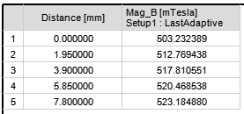

Figure 15. Magnitude of magnetic flux density on L1 for non-linear core(current = 0.435*1.5)

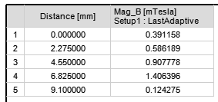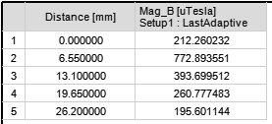

Figure 16. Magnitude of magnetic flux density on L2 and L3 for non-linear core (current = 0.435*1.5)

Average magnetic flux on core cross section is Bav = 515.4mT. (N = 20, I = 0.653, A= 138mm2)

L = = **2.17mH**

Also, average flux densities for leakage inductance are B1 = 683uT and B2 = 267uT, then leakage inductances are (N = 20, I = 0.653, A1= 18*9.1mm2, A2= 18*26.2mm2 ).

LL1 = 2.76uH, LL2 =1.08uH

Lleakage = **3.84uH**

Inductor is operates non-linear region of the B-H curve so that permeability of core is lower, reluctance of core is higher also flux and flux density is lower so that inductances became smaller for this part. Analytical calculation total inductance values for non-linear core material(partA.4, 2.2mH) is verified this total inductance value.

### Part B.4

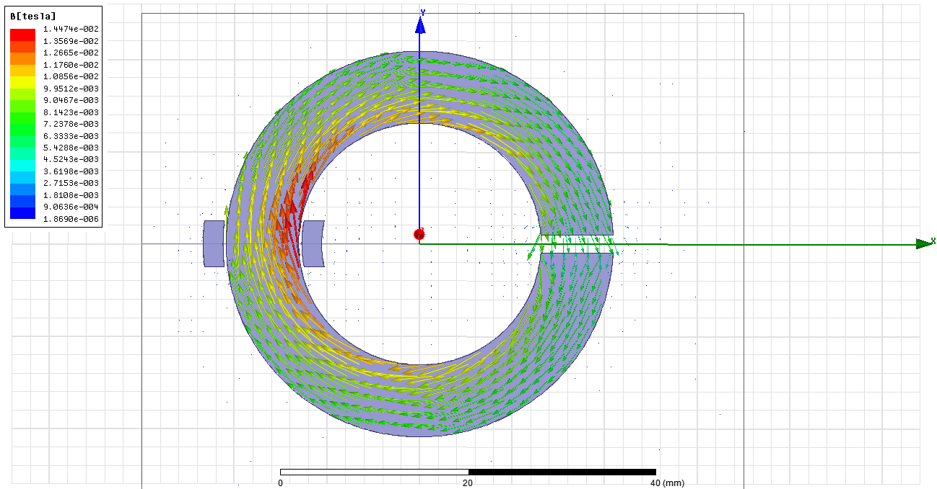

Figure 17. Magnetic flux density for non-linear core material with 2mm gap

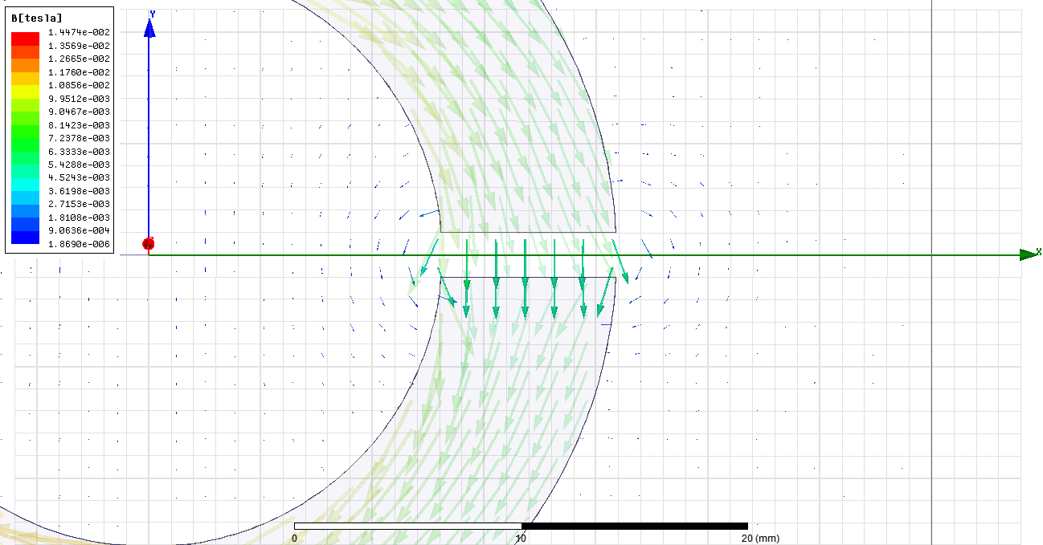

Figure 18. Fringing flux density for non-linear core material with 2mm gap

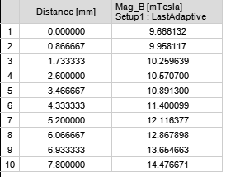

Figure 19. Magnitude of magnetic flux density on L1 for non-linear core with 2mm gap

In this part, to calculate fringing inductance with leakage inductance, L4 line is added right of the gap horizontally.

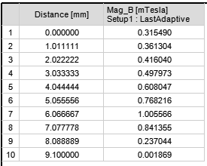 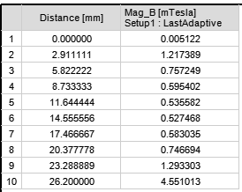 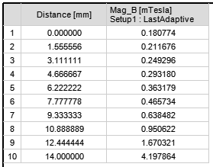

Figure 20. Magnitude of magnetic flux density on L2(top-left), L3(top-right) and L4(bottom) for non-linear core with 2mm gap

In this part, 2mm air gap is added to the core, this cause higher reluctance value of core so that inductance and flux components are decrease.

Average magnetic flux on core cross section is Bav = 11.6 mT. (N = 20, I = 0.435, A= 138mm2)

L = = **73.6uH**

Also, average flux densities for leakage and fringing inductances are B1 = 504uT, B2 = 1.1mT and B3 = 921uT, then leakage inductances are (N = 20, I = 0.653, A1= 18*9.1mm2, A2= 18*26.2mm2, A2= 18*14mm2 ).

LL1 = 3.79uH, LL2 =23.8uH, LL3 =10.67uH

Lleakage+fringing = **38.26uH**

As average flux densities around the air gap, fringing flux is an important effect for kind of applications.

At Part A.5, I have calculated this total inductance 34uH but here total inductance is 73.6uH. In analytical calculation fringing flux is ignored so if we ignore this flux at this part total inductance becomes 35.3uH, which is almost same as analytical value.

## Part C

|  |  |  |  |  |
| --- | --- | --- | --- | --- |
|  | Analytical | | FEA | |
| Linear core | Ltotal = 3mH | | Ltotal = 3mH | Lleakage = 8.72uH |
| Non-linear core (1.5*I) | Ltotal = 2.5mH | | Ltotal = 2.17mH | Lleakage = 3.83uH |
| Core with air gap | Ltotal = 34uH | Lfringing  = ~10nH | Ltotal = 73.6uH | Lleakage+fringing = 38.26uH |

In analytical calculation, leakage flux could not model because it changes according to specifications of winding. Also, only fringing flux could not be modeled FEA because we could not separate fringing and leakage fluxes. Moreover, calculation of all point on the core by analytically but FEA made it almost all point according to the meshing size.

2D analysis method is appropriate only symmetric geometrical models because we draw only one cross section of model but it can have any salience or indentation such as screw hole. All geometry especially magnetic permeable materials geometry effects magnetic circuit. for these reasons, 3D analysis is more appropriate for non-symmetrical models.

# Question 2

There is a lot of trade-offs when designing transformer so that optimization of design really important. All important parameters are explained bottom.

|  |  |
| --- | --- |
| Power, Vin,Vo, Freq, temp, Iin, Iout | These parameters depend on customer needs, main purpose is designer obtaining these needs with maximum efficiency with minimum cost |
| Temperature | It effects B-H curve directly, so it is important for calculation |
| Type (square, E, C core) | Calculation of magnetic circuit depends on shape |
| Lamination type | According to frequency and material, eddy current and core loss decrease with lamination |
| B,H | Main operating flux density is decided according to material B-H curve |
| Cable resistivity, radius etc | According to current of transformer, cable is chosen then these parameters obtained |
| Core cross section | Cross section area effects reluctance, flux, inductance of the transformer, these parameters are so critically for magnetic circuits and also size and core loss of the transformer, it should be optimized |
| N1, N2 | These parameters also effects flux, inductance etc. Choosing this value high leads to high copper loss, choosing low leads to low flux and high core size |
| Window size | This value is decided according to fill factor, winding height and also cable quantity of the winding cable |
| Power factor | It is needed for efficiency calculation |

**Table 1. Important Input Parameters of Transformer Design**

# Appendix

