INDEX
Question 1 1
Part A 1
Part A.1 1
Part A.2 2
Part A.3 4
Part A.4 7
Part A.5 7
Part B 8
Part B.1 8
Reference 9

Question 1

Part A
In this part I made all calculations with MATLAB so I have used MATLAB report generator.

Part A.1
% In this part, magnetic flux is assumed homogeneously, and use effective
% length from datasheet.
u0 = 4*pi*10^-7;
core_Al = 5040; % nH/turn^2
core_le = 103e-3; % m eff length
core_Ae = 138e-6; %m^2 cross sec area
core_height = 18e-3;
core_inner_r = 13.1e-3;
core_outer_r = 20.9e-3;
core_init_ur = 3000; %initial ur
core_ur = 4500; % @ 425mT
B_op = 0.425;
N = 20;
Imax = B_op*core_le/(core_ur*u0*N);
I = 0.43;
core_R = core_le/(core_ur*u0*core_Ae); %reluctance
core_L = N^2/core_R %H
core_L =
0.0030

Part A.2
% L = N*fi/I , fi = NI/R, L = N^2(1/R1+1/R2...)
% in order to modeled this I have calculated 10 different reluctance
% which is effected flux and inductance then calculated inductance
% inner parts of the toroid has small effective length this cause smaller
% reluctance so that magnetic flux density and magnetic flux is high at
% smaller radius and smaller higher radius. Also our assumption of the
% first part is verified.
core_r_div = linspace(core_inner_r,core_outer_r, 11);
core_r_div_effective = zeros(10,0);
core_R_div_effective = zeros(10,0);
core_le_div_effective = zeros(10,0);
core_Ae_div = zeros(10,0);
core_L_div = zeros(10,0);
core_flux_div = zeros(10,0);
total_div_flux = 0;
total_div_inductance = 0;
for i = 1:10
core_r_div_effective(i) = (core_r_div(i) + core_r_div(i+1))/2;
core_le_div_effective(i) = 2*pi*core_r_div_effective(i);
core_R_div_effective(i) = core_le_div_effective(i)/(core_ur*u0*core_Ae/10);
core_L_div(i) = N^2 / core_R_div_effective(i);
core_flux_div(i) = N*I/core_R_div_effective(i);
total_div_inductance = total_div_inductance + core_L_div(i);
total_div_flux = total_div_flux + core_flux_div(i);
end
plot(core_r_div_effective,core_L_div);
title('inductance vs radius part 1');
xlabel('radius');
ylabel('inductance');
figure;
plot(core_r_div_effective,core_flux_div);
title('flux vs radius part 1');
xlabel('radius');
ylabel('flux');
figure;
total_div_flux
total_div_inductance
total_div_flux =
6.3957e-05
total_div_inductance =
0.0030
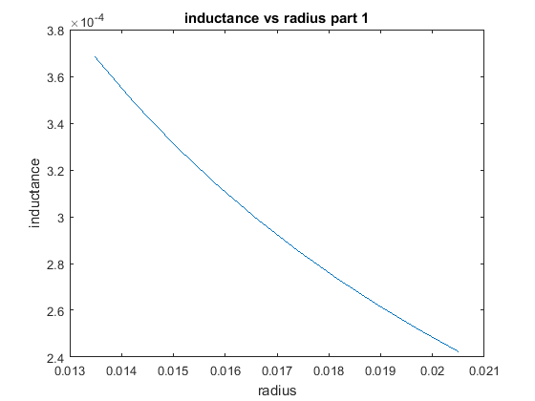
Figure 1
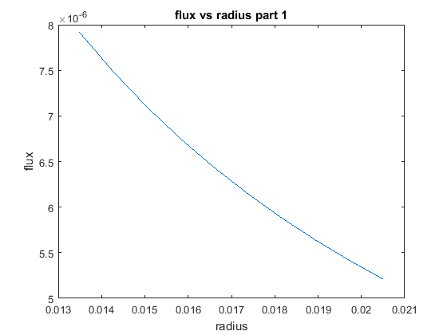
Figure 2

Part A.3
% In this part magnetic flux density is saturated so that increasing
% current cause to decrease permeability so that inductance of the inductor
% decrease also, same as part 3 magnetic flux and flux density higher
% at the smaller radius of the core because of smaller effective distance
% and reluctance.
% NI = B*A*R
core_u_part3 = 0;
I_part3 =0;
core_ur_part3 = 0;
I_part3 = I*1.5;
core_B_sat = 0.53;
core_u_part3 = (core_B_sat * core_le) /(N*I_part3);
core_ur_part3 = core_u_part3 /(4*pi*10e-7)
core_R_part3 = core_le/(core_ur_part3*u0*core_Ae); %reluctance
core_L_part3 = N^2/core_R_part3 %H
core_flux_part3 = N*I_part3/core_R_part3
% part 3 division
core_R_div_effective_part3 = zeros(10,0);
core_L_div_part3 = zeros(10,0);
core_flux_div_part3 =zeros(10,0);
total_inductance_div_part3 = 0;
total_flux_div_part3 = 0;
for i = 1:10
core_R_div_effective_part3(i) = core_le_div_effective(i)/(core_ur_part3*u0*core_Ae/10);
core_L_div_part3(i) = N^2 / core_R_div_effective_part3(i);
core_flux_div_part3(i) = N*I_part3/core_R_div_effective_part3(i);
total_inductance_div_part3 = total_inductance_div_part3 + core_L_div_part3(i);
total_flux_div_part3 = total_flux_div_part3 + core_flux_div_part3(i);
end
plot(core_r_div_effective,core_L_div_part3);
title('inductance vs radius part 3');
xlabel('radius');
ylabel('inductance');
figure;
plot(core_r_div_effective,core_flux_div_part3);
title('flux vs radius part 3');
xlabel('radius');
ylabel('flux');
figure;
total_flux_div_part3
total_inductance_div_part3
core_ur_part3 =
336.7546
core_L_part3 =
2.2679e-04
core_flux_part3 =
7.3140e-06
total_flux_div_part3 =
7.1792e-06
total_inductance_div_part3 =
2.2261e-04
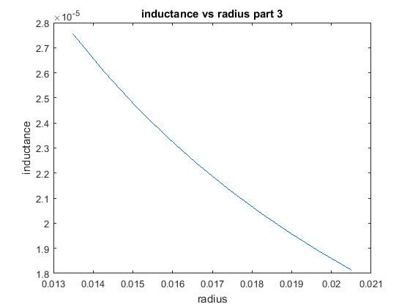
Figure 3
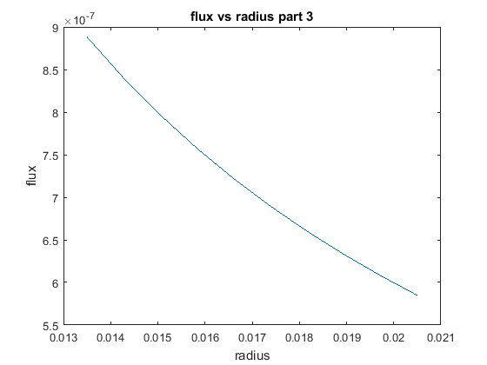
Figure 4

Part A.4
% By adding gap to core increase the reluctance so decrease the inductance and
% core flux. Fringing flux is neglected.
d_gap = 2e-3;
core_le_part4 = core_le - 2e-3;
gap_R = d_gap/(core_Ae*u0);
core_R_part4 = core_le_part4/(core_ur*u0*core_Ae); %reluctance
core_L_part4 = N^2/(core_R_part4+gap_R) %H
core_L_part4 =
3.4298e-05

Part A.5
% In this part, in order to model fringing flux I increase the air gap a
% little, in order to decide this distance I found required reluctance to model
% fringing distance. Also, ı have used this reluctance to calculate
% inductance
%
% Formula of fringing flux is 1+(d_gap/sqrt(Acore))*ln(2*window_area/d_gap)
%
area_window= 2*pi*core_inner_r;
fringing_flux = 1+(d_gap/sqrt(core_Ae))* log(2*area_window/d_gap);
d_fringing = N*I*core_Ae*u0/fringing_flux
fringing_R = d_fringing/(core_Ae*u0);
core_L_part5 = N^2/(core_R_part4+gap_R+fringing_R) %H
% By using this formula, d_fringing is came so small, so that effect of fringing
% could not seen obviously
d_fringing =
8.5178e-10
core_L_part5 =
3.4298e-05

Part B

Part B.1

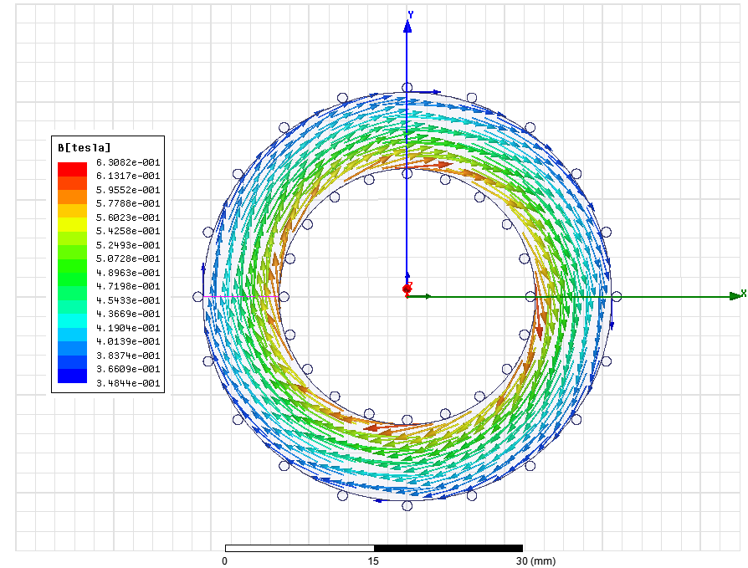
Figure 5
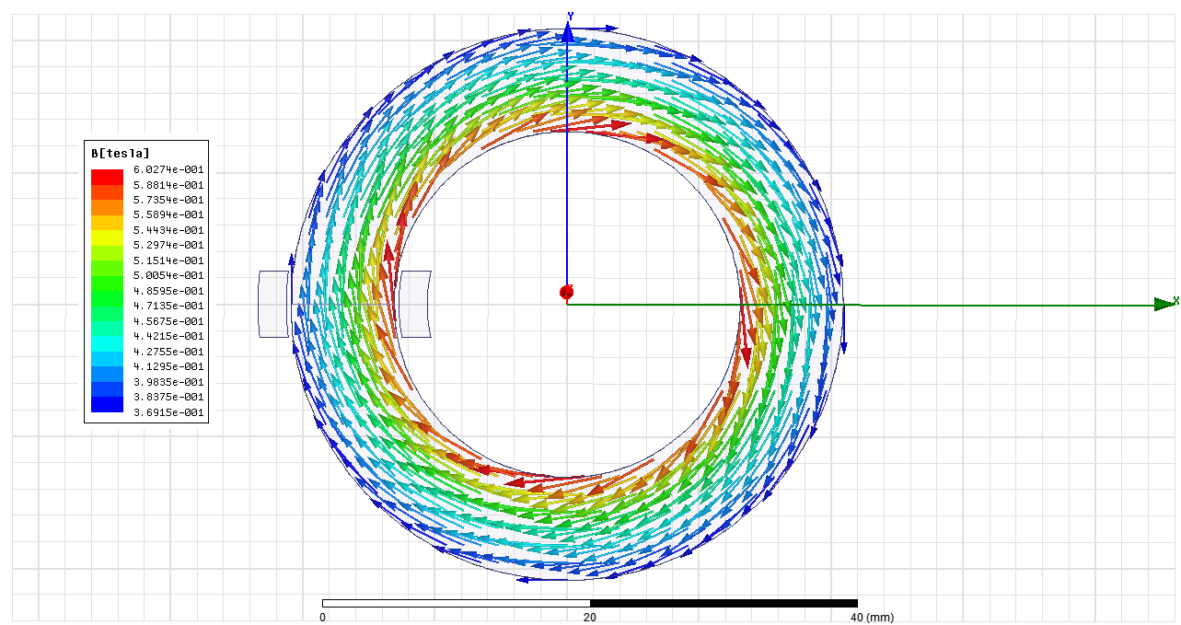
Figure 6

Part B.2
Stored energy of the core is calculated from magnetic flux passing on L1 and leakages are modeled with L2 and L3 line fluxes.
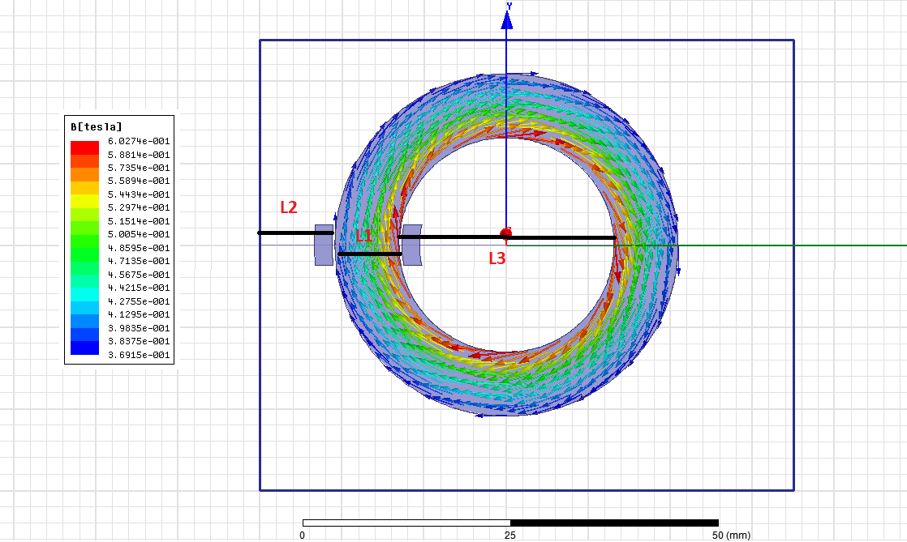
Figure 7

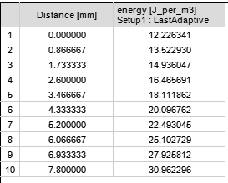
Figure 8: Calculated magnetic energy from flux on L1 for 1m depth
Avarege energy is calculated 20.18 J per m^3 but chosen core depth is 18mm, so that avarege energy for this core is 0.363J

Question 2
There is a lot of trade offs when designing transformer so that optimization of design really important. All important parameters are explained bottom.
Power, Vin,Vo, Freq, temp, Iin, Iout | These parameters depend on customer needs, main purpose is designer obtaining these needs with maximum efficiency with minimum cost
Temperature | It effects B-H curve directly, so it is important for calculation
Type (square, E, C core) | Calculation of magnetic circuit depends on shape
Lamination type | According to frequency and material, eddy current and core loss decrease with lamination
B,H | Main operating flux density is decided according to material B-H curve
Cable resistivity, radius etc | According to current of transformer, cable is chosen then these parameters obtained
Core cross section | Cross section area effects reluctance, flux, inductance of the transformer, these parameters are so critically for magnetic circuits and also size and core loss of the transformer, it should be optimized
N1, N2 | These parameters also effects flux, inductance etc. Choosing this value high leads to high copper loss, choosing low leads to low flux and high core size
Window size | This value is decided according to fill factor, winding height and also cable quantity of the winding cable
Power factor | It is needed for efficiency calculation

Reference
%http://www.encyclopedia-magnetica.com/doku.php/flux_fringing

