

**MIDDLE EAST TECHNICAL UNIVERSITY**

**ELECTRICAL AND ELECTRONICS ENGINEERING**

**EE564**

**DESIGN OF ELECTRICAL MACHINES**

**-PROJECT 2-**

***Name:* İBRAHİM GÜNGEN**

***No:* 1936939**

***Instructor:* Asst. Prof. OZAN KEYSAN**

# Winding Design and Motor Parameter Estimation

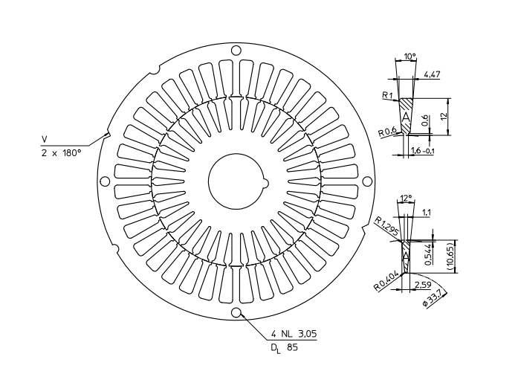

Figure 1. Chosen Lamination to Design Induction Motor

Chosen lamination has 90 mm outer diameter so that this type of lamination is available for high speed low torque and low power application, therefore I aimed that 1kW output power and 4 poles for this design. Then, synchronous speed becomes 1500 rpm.

Also, in order to eliminate 3rd harmonics on the MMF, I have chosen 220Vrms WYE connected input voltage which is equal to the 380Vrms per motor input phase. Moreover, with single layer stator winding; 5th, 7th and others except 3rd harmonics are effected so that in order to reduce 5th harmonic, I have designed double layer winding with 7/9*180 = 140 integral pitch factor.

|  |  |  |  |  |  |  |  |  |  |  |  |  |  |  |  |  |  |
| --- | --- | --- | --- | --- | --- | --- | --- | --- | --- | --- | --- | --- | --- | --- | --- | --- | --- |
| **1** | **2** | **3** | **4** | **5** | **6** | **7** | **8** | **9** | **10** | **11** | **12** | **13** | **14** | **15** | **16** | **17** | **18** |
| A1 | A2 | A3 | -C1 | -C2 | -C3 | B1 | B2 | B3 | -A4 | -A5 | -A6 | C4 | C5 | C6 | -B4 | -B5 | -B6 |
| A12 | -C10 | -C11 | -C12 | B10 | B11 | B12 | -A1 | -A2 | -A3 | C1 | C2 | C3 | -B1 | -B2 | -B3 | A4 | A5 |

|  |  |  |  |  |  |  |  |  |  |  |  |  |  |  |  |  |  |
| --- | --- | --- | --- | --- | --- | --- | --- | --- | --- | --- | --- | --- | --- | --- | --- | --- | --- |
| **19** | **20** | **21** | **22** | **23** | **24** | **25** | **26** | **27** | **28** | **29** | **30** | **31** | **32** | **33** | **34** | **35** | **36** |
| A7 | A8 | A9 | -C7 | -C8 | -C9 | B7 | B8 | B9 | -A10 | -A11 | -A12 | C10 | C11 | C12 | -B10 | -B11 | -B12 |
| A6 | -C4 | -C5 | -C6 | B4 | B5 | B6 | -A7 | -A8 | -A9 | C7 | C8 | C9 | -B7 | -B8 | -B9 | A10 | A11 |

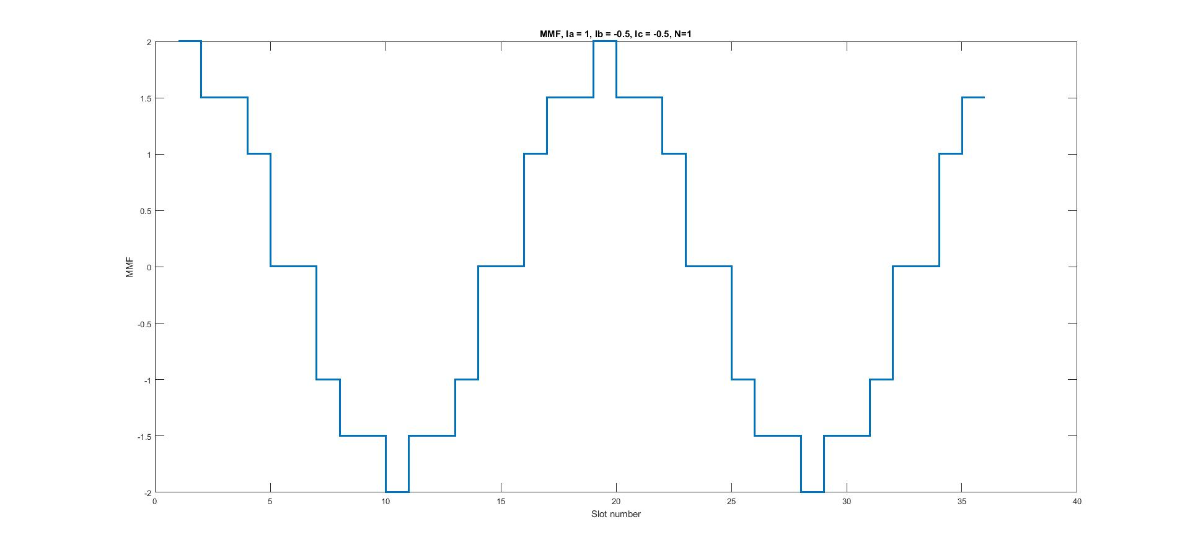

Figure 2.

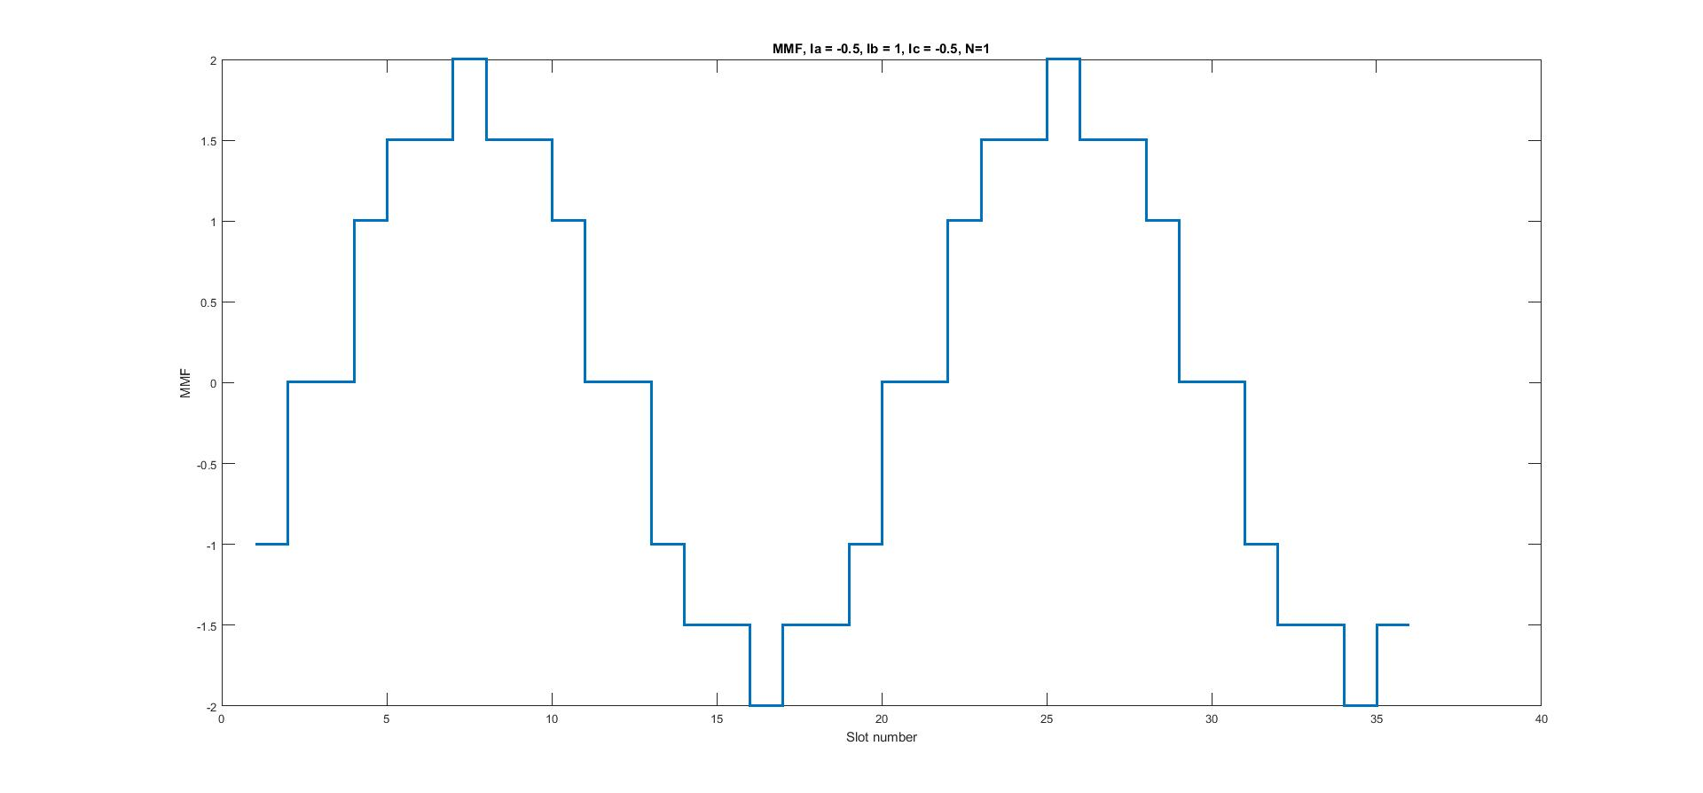

Figure 3.

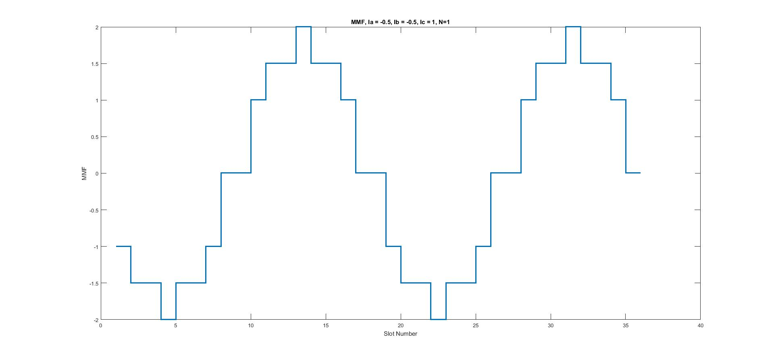

Figure 4.

Winding factors of fundamental and other harmonics are at below. Coil angle is 180/9 = 2 degree. Coil pitch degree is 7*20 = 140 degree. q is slot per pole per phase (q=36/4/3 = 3).

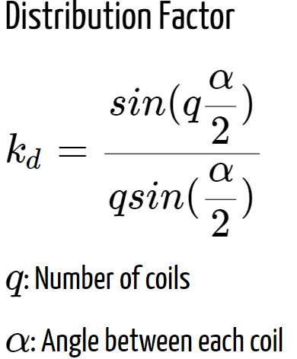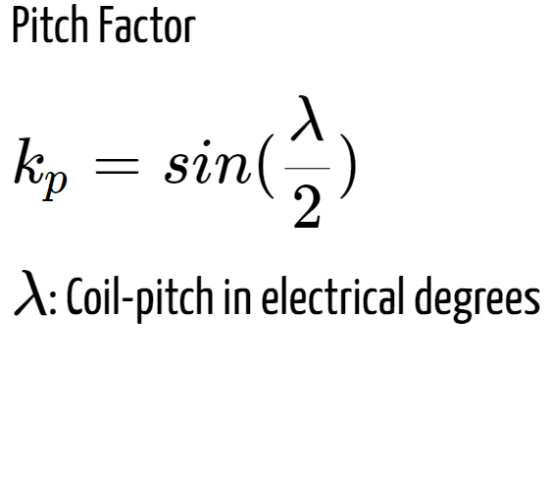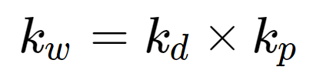

Figure 5.

By using formulas at figure 5, following winding factors are calculated.

Kw1= [sin(30) / (3*sin(10)) ]*sin(70) = 0.9

Kw3 = [sin(3*30) / (3*sin(3*10)) ]*sin(3*70) = -0.33

Kw5 = [sin(5*30) / (3*sin(5*10)) ]*sin(5*70) = -0.037

Kw7 = [sin(7*30) / (3*sin(7*10)) ]*sin(7*70) = -0.135

Kw9= [sin(9*30) / (3*sin(9*10)) ]*sin(9*70) = 0.33

Kw11= [sin(11*30) / (3*sin(11*10)) ]*sin(11*70) = -0.135

Kw13= [sin(13*30) / (3*sin(13*10)) ]*sin(13*70) = -0.037

In order to start decide specification of 3 phase induction motor, first of all, magnetic loading should be specified according to stator slot teeth magnetic saturation. In generally, at 50 Hz machine Bav can be selected between 0.35T and 0.6T. Stator is made from stainless steel in generally then, saturation point approximately 1.4T. Maximum stator slot teeth section and total slot section (with gap) is approximately 2. Instantaneous magnetic flux of teeth should be calculated to prevent saturation. Sinusoidal wave at figure 6 is represent air gap magnetic flux density then, maximum magnetic flux density can be take 0.9*pi/2*Bav. Which is equal to 1.4T/2 = 0.7 so Bav = 0.495.Becaıse of this result, I have taken magnetic loading 0.5T.

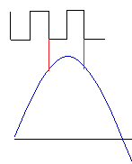

Figure 6. Illustration of air gap magnetic flux density on stator slot

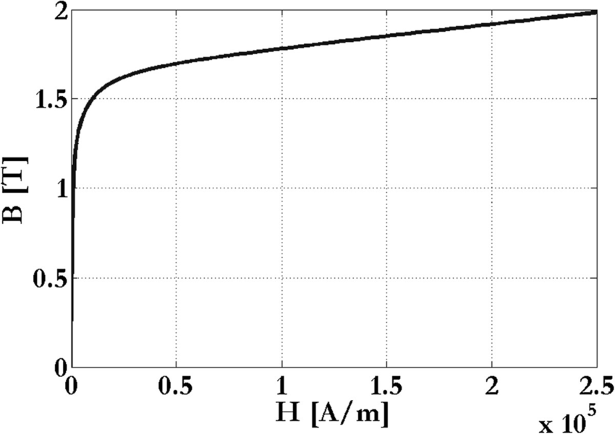

Figure 7

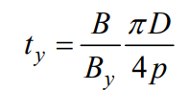

Figure 8.

Moreover Byoke depends on yoke thickness with formula at figure 8. With this formula Byoke is calculated. D = 55m, p is pole pair which is equal to the 2 then ty is yoke thickness which is equal to (90-55)/2-12 = 5.5mm.

Bav = 0.5T

Bteeth=1.41T

Byoke = 0.4T

By using typical aspect ratio axial length of motor can be calculated but designed motor is small and high speed so aspect ratio can be between 0.4<x<2. So I take L = 110mm before.

Therefore, for my design when I increase length, efficiency increases because of increasing torque.

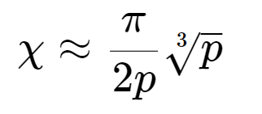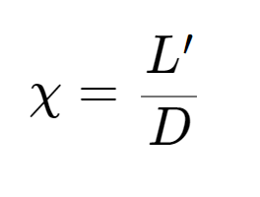

Figure 9.

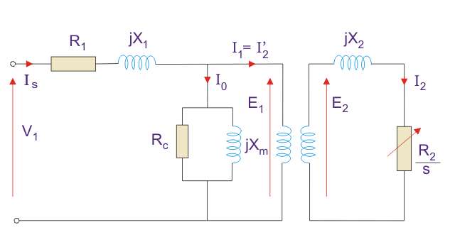

Figure 10.

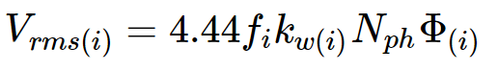

Figure

By using induced EMF formula as figure 11, we can calculate Nphase then we can specify slot current.

In order to specify number of turns and slot currents, induced emf(E1 on figure 10 ) formula can be used.

Assume E1 = V1 = 380, Flux = Bav*PoleArea, Pole area = Di*pi*L/4 = 4.7e-3 m2

L =110mm, Nph = 809, N = 67

L =250mm, Nph = 353, N = 29.

$$N*Ipeak=Bpeak*A*R=Bpeak*A*\frac{lgap}{A*u0}$$

Also, air gap is calculated 0.27mm with following criterias.

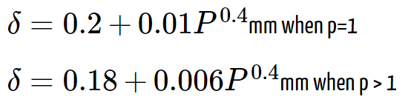

Figure

Then, Is = Ipeak/sqrt(2) = 1.13 Arms for L=110

Electrical loading A = N*Is*Q/pi/Di = 15822 for L=110

Is = 2.7 Arms for L = 250mm

Electrical loading A = N*Is*Q/pi/Di = 15822 for L=250

Minimum diameter of wire for Is = 2.7Arms is 0.45mm, AWG25 wire. Slot are is 41mm^2, with %80 fill factor, each slot has 60 turns wire area should be smaller than 0.565mm^2, so that I have chosen AWG19, Dwire = 0.81mm, Awire = 0.515mm^2, r = 26.40728 ohm/km

Fill factor is %72.

Minimum diameter of wire for Is = 1.13Arms is 0.287mm, AWG25 wire. Slot are is 41mm^2, with %80 fill factor, each slot has 134 turns wire area should be smaller than 0.244mm^2, so that I have chosen AWG24, Dwire = 0.51mm, Awire = 0.2mm^2, r = 84.1976 ohm/km

Fill factor is %66.

Then, I will make calculations only L = 110mm case.

Torque = shear stress*Vr = A*Bav*2*pi*rr2*L = 16,5 Nm

Aprx. speed = 1100/16.5 = 66.66 => 1282 rpm

Equavalent ciecuit parameter could be calculated with