

**MIDDLE EAST TECHNICAL UNIVERSITY**

**ELECTRICAL AND ELECTRONICS ENGINEERING**

**EE564**

**DESIGN OF ELECTRICAL MACHINES**

**-PROJECT 3-**

***Name:* İBRAHİM GÜNGEN**

***No:* 1936939**

***Instructor:* Asst. Prof. OZAN KEYSAN**

Index

EE564 DESIGN OF ELECTRICAL MACHINES 3

1. Introduction 3

2. Starting Values 4

3. Main Dimensions 5

4. Air gap 8

5. Magnetic Parameters 9

6. Electrical Parameters and Winding Selection 10

7. Stator Slot Dimensions 14

8. Rotor Bar Dimensions 16

9. Effective Air gap 19

10. Thermal Calculations 20

11. Inductances 20

12. Resistances 21

13. Mass Calculation 22

14. Efficiency 22

15. Characteristics 23

16. Finite Element Analysis 26

17. Conclusion 33

# 

# EE564 DESIGN OF ELECTRICAL MACHINES

PROJECT 3

## Introduction

In this project, squirrel cage induction generator will be designed for the Northel Energy's VIRA-250 wind turbine. Then, designed motor will be analyzed with FEM program. Specifications of the generator as follows,

* Rated Power: 250 kW
* Rated Wind Speed: 14 m/s
* Rated Turbine Speed: 24.3 rpm
* Gear Ratio: 31.2
* Number of Poles: 8
* Line to line voltage: 400 V
* Frequency: 50 Hz
* Rated Speed: 758 rpm
* Gearbox: (Coupled from wind turbine blade)
* Intended duty cycle :S1, direct on-line drive
* 3 phase

Design steps at below will be followed at this design.

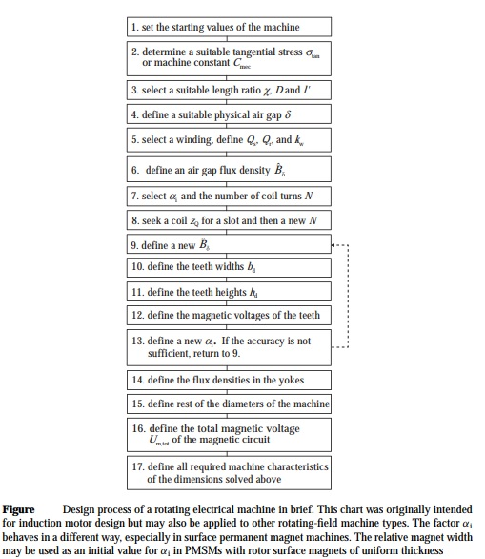

Figure 1. Design procedure of machine

## Starting Values

For this design, I aimed premium efficiency class because motor consumes high energy. It saturates %95,8 efficiency for high energy motors. Then, target efficiency is chosen %96.

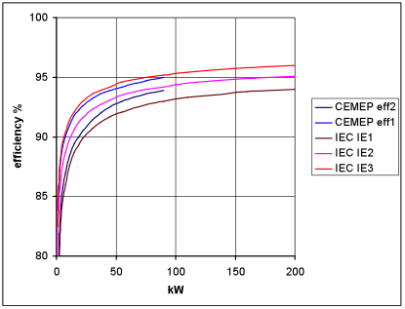

Figure 2. Efficiency class of machine

P_rated = 250000; %W  
Vline = 400; %V  
Npole = 8;  
n_rated = 758; %rpm  
w_rated = n_rated/60*2*pi;  
T_rated = P_rated/w_rated; %Nm  
f_rated = 50; %Hz  
target_eff = 0.96; % %  
target_pf = 0.87;  
Vph = Vline/sqrt(3);  
Pph = P_rated/3;  
  
Npole_pair = Npole/2;  
  
Iph = Pph/(Vph*target_eff*target_pf);% A  
  
f_syn = f_rated/Npole_pair; %hz  
n_syn = f_syn *60; %rpm  
w_syn = n_syn*2*pi/60; % rad/sec  
  
Number_of_ph = 3;  
  
u0 = 4*pi*10e-7;

## Main Dimensions

In this part, inner diameter and length of the machine will calculate. In order to achieve this Cmech(machine constant) should be detected according to calculated power per pole.

P_per_pole = P_rated/Npole;  
  
fprintf('Power per pole is %g W.\n',P_per_pole);

Power per pole is 31250 W.

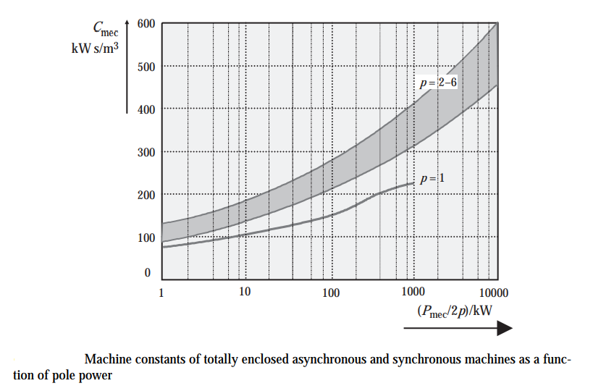

Figure 3. Cmech according to power

Cmech = 200000;

Product of inner_diameter^2 and length of the motor can be calculated from power and machine constant Cmech.

Pmech = Cmech*D^2*l'*fsync.

Also, aspect ratio should be calculated for decide dimensions. Aspect ratio can be calculated with following formula for asynchronous machines.

x = pi*(pole_pair^(1/3))/(2*pole_pair), x = L/D

D2L = P_rated/(Cmech* f_syn);  
  
Aspect_Ratio= pi*(Npole_pair^(1/3))/(2*Npole_pair);  
  
fprintf('di^2*L is %g\n',D2L);  
fprintf('Aspect ratio is %g\n', Aspect_Ratio);

di^2*L is 0.1  
Aspect ratio is 0.623371

L_machine = Aspect_Ratio * D_machine

Di^2*L is equal to the 1.66 . Also aspect ratio is equal to the 0.62. From previous parameters (D2L and aspect ratio), inner diameter and length of machine can be calculated. Moreover, outer diameter is calculated according to following table, which is generalized the outer diameter towards to the number of pole. Outer diameter coefficient is decreasing when number of pole increase because magnetic flux density at the yoke decreases proportionally.

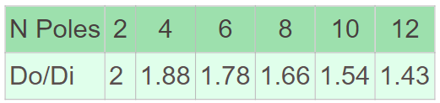

Figure 4. General Do/Di value

M_inner_diameter = (D2L/Aspect_Ratio)^(1/3);  
M_length = M_inner_diameter*Aspect_Ratio;  
M_outer_diameter = 1.66*M_inner_diameter;  
  
fprintf('Inner diameter is %g m\n',M_inner_diameter);  
fprintf('Outer diameter is %g m\n',M_outer_diameter);  
  
  
fprintf('Machine length is %g m\n',M_length);

Inner diameter is 0.543356 m  
Outer diameter is 0.901971 m  
Machine length is 0.338712 m

After decide the main dimensions, we should check it with tangential (shear) stress. It should be in interval which is specified following table.

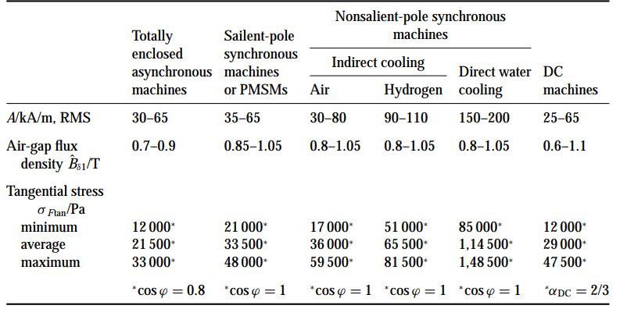

Figure 5. Table of the electrical loading and tangential stress

M_inner_radius = M_inner_diameter/2;  
F_tan = T_rated/M_inner_radius;  
M_surface_area = M_inner_diameter*pi*M_length;  
  
Shear_stress = F_tan/M_surface_area/1000; %Kpa  
  
fprintf('Shear stress is %g\n',Shear_stress);

Shear stress is 20.0504

Shear stress value is appropriate. So, dimensions are checked.

## Air gap

After deciding main dimensions of the motor, air gap should be decided according to magnetic, electrical and mechanical properties. There is a trade-off between them. According to mechanical properties air gap should be maximize to rotate the machine smoothly. Therefore, according to electromagnetic properties, it should be minimize to make power transfer more.

Following figure shows that general air gap equations of asynchronous machines

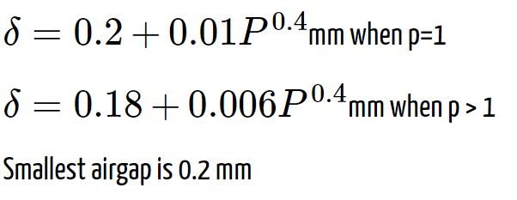

Figure 6. Air gap formula

airgap = (0.18 + 0.006*P_rated^0.4);  
  
fprintf('Airgap is %g mm\n',airgap);

Airgap is 1.04562 mm

## Magnetic Parameters

Magnetic loading is specified previous part, which is equal to the 0.51T specified at below. Calculation details are made at the Project-2. Therefore, for this design, we do not know teeth dimensions yet, so that we have to decide either magnetic parameters or teeth dimensions, then calculate other one. At previous project, we selected lamination first, and then made a design. But, at this project, I would like to experience other way so that; I will specify magnetic parameters at desired intervals which are shown at following figure from textbook.

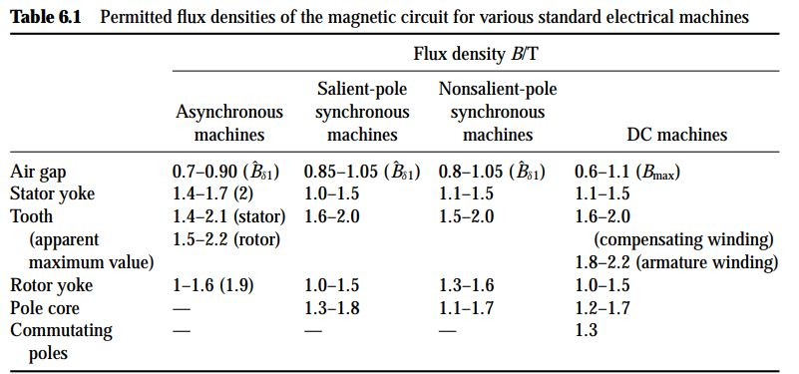

Figure 7. Magnetic loading formula

Bg_av = 0.51; %T  
Bg = 0.8; %T  
Bs_yoke = 1.6; %T  
Bs_tooth = 1.9; %T  
Br_yoke = 1.5; %T  
Br_tooth = 2.0; %T  
  
fprintf('Magnetic Loading is %g T\n',Bg_av);  
fprintf('Selected air gap flux density is %g T\n',Bg);  
fprintf('Selected stator yoke flux density is %g T\n',Bs_yoke);  
fprintf('Selected stator teeth flux density is %g T\n',Bs_tooth);  
fprintf('Selected rotor yoke flux density is %g T\n',Br_yoke);  
fprintf('Selected rotor teeth flux density is %g T\n',Br_tooth);

Magnetic Loading is 0.51 T  
Selected air gap flux density is 0.8 T  
Selected stator yoke flux density is 1.6 T  
Selected stator teeth flux density is 1.9 T  
Selected rotor yoke flux density is 1.5 T  
Selected rotor teeth flux density is 2 T

## Electrical Parameters and Winding Selection

In this part of the project, number of slots of rotor and stator and winding factors of higher harmonics are calculated. For high pole machine, it is preferred to have Qr = Qs*1.2. In order to prevent cogging problem number of rotor and stator should be different and some combinations of these should be avoided as Qs = 2Qr, Qr = Qs +-2p, etc. Moreover, if Qr = 6pg +-2p+-1, g is an integer, mechanical noise and vibrations could be observed. Number of slots per pole per phase is decided 3.

qs = 3;  
Qs = qs*Number_of_ph*Npole;

Qr = 1.2*Qs is nearly 86 and in general design, Qs/Qr = 72/88 is used.

Qr = 88;  
  
fprintf('Number of stator slots are %g\n',Qs);  
fprintf('Number of rotor slots are %g\n',Qr);

Number of stator slots are 72  
Number of rotor slots are 88

In order to eliminate 5th harmonics of the machine, it is preferred to design double layer winding with 7/9 pitch factor. 3rd harmonics are eliminated because of line to line connection of phases.

pitch_factor = 7/9;  
slot_angle = pi*Npole/Qs;  
pitch_angle = pitch_factor*pi;  
pole_pitch = pi*M_inner_diameter/Npole;  
  
Kd_1 = sin(qs*slot_angle/2)/(qs*sin(slot_angle/2));  
Kp_1 = sin(pitch_angle/2);  
Kw_1 = Kd_1*Kp_1;  
  
Kd_5 = sin(5*qs*slot_angle/2)/(qs*sin(5*slot_angle/2));  
Kp_5 = sin(5*pitch_angle/2);  
Kw_5 = Kd_5*Kp_5;  
  
Kd_7 = sin(7*qs*slot_angle/2)/(qs*sin(7*slot_angle/2));  
Kp_7 = sin(7*pitch_angle/2);  
Kw_7 = Kd_7*Kp_7;  
  
Kd_11 = sin(11*qs*slot_angle/2)/(qs*sin(11*slot_angle/2));  
Kp_11 = sin(11*pitch_angle/2);  
Kw_11 = Kd_11*Kp_11;  
  
  
fprintf('Pitch factor is %g\n',pitch_factor);  
fprintf('Slot angle is %g\n rad',slot_angle);  
fprintf('Pitch angle is %g\n rad',pitch_angle);  
  
  
  
fprintf('Winding factor of fundemental harmonic is %g\n',Kw_1);  
fprintf('Winding factor of 5th harmonic is %g\n',Kw_5);  
fprintf('Winding factor of 7th harmonic is %g\n',Kw_7);  
fprintf('Winding factor of 11th harmonic is %g\n',Kw_11);

Pitch factor is 0.777778  
Slot angle is 0.349066 rad  
Pitch angle is 2.44346 rad  
Winding factor of fundemental harmonic is 0.901912  
Winding factor of 5th harmonic is -0.0377803  
Winding factor of 7th harmonic is -0.135868  
Winding factor of 11th harmonic is -0.135868

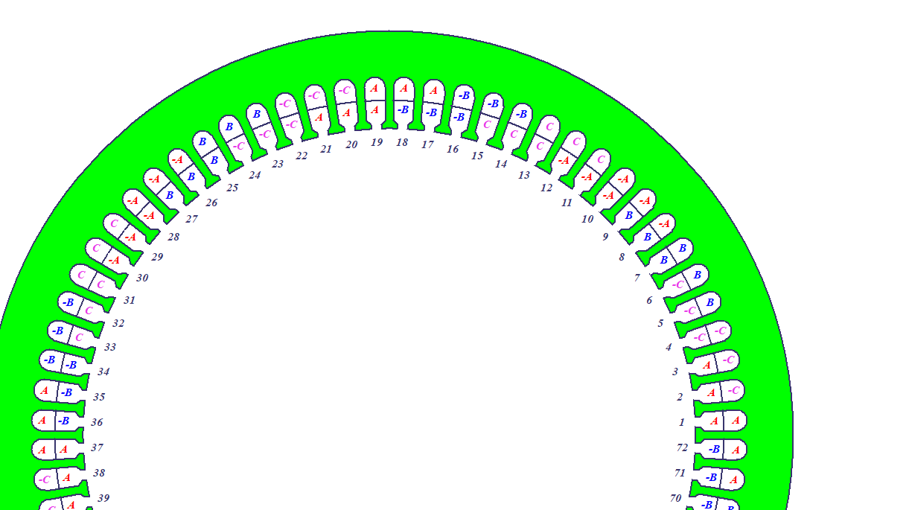

Figure 8. Winding diagram of the machine

Number of turns can be calculated induced EMF formula. Induced EMF is near to the phase voltage.

At the project-2, how I decide air gap average flux density is explained so that I have chosen peak of air gap magnetic flux density 0.8T, magnetic loading is nearly 0.51T.

Bg_av = 0.51;  
magnetic_loading = 0.51;  
  
Ind_emf = Vph;  
  
flux_per_pole = Bg_av*pole_pitch*M_length;  
Nph = Ind_emf/(4.44*f_rated*flux_per_pole*Kw_1);  
  
Ns = Nph/(Npole_pair*qs);  
  
fprintf('Calculated number of turns per phase is %g\n',Nph);  
fprintf('Calculated number of turns per slot is %g\n',Ns);

Calculated number of turns per phase is 31.2922  
Calculated number of turns per slot is 2.60769

To make number of turns integer Ns is taken 3.

Ns = 3;  
Nph = Ns*(Npole_pair*qs);  
fprintf('Number of turns per phase is %g\n',Nph);  
fprintf('Number of turns per slot is %g\n',Ns);

Number of turns per phase is 36  
Number of turns per slot is 3

Electrical loading is calculated as A = Ns*I*Qs/(pi*Di)

A = Shear_stress/magnetic_loading; %kA/m  
  
fprintf('Magnetic loading is %g T\n',magnetic_loading);  
fprintf('Electrical loading is %g kA/m\n',A);

Magnetic loading is 0.51 T  
Electrical loading is 39.3144 kA/m

Electrical loading value is appropriate according to following figure from textbook.

In general, 7A/mm2 current density is used for 8 pole air cooling machines. Also skin depth should be considered at maximum frequency.

cu_resistivity = 1.7e-8; % Ohm*m  
cu_permeability = 1.26e-6; % H/m  
f_max = f_rated;  
angular_frequency = 2*pi*f_max; % rad/sec  
skin_depth = sqrt(cu_resistivity*2/(angular_frequency*cu_permeability));  
copper_area = Iph/7;  
  
fprintf('Phase current is %g kA\n',Iph);  
fprintf('skin depth is %g mm\n',skin_depth*1000);  
fprintf('Needed copper area is %g mm2\n',copper_area);

Phase current is 432.045 kA  
skin depth is 9.26786 mm  
Needed copper area is 61.7207 mm2

According to the skin depth value cable can have maximum 20mm diameter. Phase current is calculated as 432Arms so that 5 parallel AWG4 cable can be used. Because desired current density of AWG4 is about 6A/mm2.

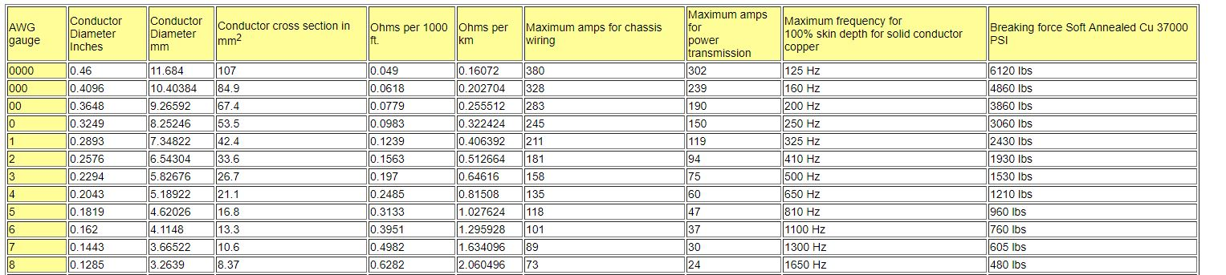

Figure 9. Cable size table

awg4_cross_area = 21.1; %mm2  
awg4_R_per_km = 0.081508; %ohm  
cable_cross_area = 5*awg4_cross_area; %mm2  
cable_R_per_km = awg4_R_per_km/5; %@25 degree

I will make an approximation about copper length with following calculation.

one_turn_length = 2*M_length+2*M_inner_diameter;  
total_copper_length = one_turn_length*Qs*Ns; %m  
ph_stator_copper_resistance = cable_R_per_km*total_copper_length/3/1000;  
  
fprintf('Total copper length is %g km\n',total_copper_length);  
fprintf('Phase copper resistance is %g ohm\n',ph_stator_copper_resistance);

Total copper length is 381.054 km  
Phase copper resistance is 0.00207059 ohm

At high power motors, fill factor is important because heating and insulation are affected to it. In general, this kind of application %50 fill factor is applicable.

fill_factor = 0.5;  
total_slot_area = 6*cable_cross_area/fill_factor; %mm^2

## Stator Slot Dimensions

Teeth dimension will be calculated according to magnnetic flux densities. Moreover, slots will be design tapered type slots because I would like to make tooth width constant.

slot_pitch = pole_pitch/9;  
  
fprintf('Pole pitch is %g mm\n', pole_pitch*1000);  
fprintf('Slot pitch is %g mm\n', slot_pitch*1000);  
fprintf('Needed slot area is %g mm2\n', total_slot_area);

Pole pitch is 213.375 mm  
Slot pitch is 23.7084 mm  
Needed slot area is 1266 mm2

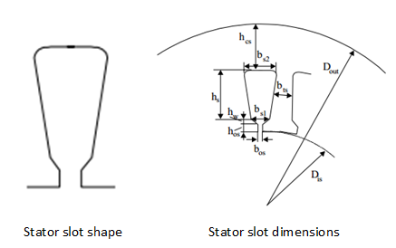

Figure 10. Stator slot illustration

All flux of air gap could not flux through to teeth because there is a leakage and fringing fluxes. So that, when I calculate teeth width, ı will take %95 of flux passes.

Kfe = 0.95;  
  
b_ts= Bg_av*slot_pitch/(Kfe*Bs_tooth)*1000; %mm  
  
fprintf('Stator slot tooth width (b_ts) is %g mm\n',b_ts);

Stator slot tooth width (b_ts) is 6.69877 mm

I will select slot opening according to the cable diameter to make producing easier.

b_os = 6; %mm  
h_os = 2;  
h_w = 2;  
  
  
b_s1 = pi*(M_inner_diameter*1e3+2*h_os+2*h_w)/Qs-b_ts; % mm  
  
fprintf('Stator slot opening width (b_os) is %g mm\n',b_os);  
fprintf('Stator slot opening height (h_os) is %g mm\n',h_os);  
fprintf('The bottom stator slot width (b_s1) is %g mm\n',b_s1);  
  
  
b_s2 = sqrt(4*total_slot_area*tan(pi/Qs)+b_s1^2);  
  
h_s = 2*total_slot_area/(b_s1+b_s2); % mm  
  
fprintf('The top stator slot width (b_s2) is %g mm\n',b_s2);  
fprintf('The useful stator slot height (hs) is %g mm\n',h_s);

Stator slot opening width (b_os) is 6 mm  
Stator slot opening height (h_os) is 2 mm  
The bottom stator slot width (b_s1) is 17.3587 mm  
The top stator slot width (b_s2) is 22.8566 mm  
The useful stator slot height (hs) is 62.9612 mm

Calculations are made by geometrical calculations.

h_cs = (1e3*M_outer_diameter-(1e3*M_inner_diameter+2*(h_os+h_w+h_s)))/2;  
  
fprintf('The thickness of stator back iron(yoke) is (h_cs) is %g mm\n',h_cs);

The thickness of stator back iron(yoke) is (h_cs) is 112.346 mm

Check the yoke magnetic flux density.

B_cs = flux_per_pole/(2*M_length*h_cs*1e-3);  
  
fprintf('Calculated Magnetic flux density at yoke is %g T\n',B_cs);  
fprintf('Aimed Magnetic flux density at yoke is %g T\n',Bs_yoke);

Calculated Magnetic flux density at yoke is 0.484313 T  
Aimed Magnetic flux density at yoke is 1.6 T

This value is smaller from saturation value of the iron so that, in order to decrease mass and cost of the motor outer diameter could decrease. I will increase B_cs value sligtly.

B_cs_aimed = 1.4; %T  
  
h_cs_new = flux_per_pole/(2*M_length*B_cs_aimed*1e-3); % mm  
  
M_outer_diameter_new = (2*h_cs_new+(1e3*M_inner_diameter+2*(h_os+h_w+h_s)))*1e-3; % m  
  
fprintf('The decreased thickness of stator back iron(yoke) is (h_cs) is %g mm\n',h_cs_new);  
fprintf('The decreased outer diameter is %g m\n',M_outer_diameter_new);

The decreased thickness of stator back iron(yoke) is (h_cs) is 38.8648 mm  
The decreased outer diameter is 0.755008 m

## Rotor Bar Dimensions

Rotor slots will fill aluminum so that fill factor is 1. Also, I will choose shape of the rotor teeth according to easy producing. Stacking factor is taken same as stator.

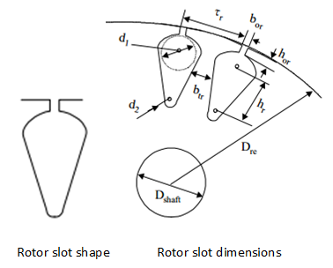

Figure 11. Rotor slot illustration

Equations are used in finding slot dimensions are given following table.

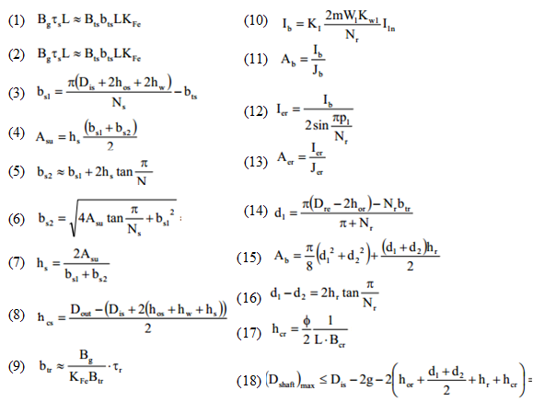

Figure 12. Equation table for rotor slot size

fprintf('Number of slot at the rotor is %g \n',Qr);  
Rotor_slot_pitch = pi*(1e3*M_inner_diameter-2*airgap)/Qr; % mm  
fprintf('Rotor slot pitch is %g mm\n',Rotor_slot_pitch);  
  
b_tr = (Bg_av*Rotor_slot_pitch)/(Br_tooth*Kfe); % mm  
  
h_or = 2; %mm  
b_or = 3; %mm

Number of slot at the rotor is 88   
Rotor slot pitch is 19.3231 mm

Rotor current should be calculated to calculate aluminum bar area. Chosen current density is decreased because of conductivity of the aluminum is smaller than copper.

J_rotor = 6; %A/mm2  
KI = 0.8*target_pf +0.2;  
I_rotor_bar = KI*2*Number_of_ph*Nph*Kw_1*Iph/Qr;  
Rotor_al_area = I_rotor_bar/J_rotor;  
I_rotor_ring = I_rotor_bar/(2*sin(2*pi/Qr)); % A  
J_ring = 0.78*J_rotor; % A/mm^2  
Rotor_ring_area = I_rotor_ring/J_ring; % mm^2  
  
fprintf('Rotor slot current density is %g A/mm2\n',J_rotor);  
fprintf('Rotor ring current density is %g A/mm2\n',J_ring);  
fprintf('Rotor bar current is %g A\n',I_rotor_bar);  
fprintf('Needed rotor aliminum area is %g mm2\n',Rotor_al_area);  
fprintf('Rotor ring current is %g A\n',I_rotor_ring);  
fprintf('Needen ring area is %g mm2\n',Rotor_ring_area);

Rotor slot current density is 6 A/mm2  
Rotor ring current density is 4.68 A/mm2  
Rotor bar current is 856.983 A  
Needed rotor aliminum area is 142.831 mm2  
Rotor ring current is 6006.4 A  
Needen ring area is 1283.42 mm2

Then, we need to calculate rotor other rotor dimensions by using given equation 14,15,16,17 and 18 at previous equation table.

d_1 = (pi*(1e3*M_inner_diameter-2*airgap-2*h_or)-Qr*b_tr)/(pi+Qr); % mm  
  
d_2 = 3; % mm  
h_r = (d_1 - d_2)/(2*tan(pi/Qr)); % mm  
rotor_slot_area = (pi/8)*(d_1^2+d_2^2)+(d_1+d_2)*h_r/2; % mm^2  
  
h_cr = 1e3*flux_per_pole/(2*M_length*Br_yoke); % mm  
  
Dshaftmax = M_inner_diameter*1e3-2*airgap-2*(h_or+h_r+h_cr+(d_1+d_2)/2); % mm  
D_shaft = 100; % mm  
  
fprintf('Tooth width of rotor slot (btr) is %g mm\n',b_tr);  
fprintf('Opening width of rotor slot (bor) is %g mm\n',b_or);  
fprintf('Opening height of rotor slot (hor) is %g mm\n',h_or);  
  
fprintf('The top diameter of rotor bar (d1) is %g mm.\n',d_1);  
fprintf('The bottom diameter of rotor bar (d2) %g mm.\n',d_2);  
fprintf('The height of rotor bar (hr) %g mm.\n',h_r);  
fprintf('Rotor slot area is %g mm^2.\n',rotor_slot_area);  
fprintf('The height of the rotor back iron (hcr) is %g mm.\n',h_cr);  
fprintf('Calculated maximum shaft diameter is %g mm.\n',Dshaftmax);  
fprintf('Selected shaft diameter of rotor is %g mm.\n',D_shaft);

Tooth width of rotor slot (btr) is 5.18673 mm  
Opening width of rotor slot (bor) is 3 mm  
Opening height of rotor slot (hor) is 2 mm  
The top diameter of rotor bar (d1) is 13.5112 mm.  
The bottom diameter of rotor bar (d2) 3 mm.  
The height of rotor bar (hr) 147.154 mm.  
Rotor slot area is 1290.07 mm^2.  
The height of the rotor back iron (hcr) is 36.2738 mm.  
Calculated maximum shaft diameter is 153.898 mm.  
Selected shaft diameter of rotor is 100 mm.

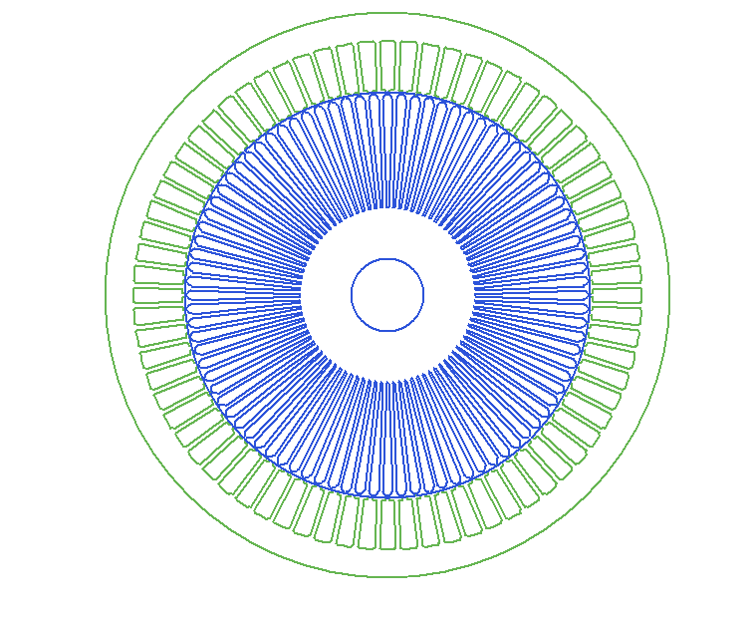

Figure 13. Machine stator and rotor

## Effective Air gap

Flux density always decreases at the slot opening so that carter coefficient should be calculated and effective air gap distance estimate to calculate MMF and other dependent parameters. It will calculate after dimensions are decided.

K_s = (b_os/(airgap))/(5+(b_os/airgap));  
k_cs = slot_pitch*1000/(slot_pitch*1000-K_s*b_os);  
  
K_r = (b_or/(airgap))/(5+(b_or/airgap));  
k_cr = Rotor_slot_pitch*1000/(Rotor_slot_pitch*1000-K_r*b_os);  
  
  
eff_airgap = k_cs*k_cr*airgap;  
fprintf('Carters coefficient of stator is %g.\n',k_cs);  
fprintf('Carters coefficient of rotor is %g.\n',k_cr);  
fprintf('Effective airgap is %g mm.\n',eff_airgap);

Carters coefficient of stator is 1.15639.  
Carters coefficient of rotor is 1.00011.  
Effective airgap is 1.20928 mm.

## Thermal Calculations

Cooling ducts is added to keep cool the rotor.

* I will add 15 cooling ducts
* Air-forced convection cooling method is using at this machine
* Fan cooled machine

According to researched wind turbine datasheet, wind turbine machines are operating temperature between -40 to 85 degree.

N_ducts = 15;  
L_ducts = 5; %mm  
  
k = (L_ducts/eff_airgap)/(5+L_ducts/eff_airgap);  
  
eff_L_ducts = k*L_ducts;  
  
eqv_M_length = M_length-1e-3*N_ducts*eff_L_ducts+1e-3*2*eff_airgap; % m  
  
fprintf('Number of cooling ducts is %g.\n',N_ducts);  
fprintf('Length of a cooling duct is %g mm.\n',L_ducts);  
fprintf('The equivalent core length with cooling ducts is %g m.\n',eqv_M_length);

Number of cooling ducts is 15.  
Length of a cooling duct is 5 mm.  
The equivalent core length with cooling ducts is 0.307183 m.

## Inductances

In this part, leakage and magnetization inductances will be calculated. Formulations are derived in class. I have used them.

Lm = (Number_of_ph/2)*M_inner_diameter*u0*eqv_M_length*(Kw_1*Nph)^2/(Npole_pair^2*eff_airgap*1e-3); % Henries  
Xm = 2*pi*f_rated*Lm; % Ohms  
  
P_stator = u0*eqv_M_length*((h_os/b_os)+(h_s/(3*b_s2))); % permeance  
Lph = P_stator*4*(Nph*Kw_1)^2*Number_of_ph/Qs; % Henries  
Xs_ph = 2*pi*f_rated*Lph; % ohms

In order to calculate rotor permeance, we have to calculate both bar and ring permeance.

P_r1 = 0.66 + 2*h_r/(3*(d_1+d_2)) + h_or/b_or; % permeance  
P_r2 = 0.9*Rotor_slot_pitch/(k_cs*eff_airgap)*1e-2; % permeance  
Kx = 1; % skin effect coefficient  
P_rotor = u0*eqv_M_length*(Kx*P_r1+P_r2); % permeance  
Lrp = P_rotor*4*(Nph*Kw_1)^2*Number_of_ph/Qr; % Henries  
Xrp = 2*pi*f_rated*Lrp; % ohms  
  
Xph = Xs_ph+Xrp;  
  
fprintf('The magnetizing inductance of the machine is %g mH.\n',Lm*1e3);  
fprintf('The magnetizing reactance at 50Hz is %g Ohms.\n',Xm);  
fprintf('leakage inductance of the stator is %g mH.\n',Lph*1e3);  
fprintf('Leakage reactance of the stator at 50Hz is %g Ohms.\n',Xs_ph);  
fprintf('Leakage inductance of the rotor referred to the stator side is %g mH.\n',Lrp*1e3);  
fprintf('Leakage reactance of the rotor referred to the stator side is %g Ohms.\n',Xrp);

The magnetizing inductance of the machine is 171.424 mH.  
The magnetizing reactance at 50Hz is 53.8544 Ohms.  
leakage inductance of the stator is 0.848857 mH.  
Leakage reactance of the stator at 50Hz is 0.266676 Ohms.  
Leakage inductance of the rotor referred to the stator side is 4.10239 mH.  
Leakage reactance of the rotor referred to the stator side is 1.2888 Ohms.

## Resistances

Stator phase copper resistance is calculated previous part also. Also rotor resistance is calculated with rotor aluminum dimensions.

resistivity_al = 3.1*1e-8; % ohm*m %25 degree  
Kr = 1.74;  
Dre = M_inner_radius-1e-3*eff_airgap; % m  
b = h_r+h_or+(d_1+d_2)/2; % mm  
ler = 1e-3*pi*(Dre+b)/Qr; % m  
Rbe = resistivity_al*((M_length*Kr/(rotor_slot_area*1e-6))+(ler/(2*Rotor_al_area*1e-6*(sin(3*pi/Qr))^2))); %ohms  
R2p = Rbe*4*Number_of_ph/Qr*(Nph*Kw_1)^2; % ohms  
  
R1p = ph_stator_copper_resistance;  
  
Rph = R1p+R2p;  
  
fprintf('Length of rotor ring is %g mm\n',ler*1000);  
  
fprintf('Stator phase copper resistance is %g ohm\n',R1p);  
fprintf('Rotor phase resistance referred to stator side is %g ohm\n',R2p);

Length of rotor ring is 5.62916 mm  
Stator phase copper resistance is 0.00207059 ohm  
Rotor phase resistance referred to stator side is 0.0097214 ohm

## Mass Calculation

cu_density = 8.96; % gr/cm^3  
al_density = 2.70; % gr/cm^3  
fe_density = 7800; % kg/m^3

Copper mass;

copper_volume = cable_cross_area/100*total_copper_length*100; %cm3  
copper_mass = copper_volume*cu_density/1000; %kg

Aluminum mass, bar and ring;

al_volume = Qr*(M_length*rotor_slot_area + ler* Rotor_al_area);%cm3  
al_mass = al_volume*al_density/1000; %kg

Iron mass;

Stator_teeth_mass = fe_density*Qs*b_ts*1e-3*(h_s+h_w+h_os)*1e-3*M_length*Kfe; % kg  
Stator_yoke_mass = fe_density*pi/4*(M_outer_diameter_new^2-(M_outer_diameter_new-2*h_cs*1e-3)^2)* M_length*Kfe; % kg  
  
Rotor_teeth_mass = fe_density*Qr*b_tr*1e-3*(h_r+(d_1+d_2)/2)*1e-3*M_length*Kfe; % kg  
  
iron_mass = Stator_teeth_mass+Stator_yoke_mass+Rotor_teeth_mass;

I increased the shaft length %20.

Shaft_mass = fe_density* pi/4*(D_shaft/1000)^2*M_length*1.2;  
  
  
Total_mass = copper_mass+al_mass+iron_mass+Shaft_mass;  
  
fprintf('Copper mass is %g kg\n',copper_mass);  
fprintf('Aliminum mass is %g kg\n',al_mass);  
fprintf('Iron mass is %g kg\n',iron_mass);  
fprintf('Shaft mass is %g kg\n',Shaft_mass);  
fprintf('Total mass is %g kg\n',Total_mass);

Copper mass is 360.202 kg  
Aliminum mass is 104.013 kg  
Iron mass is 828.392 kg  
Shaft mass is 24.8999 kg  
Total mass is 1317.51 kg

## Efficiency

In order to calculate efficiency, copper and core losses should be calculated.

Pcu_s = 3*Iph^2*(R1p);  
Pcu_r = 3*Iph^2*(R2p);  
Pcu = Pcu_s + Pcu_r;  
  
K_core = 3.3;  
Pcore = iron_mass*K_core;

Core loss resistance can be calculated for equivalent circuit.

Rc = Vph^2/(Pcore/3);  
fprintf('Core loss resistance(Rc) is %g ohm\n',Rc);  
  
Ploss = Pcore+Pcu;  
  
fprintf('Stator copper conduction loss is %g W\n',Pcu_s);  
fprintf('Rotor aliminum conduction loss is %g W\n',Pcu_r);  
fprintf('Total conduction loss is %g W\n',Pcu);  
fprintf('Total core loss is %g W\n',Pcore);  
fprintf('Total loss is %g W\n',Ploss);  
  
Efficiency = P_rated/(P_rated+Ploss);  
  
fprintf('Efficiency is %g percent\n',Efficiency*100);

Core loss resistance(Rc) is 58.5289 ohm  
Stator copper conduction loss is 1159.51 W  
Rotor aliminum conduction loss is 5443.87 W  
Total conduction loss is 6603.38 W  
Total core loss is 2733.69 W  
Total loss is 9337.07 W  
Efficiency is 96.3996 percent

## Characteristics

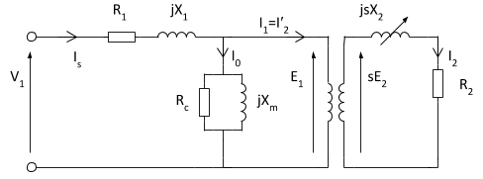

Figure 14. Equivalent circuit of machine

Thevenin variables and equivalent circuit parameters are calculated. Then using induction machine torque formula torque-speed characteristic is obtained.

Zm = (1j*Xm*Rc)/(1j*Xm+Rc); % ohms  
Z1 = Rph+1j*Xph; % ohms  
Vth = Vph*Zm/(Z1+Zm); % volts  
Zth = Z1*Zm/(Z1+Zm); % ohms  
Rth = real(Zth); % ohms  
Xth = imag(Zth); % ohms  
  
s = -1:0.001:2;  
s = fliplr(s);  
Nr = n_syn*(1-s); % rpm  
wr = Nr*2*pi/60; % rad/sec  
num = numel(s);  
Tm = (3*abs(Vth)^2/w_syn)*(1./ ( (Rth+R2p./s).^2 + (Xth+Xrp)^2 ) )...  
 .*(R2p./s); % Nm  
  
Tm((s==0)) = 0; % Nm  
figure;  
plot(Nr,Tm,'k-','LineWidth',2.0);  
xlabel('Rotor speed (rpm)','Fontweight','Bold');  
ylabel('Torque (Nm)','Fontweight','Bold');  
title ('Induction Generator Torque-Speed Characteristic','Fontweight','Bold');  
grid on;  
  
figure;  
plot(Nr,Tm,'k-','LineWidth',2.0);  
xlabel('Rotor speed (rpm)','Fontweight','Bold');  
ylabel('Torque (Nm)','Fontweight','Bold');  
title ('Induction Generator Torque-Speed Characteristic','Fontweight','Bold');  
grid on;  
xlim([650 850]);  
  
  
Rated_slip = (n_syn-n_rated)/n_syn;  
fprintf('The rated slip is %g.\n',Rated_slip);  
Starting_torque = Tm((s==1)); % Nm  
Max_torque = max(Tm); % Nm  
slip_max_torque = s((Tm==Max_torque));  
fprintf('The starting torque of this machine is %d Nm.\n', Starting_torque);  
fprintf('The maximum torque of this machine is %d Nm.\n', Max_torque);  
fprintf('The slip at maximum torque is %d.\n', slip_max_torque);

The rated slip is -0.0106667.  
The starting torque of this machine is 2.384276e+00 Nm.  
The maximum torque of this machine is 3.340213e+02 Nm.  
The slip at maximum torque is 4.000000e-03.

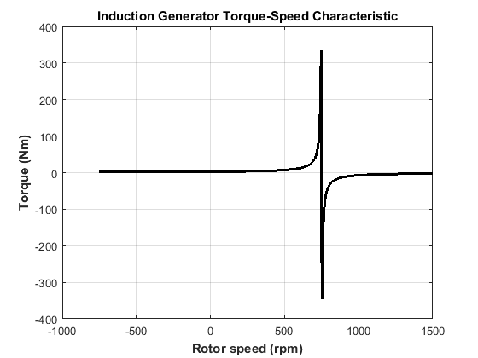

Figure 15. Torque-speed characteristic of the machine

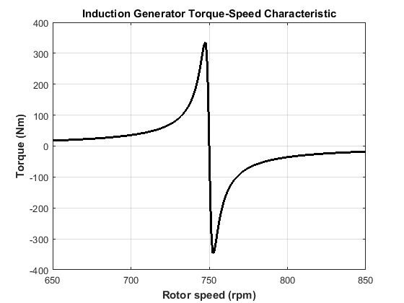

Figure 16. Torque-speed characteristic of the machine

According to my basic calculation torque-speed characteristic is as expected but I think that I have some mistake one of coefficient because torque value should be larger.

## Finite Element Analysis

I have made FEA with Maxwell Rmxprt module. This machine operates as generator so that I put the graphs after rated speed first then I will put motor operation.



Figure 17. RMxpert design of machine



Figure 18. Phase current vs speed 1



Figure 19. Phase current vs speed 2



Figure 20. Efficiency vs speed 1



Figure 21. Efficiency vs speed 2



Figure 22. Power factor vs speed 1



Figure 23. Power factor vs speed 1



Figure 24. Torque vs speed 1



Figure . Torque vs speed 1

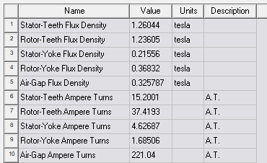

Figure 26. Table of flux densities

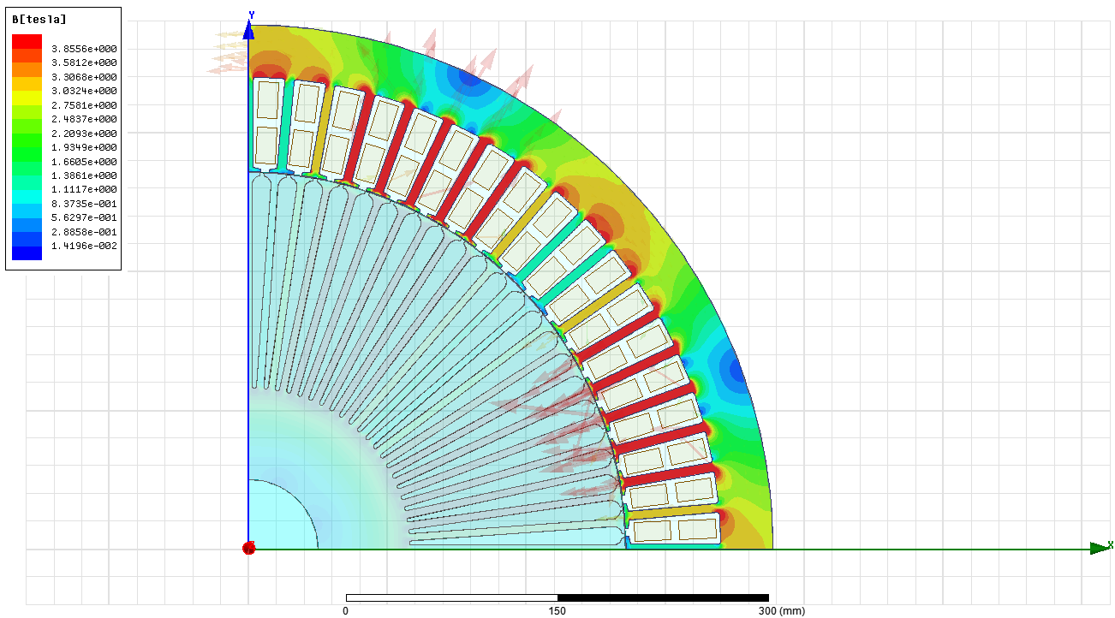

Figure 27. Magnitude of magnetic flux density of stator

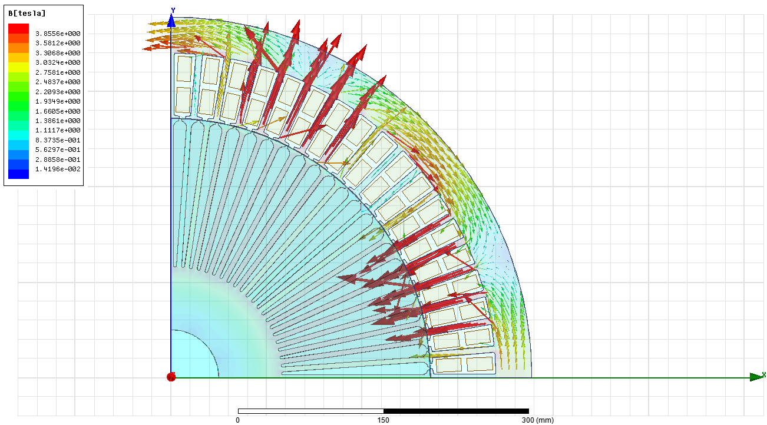

Figure 28.Vector of magnetic flux density of stator

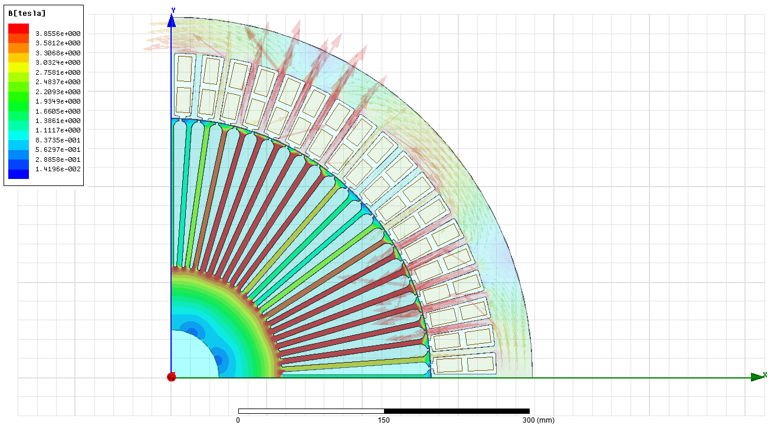

Figure 29. Magnitude of magnetic flux density of rotor

FEA results of my design conflict my calculation. I have make simulation with calculated phase current which is almost same as Rmexpert results and also flux densities are more reliable at Rmexpert value but I set this value by hand at the Maxwell 2D some parts are saturated. At the kinds of situation, all design should be repeated again and arrange mechanical dimensions again. Most probably, I have mistake at the stator slot and rotor slot winding or simulation inputs about these but I could not find the problem. If I have enough time, I redesign the mechanical dimensions. Also, efficiencies and phase current is almost same my analytical calculation. Cogging torque is not observed.

## Conclusion

In this course, I have experienced machine design steps and important points. Kinds of design analytic calculation are most important step because we have to consider all parameters with detail. In general, design step is starting with deciding specification of machine like power, voltage rating, using area etc. Then we choose machine constant according to power rating to determine size of the machine. When we focus electrical and magnetic properties we have to calculate and determine electrical and magnetic loadings. One of the most important things of the design step is magnetic saturation specification. We have to avoid magnetic saturation at the stator and rotor. Moreover, efficiency is so important especially high power application. Also near to these heating and cooling is really important for the safety of the machine. Near to the electrical design steps, mechanical considerations are extremely important like a vibration. Our electrical winding design can affect these properties. Also, there is a lot of point to work hard when we design machines like leakage losses, cogging torques, harmonics, and skin effect, temperature effect on the winding, carter coefficient, stacking factor, slot dimensions, slot types, noise, and winding type and so on.

Moreover, simulation step also critical because we cannot calculate all points on the design but FEA can do. In order to do this we have to become an expert on the FEA program because there are many parameters we have to arrange carefully. Finally, this course taught us how we can learn machine design and where we start to design.