**BLUETOOTH LOCALIZATION**

by

**Erkan Güngör**

**Mehmet Mum**

CSE497 / CSE498 Engineering Project report submitted to Faculty of Engineering

in partial fulfillment of the requirements for the degree of

**BACHELOR OF SCIENCE**

Supervised by:

Assoc. Prof. Müjdat Soytürk

Marmara University, Faculty of Engineering

Computer Engineering Department

2020

Copyright © Mehmet Mum, Erkan Güngör, 2020. All rights reserved

**BLUETOOTH LOCALIZATION**

by

**Erkan Güngör**

**Mehmet Mum**

CSE497 / CSE498 Engineering Project report submitted to Faculty of Engineering

in partial fulfillment of the requirements for the degree of

**BACHELOR OF SCIENCE**

Supervised by:

Assoc. Prof. Müjdat Soytürk

Sign

Marmara University, Faculty of Engineering

Computer Engineering Department

2020  
Copyright © Mehmet Mum, Erkan Güngör, 2020. All rights reserved.

# ABSTRACT

An Indoor Positioning System (IPS) is a system that aims to locate mobile devices in a single room or a building. In previous years, as a result of an increase in the number of large and complex buildings such positioning systems which are based on several types of wireless communication technologies are suggested. We design and develop a cost effective IPS based on Bluetooth 4. Our system uses two positioning algorithms: Trilateration and Fingerprinting. Trilateration method utilizes the Received Signal Strength Indicator (RSSI) to calculate the distance between a transmitter and a receiver. In our test environment, the trilateration method manages to locate devices with an average error of 2.231 meters. In order to increase the accuracy of the IPS, we train a support vector machine based fingerprinting model with 94% accuracy. Then we combine these algorithms to get final estimation of a device’s location. Our hybrid algorithm locates devices with an average error of 1.626 meters. Also, we analyze the location and trace data for predictions and post-processing. We make use of the collected data to generate heatmaps in desired time periods in addition to the analysis of behavior of assets and people.

**TABLE OF CONTENTS**

ABSTRACT iii

TABLE OF CONTENTS v

LIST OF FIGURES vii

LIST OF TABLES viii

**1.** **INTRODUCTION** 1

**1.1** **Problem Description and Motivation** 1

**1.2** **Aims of the Project** 1

**2.** **DEFINITION OF THE PROJECT** 3

**2.1** **Scope of the Project** 3

**2.2** **Success Factors and Benefits** 4

**2.3** **Professional Considerations** 4

**2.4** **Literature Survey** 5

**3.** **SYSTEM DESIGN AND SOFTWARE ARCHITECTURE** 7

**3.1** **Project Requirements** 7

3.1.1 Functional Requirements 7

3.1.2 Nonfunctional Requirements 7

**3.2** **System Design** 7

3.2.1 UML Use case Diagram(s) for the main use cases 7

3.2.2 UML Class and/or Database ER diagram(s) 9

3.2.3 User Interface 10

3.2.4 Test Plan 12

**3.3** **Software Architecture** 15

3.3.1 Data Flow 15

3.3.2 Control Flow 15

3.3.3 Modular Design 16

3.3.4 Hardware - Software Interaction 17

**4.** **TECHNICAL APPROACH AND IMPLEMENTATION DETAILS** 18

**4.1** **Range Based Methods** 18

**4.2** **Fingerprinting** 19

**4.3** **Combination of Algorithms** 20

**5.** **SOFTWARE TESTING** 22

**5****.1** **Range Based Algorithm** 22

5.1.1 Determining unknown of the distance equation 22

5.1.2 Evaluating the algorithm 22

**5****.2** **Fingerprinting** 23

**5****.3** **Combination of Algorithms** 24

**6.** **CONCLUSION AND FUTURE WORK** 26

**6****.1** **Range Based Algorithm** 26

**6****.2** **Feature Work** 26

**REFERENCES** 28

# LIST OF FIGURES

Figure 3.1: IPS web page use case diagram 1

Figure 3.2: IPS UML class diagram 1

Figure 3.3: IPS database ER diagram 1

Figure 3.4: IPS web page live locations 1

Figure 3.5: IPS web page heatmap 1

Figure 3.6: IPS web page user trace 1

Figure 3.7: IPS web page person and card 1

Figure 3.8: IPS data flow diagram 1

Figure 3.9: IPS control flow diagram 1

Figure 3.10: IPS modular design 1

Figure 3.11: Hardware-software interaction 1

Figure 4.1: Possibility circle 1

Figure 4.2: Trilateration 1

Figure 4.3: Fingerprinting 1

Figure 4.4: Flow diagram of the positioning algorithm 1

Figure 5.1: Trilateration error margin 1

Figure 5.2: Average error of combined algorithm in selected positions 1

# LIST OF TABLES

Table 4.1: Fingerprinting output 2

Table 5.1: Reference distance and RSSI of receivers 2

Table 5.2: SVM results 2

1. **INTRODUCTION**
   1. **Problem Description and Motivation**

Due to the increase in the number of large and complex buildings such as malls, companies, museums, warehouses and airports, security and wayfinding are starting to become enormous problems. In a company, a visitor may enter an unauthorized area. In this case, a security guard can observe the behavior of the visitor, take the necessary action and/or report the visitor. It is a well known fact that in malls, people are wasting too much time to find the specific store they are looking for.

“Indoor localization is the process of obtaining a device or user location in an indoor setting or environment [1].” Many systems have been developed since this problem arose. Such systems are based on several technologies like Wi-Fi, computer vision, and sound waves. Each technology has some disadvantages. Computer vision based systems are too expensive. Systems that use sound waves for localization have short range. Although a Wi-Fi based system uses many access points, it still has low accuracy. Another approach to this problem is combining some systems in order to achieve higher accuracy. But these systems tend to become more complex and expensive. Bluetooth Low Energy technology has recently started to be used with indoor IPS. Being highly cost-effective and more accurate, such innovation has pleased this part of the field. This advantage distinguishes it from other systems. In this project, we designed an IPS with bluetooth technology.

* 1. **Aims of the Project**

Primary aim of the project is to design an Indoor Positioning System. Specific aims of the project are listed below.

* + Implementing location-finding algorithm(s) that uses the collected data by receivers at known positions in the IPS (Bluetooth 4) and gives the position(s) with 2 meters error margin.
  + Providing live locations which shows all locations on a map.
  + Providing a heat map by using results (positions) which come from location-finding algorithm(s).
  + Providing a user-trace feature by using previous results saved in the database. There are two different display ways, displaying traces visually like in the heat map and verbally like in the log record.
  + Providing an interface to show live locations, heat maps and detailed user traces.
  + Evaluating the performance, accuracy, benefits and disadvantages of algorithm(s) designed for IPS (Bluetooth 4).

1. **DEFINITION OF THE PROJECT**
   1. **Scope of the Project**

A real time positioning system has to locate assets in a duration that varies depending on the environment. If the system is an IPS, it also has to have high accuracy. Thus, the capability of an IPS can be evaluated under two headings; reliability and speed of the communication methods that are used in the system, accuracy of the indoor positioning algorithms. In our project, we design a cost effective IPS that satisfies these terms using Bluetooth 4.

Accuracy is the key point of an IPS. Therefore, we wanted to improve the system’s accuracy as much as possible. But we did not want to increase the cost too much. Thus, while improving the system’s accuracy, we did not design or enhance any kind of hardware. Instead, we focused on designing more efficient and more accurate indoor positioning algorithms than previously proposed algorithms.

The system will not be useful if it can not locate assets in a reasonable duration even though it can locate them with perfect accuracy. Therefore, we planed to improve the communication methods by:

* Increasing size of the packets which are sent from transmitter to receiver.
* Choosing more feasible communication technologies.

In the real world, there are many complex buildings that are challenging for indoor positioning. We could have encountered lots of issues when setting up an IPS to these kinds of buildings. Depending on the building structure, we could not be able to put the receivers at desired locations or due to the high signal interference, indoor positioning algorithms could have lower accuracy. In order to avoid these problems, we designed the IPS for a simple room. Therefore, our IPS may not be sufficient for such complex buildings.

When the localization part is done, we had an IPS that produces valuable data. This data can be used for many purposes such as optimization and security. We processed this data in order to obtain:

* A heatmap that states crowded areas.
* Trace of individual users.

At this point, we had three outputs: heatmap, user traces and real time locations. In order to make them easily observable, we designed a user interface on the web.

* 1. **Success Factors and Benefits**

The project aimed at some success factors which are listed below.

* 95% of the estimated positions must have less than two meters error in the system based on Bluetooth 4.
* User trace must display all routes that the user passes and it must also give the specific time.
* For real time positioning systems, it is possible that delays may occur. Therefore, IPS should update the result on the real time positioning system every 3 seconds.

Indoor positioning systems have a wide range of applications. Some of the potential benefits of the project are listed below.

* The real time location system can be used for many things such as security; e.g., a security guard can observe visitors easily by monitoring real time locations.
* Heat maps can be used for optimization purposes; e.g., advertisers may analyze the heat map to find out most visited locations in specific areas of the buildings.
* User track feature has many areas of utilization. In some cases, it can be a matter of life or death; e.g., in case of a disaster, a person’s last known position can save his/her life.
  1. **Professional Considerations**

2.3.1 Methodological considerations/engineering standards

We have used $Github$ for source code control. All versions of the project are accessible in the GitHub repository. We have used python for designing algorithms, React JS for WEB user interface (UI) and amazon web server for the database.

2.3.2 Societal/ethical considerations

* Economical: Number of beacons and access points needed to place is varying depending on the environment. Since BLE beacons and access points are not expensive and easy to maintain, the cost of this project was not high for clients that we were targeting.
* Environmental: The project does not put the environment in danger. We have used BLE beacons as receivers and they consume low energy. For future generations, our project is nature friendly and consumes less energy which makes it beneficial and effective.
* Ethical: The main aim of the project is to help people via localization and its features. The project is locating people only indoors. Our project is providing user traces only for the company that has the system. If apublic place like a museum/malluses this project, we will not collect or store any information other than device locations.
* Sustainability: Bluetooth technologies are continuously supported and improved by the producers. A BLE beacon’s battery can operate for about two years with a button battery.

2.3.3 Legal considerations

All frameworks/programs that will be used during this project are open source. So, we will not need a license for developing tools.

* 1. **Literature Survey**

In the work of Chouchang Yang and Huai-Rong Shao [2], authors worked on Wi-Fi based IPS. In this system, devices that are desired to locate should have Wi-Fi capabilities. For positioning, they have used two types of localization approaches: Angle of Arrival (AoA) and Time of Arrival (ToA). If there is one Access Point (AP) nearby, they applied the ToA method. Otherwise, they applied the AoA method to obtain higher accuracy. They used Round Trip Time to measure distance between transmitters and receivers. On the other hand, they obtained the angle via AP which has multiple antennas. Performance of the AoA method increases with respect to the number of antennas.

In the work of Cheng Zhou, Jiazheng Yuan, Hongzhe Lou and Jing Qui [3], the authors proposed an indoor positioning algorithm based on Bluetooth Low Energy 4.0. They divided the problem into three phases: Collecting Bluetooth signals, Bluetooth signal propagation model, real-time position output. In the first phase, they are collecting Bluetooth signals and calculating the distance between receiver and transmitter using RSSI values. Main idea of the second phase is improving accuracy. They erase obvious errors and smooth the RSSI using Kalman Filters. In the third phase, using Kalman Filters, weighted least square and four border positioning they estimate the positions.

In the work of Cemin Zhang, Michael Kuhn, Brandon Merkl, Aly E. Fathy, Mohamed Mahfouz [4], authors worked on Ultra Wideband (UWB) IPS utilizing time difference of arrival (TDoA). They experienced this system for both 1D and 2D localization. In the 1D experiment, using 1 receiver and 1 transmitter they located the assets with less than a millimeter error. In the second experiment, they used 3 receivers which are put at known positions and 1 transmitter. They used TDoA technique and triangulation method to indicate the position. For the 2D experiment, they located the transmitter with an error of 1.68mm.

In these works, the authors have focused on only positioning. In our work, we find positions, store them in a database. And then, we interpret this data for creating heatmap and user traces. In addition to these, we visualize the positions, create heatmap and the user traces.

1. **SYSTEM DESIGN AND SOFTWARE ARCHITECTURE**
   1. **Project Requirements** 
      1. Functional Requirements

* An admin should be able to add / delete / edit a person or a card.
* An admin should be able to select a person for user trace.
* An admin should be able to select begin date and end date for user trace and heatmap.
  + 1. Nonfunctional Requirements

Performance:

* Real time locations should be updated every 3 seconds.
* Heat map should be displayed on the screen in 5 seconds after requested.
* User tracking service should be displayed on the screen when it is requested.

Reliability:

* We should update the database before displaying any data in the real time location system. Not displaying data in the database for a real time location system may be tolerable, but displaying data which is not in the database can cause problems.

Usability:

* The interface should be clear and easy to use. In case of any emergency situation, users should not face any difficulty using the user interface.
* User interface should be updated automatically.
  1. **System Design** 
     1. UML Use case Diagram(s) for the main use cases

Admin can do all possible actions. User has no access to the system. So he/she can not do anything.

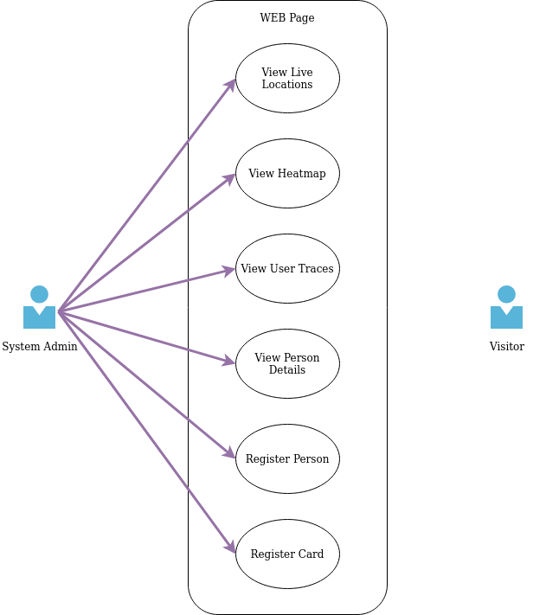

Figure 3.1: IPS web page use case diagram

* + 1. UML Class and/or Database ER diagram(s)

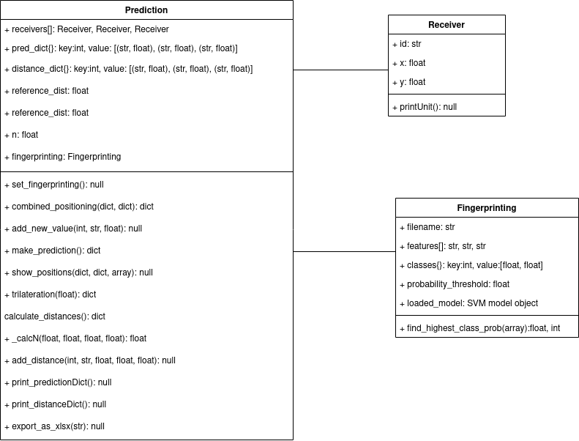

Figure 3.2: IPS UML class diagram

In the database we stored personal details, card details, and estimated positions. For personal information, we stored first name, last name, person id and card id which is assigned to the person. For card information, we stored card id. For position information, we stored estimated positions of persons and the time.

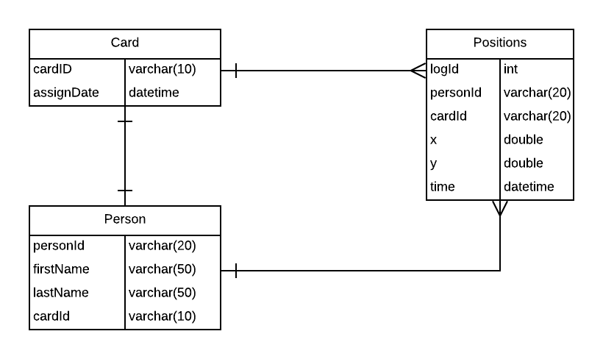

Figure 3.3: IPS database ER diagram

* + 1. User Interface

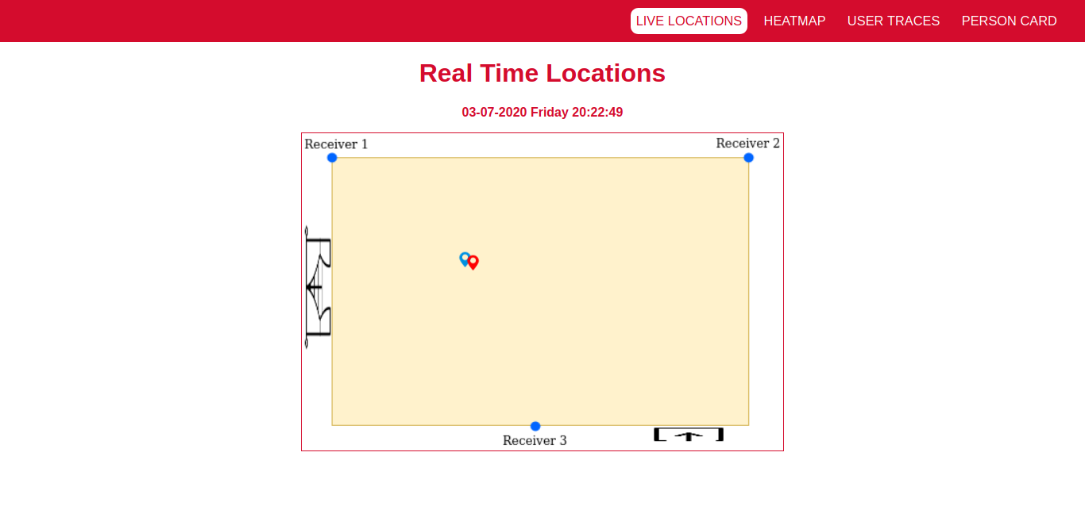

Figure 3.4: IPS web page live locations

Figure 3.4 shows the web page that the user can observe live locations.

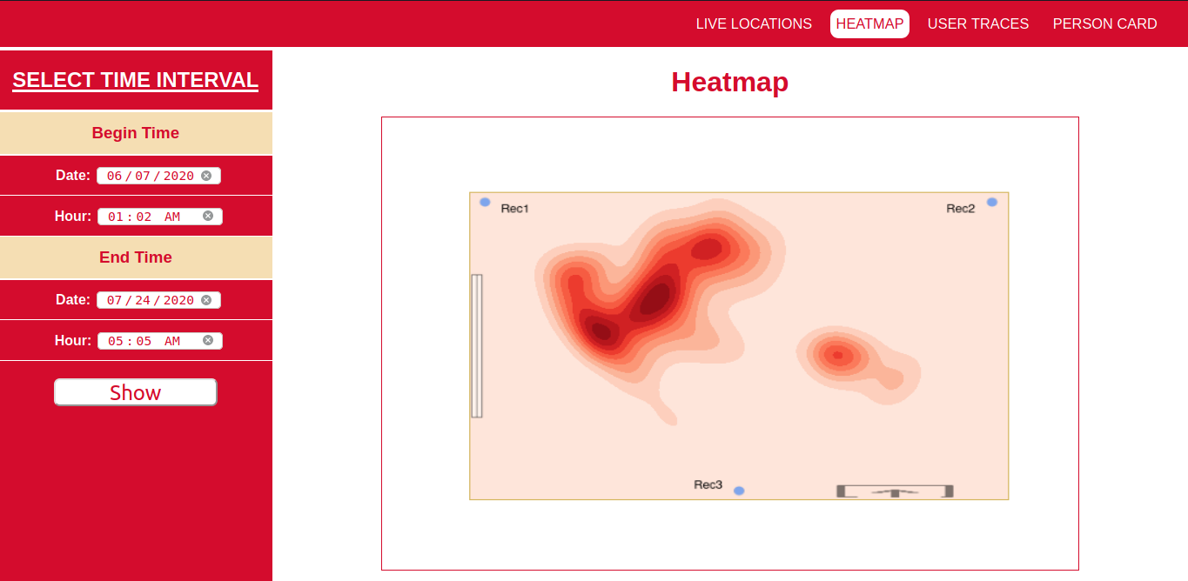

Figure 3.5: IPS web page heatmap

Figure 3.5 shows the web page that the user selects begin date and end date. A heatmap is created on cloud using positions in the given time interval and it is shown on the screen.

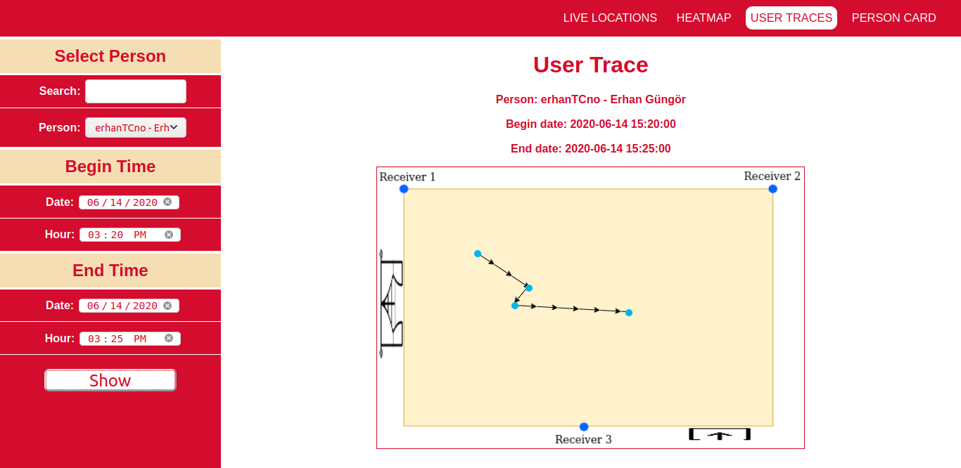

Figure 3.6: IPS web page user trace

Figure 3.6 shows the web page that the user selects begin date and end date. User trace is created using positions in the given time interval and it is shown on the screen.

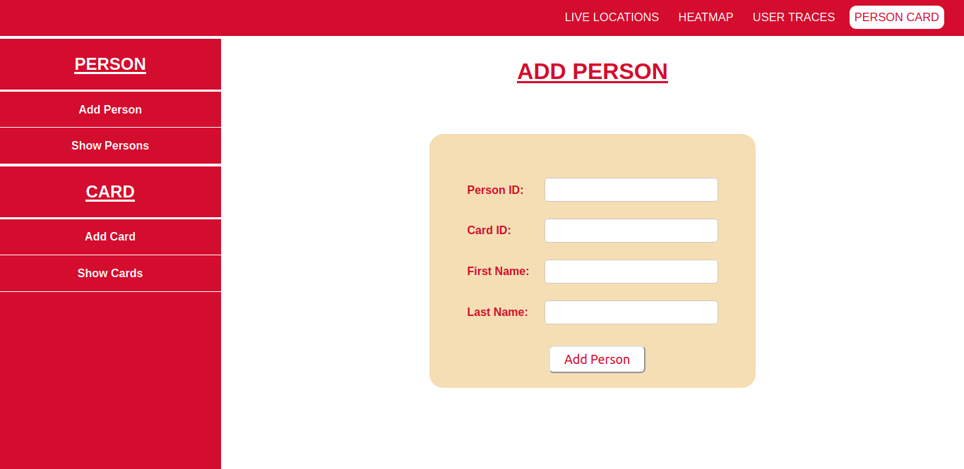

Figure 3.7: IPS web page person and card

Figure 3.7 shows the web page that the user can either add a person or add a card to the system. Also, the user can edit or delete a person or delete a card from the system.

* + 1. Test Plan

In this section, we will describe how to test our system. We have divided our system into subsystems. Each subsystem should be tested individually. So, the tests will be applied at various times during the development cycle.

The following subsystems will be tested:

* Web UI
  + Real Time Location
  + Auto Update
  + Heatmap
  + User Trace
* System setup (communication between devices)
* RSSI based positioning algorithm
* Fingerprinting based positioning algorithm
* Combination algorithm

|  |  |
| --- | --- |
| Test Case Name | Real Time Location |
| Requirement | UI shall display everyone’s location |
| Procedure | Give positions as input |
| Expected Result | Display each person’s location |

|  |  |
| --- | --- |
| Test Case Name | Auto Update |
| Requirement | Positions should be updated automatically every 3 seconds. |
| Procedure | Give new positions every 3 seconds as input. |
| Expected Result | Display updated positions automatically every 3 seconds. |

|  |  |
| --- | --- |
| Test Case Name | User Trace |
| Requirement | UI shall display the locations that are visited by a person in a given time period. |
| Procedure | Give locations of a person with timestamps. |
| Expected Result | Display the locations that are visited by a person in a given time period. |

|  |  |
| --- | --- |
| Test Case Name | Heatmap |
| Requirement | UI should display a smooth heatmap |
| Procedure | Give matrix as input |
| Expected Result | Display which areas were visited more by people. |

|  |  |
| --- | --- |
| Test Case Name | Communication of Components |
| Requirement | Receivers and the access point should be connected. |
| Procedure | Give data as input to receivers. |
| Expected Result | Received data should be correct, delay should not be more than 2 seconds. |

|  |  |
| --- | --- |
| Test Case Name | RSSI based positioning algorithm |
| Requirement | The algorithm shall find the position of users. |
| Procedure | Give RSSI values as input. |
| Expected Result | The algorithm should estimate the positions. |

|  |  |
| --- | --- |
| Test Case Name | Fingerprinting based positioning algorithm |
| Requirement | The algorithm shall find the possibilities of chosen position |
| Procedure | Give RSSI values as input. |
| Expected Result | Class possibilities of the chosen positions. |

|  |  |
| --- | --- |
| Test Case Name | Combination algorithm |
| Requirement | The algorithm shall combine 2 estimated positions |
| Procedure | Give the positions which are estimated using RSSI based and fingerprinting algorithms. |
| Expected Result | The algorithm should estimate the final positions with at most 2 meters error. |

* 1. **Software Architecture** 
     1. Data Flow

In our application, users can display, register, edit and delete users and cards. They can request a person’s trace, heat map in a given period of time and they can observe latest estimated positions (live locations).

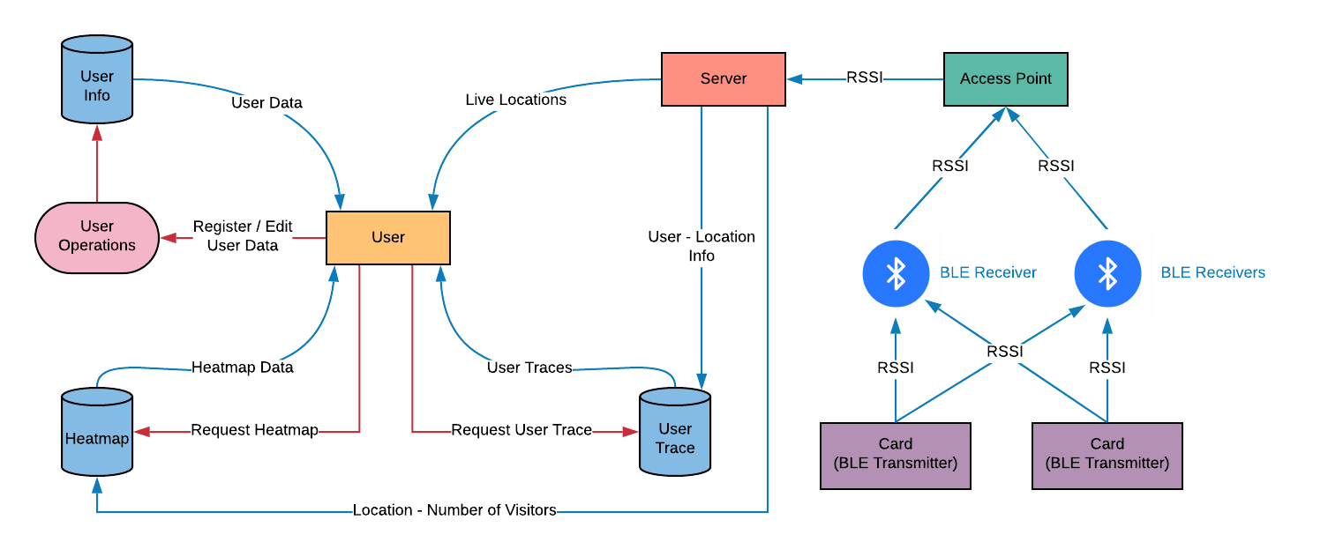

Figure 3.8: IPS data flow diagram

* + 1. Control Flow

The IPS that plan to design can be divided into three headings: Data collection, positioning and data interpretation. The system should wait until the receivers collect data which satisfies the expected format. If this data is successfully transmitted to the server, then the system can run positioning algorithms and estimate the positions of target devices. These positions should be recorded in the database, then Web UI can display new locations, new heatmap and updated user traces.

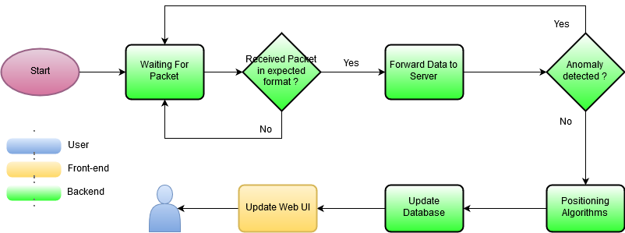

Figure 3.9: IPS control flow diagram

* + 1. Modular Design

This project will consist of three parts: UI/Front-End, Back-End components and the web application.

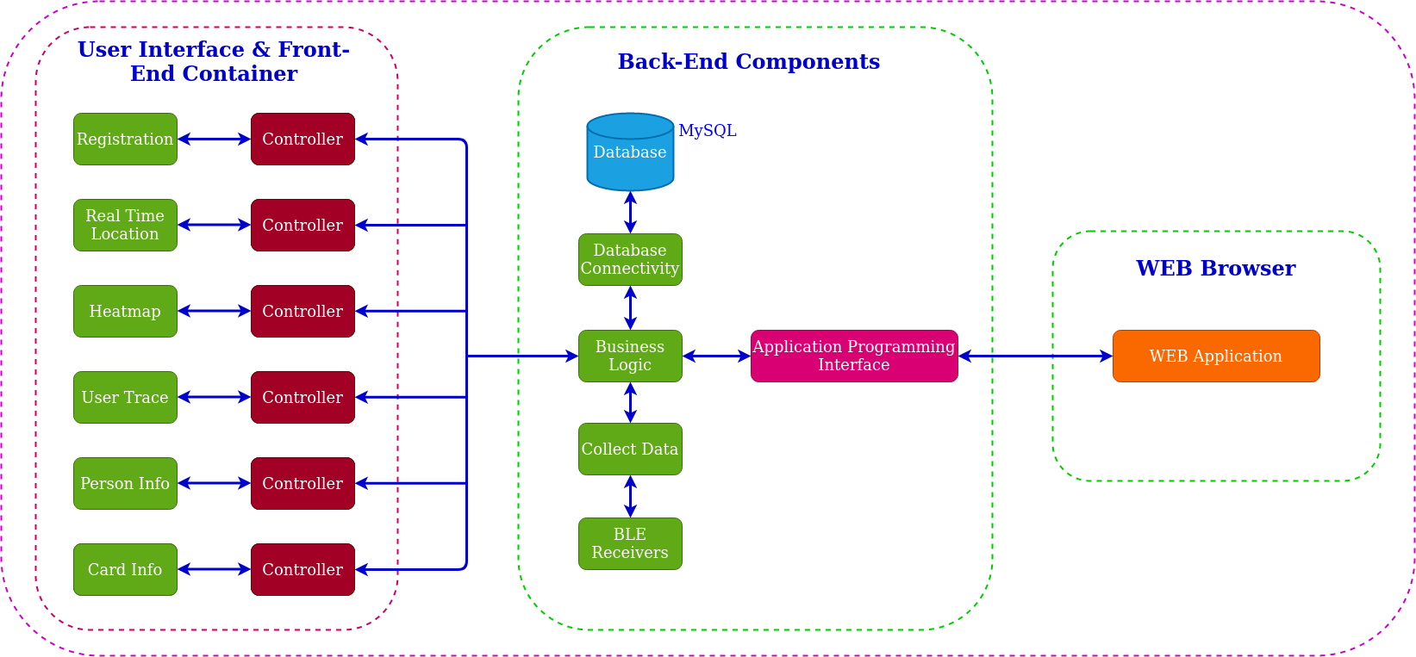

Figure 3.10: IPS modular design

* + 1. Hardware - Software Interaction

The following diagram shows the data flow and interaction between hardware and software. Also, we plan to use MQTT and REST methods in data transmitting part. We will use three types of hardware in this project:

* Transmitters: BLE cards
* Receivers: Raspberry Pis
* Server: A computer

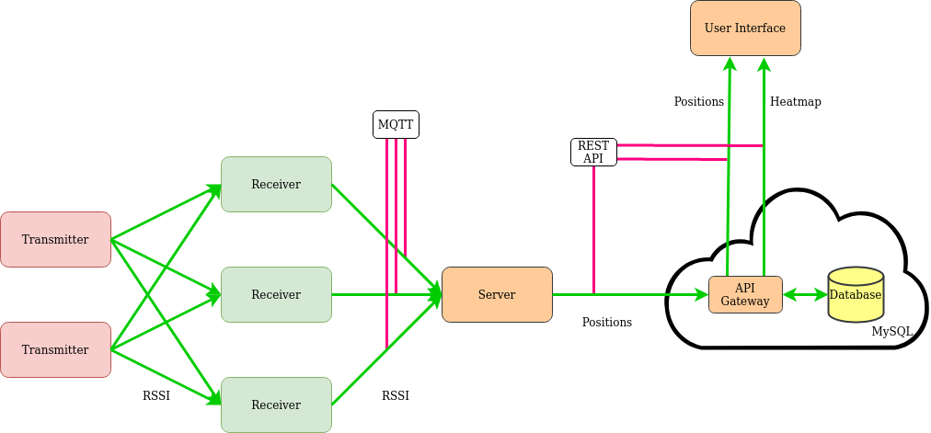

Figure 3.11: Hardware-software interaction

1. **TECHNICAL APPROACH AND IMPLEMENTATION DETAILS**
   1. **Range Based Methods**Range based methods try to calculate the real distance between the receiver and the transmitter. These methods do not provide any information about the angle of signal. The most common techniques are using Received Signal Strength Indicator (RSSI) and Time of Arrival (ToA) a.k.a. Time of Flight (ToF).

In order to use ToA method effectively, exact time of signal arrival ($t_{arrival}$), time of signal sent ($t_{sent}$) and the speed of the signal ($c$) must be known. The speed of signal is usually taken as the speed of light. Then the distance ($d$) can be calculated with the equation 4.1 [5]:

$d = c*(t_{arrival}-t_{sent})$ (Equation 4.1)

The relation between RSSI and distance($d$) can be expressed as [6]:

${RSSI}_{d}=(-10*n)*\log_{10}(\frac{d}{d_{0}})+{RSSI}_{d_{0}}$ (Equation 4.2)

where:

* $d_{0}$: reference distance (usually 1 meter)
* $d$: distance desired to calculate
* ${RSSI}_{d_{0}}$: measured RSSI at reference distance $d_{0}$
* ${RSSI}_{d}$: measured RSSI at distance $d$
* $n$: coefficient depends on the environment

Since the value of n varies for different environments, it needs to be calculated in order to use the equation 4.2. At least two measurements are required for this purpose. Most common values of n are between 2.0 and 2.5. When the value of n is determined, the equation 4.2 can be used for distance estimations.

Whichever range based method is used, there will be no information regarding angle. Only two things are known: position of the receiver, transmitter distance to the receiver. A possibility circle can be drawn with the information.

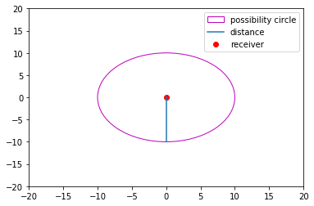

Figure 4.1: Possibility circle

Using three receivers that are in different positions, three possibility circles can be drawn and the center of the intersection points can be returned as the estimated position of the transmitter. This method is called trilateration [7].

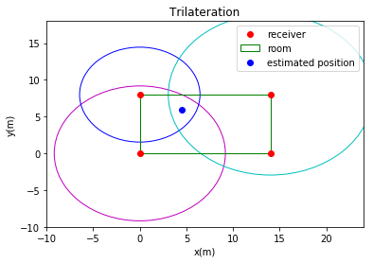

Figure 4.2: Trilateration

* 1. **Fingerprinting**

Fingerprinting [8] has two phases:

* Offline Phase: This is a preparation phase. Before using this method, points of interest should be picked and a radio map of the area should be created. For each point data should be collected. This process is time consuming but increases the accuracy of the system.
* Online Phase: Also known as the localization phase. In this phase, the system tries to estimate the position of the target using collected data at the offline phase. Characteristics of received signals should be compared with a dataset and the most similar point should be determined. Widely used methods for comparison are:
  + Naive Bayes Classifier
  + k-Nearest Neighbors
  + Neural Networks
  + Support Vector Machine
  + smallest M-vertex polygon

## 

Figure 4.3: Fingerprinting

We implemented and compared the results of these algorithms and decided to use Support Vector Machine. And the output of this algorithm shows us the probability of each location (class) for each transmitter.

|  |  |
| --- | --- |
| **Class** | **Probability** |
| [1, 1] | 0.91 |
| [4.25, 2.45] | 0.09 |

Table 4.1: Fingerprinting output

* 1. **Combination of Algorithms**

This algorithm uses the results of fingerprinting and RSSI based positioning algorithms. Using the highest class probability and positions (x,y) of that class which are calculated by the fingerprinting algorithm and estimated positions from the trilateration algorithm, the combination algorithm takes a weighted average using equation 4.3.

$pos =(highestProb*classPos)+(( 1-highestProb)*trilaterationPos)$ (Equation 4.3)

In figure 4.5, the flow diagram of the positioning system is represented by a UML diagram.

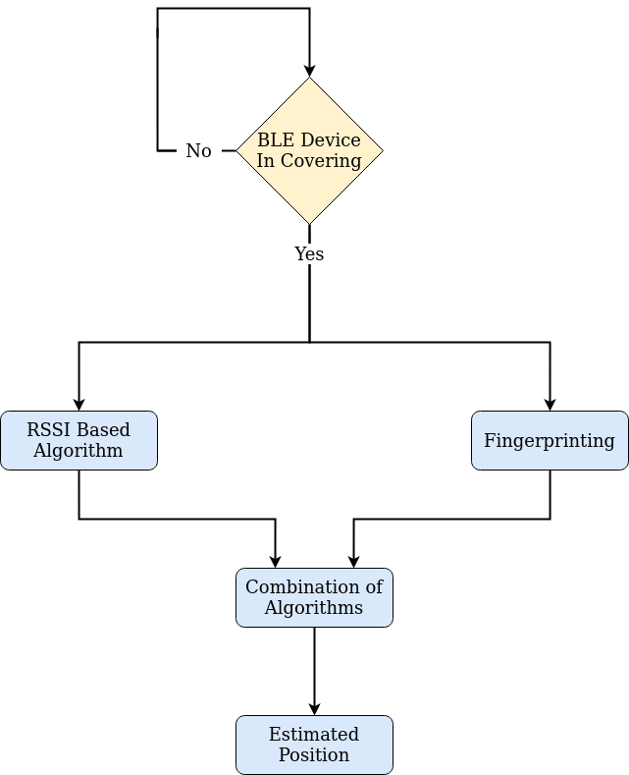

Figure 4.4: Flow diagram of the positioning algorithm

1. **SOFTWARE TESTING**

* 1. **Range Based Algorithm**5.1.1 Determining unknown of the distance equationSince this algorithm is based on RSSI between BLE receiver and BLE transmitter, we can say that this algorithm highly depends on the hardware. Therefore, IPS uses the same hardwares for all receivers and transmitters. But in our case we had to use 3 different types of receivers. Which means we had to measure unknowns in equation 4.2 seperately. Table 5.1 shows the final values of these unknown for each receiver.

|  |  |  |
| --- | --- | --- |
| **Device Name** | $d_{0}$ | ${RSSI}_{d_{0}}$ |
| raspberry-10 | 1 | -54 |
| msi-gt70 | 1 | -58 |
| erhan-e570 | 2 | -50 |

Table 5.1: Reference distance and RSSI of receivers

5.1.2 Evaluating the algorithm

We started testing the distance formula by collecting RSSI values in 1, 2, 3 and 4 meters away from a receiver. Then we labeled these results with the real distances. Figure 5.1 shows the real distances and calculated distances using equation 4.2. It can be seen that when distance between transmitter and receiver increases, the error increases. Also in some cases, we observe high error in RSSI values caused by multipath propagation. [9] We calculated the average error as 2.12 meters for equation 4.2.

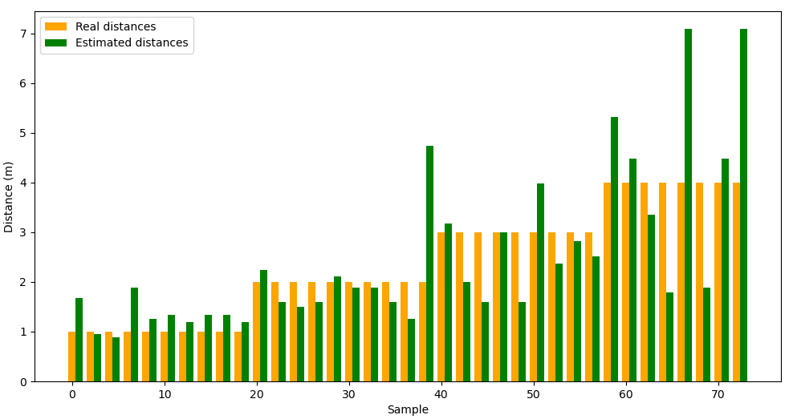

Figure 5.1: Trilateration error margin

In the literature, the accepted average error is around 3 meters. We wanted to build an IPS with 2 meters average error as discussed in section 2.1. We calculated the average error of the trilateration algorithm as 2.231 meters.

* 1. **Fingerprinting**This kind of IPS is usually built in a 100-150 meter square area because the indoor max range of Bluetooth 4 is 10-12 meters. [10] But because of Covid-19 [11] and quarantine during the project, we had to build this system in a room of our apartment and the room is 18 $m^{2}$. Therefore 2.231 meters average error of the trilateration algorithm was a little bit high. So, we wanted to use the fingerprinting algorithm in order to increase the accuracy of IPS.

Since the area is 18 $m^{2}$ and no special points to choose in a small room, we chose a class on the left side of the room (1m, 1m), and another class on the right side of the room (4.25m, 2.45m). Our goal was to determine if a person is in the right side of the room or the left side of the room. As discussed in section 4.2, we used support vector machine (SVM) as the machine learning model. Table 5.2 shows the evaluation parameters of our machine learning model.

|  |  |  |  |
| --- | --- | --- | --- |
|  | **Precision** | **Recall** | **F1-Score** |
| (1, 1) | 0.84 | 0.81 | 0.83 |
| (4.25, 2.45) | 0.96 | 0.97 | 0.97 |
| accuracy |  |  | 0.94 |
| macro average | 0.90 | 0.89 | 0.90 |
| weighted average | 0.94 | 0.94 | 0.94 |

Table 5.2: SVM results

* 1. **Combination of Algorithms**When we were convinced that our model is good enough, we started testing the accuracy of the combined algorithm. But we realized that most of the time the class which has the highest probability has 0.99 probability. Which means, when we were calculating the final position using equation 4.3, we were ignoring the trilateration algorithm. Therefore we decided to determine an upper threshold for this formula. After experiments, 0.70 gave the best results.

In order to evaluate our final algorithm, we chose 5 locations that cover the room and we measured average error as 1.626 meters. Figure 5.2 shows the selected locations and measured average errors at those locations.

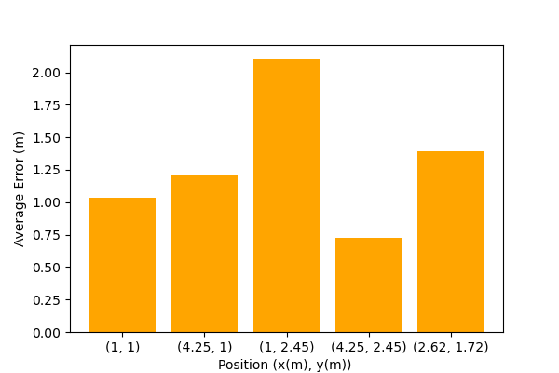

Figure 5.2: Average error of combined algorithm in selected positions

1. **CONCLUSION AND FUTURE WORK**

* 1. **Range Based Algorithm**

We develop an indoor positioning system based on bluetooth technology. In this system, an admin that sees every person’s current location on a map, sees which locations are most used, keeps track of a person, registers persons and cards. In order to make the system user friendly, we develop a simple web user interface. We managed to build an IPS that locates people with less than 2 meters average error.

* 1. **Feature Work**

At the beginning of the project, we wanted to develop this system for 130 $m^{2}$ environment because the error margin of bluetooth base IPS is acceptable for large areas. But, due to Covid-19 [10] we had to build and test this system in 18 $m^{2}$ area. The system we built should be tested in a larger area.

We wanted to implement a dead reckoning algorithm [11] which is based on information obtained from an accelerometer. Because, as we discussed in previous sections, RSSI is not a stable measure and can be affected by so many factors. Also we wanted to work on angle based positioning [12] as well as range based positioning. But unfortunately we could not implement these algorithms due to some hardware issues.

If we continue to improve our system, we are planning to set up the system for complex structures. In order to improve the accuracy of the system, we plan to implement a dead reckoning algorithm and angle based positioning algorithms.

Such IPS should be secure and easy to use. In order to achieve these goals, a sign up/login system should be developed. Also, different types of roles which limits access of users should be assigned to users according to their duties.

The user interface we developed shows the positions on a 2-dimensional map. Considering the 3d positioning feature of angle based algorithms, the UI might be updated with a 3-dimensional map. Also, current user trace shows the path of a person in a select time interval. We can add a feature that has shows the interactions of people like who spent how much time with whom.

**REFERENCES**

[1] F. Zafari, A. Gkelias and K. K. Leung, "A Survey of Indoor Localization Systems and Technologies," in *IEEE Communications Surveys & Tutorials*, vol. 21, no. 3, pp. 2568-2599, 3rd quarter 2019.

[2] C. Yang and H. Shao, "WiFi-based indoor positioning," in *IEEE Communications Magazine*, vol. 53, no. 3, pp. 150-157, March 2015.

[3] Zhou, C., Yuan, J., Liu, H. et al. Wireless Pers Commun (2017) 96: 4115.

[4] C. Zhang, M. Kuhn, B. Merkl, A. E. Fathy and M. Mahfouz, "Accurate UWB indoor localization system utilizing time difference of arrival approach," *2006 IEEE Radio and Wireless Symposium*, San Diego, CA, 2006, pp. 515-518.

[5] Shi, G., & Ming, Y. (2016). Survey of Indoor Positioning Systems Based on Ultra-wideband (UWB) Technology. In Wireless Communications, Networking and Applications(pp. 1269-1278). Springer India

[6] Zheng J., Wu C., Chu H. and Xu Y., “An Improved RSSI Measurement In Wireless Sensor Networks”, *Elsevier Procedia Engineering*, vol.15, pp. 876 – 880, 2011.

[7] X. Yan, Q. Luo, Y. Yang, S. Liu, H. Li and C. Hu, "ITL-MEPOSA: Improved Trilateration Localization With Minimum Uncertainty Propagation and Optimized Selection of Anchor Nodes for Wireless Sensor Networks," in *IEEE Access*, vol. 7, pp. 53136-53146, 2019.

[8] BEKKELIEN, Anja. *Bluetooth Indoor Positioning*. Université de Genève. Maîtrise, 2012, pages 12-14.

[9] K. Staniec, "IEEE 802.15.4 (ZigBee) immunity to in-band interference and multipath propagation," *2015 Radio and Antenna Days of the Indian Ocean (RADIO)*, Belle Mare, 2015, pp. 1-2, doi: 10.1109/RADIO.2015.7323415.

[10] Mehta P, McAuley DF, Brown M, et al. COVID-19: consider cytokine storm syndromes and immunosuppression. *Lancet*. 2020;395(10229):1033-1034. doi:10.1016/S0140-6736(20)30628-0

[11] A. A. Panyov, A. A. Golovan and A. S. Smirnov, "Indoor positioning using Wi-Fi fingerprinting pedestrian dead reckoning and aided INS," *2014 International Symposium on Inertial Sensors and Systems (ISISS)*, Laguna Beach, CA, 2014, pp. 1-2.

[12] Martin Woolley 2019, *Bluetooth Core Specification v5.1 Feature Overview,* Bluetooth SIG, viewed November 2019,

<<https://www.bluetooth.com/bluetooth-resources/bluetooth-core-specification-v5-1-feature-overview/>>