**UNIVERSITY INSTITUTE OF COMPUTING**

**CASE STUDY REPORT**

**ON**

**PARTICULAR CASE STUDY**

Program Name: BCA

Subject Name/Code: Database Management System (23CAT-251)

**Submitted by: Submitted to:**

**Name:** Hardeep kaur **Name: Mr. Arvinder Singh**

**UID:23BCA**10712 **Designation: Professor**

**Section:4’a’**

ABSTRACT

* Introduction:

📘 Introduction: Inventory Management in a Retail Store– Database Project

Inventory management in a retail store refers to the process of overseeing and controlling the flow of goods, from acquisition to sale, ensuring that the store always has the right quantity of products available for customers. This involves managing stock levels, orders, storage, and sales in an efficient and cost-effective manner. Proper inventory management is crucial to maintaining optimal stock levels, reducing excess inventory, minimizing stockouts, and enhancing customer satisfaction. It helps in balancing supply and demand, maximizing profitability, and reducing waste or losses.

For retail businesses, effective inventory management is not just about tracking products but also involves strategic decision-making regarding purchasing, sales trends, and supplier relationships. With the advent of technology, modern retail stores often use inventory management systems (IMS) or enterprise resource planning (ERP) software to automate many aspects of this process, providing real-time data and insights that aid in decision-making.

A well-organized inventory system ensures that retailers can offer a broad selection of products without overstocking, ultimately contributing to smoother operations and better financial performance.

* Technique:

Techniques of Inventory Management in a Retail Store

1. **Just-in-Time (JIT) Inventory:**This technique involves ordering and receiving inventory only when needed for production or sales. It helps reduce storage costs and minimizes the risk of overstocking. However, it requires accurate demand forecasting and reliable suppliers.
2. **Economic Order Quantity (EOQ):**  
   EOQ is a formula used to determine the optimal order quantity that minimizes total inventory costs, including ordering and holding costs. This helps retailers avoid overstocking or understocking by balancing these costs.
3. **ABC Analysis:**  
   ABC analysis categorizes inventory into three classes based on value and turnover rate:
   * A items: High-value, low-volume items
   * B items: Moderate value, moderate turnover
   * C items: Low-value, high-volume items  
     This method helps retailers prioritize management efforts on the most valuable products.
4. **FIFO (First-In, First-Out):**  
   FIFO is a technique where the oldest inventory items are sold first. This is particularly useful for perishable goods or products with expiration dates, ensuring that the older stock is sold before newer items.
5. **LIFO (Last-In, First-Out):**  
   LIFO assumes that the most recent inventory is sold first. This technique is often used in industries where the prices of goods are rising, as it allows businesses to match the most recent costs with current revenues. However, it may not be ideal for perishable products.
6. **Reorder Point (ROP):**  
   The reorder point is the inventory level at which a new order should be placed to replenish stock before it runs out. It takes into account lead time, demand, and safety stock to ensure that the store does not experience stockouts.
7. **Drop Shipping:**  
   In drop shipping, the retailer doesn't keep products in stock but instead transfers customer orders directly to the supplier or manufacturer, who then ships the products directly to the customer. This reduces inventory costs and the need for storage space.
8. **Vendor-Managed Inventory (VMI):**  
   With VMI, the supplier manages the retailer’s inventory by monitoring stock levels and making automatic replenishment decisions. This helps ensure that stock levels are optimized and reduces the retailer's burden of tracking inventory.
9. **Perpetual Inventory System:**  
   This technique involves continuously updating inventory records with each transaction (sale or purchase) in real-time. It ensures accurate and up-to-date stock information and helps with immediate decision-making.
10. **Periodic Inventory System:**  
    Under this system, inventory levels are checked and updated at regular intervals (e.g., weekly, monthly). It's often used in smaller retail stores with less complex inventory needs but can be less accurate than perpetual systems.

* System Configuration:

In the context of **Database Management Systems (DBMS)**, **system configuration** refers to the setup and management of the various components that enable a DBMS to perform its functions effectively. This includes configuring the database environment, defining schemas, tables, user roles, and establishing optimal settings for performance, security, and backup. Here's an outline of what system configuration typically involves in a DBMS:

### **System Configuration in DBMS**

1. **Database Installation and Setup**:
   * **Software Installation**: The first step is installing the DBMS software (e.g., MySQL, Oracle, SQL Server, PostgreSQL) on the server or system. This involves choosing the right version of the DBMS (e.g., community edition or enterprise edition) and configuring the installation parameters (e.g., port number, memory allocation).
   * **Storage Configuration**: Defining the storage paths for the database files (e.g., tablespaces, data files, log files) is a critical configuration step. The database's data storage should be set up to optimize performance, particularly for large-scale applications.
2. **Database Creation**:
   * **Schema Definition**: A database schema is created to define the structure of the data, such as tables, columns, indexes, and relationships. This includes the design and configuration of how data will be stored and accessed.
   * **Table Configuration**: Tables are defined with appropriate data types, primary keys, and constraints (e.g., UNIQUE, NOT NULL). Proper indexing should also be configured to speed up data retrieval.
   * **Normalization**: Configuring normalization rules to eliminate redundancy and ensure data integrity through techniques like 1NF, 2NF, 3NF, etc.
3. **User and Access Management**:
   * **User Roles and Permissions**: Setting up different user accounts and defining access control policies is a key part of system configuration. Different users or roles (e.g., admin, data entry, read-only) are granted specific privileges (e.g., SELECT, INSERT, UPDATE, DELETE) to control access to sensitive data.
   * **Authentication Mechanisms**: Configuring security protocols such as password policies, multi-factor authentication (MFA), or integrating with an external authentication system (e.g., LDAP) to verify user identity.
4. **Backup and Recovery Configuration**:
   * **Backup Strategy**: Defining how often and where backups will be taken is an essential part of system configuration. This may include full backups, incremental backups, or point-in-time recovery strategies.
   * **Automated Backups**: Configuring automated backup schedules to ensure regular backups and minimize the risk of data loss.
   * **Disaster Recovery Plan**: Ensuring the database can be recovered after a failure by setting up disaster recovery protocols and testing recovery procedures.
5. **Performance Tuning**:
   * **Memory Allocation**: Configuring the memory settings (e.g., buffer pools, cache sizes) to ensure efficient data processing and minimize disk I/O.
   * **Query Optimization**: Configuring the DBMS's query optimization parameters to improve query performance. This includes setting up indexes, executing query execution plans, and configuring caching mechanisms.
   * **Concurrency Control**: Configuring settings related to locking mechanisms and isolation levels (e.g., READ COMMITTED, SERIALIZABLE) to ensure that multiple users can access the database without data conflicts.
   * **Database Partitioning**: Splitting large tables into smaller, more manageable pieces (e.g., horizontal partitioning) to improve performance, particularly for large-scale databases.
6. **Replication and High Availability**:
   * **Replication Configuration**: Setting up database replication allows data from one database (master) to be copied to one or more other databases (slaves) for redundancy and high availability.
   * **Clustering and Load Balancing**: For larger systems, configuring database clustering and load balancing ensures that database queries are distributed across multiple servers, improving scalability and fault tolerance.
7. **Data Integrity Constraints**:
   * **Foreign Key Constraints**: Configuring referential integrity by setting up foreign keys to ensure that relationships between tables are properly enforced.
   * **Triggers and Stored Procedures**: Setting up triggers to automatically perform specific actions in response to database events (e.g., insert, update, delete). Stored procedures can be used to encapsulate business logic and ensure data consistency.
8. **Transaction Management**:
   * **Transaction Logs**: Configuring transaction logging to track changes made to the database. This is crucial for recovery and maintaining data integrity in case of failures.
   * **ACID Compliance**: Ensuring that the DBMS is set to handle transactions in an **ACID** (Atomicity, Consistency, Isolation, Durability) compliant manner, which guarantees reliable and safe database transactions.
9. **Security Configuration**:
   * **Encryption**: Configuring encryption for sensitive data both at rest (in the database) and in transit (during communication between the DBMS and clients).
   * **Audit Trails**: Enabling auditing and logging to track user activities, changes, and access to sensitive data. This is important for compliance and security monitoring.
10. **Database Maintenance and Monitoring**:

* **Health Checks and Monitoring**: Setting up automated health checks, system monitoring, and performance alerts to ensure the DBMS is running optimally. Tools may be configured to monitor query performance, resource usage (CPU, memory), and database status.
* **Automatic Indexing**: Configuring automatic index maintenance, such as rebuilding or defragmenting indexes, to maintain query performance over time.

1. **Integration with Other Systems**:

* **External System Integration**: Configuring the DBMS to interact with external systems, applications, or APIs. This might include integrating with web applications, ERP systems, or analytics tools.
* **Data Import/Export**: Configuring ETL (Extract, Transform, Load) processes to regularly import and export data from external sources or to back up data to other systems.
* INPUT:

In the context of **Database Management Systems (DBMS)**, **input** refers to the data or information that is entered or provided to the system for processing, storage, and management. Inputs can come from various sources and are crucial for the DBMS to function effectively. Here’s a breakdown of what **input** encompasses in a DBMS:

### **Types of Input in DBMS**

1. **Data Entry/Input by Users**:
   * **Manual Data Entry**: Users or database administrators manually enter data into the system through forms, applications, or directly into the database.
   * **User Input**: End users may input data through user interfaces such as web forms, mobile applications, or command-line interfaces (CLI). For example, a retail customer entering personal information during checkout or an employee entering inventory data into a system.
2. **Data from External Systems**:
   * **External Databases**: Data may be input into the DBMS from other databases via integration, often using **ETL (Extract, Transform, Load)** processes to import data from external sources such as other DBMSs, cloud systems, or third-party applications.
   * **APIs**: Data can also be input into the DBMS through APIs (Application Programming Interfaces) that allow communication between the DBMS and other software systems or applications. For example, integrating customer order information from an e-commerce website.
3. **Files**:
   * **Flat Files**: Data is input into the DBMS from flat files like **CSV** (Comma-Separated Values), **Excel spreadsheets**, or **text files**. These files are often used for bulk data entry and can be processed and stored within the database using import tools.
   * **XML/JSON Files**: Structured data in formats like **XML** or **JSON** can be imported into the DBMS, especially when dealing with data exchanges between different systems or services.
4. **Sensors and Devices**:
   * **IoT Devices**: In applications involving the **Internet of Things (IoT)**, input data may come from sensors and devices, such as temperature sensors, barcode scanners, or smart meters. This data can be used in real-time to update databases, monitor inventory, or track assets.
   * **RFID Barcodes**: For retail inventory management, input can come from barcode scanners or **RFID** (Radio Frequency Identification) readers, which scan items and input their information (e.g., product ID, price, quantity) into the database.
5. **Queries and Requests**:
   * **SQL Queries**: Input also includes database queries made by users or applications to request or manipulate data. For example, a SELECT statement to retrieve data or an UPDATE statement to modify existing records.
   * **Reports and Analytics Requests**: Users or systems may provide input in the form of requests for reports or data analysis. These inputs are processed by the DBMS to generate outputs such as summaries, trends, or statistics.
6. **Data from Applications**:
   * **Web Applications**: Users entering data through forms on websites or web applications. The input data might include registration information, order details, or product reviews, which are sent to the database for storage.
   * **Desktop and Mobile Applications**: Input is provided via desktop applications or mobile apps where users interact with the database through graphical user interfaces (GUIs), entering customer details, sales transactions, or product updates.
7. **System-generated Inputs**:
   * **Logs and Events**: System logs and event data can be input into the DBMS for monitoring and analysis. This includes error logs, transaction logs, or performance metrics.
   * **Automated Data Inputs**: In some systems, automated data inputs are generated based on predefined triggers or schedules. For instance, automated data feeds from financial markets or inventory updates from a warehouse management system.
8. **Data Validation Inputs**:
   * **Input Validation Rules**: The DBMS often has built-in validation rules (e.g., data type checks, unique constraints, or foreign key relationships) that check if the input data is correct, ensuring data integrity and consistency. These validation checks may act as part of the input process, either preventing incorrect data from being entered or correcting it.

* ER DIAGRAM:

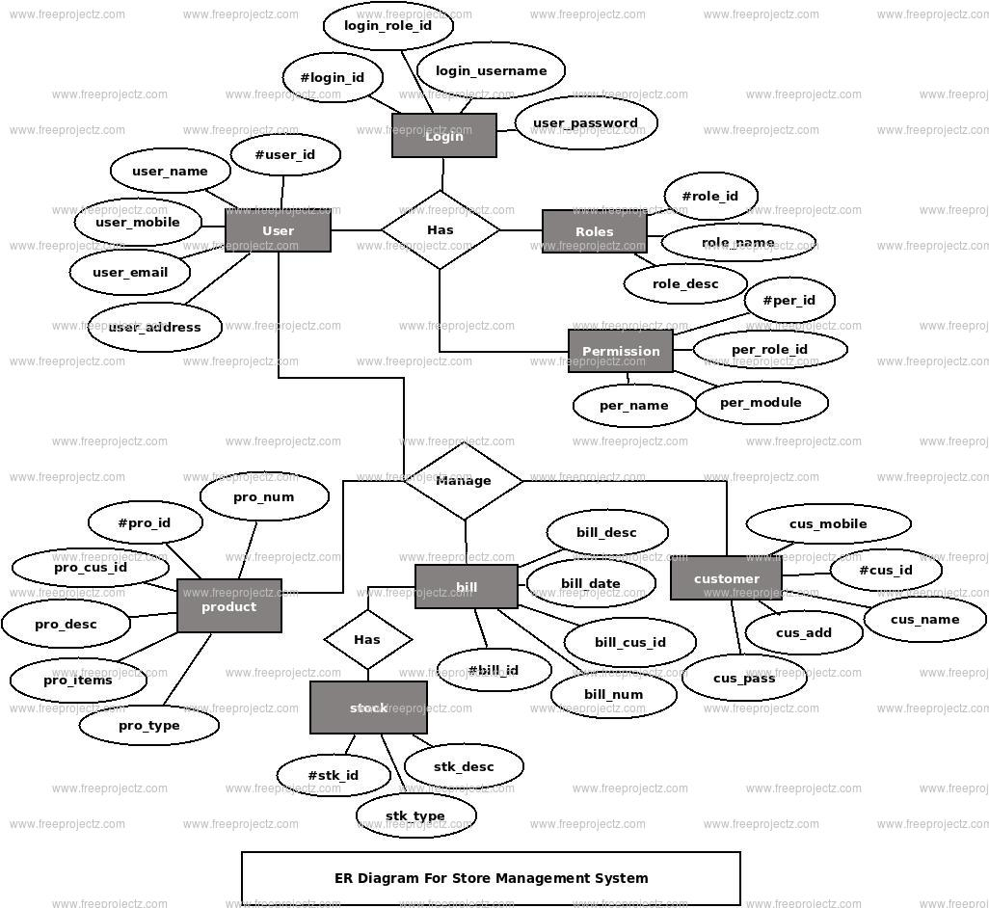

* TABLE REALTION:

In the context of **Database Management Systems (DBMS)**, a **table relation** refers to the logical relationship between tables in a relational database. A relational database is based on the concept of storing data in tables, and these tables can be related to each other through keys and constraints. The relationships between tables define how data in one table is connected or linked to data in another table. Understanding these relationships is fundamental to querying and organizing data in relational databases.

### Types of **Table Relations** in a Relational Database

1. **One-to-One Relationship** (1:1)
   * In a **one-to-one (1:1)** relationship, each record in one table is related to exactly one record in another table.
   * Example:
     + **Employee Table** (Employee_ID, Name, Address)
     + **Employee Details Table** (Employee_ID, SSN, Salary)
     + Each employee has exactly one set of details (SSN, Salary), and each set of details is related to only one employee.
   * In practice, one-to-one relationships are less common and are used when the data for a given entity is large and can be split across two tables for optimization or security reasons.
2. **One-to-Many Relationship** (1:M)
   * In a **one-to-many (1:M)** relationship, a single record in one table can be associated with multiple records in another table.
   * Example:
     + **Customer Table** (Customer_ID, Name, Email)
     + **Order Table** (Order_ID, Order_Date, Customer_ID)
     + One customer can place multiple orders, but each order belongs to only one customer. The **Customer_ID** in the Order Table is a foreign key linking back to the **Customer Table**.
   * This is the most common type of relationship in relational databases.
3. **Many-to-One Relationship** (M:1)
   * In a **many-to-one (M:1)** relationship, multiple records in one table are associated with a single record in another table. This is essentially the reverse of a one-to-many relationship.
   * Example:
     + **Order Table** (Order_ID, Order_Date, Customer_ID)
     + **Customer Table** (Customer_ID, Name, Email)
     + Multiple orders (from the Order Table) can belong to one customer (from the Customer Table).
4. **Many-to-Many Relationship** (M:N)
   * In a **many-to-many (M:N)** relationship, multiple records in one table can be associated with multiple records in another table. This requires the use of a **junction table** (also called a **link table** or **bridge table**) to store the relationship.
   * Example:
     + **Student Table** (Student_ID, Name)
     + **Course Table** (Course_ID, Course_Name)
     + **Enrollment Table** (Student_ID, Course_ID)
     + A student can enroll in multiple courses, and a course can have multiple students. The **Enrollment Table** is the junction table linking the two tables.

### **Key Concepts in Table Relations**

1. **Primary Key**:
   * A **primary key** is a column (or a set of columns) in a table that uniquely identifies each row in the table.
   * Example: In the **Customer Table**, **Customer_ID** could be the primary key.
2. **Foreign Key**:
   * A **foreign key** is a column (or set of columns) in one table that establishes a link between the data in two tables. The foreign key points to the primary key in another table.
   * Example: In the **Order Table**, **Customer_ID** would be a foreign key pointing to **Customer_ID** in the **Customer Table**.
3. **Referential Integrity**:
   * **Referential integrity** ensures that the foreign key in one table always refers to a valid record in another table. This means that foreign keys must match primary keys, or be NULL if the relationship allows for it.
4. **Normalization**:
   * **Normalization** is the process of organizing data in such a way that it minimizes redundancy and dependency by dividing large tables into smaller ones. This is done using the concept of relationships and ensures efficient storage and retrieval.
5. **Join Operations**:
   * **Join operations** are used to query data from multiple related tables. The most common types of joins are:
     + **INNER JOIN**: Returns records that have matching values in both tables.
     + **LEFT JOIN**: Returns all records from the left table and matched records from the right table. Non-matching records from the right table will have NULL values.
     + **RIGHT JOIN**: Similar to LEFT JOIN but returns all records from the right table.
     + **FULL JOIN**: Returns all records when there is a match in either left or right table.

* TABULAR FORMAT:

### **1. Customer Information Table**

| **Customer_ID** | **First_Name** | **Last_Name** | **Email** | **Phone_Number** | **Address** |
| --- | --- | --- | --- | --- | --- |
| 1 | John | Doe | john.doe@example.com | 555-1234 | 123 Main St, NY |
| 2 | Alice | Smith | alice.smith@example.com | 555-5678 | 456 Oak St, CA |
| 3 | Bob | Johnson | bob.johnson@example.com | 555-8765 | 789 Pine St, TX |
| 4 | Carol | White | carol.white@example.com | 555-4321 | 101 Maple St, FL |

### **2. Product Information Table**

| **Product_ID** | **Product_Name** | **Category** | **Price** | **Stock_Quantity** | **Supplier** |
| --- | --- | --- | --- | --- | --- |
| 101 | Laptop | Electronics | 800 | 25 | ABC Electronics |
| 102 | Coffee Maker | Appliances | 50 | 100 | XYZ Appliances |
| 103 | Desk Chair | Furniture | 120 | 15 | Furniture Co. |
| 104 | Wireless Mouse | Accessories | 25 | 200 | Tech Supplies |

### **3. Employee Records Table**

| **Employee_ID** | **Name** | **Position** | **Salary** | **Department** | **Joining_Date** |
| --- | --- | --- | --- | --- | --- |
| 001 | Jane Doe | Manager | 5000 | Sales | 2020-06-15 |
| 002 | John Smith | Assistant | 3000 | Marketing | 2021-09-20 |
| 003 | Emily Johnson | Developer | 4500 | IT | 2019-03-10 |
| 004 | Michael Brown | HR Executive | 3500 | Human Resources | 2018-12-05 |

### **4. Order Information Table**

| **Order_ID** | **Customer_ID** | **Order_Date** | **Product_ID** | **Quantity** | **Total_Amount** | **Status** |
| --- | --- | --- | --- | --- | --- | --- |
| 1001 | 1 | 2025-04-01 | 101 | 1 | 800 | Shipped |
| 1002 | 2 | 2025-04-02 | 102 | 2 | 100 | Pending |
| 1003 | 3 | 2025-04-03 | 103 | 1 | 120 | Delivered |
| 1004 | 4 | 2025-04-04 | 104 | 3 | 75 | Cancelled |

### **5. Inventory Table**

| **Product_ID** | **Product_Name** | **Category** | **Stock_Level** | **Restock_Level** | **Location** |
| --- | --- | --- | --- | --- | --- |
| 101 | Laptop | Electronics | 25 | 10 | Warehouse A |
| 102 | Coffee Maker | Appliances | 100 | 50 | Warehouse B |
| 103 | Desk Chair | Furniture | 15 | 5 | Warehouse C |
| 104 | Wireless Mouse | Accessories | 200 | 100 | Warehouse A |

### **6. Sales Transaction Table**

| **Transaction_ID** | **Customer_ID** | **Product_ID** | **Quantity** | **Unit_Price** | **Total_Price** | **Date** |
| --- | --- | --- | --- | --- | --- | --- |
| 5001 | 1 | 101 | 1 | 800 | 800 | 2025-04-01 |
| 5002 | 2 | 102 | 2 | 50 | 100 | 2025-04-02 |
| 5003 | 3 | 103 | 1 | 120 | 120 | 2025-04-03 |
| 5004 | 4 | 104 | 3 | 25 | 75 | 2025-04-04 |

* TABLE CREATION:

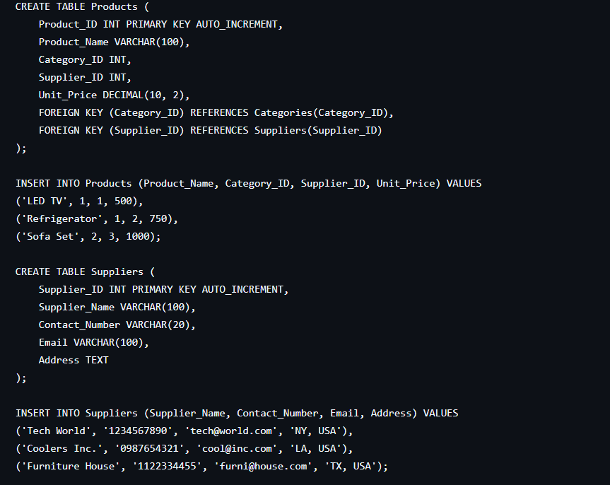

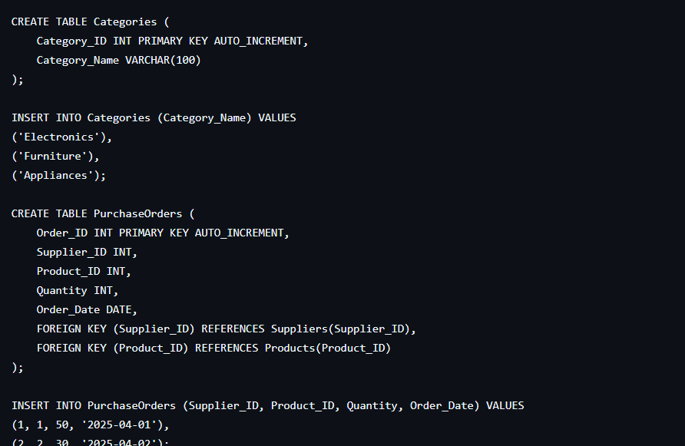

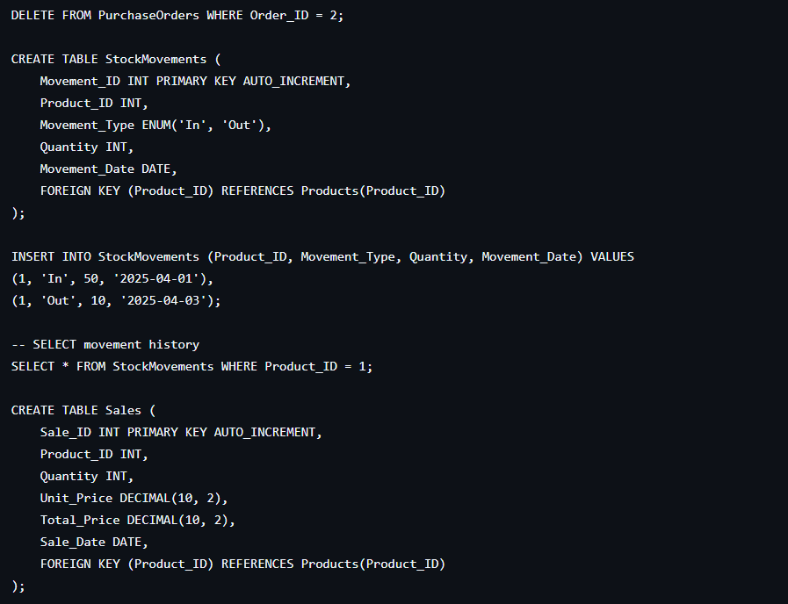

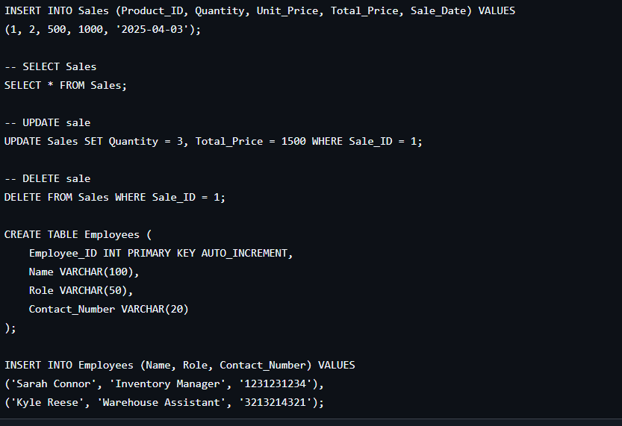

* SQL QUERIES WITH OUTPUT:

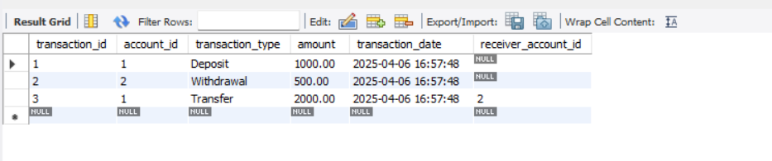

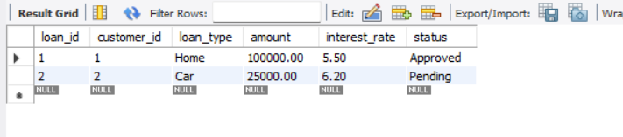

* SUMMARY:

### **Summary: Inventory Management in a Retail Store in DBMS**

Inventory management in a retail store is crucial for ensuring that products are available to meet customer demand while minimizing excess stock. A **Database Management System (DBMS)** plays a vital role in efficiently managing and tracking inventory data, streamlining operations, and optimizing the supply chain. The integration of a DBMS in inventory management allows for real-time data access, better accuracy, and improved decision-making.

The key components involved in **inventory management in a retail store** using a DBMS include:

1. **Product Information**: Storing detailed data about each product, such as product IDs, names, descriptions, prices, and quantities in stock.
2. **Stock Tracking**: Real-time updates on stock levels, with triggers or alerts for low stock, helping store managers reorder products before they run out.
3. **Sales and Purchase Records**: The DBMS captures all sales and purchase transactions, allowing the system to adjust stock levels automatically and maintain an accurate inventory.
4. **Supplier Information**: The system can store details about suppliers, lead times, and costs to facilitate better procurement and restocking decisions.
5. **Database Queries and Reporting**: The ability to query the database allows managers to generate reports such as stock status, sales trends, and product performance, which aids in better planning and forecasting.
6. **Security and Integrity**: A DBMS ensures data security and integrity by controlling access permissions and maintaining transaction logs, preventing issues like data loss or unauthorized access.

In conclusion, using a **DBMS** in inventory management helps retail stores maintain efficient operations, reduce errors, and provide better service to customers by ensuring that the right products are available at the right time. By integrating features like real-time updates, data tracking, and reporting, a DBMS enhances the overall management of inventory, contributing to cost savings and improved customer satisfaction.

* CONCLUSION:

### **Conclusion: Inventory Management in a Retail Store in DBMS**

In conclusion, inventory management in a retail store, when integrated with a **Database Management System (DBMS)**, greatly enhances the efficiency and accuracy of managing stock levels. The DBMS allows for real-time tracking of inventory, ensuring that stores can meet customer demand without overstocking or running out of stock. By automating processes such as stock updates, order management, and supplier coordination, the DBMS streamlines operations and helps reduce human errors.

Moreover, a DBMS provides tools for generating detailed reports and insights into sales trends, stock performance, and supply chain operations, aiding decision-making and forecasting. It also enhances security by safeguarding inventory data and ensuring data integrity through access controls and transaction logs.

Overall, utilizing a **DBMS** in inventory management ensures that retail stores can operate more effectively, reduce operational costs, and improve customer satisfaction by maintaining the right stock levels at all times. The use of real-time updates and accurate data management leads to a more responsive and efficient retail environment.

🎯 Final Thought:  
Incorporating a Database Management System (DBMS) into inventory management for a retail store is a game-changer. It not only streamlines the entire process of tracking and managing stock but also provides a level of control, accuracy, and efficiency that manual systems simply can't match. With features like real-time data updates, automated stock adjustments, and robust reporting tools, a DBMS allows retail businesses to optimize their operations, reduce waste, and make more informed decisions.

Ultimately, the success of a retail store depends on maintaining the right balance of inventory, and a DBMS ensures that this balance is achieved. Whether it's preventing stockouts, improving order fulfillment, or forecasting demand, the integration of a DBMS is essential for staying competitive in today's fast-paced retail environment. Embracing this technology not only boosts operational efficiency but also enhances the overall customer experience, paving the way for business growth and long-term success. 

<https://github.com/gungun49159/Inventory-Management-in-a-Retail-Store/tree/main>