Frame It as Cases
Work That Speaks for Itself — Case Study Portfolio

Voice Card
direct, clear, professional, no buzzwords
(Pasted into my Claude Project as a standing custom instruction.)

Case 1 — Environment and AI Toolchain (FE-01)
The Problem: Starting the Frontend AI Engineering track required a working AI-assisted development environment before any real build work could begin — without it, every later assignment would stall.
What I Did: Installed Node.js (LTS) and Git, and set up Claude Code as the AI assistant. Created the capstone GitHub repository on a React 19 + Vite + Tailwind CSS stack (plain JavaScript, no TypeScript, no framework routing), with a README, license, .gitignore, and a CLAUDE.md describing project conventions — including rules like "every form input must have a label," "validate all user inputs with inline, announced errors," and "mobile-first development, breakpoints layered on top."
What Came of It: A working toolchain and a capstone repo with three Conventional-Commits-formatted commits, ready to build real, accessible, component-based features on. Setup went smoothly with no major blockers.

Case 2 — The AI-Assisted Workflow Drill (FE-03)
The Problem: I needed to see, concretely, the difference between a vague AI prompt and a precise, verified one — not just believe it in theory. I picked an account Settings form (name, email, language, dark mode, save) as the test feature.
What I Did: Built the form twice, on separate branches. Round one used one vague, one-sentence prompt — "Make a settings page in React with name, email, language, dark mode, and a save button" — and I accepted the output as-is. Round two used a fully specified prompt naming the exact stack, validation rules, accessibility requirements (label association, keyboard nav, visible focus, semantic HTML), responsive breakpoints, and an explicit four-component structure (InputField, Toggle, Button, SettingsForm).
The AI Mistake I Caught: Even in the precise Round 2 build, the AI’s first draft of InputField validated the email field’s format but linked its aria-describedby to an id that didn’t match the rendered error paragraph, and left out aria-invalid entirely. It looked correct — the error text showed up fine visually — but a screen-reader user tabbing into the field would have heard only the label, never the error. I fixed it by deriving a single shared errorId for the id/aria-describedby pair and adding aria-invalid={hasError}.
What Came of It: Round 1 produced one unreviewable file: no validation, placeholder-only labels, a bare checkbox for dark mode, and a layout that broke under 500px. Round 2 produced four focused, reusable components with real inline validation, a keyboard-operable custom Toggle, mobile-first responsive layout, and a live-region success message — needing a spot-check instead of a rewrite. I updated CLAUDE.md with rules like "every form input must have a label," "accessibility before styling," and "small, focused components," learned directly from this comparison.

Case 3 — What Are You Proving?
The Problem: A portfolio with no clear claim is just decoration — it needed one narrow, honest claim, one specific audience, and one action before any other page could be designed.
What I Did: Used Claude as an interviewer, not an author — it asked sharp follow-up questions until the claim was genuinely narrow and true, pushing back on vague or overclaimed language. Landed on this proof statement, built around a real project: "I built BugHunter AI, a Streamlit tool that uses the Gemini API to detect bugs in code and return a corrected fix — solo, end to end. I tested it against a handful of broken code samples and it correctly identified the bug and produced a working fix in each case. It’s not a finished product yet — explanations and code-quality review are still unbuilt — but the core piece, getting an LLM to actually localize and fix a real bug, already works. I’m a 5th-semester engineering student building this because I want to get good at using AI as a force-multiplier on real problems, not just talk about it. If you’re a technical hiring manager who wants to see how someone actually thinks through a problem rather than just what’s on a resume, take a look at my work — then reach out."
One Claim: I can build a working, solo, end-to-end AI-powered tool (BugHunter AI) that uses an LLM to localize and fix real bugs in code — not just talk about using AI.
One Person: A technical hiring manager who wants to see how someone actually thinks through a problem, not just what’s listed on a resume.
One Action: Look at the work, then reach out.
What Came of It: A one-paragraph proof statement (claim + person + action) plus one honest line on why this needs to exist: a resume can say "used Gemini API," but it can’t show how I actually approached debugging a real fix or the judgment behind it — that’s what the case study on this site is for.

Case 4 — Draw the Path: Portfolio Sitemap + Toolkit
The Problem: Once the proof statement was settled, I needed the smallest possible sitemap that could walk one specific person from landing on the site to believing the claim to taking the one action — without adding pages "just because."
What I Did: Sketched a four-page sitemap by hand — Home, Work, About, Contact — mapped directly to the claim and the one action: Home carries the claim ("fast, quality work using AI"), Work holds the proof/examples, About is a short bio, and Contact is the one action ("get in touch"). Set up free accounts across Claude, ChatGPT, Gemini, and Perplexity, and created a dedicated Claude Project with the proof statement pasted in as a custom instruction, configured to act as a tutor. Ran a pressure-test prompt asking Claude to stress-test the sitemap against the claim and the one action.
What Came of It: The pressure-test surfaced a real weakness: the Work / Case Studies page was the weakest link, because it needed concrete proof of speed — manual time versus AI-assisted time — rather than just a finished output. That finding directly shaped how this case-study document itself was built.
Sitemap Sketch:
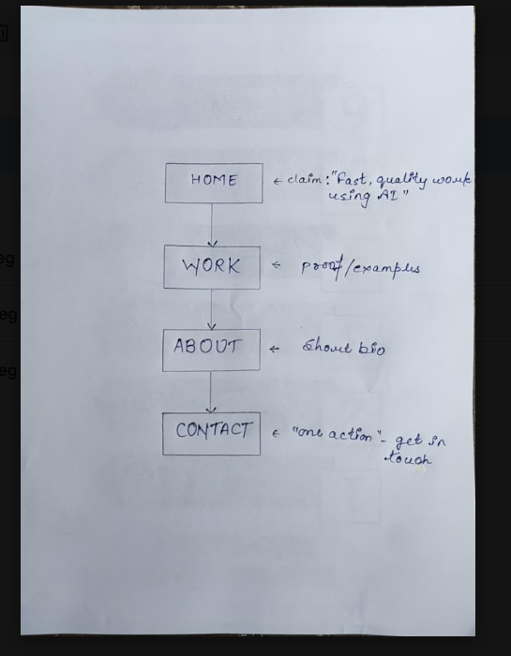
Configured Claude Project ("AI Workflow Audit"):
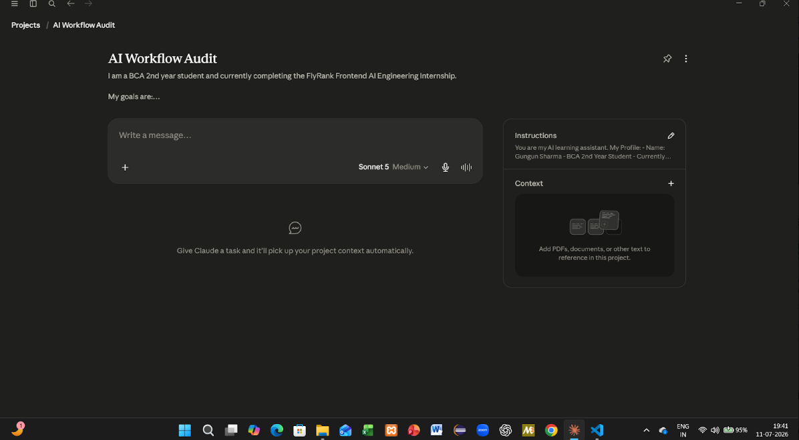

Case 5 — AI Workflow Audit and Tool Setup (FL-01)
The Problem: Improving how I work with AI first required mapping how I actually work today — where AI genuinely helps, where it wastes time, and where it should never be trusted — rather than guessing.
What I Did: Listed recurring tasks from a real week as a BCA 2nd-year student currently completing the FlyRank Frontend AI Engineering Internship, and classified each:
Task | Classification | Rationale
Building UI components (e.g. settings form) | Delegate to AI with review | AI drafts fast, but I review for accessibility and correctness before merging.
Researching library docs / APIs (e.g. Gemini API) | Collaborate with AI | AI helps surface options quickly, but I cross-check against official docs.
Debugging failing code | Collaborate with AI | AI is good at spotting likely causes, but I verify the actual fix myself.
Writing Git commit messages | Delegate to AI with review | Fast to generate, low risk, quick to edit if the summary is off.
Core algorithm / logic design | Just me | This is where I actually learn — outsourcing it defeats the point of the coursework.
Writing unit tests | Collaborate with AI | AI drafts test cases, I decide which edge cases actually matter.
Exam / concept revision | Just me | Understanding has to be mine; AI summaries don’t stick the same way.
Formatting README / documentation | Delegate to AI with review | Low-stakes, mostly structural — quick to check over.
Proofreading assignment write-ups | Collaborate with AI | AI catches phrasing issues, I keep the actual voice and claims mine.
Scheduling / reminders for deadlines | Fully automate | No judgment needed — a calendar/AI reminder handles this reliably.
Exploring project ideas (e.g. BugHunter AI concept) | Collaborate with AI | AI is a good sounding board, but the direction and scope decisions are mine.
Reviewing AI-generated code for accessibility/security gaps | Just me | This is exactly the kind of gap (like the FE-03 aria-describedby bug) that AI itself misses — needs a human check.

What Came of It: Set up Claude, ChatGPT, and Anthropic Academy accounts, enrolled in AI Fluency: Framework & Foundations, and created a Claude Project with custom instructions covering who I am, tone preferences, and current goals. Selected three target tasks to reuse across FL-02 through FL-04:
1. Building UI components: "Done well" means the AI output passes an accessibility and semantics check (correct labels, aria-* wiring, keyboard support) before merge, not just a visual check.
2. Researching APIs/libraries: "Done well" means claims are cross-verified against the official docs, not taken as-is from an AI summary.
3. Reviewing AI-generated code for accessibility/security gaps: "Done well" means every AI-authored component gets a manual keyboard-only and screen-reader pass before it’s considered reviewed, since this is the category where AI mistakes are least visible on the surface.
Anthropic Academy Certificate of Completion (AI Fluency: Framework & Foundations):
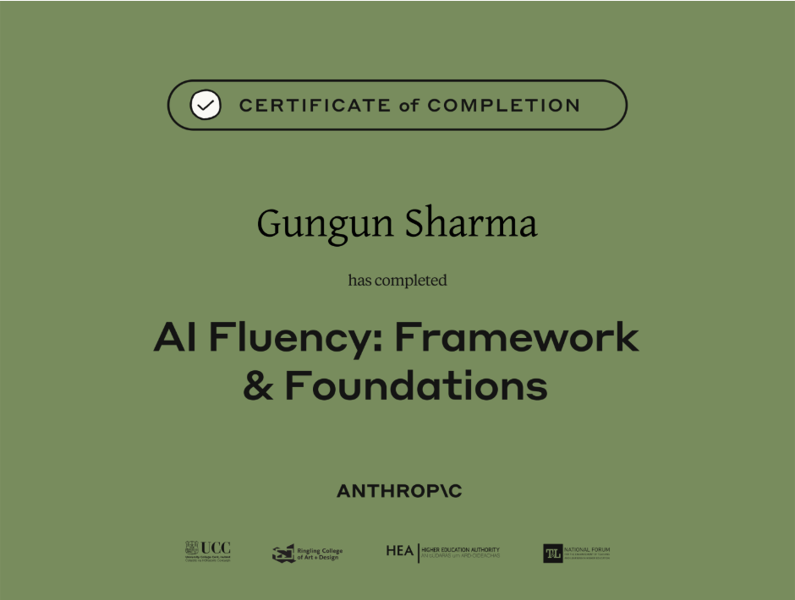

Before / After Example
Generic AI line: "I leverage cutting-edge AI tools to deliver results-driven solutions that exceed expectations."
My edited version: "I built BugHunter AI solo — a tool that uses the Gemini API to actually find and fix real bugs in code, not just talk about using AI."
The generic line could describe anyone. The edited version names the actual project, the actual technology, and the actual claim — which is exactly what a specific hiring manager needs to evaluate, and what no amount of "results-driven" language can substitute for.

