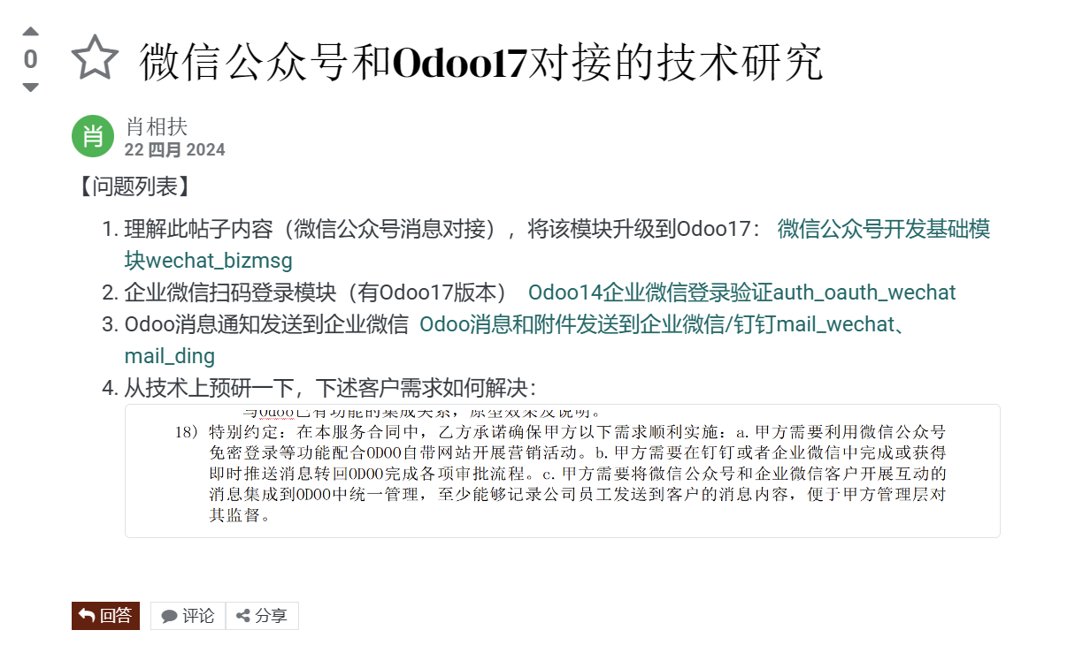

1.微信模块：
NO | 功能模块 | 模块名称 | 模块依赖 | 描述 | 测试环境 | 源码来源 | 版本差异 | 本次扩展
1 | 微信登录模块 | wechat_login | auth_oauth | 扫码登录+点击登录 | 16,17 | 老周 | 一般 | 无
2 | 企业微信登录模块 | auth_oauth_wechat | auth_oauth | 扫码登录+点击登录+自动登录 | 16,17 | 祥海 | 未知 | 扩展：自动登录
3 | 企业微信消息推送模块 | mail_wechat | auth_oauth_wechat | 消息推送 | 17 | 肖总 | 较大 | 扩展：适配
4 | 公众号接口模块 | wechat_bizmsg |  | 自动登录+聊天打通odoo | 16 | 肖总 | 较大 | 扩展：全部
2.知识点：
关于微信基本思路：
2.1微信登录
2.2微信消息
  - odoo-消息

2.1微信登录流程
2.1.1情况1：
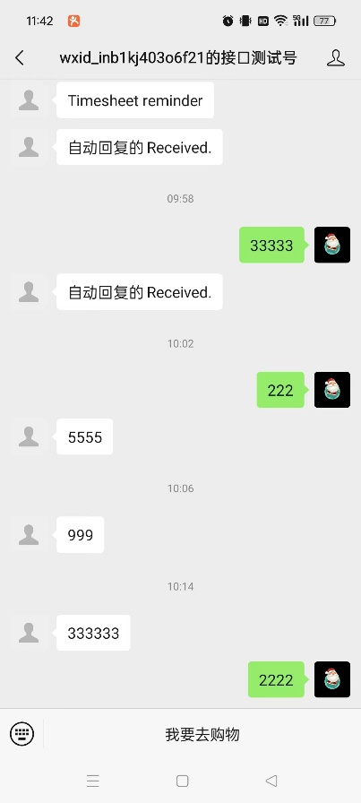
Button_URL:https://open.weixin.qq.com/connect/oauth2/authorize?appid=wx0122687d0c0027e7&redirect_uri=https%3A%2F%2Ferp2279.s2.oscg.cn%2Fwechat%2Fsignin&response_type=code&scope=snsapi_userinfo&state=erp2279#wechat_redirect

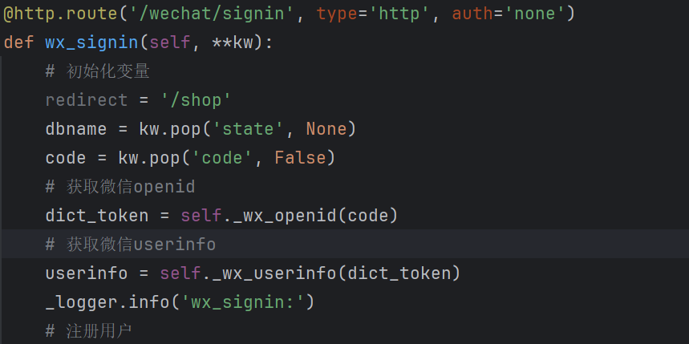

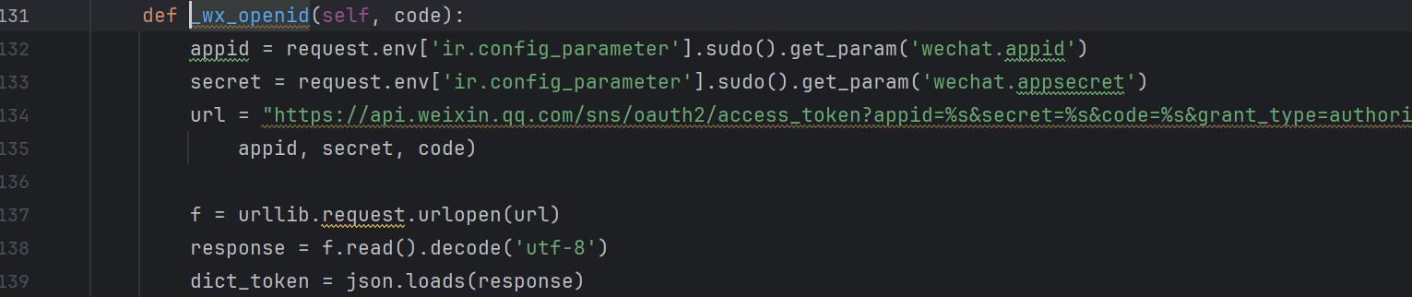
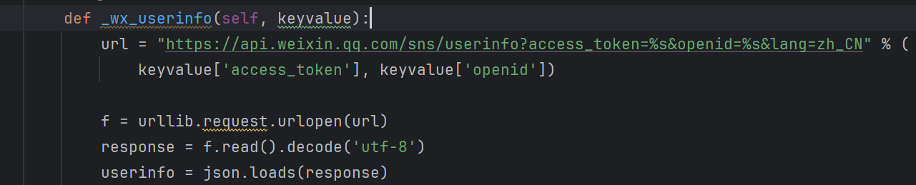

微信测试账号申请：
微信公众平台 (qq.com)
https://mp.weixin.qq.com/debug/cgi-bin/sandbox?t=sandbox/login
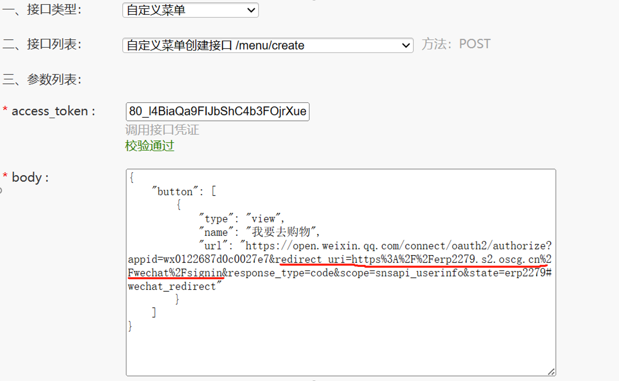
接口调试工具网址：
https://mp.weixin.qq.com/debug/cgi-bin/apiinfo?t=index&type=%E8%87%AA%E5%AE%9A%E4%B9%89%E8%8F%9C%E5%8D%95&form=%E8%87%AA%E5%AE%9A%E4%B9%89%E8%8F%9C%E5%8D%95%E5%88%9B%E5%BB%BA%E6%8E%A5%E5%8F%A3%20/menu/creat

下边是菜单设置：

{
"button": [
{
"type": "view",
"name": "去购物17",
"url": "https://open.weixin.qq.com/connect/oauth2/authorize?appid=wx0122687d0c0027e7&redirect_uri=https%3A%2F%2Fwechat.oscg.cn%2Fwechat%2Fsignin&response_type=code&scope=snsapi_userinfo&state=odoo17_new#wechat_redirect"
},
{
"name": "发图",
"sub_button": [
{
"type": "pic_sysphoto",
"name": "系统拍照发图",
"key": "rselfmenu_1_0",
"sub_button": [ ]
},
{
"type": "pic_photo_or_album",
"name": "拍照或者相册发图",
"key": "rselfmenu_1_1",
"sub_button": [ ]
},
{
"type": "pic_weixin",
"name": "微信相册发图",
"key": "rselfmenu_1_2",
"sub_button": [ ]
}
]
}
]
}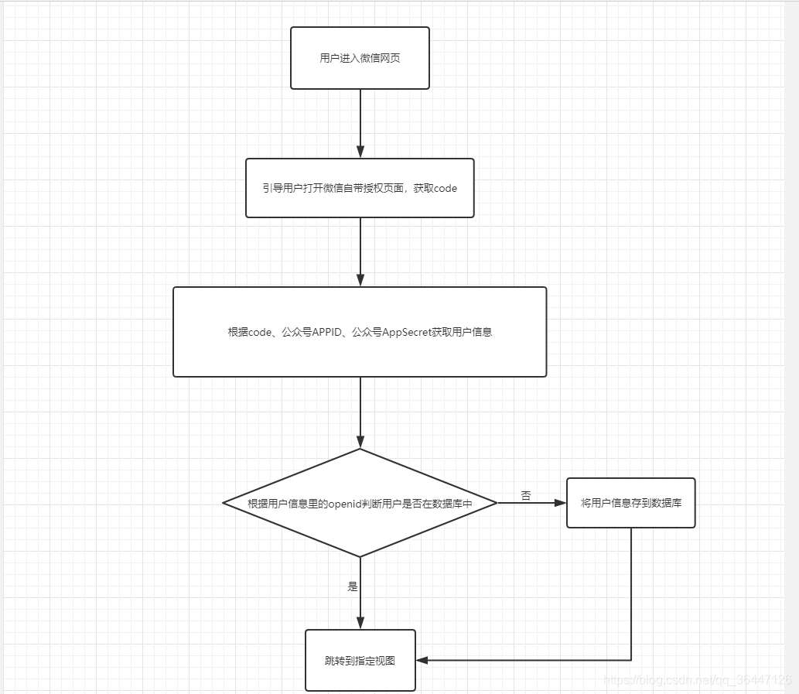

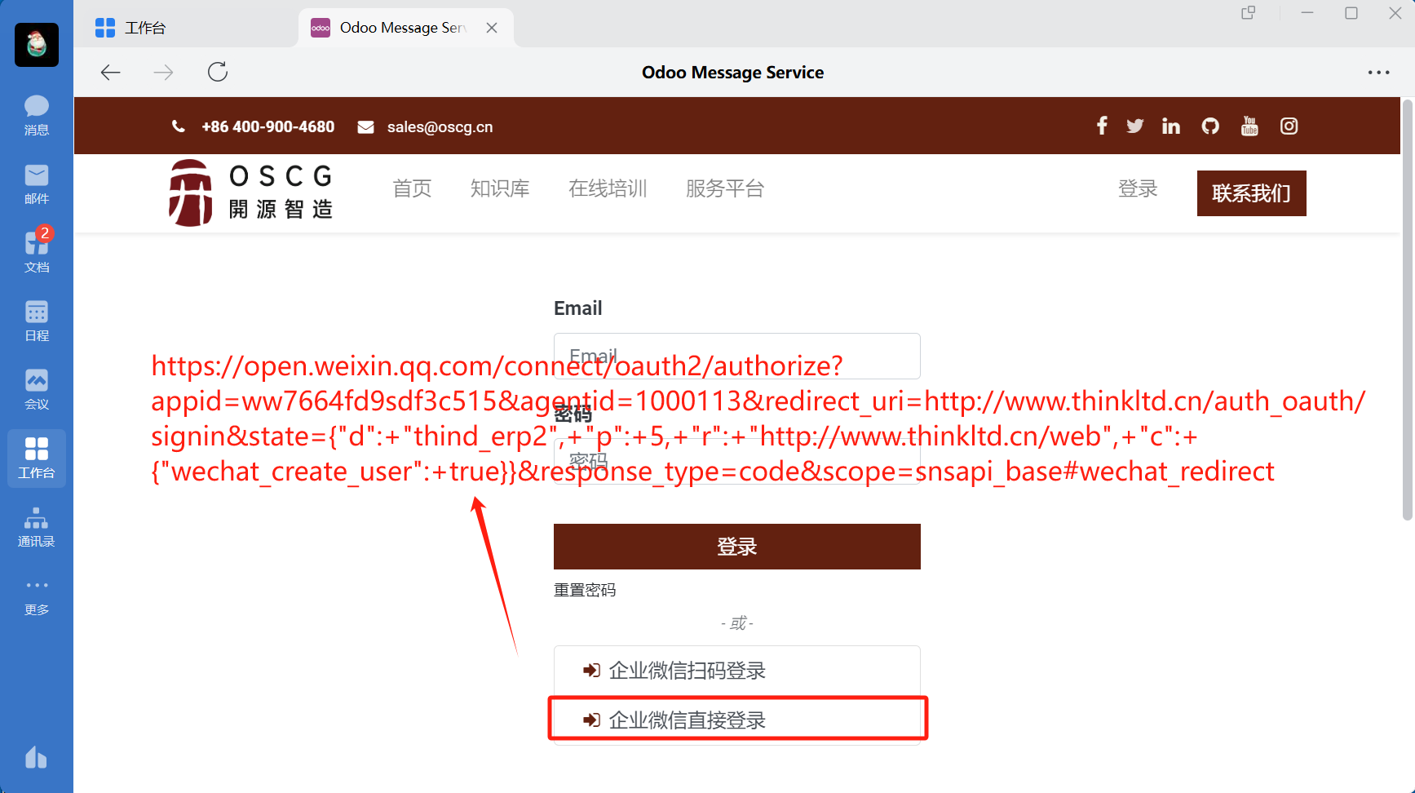
2.1.1情况2，

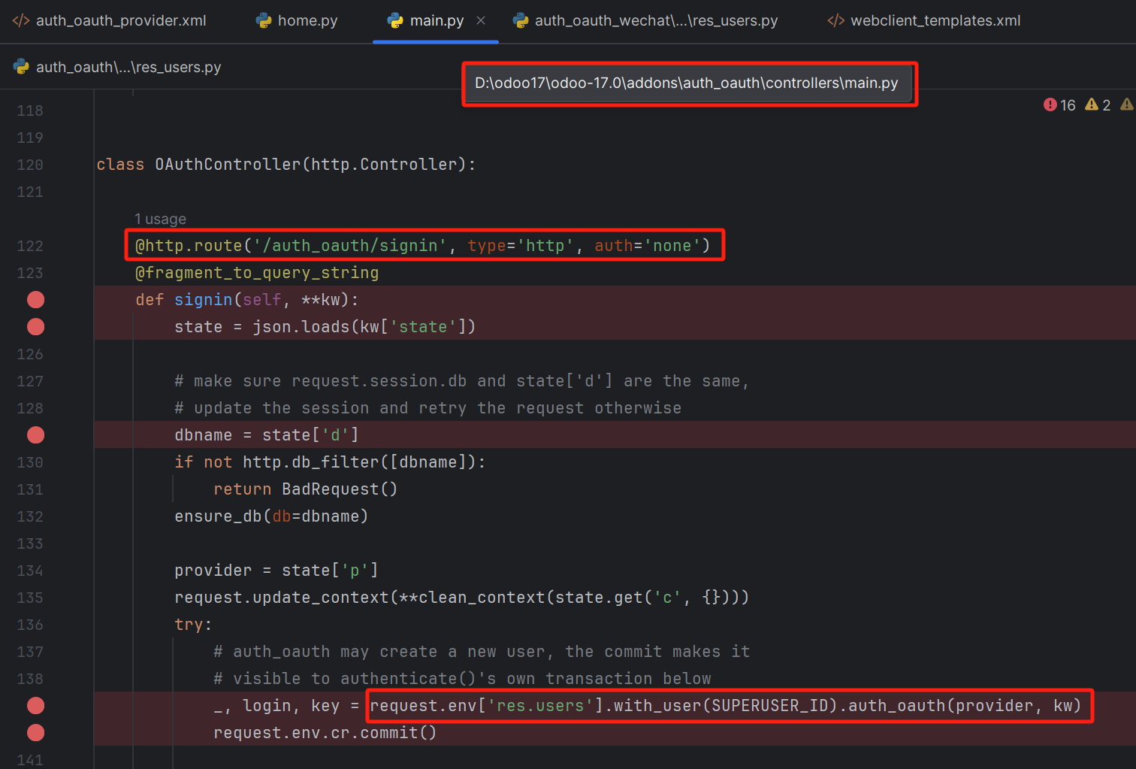

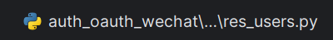
class ResUsers(models.Model):
_inherit = 'res.users'
@api.model
def auth_oauth(self, provider, params):
oauth_provider = self.env['auth.oauth.provider'].browse(provider)
if oauth_provider.auth_endpoint.find('weixin') >= 0: # 微信认证
return self.auth_oauth_wechat(oauth_provider, params)
else:
return super(ResUsers, self).auth_oauth(provider, params)

@api.model
def auth_oauth_wechat(self, provider, params):
# 微信获取访问用户身份的URL https://qyapi.weixin.qq.com/cgi-bin/user/getuserinfo?access_token=ACCESS_TOKEN&code=CODE
# 微信获取access_token的URL https://qyapi.weixin.qq.com/cgi-bin/gettoken?corpid=ID&corpsecret=SECRET
#
#
def gettoken(url, corpid, corpsecret):
url_token = "%s?corpid=%s&corpsecret=%s" % (url, corpid, corpsecret)
headers = {'Content-Type': 'application/json'}
response = requests.get(url_token, headers=headers)
dict_token = response.json()
if dict_token["errcode"] == 0:
return dict_token["access_token"]
else:
raise OAuthLogin(
"微信获取access_token错误：err_code=%s, err_msg=%s" % (dict_token["errcode"], dict_token["errmsg"]))

client_ids = provider.client_id.split(' ')
if not client_ids or len(client_ids) != 3:
raise OAuthLogin("请正确设置微信登录验证的corpid agentid corpsecret！")
corpid = client_ids[0]
corpsecret = client_ids[2]
access_token = provider.scope
code = params.get('code', False)
if not access_token:
access_token = gettoken(provider.validation_endpoint, corpid, corpsecret)
if not code:
raise OAuthLogin("微信扫码错误：没有 code！")
provider.scope = access_token

oauth_uid = False
headers = {'Content-Type': 'application/json'}
user_url = "%s?access_token=%s&code=%s" % (provider.data_endpoint, access_token, code)
response = requests.get(user_url, headers=headers)
dict_user = response.json()
if dict_user["errcode"] == 0:
oauth_uid = dict_user["UserId"]
elif dict_user["errcode"] == 40014 or dict_user[
"errcode"] == 42001: # 40014: 不合法的access_token, 42001: access_token expired
access_token = gettoken(provider.validation_endpoint, corpid, corpsecret)
provider.scope = access_token
user_url = "%s?access_token=%s&code=%s" % (provider.data_endpoint, access_token, code)
response = requests.get(user_url, headers=headers)
dict_user = response.json()
oauth_uid = dict_user["UserId"]
else:
raise OAuthLogin(
"微信获取访问用户身份错误：err_code=%s, err_msg=%s" % (dict_user["errcode"], dict_user["errmsg"]))

user_id = self.search([('oauth_uid', '=', oauth_uid), ('oauth_uid', '!=', False)], limit=1)
if not user_id:
if self.env.context.get('wechat_create_user', False): # 自动创建企业微信User
user_id = self.create_from_wechat(provider, access_token, oauth_uid, code)
if not user_id:
_logger.exception(
"OAuth Wechat: 微信访问用户【UserId：%s】没有关联Odoo账号，且自动创建失败！" % (oauth_uid,))
raise AccessDenied("微信访问用户【UserId：%s】没有关联系统账号！" % (oauth_uid,))
else:
_logger.exception("OAuth Wechat: 微信访问用户【UserId：%s】没有关联Odoo账号！" % (oauth_uid,))
raise AccessDenied("微信访问用户【UserId：%s】没有关联系统账号！" % (oauth_uid,))
else:
user_id.oauth_access_token = code

return (self.env.cr.dbname, user_id.login, code)

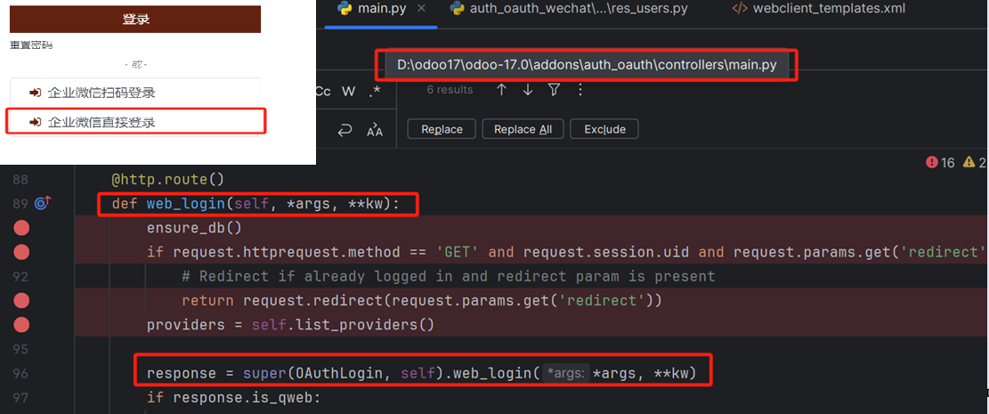

以下代码完成自动登录，实际上是模拟人点击的动作：


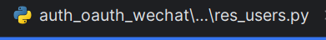
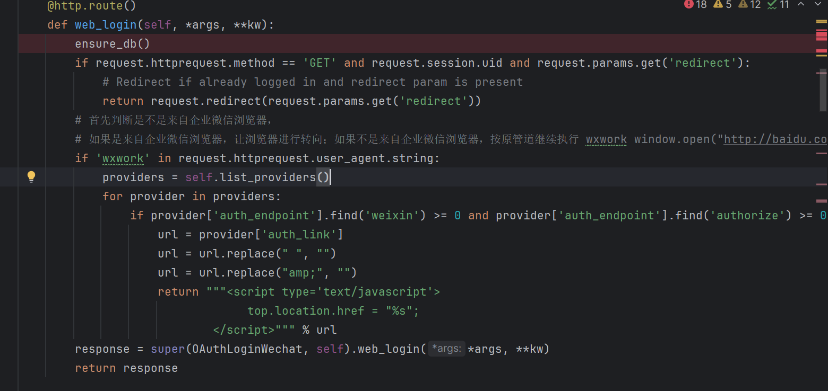

2.2微信消息
2.2.1企业微信消息推送
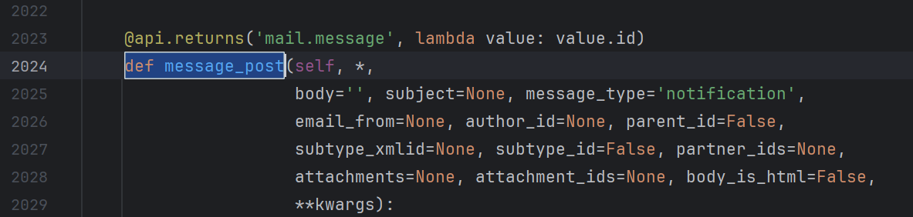

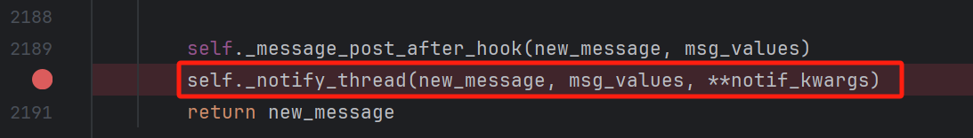

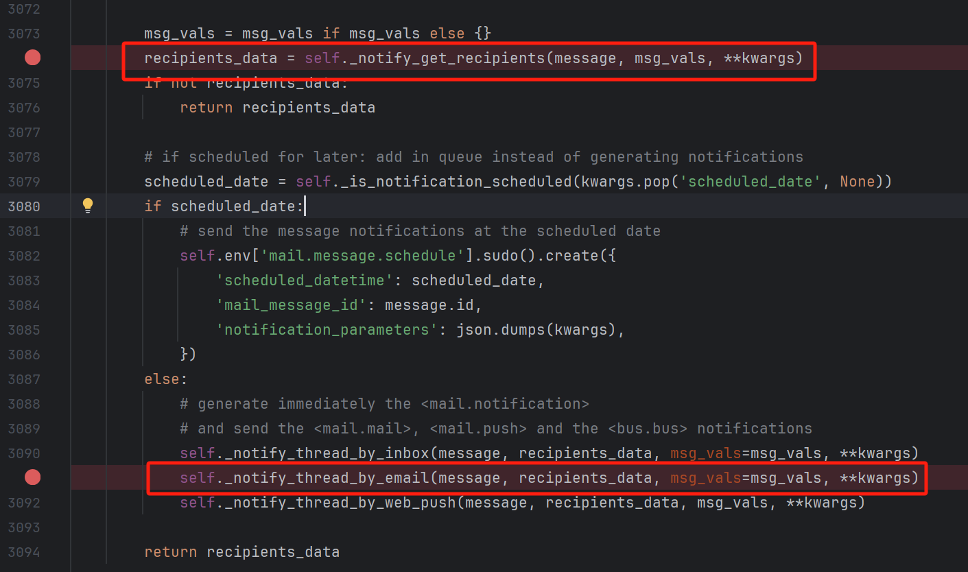

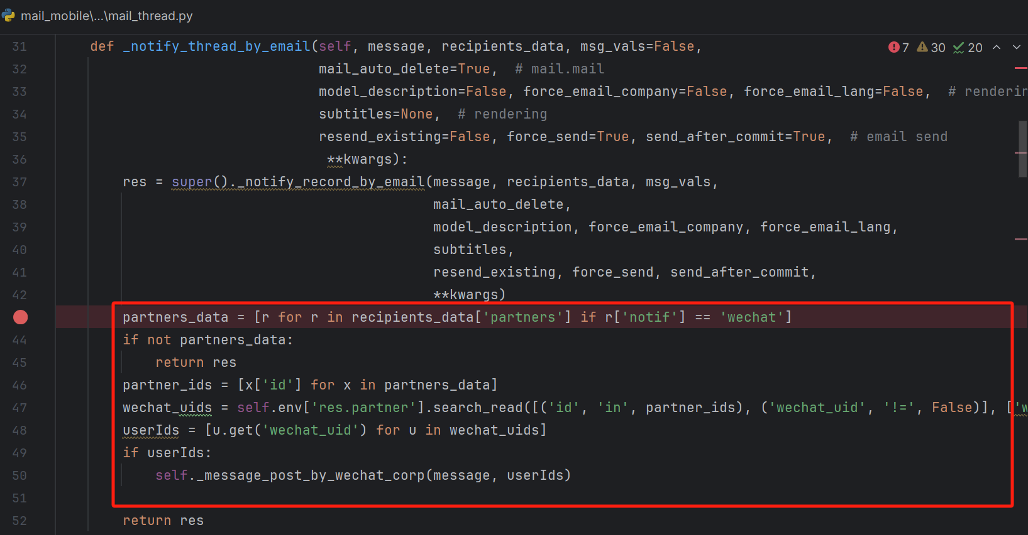

2.2.1公众号微信消息
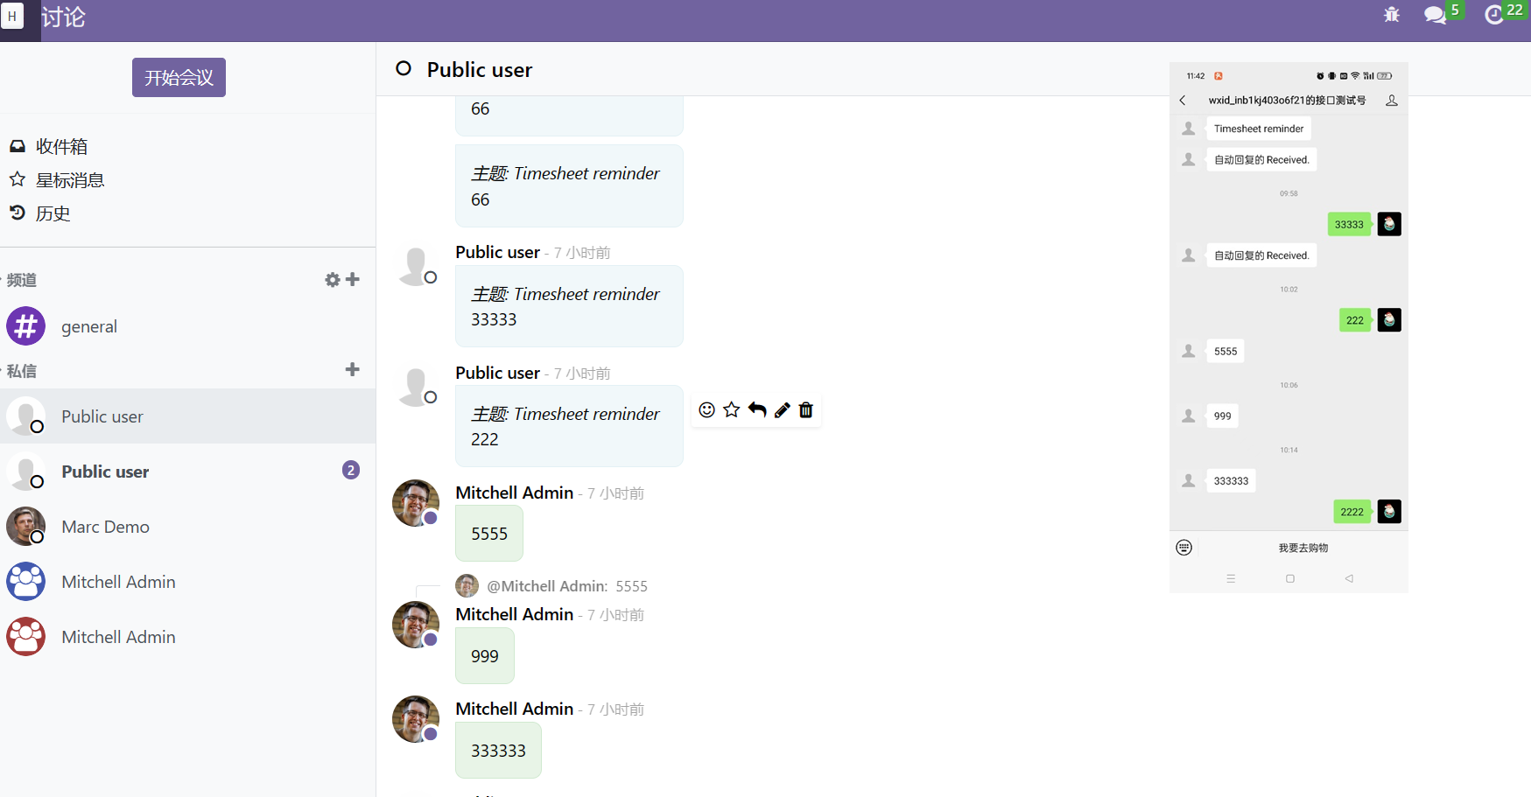
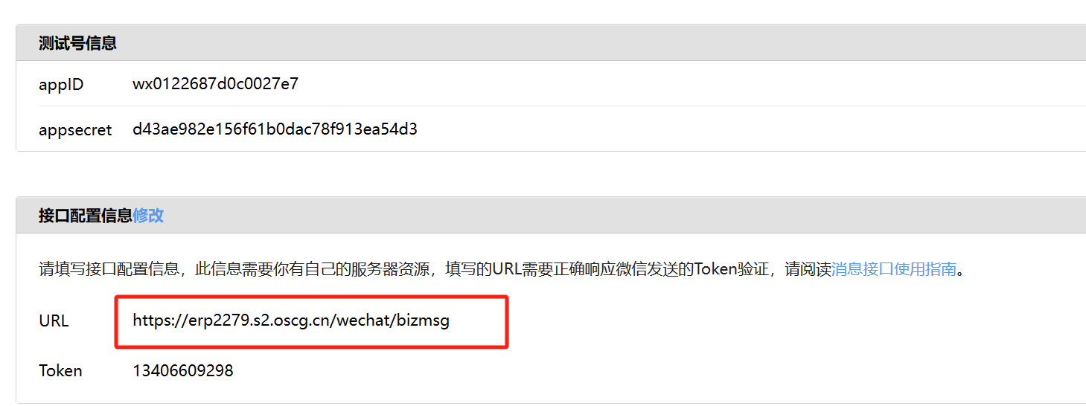

@http.route(‘/wechat/bizmsg’, type=”http”, auth=’public’, csrf=False)
def wx_bizmsg(self, **kwargs):
“””微信公众号消息处理
“””
signature = kwargs.get(“signature”)
timestamp = kwargs.get(“timestamp”)
nonce = kwargs.get(“nonce”)
response_msg = self._check_sign(signature, timestamp, nonce)
if response_msg and request.httprequest.method == ‘GET’:
echostr = kwargs.get(“echostr”)
return echostr
if not response_msg: # 校验通不过，不是来自微信的消息
return “”
openid = kwargs.get(“openid”)
chat_xml = request.httprequest.data
msg = parse_message(chat_xml)

if msg.type == “text”:
# 回复文本消息
# 让这个消息，进入odoo的消息管道
user = request.env[‘res.users’].sudo().search([(‘wx_openid’, ‘=’, openid)], limit=1)
if user:
_logger.info(‘用户存在接收该用户的消息: ‘)
# 要建立跟客服的消息 桥梁
# 测试中代码
request.env[‘res.users’].sudo().create_channel(user.partner_id, 3,openid)
_logger.info(‘创建消息管道结束: ‘)
#request.env[‘res.users’].sudo().in_message(3, 7, msg.content)
Request.env[‘res.users’].sudo().in_message(3, user.partner_id.id, msg.content,openid)

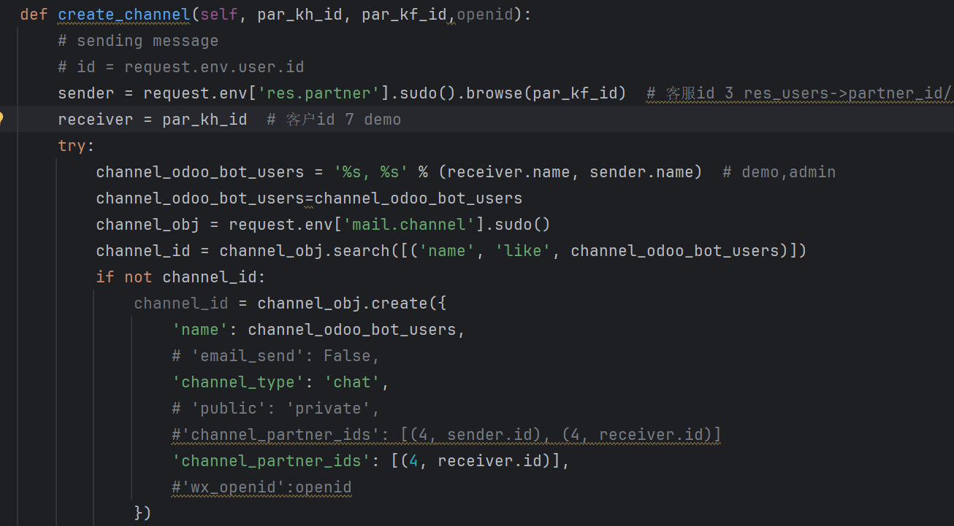

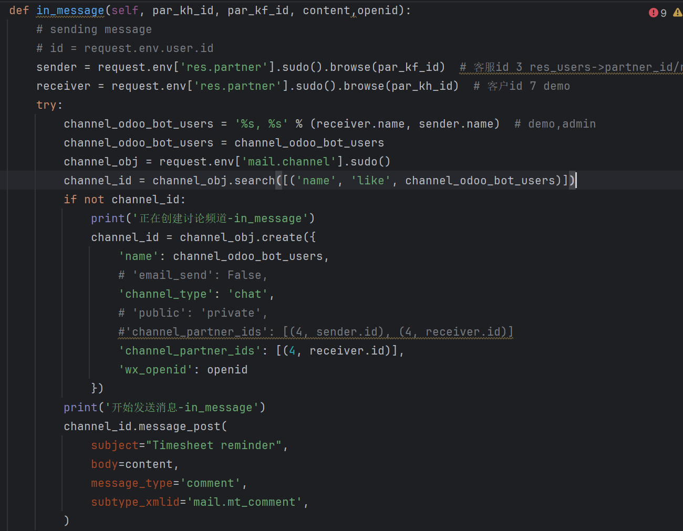
Odoo端发送消息到微信：拦截这个消息
