Power BI Project Report
Manufacturing Data Analysis and Interactive Dashboard
Student Name: GUNIKA SETHI
Registration Number: PIET24CD028
Project Title: Manufacturing Data Analysis and Interactive Dashboard Using Power BI

1. Introduction
Manufacturing data can help organizations understand production activity, machine performance, and energy usage. This project uses Microsoft Power BI to organize manufacturing data into an interactive dashboard. KPI cards, charts, and slicers present key information and let users explore production performance.
The report describes the dataset, preparation approach, data model, example DAX measures, dashboard topics, and operational insights. It is structured as a practical project report, with one major topic on each page.

2. Dataset Description
The project uses a manufacturing dataset containing approximately 1,000 job records. Each row represents a job and includes fields such as:
- Job_ID and Job_Status
- Machine_ID and Machine_Availability
- Operation_Type and Material_Used
- Processing_Time and Energy_Consumption
- Scheduled_Start, Scheduled_End, Actual_Start, and Actual_End
These fields support analysis of job completion, machine performance, processing time, and energy consumption. The dataset does not include revenue, cost, or profit fields. As a result, the report focuses on operational performance rather than financial profit.

3. Project Objectives
The project aims to turn manufacturing records into a clear, interactive view of operational performance. Its objectives are to:
- Clean and prepare manufacturing data for analysis.
- Summarize total, completed, and failed jobs.
- Compare job status and performance across machines.
- Analyze processing time and machine availability.
- Examine energy consumption by operation type.
- Create a multi-page interactive Power BI dashboard.
- Present findings in a clear and useful format.

4. Data Cleaning Performed
The dataset was imported into Power BI and reviewed in Power Query. The draft cleaning workflow includes these checks and transformations:
- Review column names and data types.
- Apply Trim and Clean to relevant text columns to remove unwanted spaces and non-printing characters.
- Check Job_ID for duplicate records.
- Check Actual_Start and Actual_End for blank or null values.
- Apply Power Query changes using Close & Apply.

5. Data Model
The report uses hybrid_manufacturing_categorical as its main data table. It contains the job, machine, timing, operation, material, status, availability, and energy fields used in the analysis.
The report is arranged into separate pages. Slicers and page navigation allow users to explore the dashboard and filter relevant visuals. The model view screenshot should be added below to document the final Power BI model.
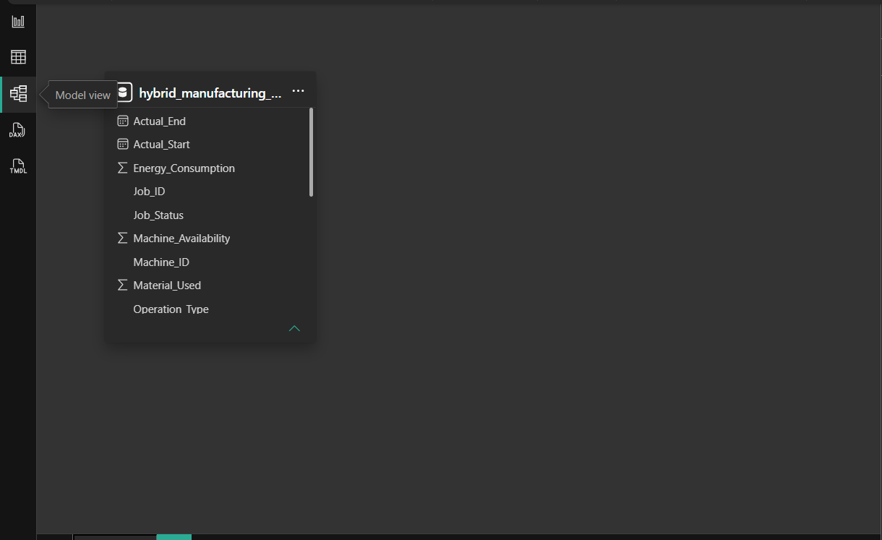

6. DAX Measures
The formulas below are examples for the dashboard. Confirm that the measure names and formulas match the measures in the final Power BI file.
Total Jobs =
COUNT('hybrid_manufacturing_categorical'[Job_ID])
Completed Jobs =
CALCULATE(
[Total Jobs],
'hybrid_manufacturing_categorical'[Job_Status] = "Completed"
)
Failed Jobs =
CALCULATE(
[Total Jobs],
'hybrid_manufacturing_categorical'[Job_Status] = "Failed"
)
Completion Rate =
DIVIDE([Completed Jobs], [Total Jobs], 0)
Total Machines =
DISTINCTCOUNT('hybrid_manufacturing_categorical'[Machine_ID])
Average Processing Time =
AVERAGE('hybrid_manufacturing_categorical'[Processing_Time])
Average Machine Availability =
AVERAGE('hybrid_manufacturing_categorical'[Machine_Availability])
Machine_Availability is stored on a 0–100 scale. For example, 89.16 represents 89.16%; it should not be formatted as a decimal percentage again.

7. Manufacturing Overview
This page presents an overall summary of manufacturing activity. KPI cards show total jobs, completed jobs, failed jobs, and completion rate. Charts provide an overview of job status and production information.
Use this page as the entry point to the report. It should help a reader understand the overall workload and status mix before exploring the more specific machine, job, and energy views.
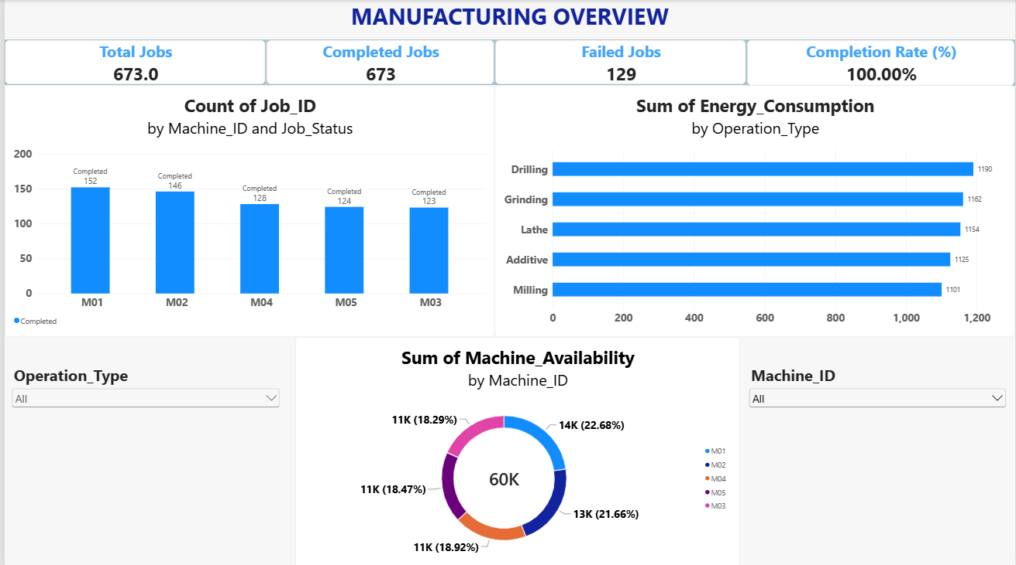

8. Machine Performance
This page focuses on machine-level performance. It includes measures such as total machines, average processing time, and average machine availability, along with visuals for comparing machines.
Machine comparisons can help users identify differences in processing time and availability. Interpret patterns in context and confirm that the visuals use the intended filters and aggregation.
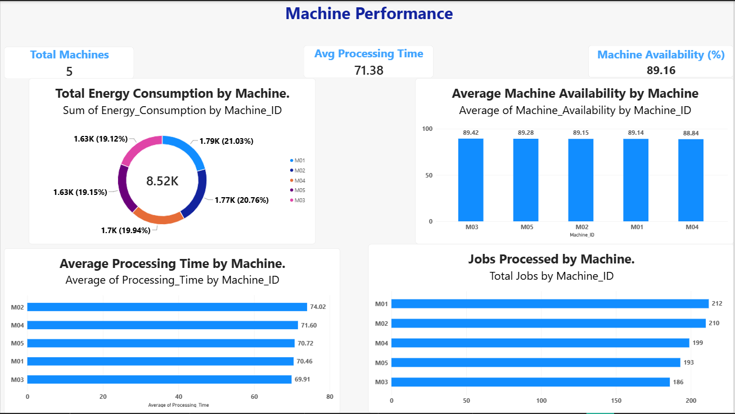

9. Job Analysis
This page provides a detailed view of jobs and job status. Users can explore the data using relevant slicers, such as machine, operation type, or job status.
A job-level view can make it easier to investigate how work is distributed and compare status categories. Add only the slicers and visuals that are present in the completed report.
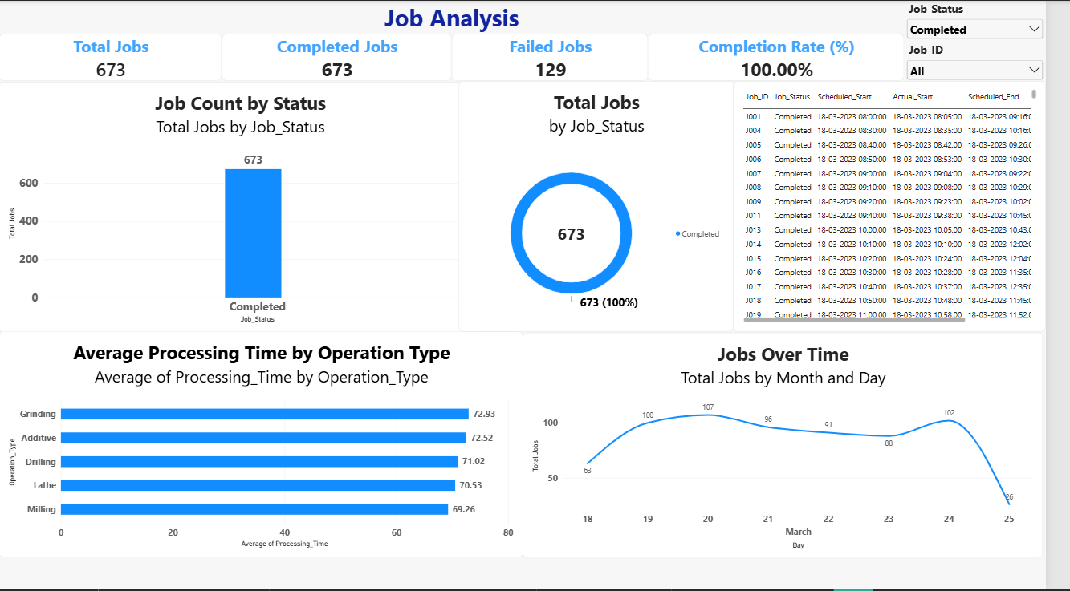

10. Energy and Optimization
This page examines energy consumption and optimization-related information, including comparisons by operation type or optimization category.
The energy view can support operational discussion about where consumption varies. Any optimization interpretation should be based on the fields and comparisons available in the final dashboard.
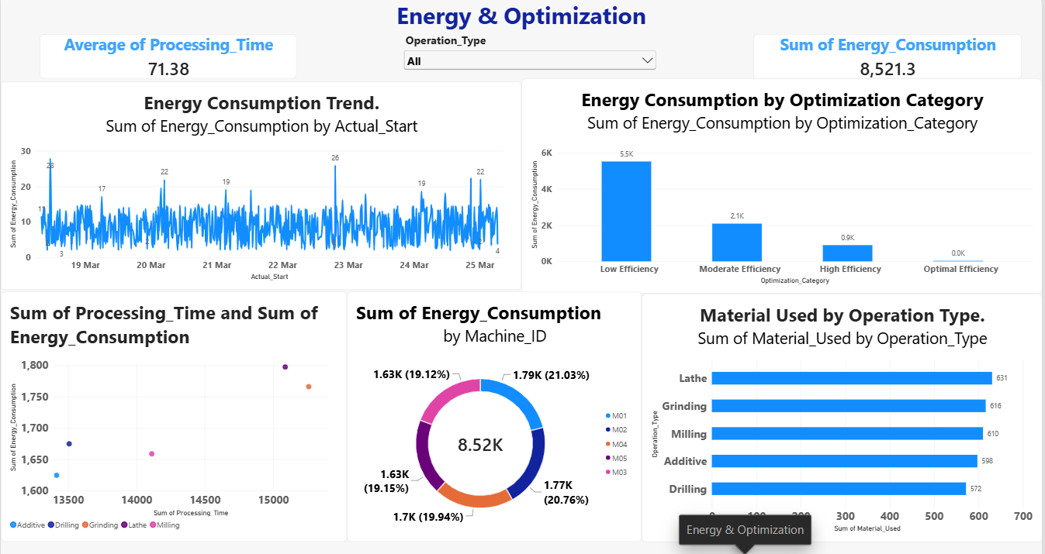

11. Daily Job Analysis
This page shows completed job counts by date using Actual_Start. The chart measures job volume, not profit. It can be used to examine changes in completed-job counts across dates.
The highest completed-job count by date should be reported only after checking the final chart and its filters. Revenue and cost data would be required to calculate daily profit; those fields are not included in this dataset.
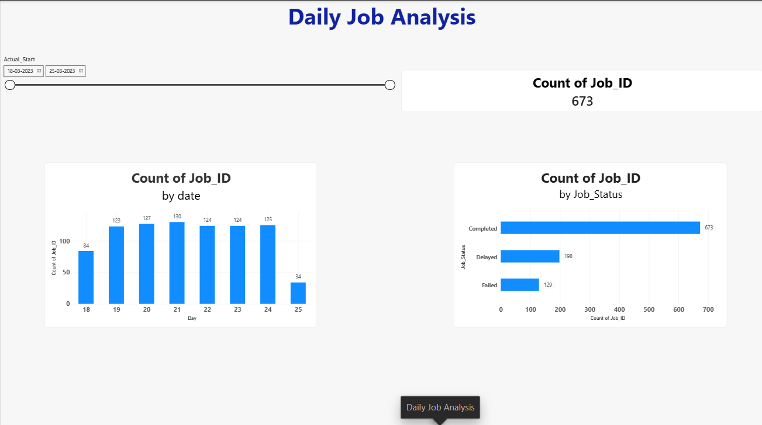

12. Findings, Conclusion, and Submission Checklist

Key Findings
The dashboard can be used to examine:
- The number of jobs and the distribution of job statuses.
- Differences in processing time and availability across machines.
- Variation in energy consumption by operation type.
- Changes in completed-job counts across dates.
The dataset does not include financial fields. Therefore, the dashboard cannot determine which day had the highest profit. Revenue and cost data would be required for that analysis.

Conclusion
This project demonstrates how Power BI can transform manufacturing data into an interactive dashboard. Data cleaning and DAX measures support the analysis, while separate report pages organize views of overall production, machine performance, job analysis, and energy consumption. The dashboard helps users explore manufacturing activity and identify operational patterns. Reliable revenue and cost data could extend the project to profit analysis.

