1.

#include <iostream>

#include <math.h>

#include <bits/stdc++.h>

using namespace std;

float sq(float num,float a,float b)

{

float mid=(a+b)/2;

float prod=mid\*mid;

if(prod==num)

return mid;

else if(prod>num)

sq(num,a,mid);

else

sq(num,mid,b);

}

int main()

{

//cout<<floor(sqrt(5));

float n=5,i=1;

int f=0;

while(f==0)

{

if((i\*i)==n)

{

cout<<i;

f=1;

}

else if((i\*i)>n)

{

float p=sq(n,i-1,i);

cout<<floor(p);

f=1;

}

i++;

}

return 0;

}

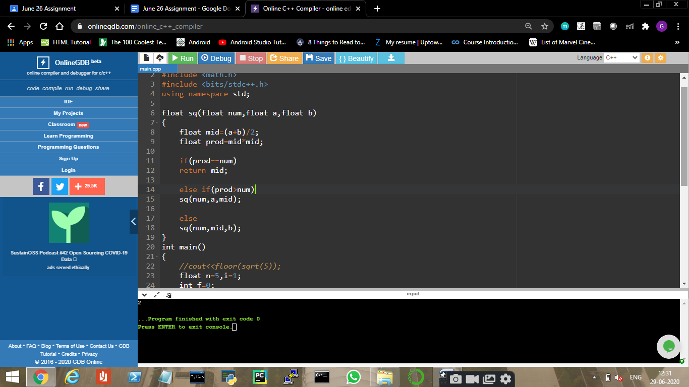

2.

#include <iostream>

#include <bits/stdc++.h>

using namespace std;

int main()

{

vector <int> a={5,17,100,11};

int n=a.size(),l=0,r=n-1;

while(l<=r)

{

int m=(l+r)/2;

if(a[m]<a[m-1]) //mid smaller than left

r=m-1;

else if(a[m]<a[m+1]) //mid smaller than right

l=m+1;

else

{

cout<<a[m];

break;

}

}

return 0;

}

