Application.properties contain the path of the input files 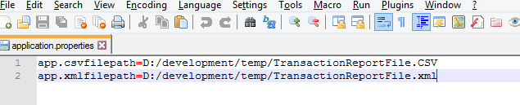

If Type is invalid than error message thrown

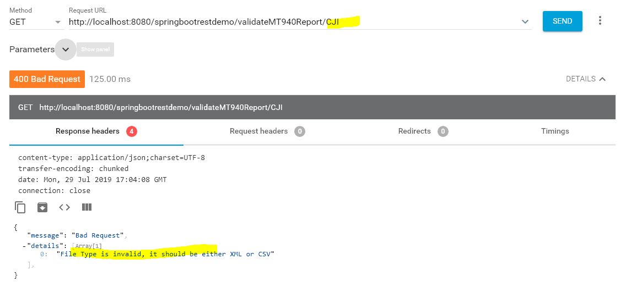

If file Type is XML

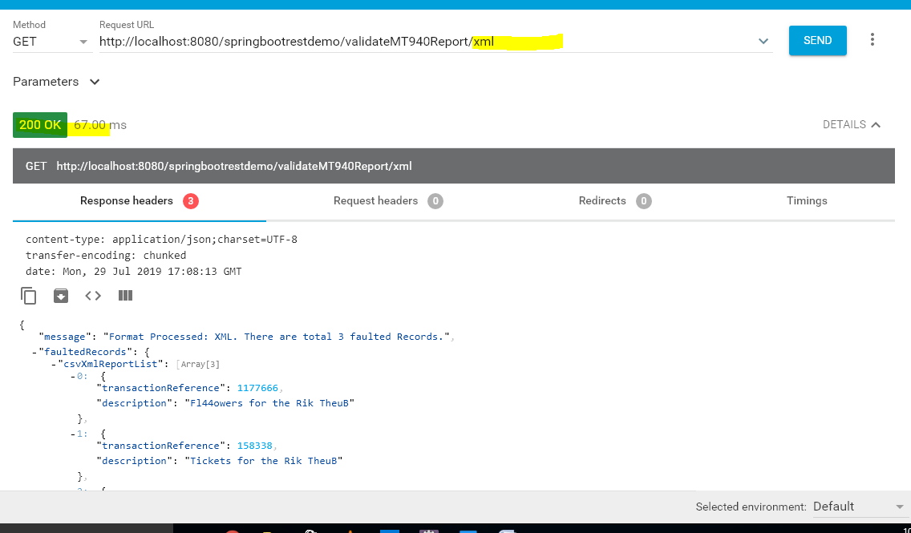

If file Type is CSV

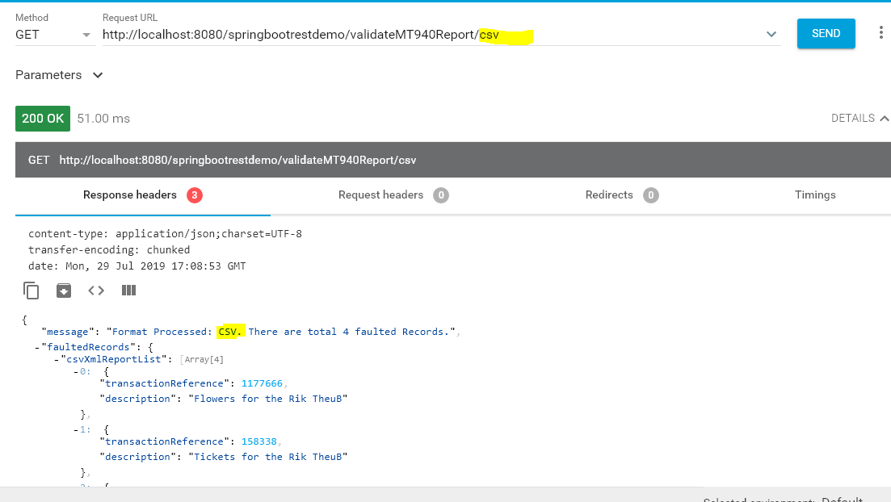

Junit Snapshot:

