QUESTON 1

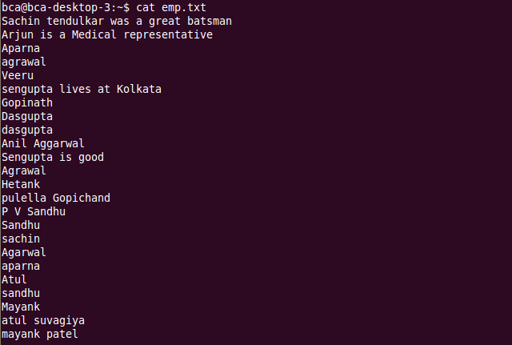

QUESTION 2



QUESTION 3



QUESTION 4

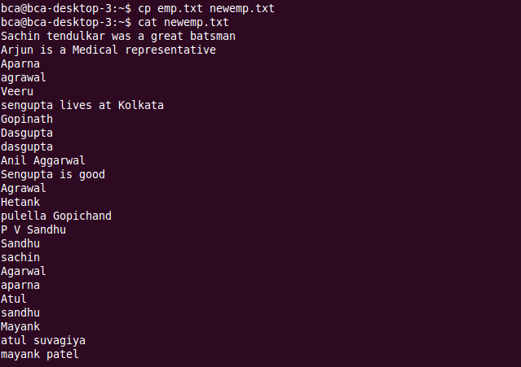

QUESTION 5



QUESTION 6



QUESTION 7

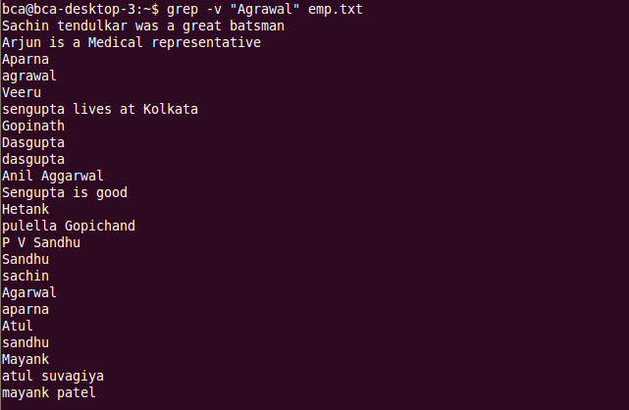

QUESTION 8



QUESTION 9



QUESTION 10

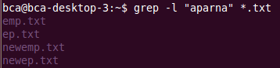

QUESTION 11



QUESTON 12



QUESTION 13

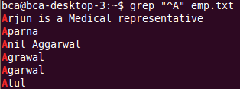

QUESTION 14



QUESTION 15

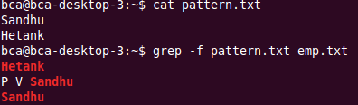

Question 16

